**1、用户注册登录**

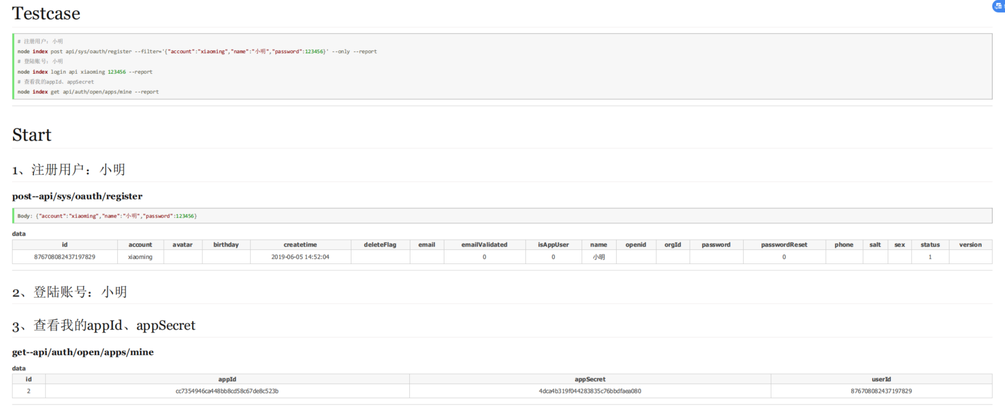

1. **用户使用appId、appSecret调用zero open api打印pdf服务，这里只是测试**

**Method：Post**

**Url：**

localhost:8888/api/zero/open/pdf/print?appId=cc7354946ca448bb8cd58c67de8c523b&appSecret=4dca4b319f044283835c76bbdfaea080

**Request Body：**

{"templateName":"distributor-order","content":"{\"${sum}\":[{\"${price}\":24240.00,\"${quantity}\":200}],\"${originatorName}\":\"admin\",\"${transactionTime}\":\"2018-11-21 15:56:46\",\"${item}\":[{\"${totalPrice}\":24240.00,\"${barcode}\":\"FDI1238HXI891K1\",\"${code}\":\"00010312\",\"${price}\":121.20,\"${rowSeq}\":1,\"${unit}\":\"Ping\",\"${name}\":\"Test ItemTEST\",\"${quantity}\":200}],\"${code}\":\"SAL2018211100015mzo\",\"${transactionBy}\":\"\",\"${traderName}\":\"陈力公司\",\"${traderContactPhone}\":\"020-90909090\",\"${salesNote}\":\"\",\"${deliveredAddress}\":\"广东广州天河区天河大夏\"}"}

**Response：**

{

"code": 200,

"message": "Success",

"data": "/pdf/5bfa29ca05e74b63ac135eb500103bfd.pdf"

}