State University of New York at Oswego

Department of Biomedical and Health Informatics

*SafeSpace: A Digital Community for People with Substance Use Disorder (SUD)*

Gerald Gaitos

**Introduction:**

Since the 1990s, drug overdose cases have continuously increased in numbers in the United States, calling this phenomenon the “Opioid Epidemic.” They already have recorded nearly 500,000 cases of people dying from an overdose involving prescription and illicit opioids (CDC, n. d.). Most people addicted to these substances try to cope with different stresses, traumas, or mental health issues. Unfortunately, they soon develop substance use disorder after misusing these prescribed medications (CDC, n. d.). Hence, providing a safe space and community to individuals who face substance use disorder, cope with various mental health issues, traumas, and stresses, and are recovering or have recovered from this disorder is essential. The emergence of telehealth has provided the potential increase in the use of mental health services, such as emotional support and social contact, reducing risks of mental health impacts and increasing the desire to seek basic information strategies, reducing various risks (Green et al., 2021).

This project intends to create a safe online space community that showcases various information about substance use disorder and a forum where individuals can share and partake in their stories. It aims to build a community that will connect people from various backgrounds. This project primarily caters to individuals who suffer from substance use disorder, have recovered from it, have relatives suffering from it, or are interested in gaining more information about it.

**Background:**

The history of the opioid pandemic started in the 1990s with good intentions gone bad when, initially, physicians were not aware of the addictive effects of drugs, combined with the greedy interests of pharmaceutical companies and drug cartels encouraging unsolicited opioid and opioid derivative use to the public. These factors have formed gigantic waves of addiction and deaths that are continuously increasing until today (deShazo et al., 2018). Affected individuals predominantly suffer from mental health issues, traumas, stresses, chronic diseases, and chronic pain (CDC, n. d. & Azadfard et al., 2023). These individuals need to be understood, and people need to realize that addiction is a disease and it can be cured.

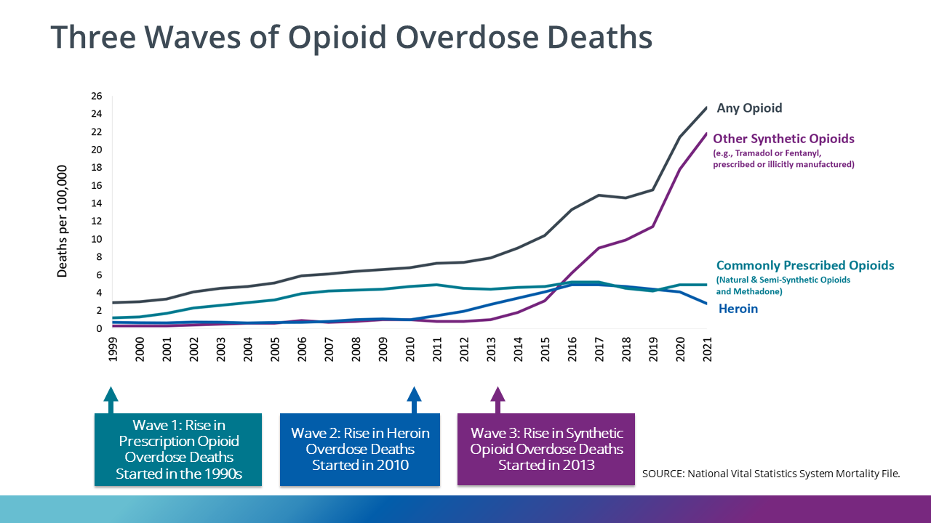

**Figure 1.** Three waves of opioid overdose deaths from the 1990s to the present.

Figure 1 shows that in past decades, there have been three waves of opioid overdose mortality. Wave 1 started in 1990 when physicians were not aware of the side effects of prescription opioids. People medicated with opioids started to become addicted and dependent on the medication. Wave 2 was initiated in 2010, when people were introduced to a new type of illicit drug, namely, heroin. The number of cases of drug overdose mortality kept constantly increasing through the years until Wave 3 happened, when new synthetic opioid drugs were created and manufactured, a steep rise in the number of cases of drug overdose mortality was observed (CDC, n. d.).

The US Health and Human Services have provided strategies to fight the opioid epidemic. The strategies mainly involve improving the accessibility to health services programs assisting in the prevention, treatment, recovery, and pain management, improving the reporting and recording of public health data, supporting research to deepen the understanding of addiction and overdose, and many more (Texas Health and Human Services, n. d.). These strategies can be implemented and fortified by creating a safe online space and community primarily for individuals suffering from substance use disorder.

Online communities are beneficial in providing various sources of support, primarily to particular groups of individuals (Green et al., 2021). Moreover, they are bridging the information gap brought about by limited resources and facilities, creating venues to talk about the mental health impacts of the disorder, and speaking for the need for supporting the desire for human connectedness in times of societal upheaval and the resultant severe isolation (Green et al., 2021).

**Project Objective:**

The main objective of this project is to build an electronic health system catering to information that can provide answers for people seeking substance use disorder and a community where individuals can share, be informed, and get informed.

**System Requirements:**

The Safe Space Online Community will serve as an online community forum that primarily caters to people who suffer from substance abuse disorder, but this community is not limited to their usage only; everyone who wants to become informed about the current situation of substance use disorder and to share stories that can help people suffering from the disorder in the United States are welcome. The project will provide the latest information on substance use disorder and serve as a social media outlet where everyone can share their views. The project will be built using WordPress.

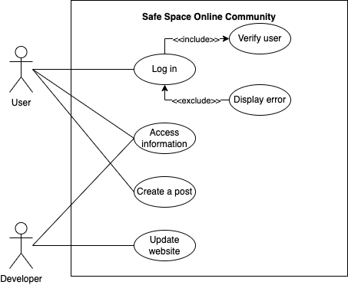

**Figure 1.** Use-case diagram

Figure 1 shows the two main actors in this project: the user and the developer. The user comprises different individuals but primarily caters to people who are suffering from substance use disorder, while the developer is the one who creates and updates the project. The user needs to log in with their credentials before they can access the home page. On the home page, the user can access the information tab where recent news on substance use disorder is displayed, and they can also access the forum where they can share insights, respond, or even generate a new thread. The developer can access the project without logging in and continuously provide content and website updates.

For this project, the non-functional requirements are the following:

1. Internet Access
2. Open source
3. Security
4. Portability
5. Usability
6. Confidentiality of the users' comments and information
7. Reliability

**Architectural Design:**

This project will be implemented via the WordPress platform since it is free and widely available, updated frequently, and has numerous features. This project will be customized according to the specific requirements of the system.

**High-Level Design:**

The project's design will use four static pages along with a dynamic page. The log-in page will welcome the user to the site, and the user will be asked to enter their credentials before proceeding to the home page. The home page will share the latest information about substance use disorder that is happening in the United States. The home page displays an information button, forum button, and log-out button. The information page will show all the latest news, graphs, and trends about substance use disorder. The forum page will offer the user a variety of postings where they can share, reply, and contribute to different available discussions.

**References:**

Azadfard, M., Huecker, M. R. & Learning, J. M. (2023, July 21). *Opioid Addiction*. Treasure

Island (FL): StatPearls Publishing. Retrieved September 27, 2023, from <https://www.ncbi.nlm.nih.gov/books/NBK448203/>

Centers for Disease Control and Prevention. (n. d.). *Uncovering the Opioid Epidemic*. Centers

for Disease Control and Prevention. Retrieved September 26, 2023, from <https://www.cdc.gov/museum/pdf/cdcm-pha-stem-uncovering-the-opioid-epidemic-lesson.pdf>

Congressional Budget Office. (2022, September). *The Opioid Crisis and Recent Policy*

*Responses*. Congressional Budget Office. Retrieved September 26, 2023, from <https://www.cbo.gov/system/files/2022-09/58221-opioid-crisis.pdf>

deShazo, R. D., Johnson, M., Eriator, I. & Rodenmeyer, K. (2018, June). Backstories on the US

Opioid Epidemic. Good Intentions Gone Bad, an Industry Gone Rogue, and Watch Dogs Gone to Sleep. *The American Journal of Medicine, Vol. 131, No. 6*. <https://doi.org/10.1016/j.amjmed.2017.12.045>

Green, B. M., Hribar, C. A., Hayes, S., Bhowmick, A., & Herbert, L. B. (2021, December 3).

Come for Information, Stay for Support: Harnessing the Power of Online Health Communities for Social Connectedness during the COVID-19 Pandemic. *Internal Journal of Environmental Research and Public Health, Vol. 18, 12743*. <https://doi.org/10.3390/ijerph182312743>

McGranahan, D. A. & Parker, T. S. (2021, April). *The Opioid Epidemic: A Geography in Two*

*Phases*. U.S. Department of Agriculture, Economic Research Services. Retrieved September 26, 2023, from <https://www.ers.usda.gov/webdocs/publications/100833/err-287.pdf>

Texas Health and Human Services. (n. d.). Quality Monitoring Program “Opioids: An Epidemic

Crisis”. Texas Health and Human Services. Retrieved September 27, 2023, from <https://www.hhs.texas.gov/sites/default/files/documents/doing-business-with-hhs/provider-portal/QMP/opioids-epidemic-crisis.pdf>