JDBC – standart care conecteaza o aplicatie Java cu un RDBMS. El propriu zis nu comunica cu o baza de date, dar ofera interfete si clase abstracte pentru implementari ce comunica cu diferite baze de date, dar sa fie in mod identic la toate, fie ca e MySql, Oracle etc.

Implementarile lui JDBC ofera un Driver, pentru a lucra cu baza e date, ca de ex com.mysql.Driver

**JDBC are mereu nevoie de un JDBC Driver!!!**

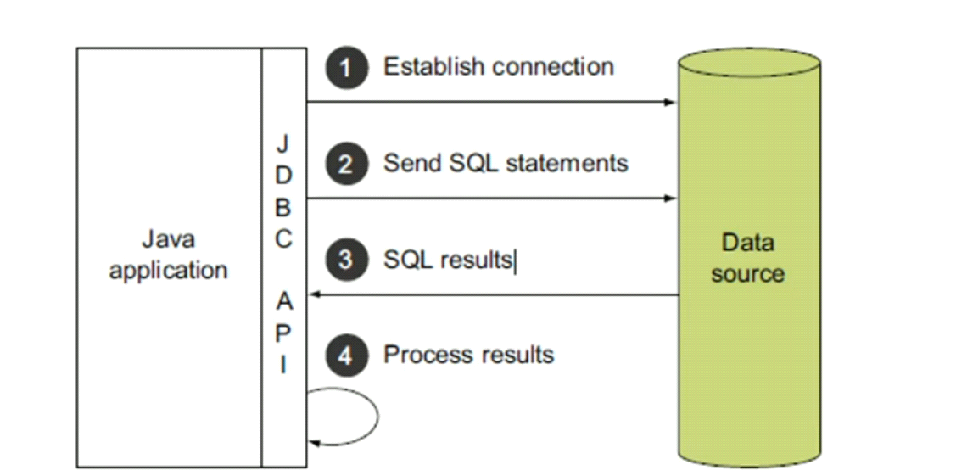

**Interfete in java.sql**

* Driver – asigura conectarea la baza de date. Adica, ofera posibilitatea de a crea conexiuni la baza de date
* Connection
* DataSource
* Statement – simpla clase care ne ajuta sa executam query. Ne ajuta sa extragem date in baza de date, dar nu putem seta parametri cu el si deci nu putem pune data. Are si el metoda .close()

- close()

- execute() – returneaza boolean

- executeQuery() – returneaza ResultSet

* PreparedStatement – ne ajuta sa inseram date in baza de date si previne sql injection. Putem seta parametri. Previne bine sql injection.

- close()

- execute() – returneaza boolean

- executeQuery() – returneaza ResultSet

- setInt(index,valoare)

- setString(index, “string”)

* CallableStatement – apeleaza functii si proceduri din baza de date. Se creaza cu metoda prepareCall(“...”)

- setString/Int(index, valoare)

- execute()

- close()

* ResultSet – pentru datele care vin inapoi. Are nevoie de next() pentru a primi fiecare element extras

- next() – trece la urmatorul resultat

- getInt(“nume coloana tabel”)

- getString(“nume coloana tabel”)

- getMetaData() – ofera metadate despre tabelul din care s-au extras date, si apoi putem executa getMetaData().getColumnName(NumarColoana)

**Connection Method**

* connection.setAutoCommit(false/true) – default e true. Orice operatie in baza de date va fi automat commited, deci nu va fi necesar sa apelam .commit()
* connection.commit()
* connection.rollback()
* connection.execute(StringQuery)
* connection.updateExecute(StringQuery)
* connection.executeQuery(StringQuery)
* isValid(timeout)
* isClosed()

**Examples**

public static void main(String[] args) throws SQLException {  
 MysqlDataSource dataSource = new MysqlDataSource();  
 dataSource.setUser("testuser");  
 dataSource.setPassword("Frb2eshox!");  
 dataSource.setURL("jdbc:mysql://localhost:3306/test");  
  
 Connection connection = dataSource.getConnection();  
  
 Statement statement = connection.createStatement();  
 statement.execute("INSERT INTO teacher VALUES(100,'Cornel','Catan',18)");  
 connection.close();  
  
}

**Statement**

public static void main(String[] args) throws SQLException {  
 MysqlDataSource dataSource = new MysqlDataSource();  
 dataSource.setUser("testuser");  
 dataSource.setPassword("Frb2eshox!");  
 dataSource.setURL("jdbc:mysql://localhost:3306/test");  
  
 Connection connection = dataSource.getConnection();  
  
 Statement statement = connection.createStatement();  
 ResultSet resultSet = statement.executeQuery("SELECT * FROM teacher");  
 resultSet.next();  
 String teacher = String.*format*("Teacher = {id=%d, first_name=%s, last_name=%s, expirience=%d}",  
 resultSet.getInt("id"),resultSet.getString("first_name"),resultSet.getString("last_name"),resultSet.getInt("expirience"));  
 System.*out*.println(teacher);  
  
 connection.close();  
  
}

**Statment cu mai multe rezultate**

public static void main(String[] args) throws SQLException {  
 MysqlDataSource dataSource = new MysqlDataSource();  
 dataSource.setUser("testuser");  
 dataSource.setPassword("Frb2eshox!");  
 dataSource.setURL("jdbc:mysql://localhost:3306/test");  
  
 Connection connection = dataSource.getConnection();  
  
 Statement statement = connection.createStatement();  
 String query = "SELECT * FROM teacher";  
 statement.execute(query);  
 ResultSet resultSet = statement.getResultSet();  
  
 while(resultSet.next()){  
 System.*out*.printf("Teacher = {%d, %s, %s, %d}",resultSet.getInt("id"),resultSet.getString("first_name"),resultSet.getString("last_name"),resultSet.getInt("expirience"));  
 }  
   
 connection.close();  
  
}

**executeQuery = execute() + getResultSet()**

**PreparedStatement**

MysqlDataSource dataSource = new MysqlDataSource();  
dataSource.setUser("testuser");  
dataSource.setPassword("Frb2eshox!");  
dataSource.setURL("jdbc:mysql://localhost:3306/test");  
  
Connection connection = dataSource.getConnection();  
  
PreparedStatement statement = connection.prepareStatement("INSERT INTO teacher VALUES(?,?,?,?)");  
statement.setInt(1,123);  
statement.setString(2,"CAPATINA");  
statement.setString(3,"VLADA");  
statement.setInt(4,25);  
statement.execute();  
  
  
connection.close();

**Observam ca avem ?, nu ?1**

**Connection Pool**

* O connection pool creaza un numar de conexiuni deja definite. La rularea programului se vor crea atatea conexiuni deodata, cate am specificat si anume aceste conexiuni vor fi mereu folosite
* In caz ca sunt folosite toate conexiunile, va fi necesar de a se crea una noua
* Cand o conexiune termina lucrul, ea e rentoarsa inapoi in pool
* cand sunt create un numar maxim de conexiuni si mai e nevoie de una pentru o transactie, transactia va astepta ca o conexiune sa se elibereze, adica sa fie inchisa si returnata in pool

**DriverManager**

* **In loc de MySqlDataSource, putem folosi DriverManager**
* public static void main(String[] args) throws SQLException {  
   Connection connection = DriverManager.*getConnection*("jdbc:mysql://localhost:3306/test","testuser","Frb2eshox!");  
   Statement statement = connection.createStatement();  
   statement.execute("SELECT * FROM teacher WHERE id=21");  
   ResultSet resultSet = statement.getResultSet();  
   resultSet.next();  
   System.*out*.println(resultSet.getInt("id")+" "+resultSet.getString("first_name"));  
    
  }