**/health**



* In mod default, /health ne arata doar statusul la aplicatie, daca e UP sau nu, dar mai poate arata si alte chestii
* Putem de ex face sa se arate toate datele pentru health

management.endpoint.health.show-details=*always*

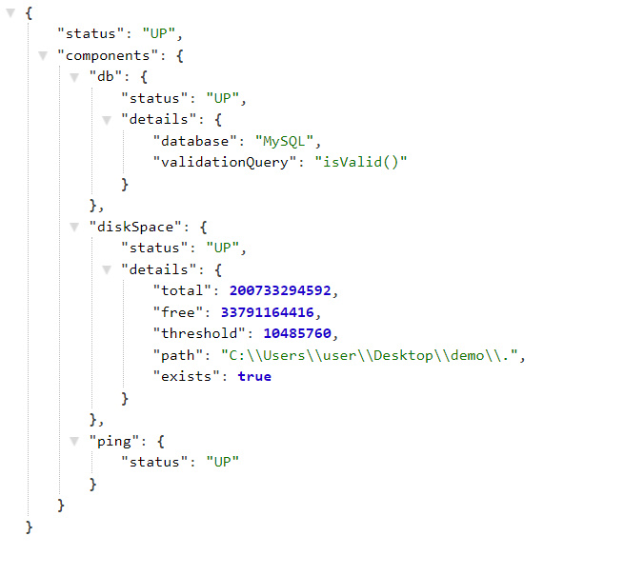

* Putem pune si multe altele inca.

**/beans**



**/conditions**

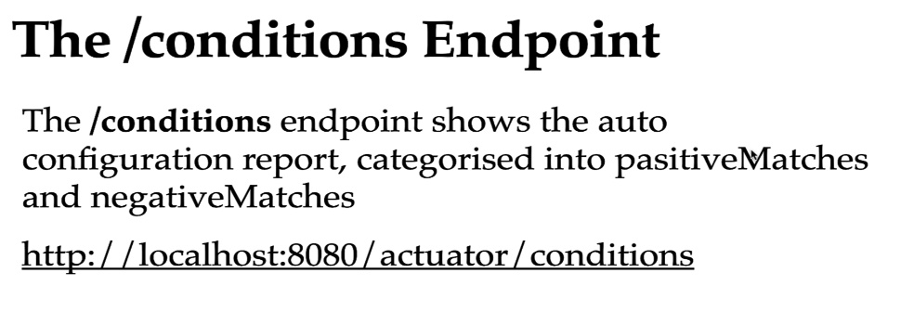

Arata toate beanurile create ce corespund unei conditii @Condition...., in positiveMatches, si cele care nu corespund conditieie puse in negativeMatches

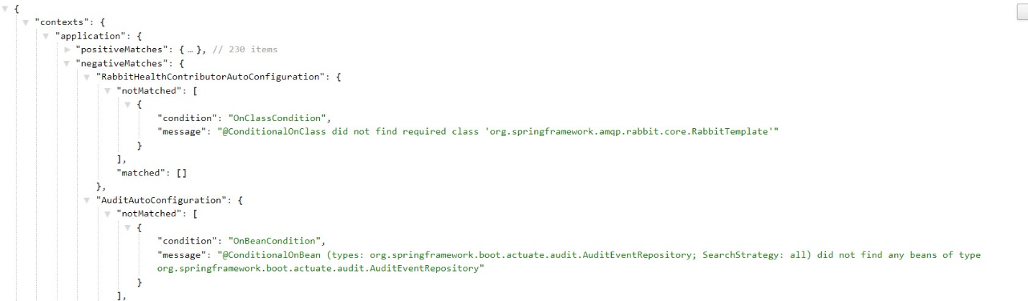

**/mappings**



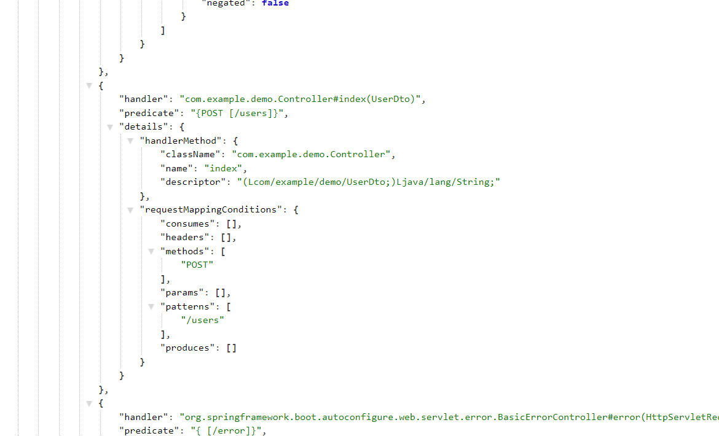

**/configprops**



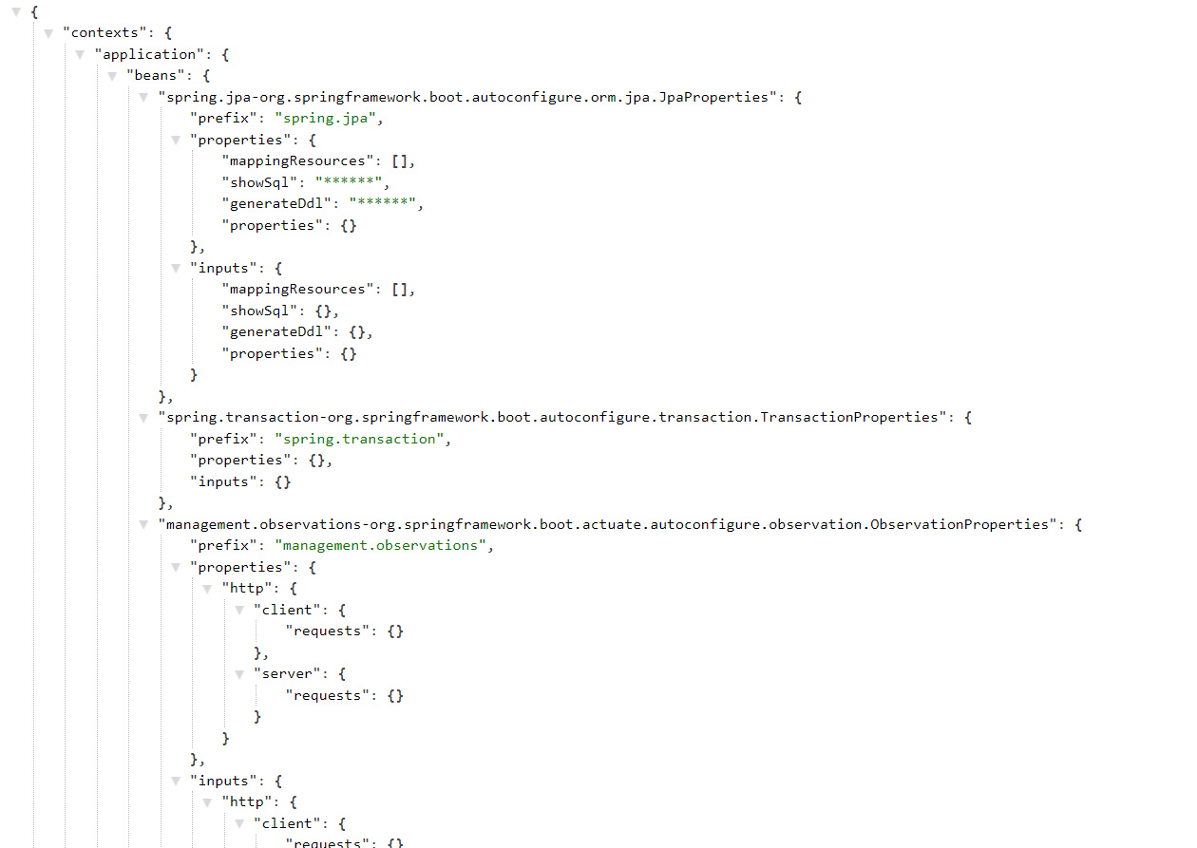

**/metrics**



Totusi, folosirea la [localhost:8080/actuator/metrics](http://localhost:8080/actuator/metrics) va arata asta:

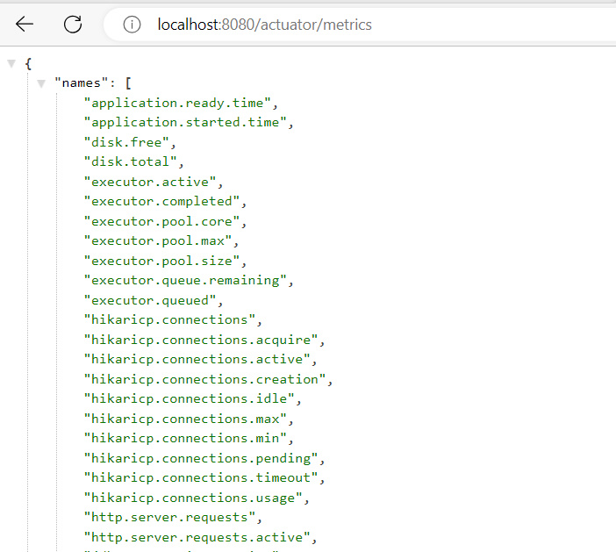

alegem unul si il punem dupa /, gen asa:

[localhost:8080/actuator/metrics/application.started.time](http://localhost:8080/actuator/metrics/application.started.time)

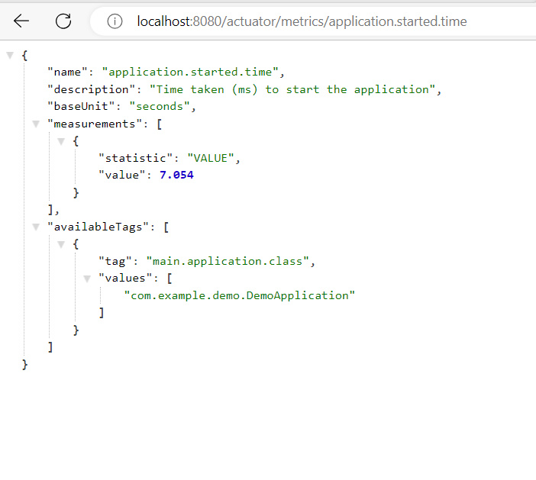

**/env**

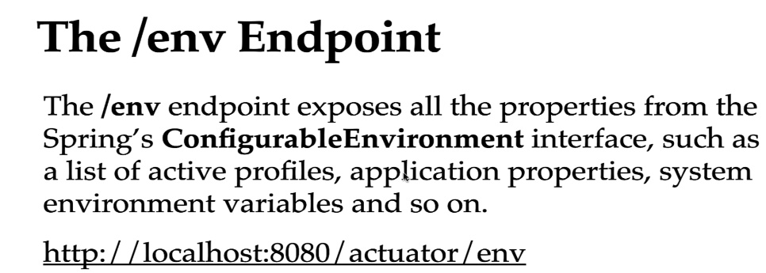

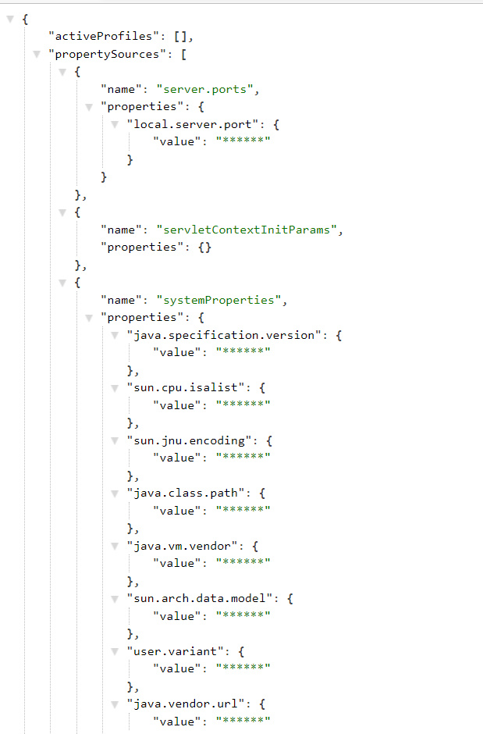

**/threaddump**



**/loggers**

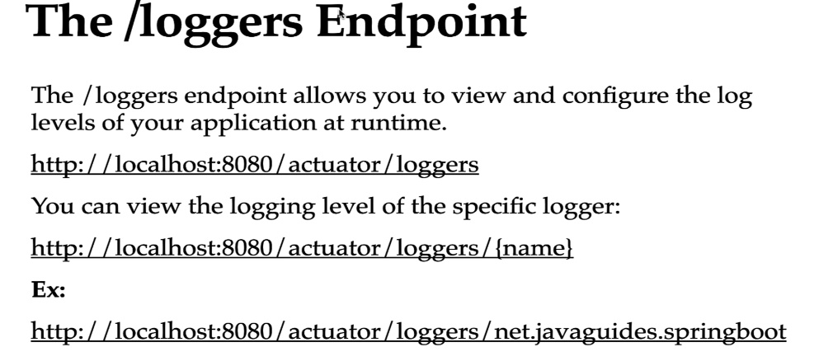

[localhost:8080/actuator/loggers](http://localhost:8080/actuator/loggers) – doar arata log level la diferite package

* Putem modifica log level la un package prin POST cu link:

<http://localhost:8080/actuator/loggers/org.hibernate.boot.model.process.internal>

Si body:

{

"effectiveLevel": "WARN"

}

**/shutdown**

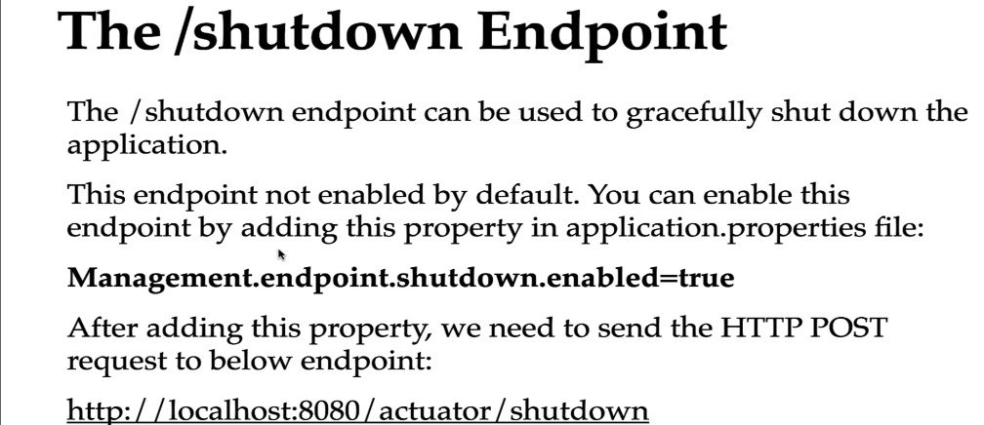

Facem doar un POST fara body si gata.