Stock screener
(Datamatican, Final project-Octber-2008)
Vejle handel skole

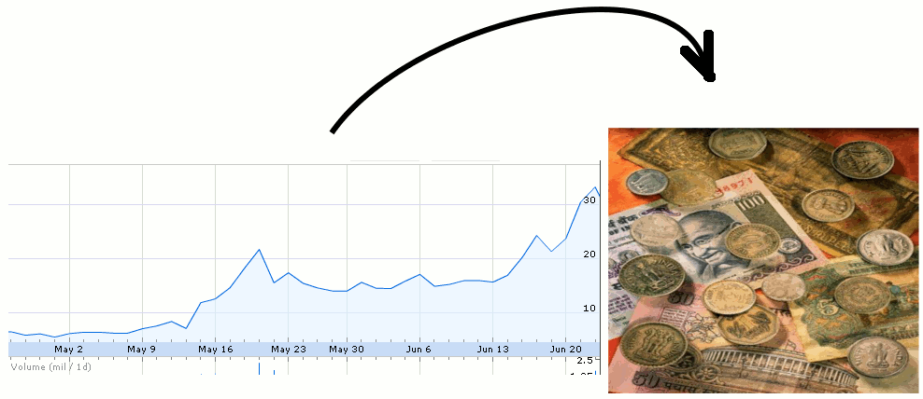

Project Proposer | Freyr.dk, http://www.freyr.dk/
Address | Kollerupvej 15, 7300 Jelling
Phone | +45 42404077
Project group and class | Yani Kereena Atmakuri,DMU-6018
Supervisor | Jens Toft Madsen
Contact person at company | Jens Kristian Davidsen
Submit date | 31-10-2008

