Part 1

**Initial State:** Any node can be designated as the starting node of the algorithm (such as “at B” or “at C”)

**Goal test:**

The conditions to test if goal is reached:

* if(currentNode == startNode)
* if(listOfUnvisitedNodes.lenght == 0)
* for node in nodes: node.visitCount = 1

**State space:** List of all nodes and the edges between them.

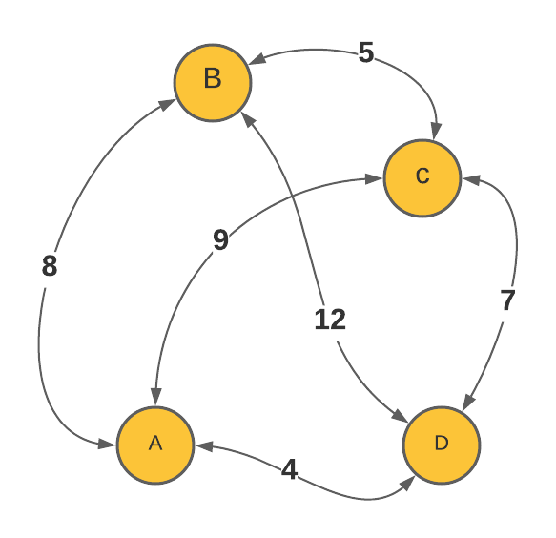

**Successor Function:** The successor function in this context is to go from one of the nodes to another in the state space, using an edge that is defined in between them.

**Cost Function:** The weight (cost) of any given edge between two nodes where successor function can be applied.

Informed search algorithms can use variety of possible heuristics. Two of the most popular ones are:

**Greedy Algorithm:** This algorithm takes advantage of heuristics by calculating an estimation of distance left to its goal at each given state. This calculation is bases on a bird’s eye view that disregards any obstructions that may exist between the goal and the current position, however it is still a good enough estimation to be considered in the decision making.

**A* Algorithm:** This algorithm can be considered as an improved version of the greedy one, as this time it takes the distance travelled so far to account as well. By adding this extra variable, it is able to pre-empt a possible obstruction better than the plain greedy algorithm would.

**Part 2**

1. According to Wikipedia, MST “is a subset of the edges of a connected, edge-weighted undirected graph that connects all the vertices together, without any cycles and with the minimum possible total edge weight”. In the TSP the tour with the minimum cost must be a cycle, since in a non-cyclic case a node would be visited twice. However, by the definition of MST, a cycle is not possible. Hence a relaxation of TSP is needed, if we want to solve this problem by using MST. If we relax the constraints such that a node can be visited more than one time and those repeated costs are not added to the overall sum, then it is possible that TSP would be solved by using MST.
2. MST is dominant in a straight-line case because of the very definition of it. Given two nodes A and B, if they are perfectly straight, that is, the angle between them is 0 degrees, then that is the shortest distance possible in a 2-dimensional plane.