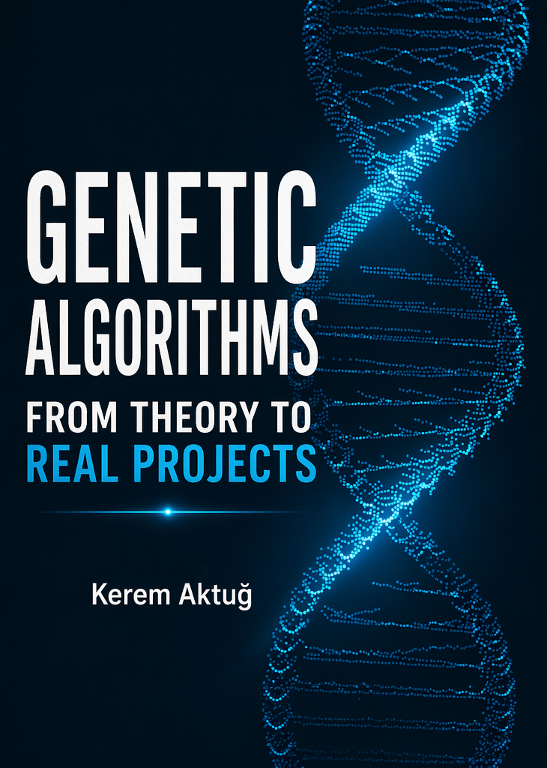
Genetic Algorithms from theory to Real Projects
KEREM AKTUĞ

brief contents

Table of Contents
FOUNDATIONS ...................................................................... 1
  - ■ Definition and History 5
  - ■ Usage Fields 7
  - ■ Biological Background 10
CORE CONCEPTS ................................................................. 1
  - ■ Genes 3
  - ■ Chromosomes 32
  - ■ Population 32
  - ■ Selection 32
  - ■ Crossover 32
  - ■ Mutation 32
  - ■ Elitism 32
HOW GA WORKS .................................................................. 1
  - ■ Genetic Algorithm Workflow 83
  - ■ Parameter Tuning (mutation rate, population size, etc.) 83
BASIC PROJECTS ................................................................. 1
  - ■ Evaluating a Phrase - 83
  - ■ Common Library - 83
  - ■ GUI – 83

CLASSIC PROBLEMS .......................................................... 1
  - ■ 8-Queens - 29
  - ■ Knapsack - 262
  - ■ Timetabling – 96
ADVANCED / REAL WORLD .............................................. 1
  - ■ Analog RC - 22
  - ■ Analog Op-Amp - 33
  - ■ ML Hyperparameter Optimization - 222
  - ■ Random Forest Hyperparameter Optimization – 22

Foundations
Definition and History
Genetic Algorithms (GAs) are a class of optimization techniques inspired by the process of natural selection. They belong to the broader field of evolutionary computation, which models computational problem-solving based on mechanisms observed in biological evolution.

At their core, genetic algorithms operate on a simple yet powerful principle:

Solutions evolve over time through selection, recombination, and variation

Rather than following a deterministic path toward a solution, genetic algorithms explore a population of candidate solutions and iteratively improve them. This population-based approach allows the algorithm to search complex and high-dimensional spaces more effectively than many traditional optimization methods.

The conceptual roots of genetic algorithms can be traced back to the 1950s and 1960s, when researchers began exploring the idea of simulating evolutionary processes using computers. Early work in this area focused on evolutionary strategies and adaptive systems, laying the groundwork for later developments.
However, these early efforts lacked a unified theoretical framework.

John Holland and Formalization


The formal development of genetic algorithms is primarily credited to John Holland in the 1970s. As a professor at the University of Michigan, Holland developed the first comprehensive theory of genetic algorithms and their application to optimization problems.
In his seminal 1975 book Adaptation in Natural and Artificial Systems, Holland introduced the key components of genetic algorithms, including:
- Representation of solutions as chromosomes
- Evaluation through a fitness function
- Evolutionary operators such as selection, crossover (recombination), and mutation
Holland’s work demonstrated that these biologically inspired mechanisms could be used to solve complex computational problems without requiring explicit mathematical models of the search space.
Growth and Popularization
During the 1980s and 1990s, genetic algorithms gained significant attention across multiple disciplines. Researchers and practitioners began applying GAs to real-world problems, particularly in areas where traditional optimization techniques were ineffective.
One of the key figures in popularizing genetic algorithms was David E. Goldberg, whose work in engineering optimization demonstrated their practical value. His book Genetic Algorithms in Search, Optimization, and Machine Learning became a widely referenced resource in the field.
During this period, genetic algorithms were successfully applied in:
- Engineering design optimization
- Control systems
- Scheduling and planning
- Artificial intelligence
This era marked the transition of genetic algorithms from a theoretical concept to a practical problem-solving tool.

Modern Developments
In recent years, genetic algorithms have continued to evolve and remain relevant, particularly in the context of modern computational challenges. With the rise of machine learning and data-driven systems, GAs are increasingly used for:
- Hyperparameter optimization
- Feature selection
- Neural architecture search
Additionally, advances in computing power and parallel processing have significantly improved the scalability and efficiency of genetic algorithms.
Today, genetic algorithms are often combined with other techniques, forming hybrid approaches that leverage the strengths of multiple optimization strategies.

Summary
Genetic algorithms have evolved from early theoretical ideas into a powerful and widely used optimization framework. Rooted in biological principles and formalized through rigorous research, they provide a flexible approach to solving complex problems across diverse domains.
Their continued relevance highlights a key insight:
Nature-inspired computation remains one of the most effective ways to tackle challenging optimization problems.

Foundations
Usage Fields
At first glance, Genetic Algorithms may seem like an abstract idea—an elegant concept inspired by nature. But their true power reveals itself when they are applied to real-world problems.
Across industries and disciplines, Genetic Algorithms quietly solve problems that are too complex, too nonlinear, or simply too vast for traditional methods. In this section, we explore where these algorithms truly come to life.

Engineering: Shaping the Physical World
Imagine designing a bridge, an aircraft component, or even an antenna.There isn’t just one “correct” solution—there are thousands, sometimes millions, each with trade-offs.

This is where Genetic Algorithms thrive.
Instead of searching for a perfect answer directly, they evolve better designs over time:
- lighter structures that remain strong
- more efficient mechanical systems
- finely tuned control parameters
- optimized electronic and antenna designs

In engineering, GAs don’t just find solutions—they discover better designs than intuition alone could reach.

Finance: Navigating Uncertainty
Financial systems are unpredictable, dynamic, and often chaotic.
How do you balance risk and return?
How do you build a portfolio that survives uncertainty?
Genetic Algorithms approach this like evolution:
- strategies compete
- poor performers are eliminated
- better ones survive and improve
Over generations, portfolios evolve, trading strategies adapt, and decision-making becomes more robust.
In a world of uncertainty, GAs provide a way to search intelligently without knowing the future.

Environment: Understanding Complex Systems
Environmental systems are vast and interconnected.
Air pollution, climate models, and geophysical processes involve countless variables interacting in ways we cannot fully observe.
Genetic Algorithms help by exploring possibilities:
- estimating pollution sources
- tuning environmental models
- solving inverse geophysical problems
- optimizing spatial resource use
They allow us to work with incomplete data and still move toward meaningful answers.
In these domains, GAs become tools for understanding systems we cannot directly control.

Machine Learning & AI: Improving Intelligence
Modern AI systems are powerful—but also complex and sensitive.
Small changes in parameters can lead to huge differences in performance.
Genetic Algorithms step in as intelligent explorers:
- tuning hyperparameters
- selecting the most relevant features
- evolving neural network architectures
- optimizing model combinations
When gradients fail or the search space becomes too irregular, GAs continue searching.
They don’t rely on perfect information—they rely on progress through iteration.

Biology & Medicine: Returning to Their Roots
It is no coincidence that Genetic Algorithms shine in biological domains.
After all, they are inspired by life itself.
They are used to:
- model genes and proteins
- explore drug candidates
- analyze biological sequences
- support medical decision systems
These problems often involve enormous search spaces—far beyond brute-force methods.
Here, GAs feel almost natural—an algorithm inspired by evolution, solving problems of life.

Operations & Scheduling: Taming Complexity
Some problems are not continuous—they are combinatorial.
Scheduling tasks, routing vehicles, organizing resources—these are problems where possibilities explode exponentially.
Genetic Algorithms offer a practical approach:
- building efficient schedules
- optimizing delivery routes
- improving logistics systems
- balancing resource allocation
Exact solutions may be impossible to compute, but GAs provide solutions that are good, fast, and practical.

Creative Fields: Beyond Optimization
Perhaps the most surprising applications of Genetic Algorithms are in creativity.
Instead of optimizing numbers, they evolve ideas.
- game behaviors that adapt over time
- procedurally generated worlds
- music and visual art
- evolving designs and patterns
In these areas, the goal is not always perfection—it is exploration.
Genetic Algorithms become tools not just for solving problems, but for creating new possibilities.

Scientific Discovery: Searching the Unknown
In research, some questions don’t have clear answers—or even clear paths.
Genetic Algorithms help explore:
- symbolic regression (discovering equations)
- multi-objective optimization
- simulation tuning
- model discovery
They allow scientists to search through immense spaces of possibilities, often revealing solutions that were not previously considered.
In this sense, GAs are not just optimization tools—they are engines of discovery.

Closing Thought
Across all these domains, one pattern remains the same:
Genetic Algorithms do not require perfect knowledge.
They require only a way to evaluate progress.
From engineering structures to creative art, from financial strategies to scientific discovery, they offer a powerful idea:
Instead of solving a problem directly, evolve the solution.

Foundations
Biological Background
Genetic Algorithms are inspired by one of the most powerful processes in nature: evolution by natural selection.
For millions of years, living organisms have adapted to their environments through a simple yet remarkably effective mechanism. Individuals that are better suited to their surroundings are more likely to survive and reproduce. Over time, beneficial traits are preserved, while less effective ones gradually disappear.
This process—slow, iterative, and decentralized—has produced the incredible diversity and complexity of life we observe today.
Genetic Algorithms borrow these core principles and translate them into a computational framework.

Natural Selection: Survival of the Fittest
In nature, not all individuals are equally successful. Some are faster, stronger, or better adapted to their environment. These individuals are more likely to survive and pass their traits to the next generation.
In Genetic Algorithms, this idea is represented through a fitness function.
Each candidate solution is evaluated based on how well it solves a problem. The better the solution, the higher its fitness—and the more likely it is to contribute to future generations.
Over time, weaker solutions are discarded, and stronger ones dominate the population.

Genes and Chromosomes
Biological organisms store information in the form of genes, which are organized into chromosomes.
These genes determine observable traits such as eye color, height, or resistance to disease.
In Genetic Algorithms, solutions are encoded in a similar way:
- A chromosome represents a complete solution
- Genes represent individual components of that solution
For example, in a simple problem, a chromosome might be a string of characters. In more complex cases, it could represent numbers, parameters, or even neural network structures.
This encoding allows solutions to be manipulated, combined, and evolved over time.

Reproduction and Crossover
In biological reproduction, offspring inherit genetic material from their parents. This process mixes traits, sometimes producing better combinations than either parent alone.
Genetic Algorithms mimic this process through crossover (recombination).
Two parent solutions are selected, and parts of their structure are combined to create a new solution. This allows useful traits from different individuals to be merged, potentially producing stronger offspring.
Crossover is one of the key mechanisms that enables exploration of the search space.

Mutation: Introducing Diversity
While inheritance passes down traits, evolution would quickly stagnate without variation.
This variation is introduced through mutation—random changes in genetic material.
In nature, mutations can be beneficial, neutral, or harmful. However, even small random changes can occasionally lead to significant improvements.
In Genetic Algorithms, mutation plays a similar role:
- it prevents the population from becoming too similar
- it helps escape local optima
- it introduces new possibilities into the search process
Without mutation, the algorithm would lose diversity and converge too early.

Population and Evolution Over Generations
Evolution does not occur in a single individual—it happens across populations over generations.
A population of organisms evolves as:
- Individuals are evaluated (fitness)
- The best are selected
- New individuals are created through reproduction
- Random variations are introduced
Genetic Algorithms follow the same cycle.
Each iteration (generation) improves the overall quality of solutions. While not every step leads to improvement, the overall trend is toward better and better solutions.

From Biology to Computation
What makes this biological analogy so powerful is its simplicity.
There is no central controller.
There is no exact formula for the perfect solution.
There is only a process:
- variation
- selection
- inheritance
From these simple rules, complex and highly effective solutions emerge.
Genetic Algorithms capture this idea and apply it to computational problems.

A Different Way of Thinking
Traditional algorithms often try to construct a solution directly.
Genetic Algorithms take a different approach:
They start with many imperfect solutions and let them evolve.
Instead of solving the problem step by step, they search through possibilities, guided by feedback.
This makes them especially useful when:
- the search space is large
- the problem is nonlinear
- or the optimal solution is unknown

Closing Perspective
By mimicking the principles of natural evolution, Genetic Algorithms provide a powerful and flexible framework for solving complex problems.
They remind us of an important idea:
Complex solutions do not always need to be designed—they can emerge.
And just like in nature, this emergence is driven by a simple but profound mechanism:
the continuous refinement of better solutions over time.

Core Concepts
Genes

A gene is the smallest unit of information in a Genetic Algorithm.
It represents a single component of a potential solution.
Just as genes in biological systems encode traits such as eye color or height, genes in Genetic Algorithms encode parts of a solution to a problem.

Genes as Building Blocks of Solutions
In Genetic Algorithms, a solution is not treated as a whole from the beginning.
Instead, it is broken down into smaller pieces—genes.
Each gene carries a piece of information, and together, they form a complete solution.
This idea allows the algorithm to:
- modify solutions partially
- combine useful pieces from different solutions
- explore the search space more effectively

Suppose we want to solve the following expression:

target = x + y + z + t
Gene
Gene
Gene
Gene

In this case, each variable can be treated as a gene:
- $x$→ gene
- $y$→ gene
- $z$→ gene
- $t$→ gene

So a possible solution (chromosome) might look like:

[ x = 3, y = 7, z = 2, t = 5 ]

Different Types of Gene Representations
Depending on the problem, genes can take different forms:
- Binary genes → 0 or 1 (used in classic GA problems)
- Integer genes → discrete values (e.g., scheduling, routing)
- Real-valued genes → continuous parameters (e.g., engineering design)
- Categorical genes → predefined choices (e.g., strategy selection)
- Symbolic genes → characters or tokens (e.g., evolving strings)
The choice of representation is critical, as it directly affects how the algorithm explores solutions.

Why Genes Matter
Genes are important because they define how a problem is represented.
A good gene representation:
- makes meaningful variations possible
- allows useful traits to be inherited
- enables efficient exploration
A poor representation, on the other hand:
- slows down convergence
- limits the search space
- may prevent the algorithm from finding good solutions

Intuition Behind Genes
You can think of genes as adjustable parameters of a solution.
Instead of searching for a solution directly, the algorithm:
- adjusts genes
- evaluates the result
- keeps better combinations
Over time, good gene values spread across the population.

Closing Insight
At its core, a Genetic Algorithm does not evolve entire solutions—it evolves genes.
By refining small pieces of information step by step, it gradually builds better and better solutions.
Small changes at the gene level can lead to significant improvements at the solution level.

Core Concepts
Chromosomes

While a gene represents a single unit of information, a chromosome represents a complete candidate solution.
In Genetic Algorithms, chromosomes are composed of multiple genes working together to describe a solution to a problem.
Just as biological chromosomes carry genetic information that defines an organism, chromosomes in Genetic Algorithms define how a solution behaves.

From Individual Genes to Complete Solutions
A single gene on its own has limited meaning.
It only becomes useful when combined with other genes.
A chromosome is simply a collection of these genes:

Chromosome: [g₁, g₂, g₃, ..., gₙ]

Each gene contributes a part of the solution, and together they form a complete representation.

Example: A Simple Numerical Problem
Consider again the expression:
$$\text{target}=x+y+z+t$$
If each variable is a gene, then a chromosome represents one possible solution:

Chromosome: [3, 7, 2, 5]

Here:
- gene 1 → value of $x$
- gene 2 → value of $y$
- gene 3 → value of $z$
- gene 4 → value of $t$
This chromosome represents a single candidate solution that can be evaluated.

Chromosomes as Search Space Explorers
A Genetic Algorithm does not work with just one chromosome—it works with a population of chromosomes.
Each chromosome:
- represents a different solution
- explores a different part of the search space
Over time, better chromosomes are selected, combined, and improved.

Structure Matters
The way a chromosome is structured is crucial.
Depending on the problem, a chromosome can take different forms:
- Array / List → most common (e.g., [3, 7, 2, 5])
- Binary string → e.g., 10110101
- Permutation → e.g., [3, 1, 4, 2] (used in routing problems)
- Real-valued vector → continuous optimization
- Custom structures → trees, graphs, or neural networks
Choosing the right structure directly affects how effectively the algorithm can search for solutions.

Chromosomes in Action
During the evolution process, chromosomes are continuously modified:
- Selection chooses the best chromosomes
- Crossover combines parts of two chromosomes
- Mutation alters some genes randomly
For example:
Parent 1: [3, 7, 2, 5]
Parent 2: [6, 1, 9, 4]

Crossover →

Child: [3, 7, 9, 4]

This ability to mix and modify solutions is what makes Genetic Algorithms powerful.

Evaluation Through Fitness
Each chromosome is evaluated using a fitness function.
The fitness value tells us:
- how good the solution is
- how close it is to the desired result
Better chromosomes are more likely to:
- survive
- reproduce
- influence future generations

Intuition Behind Chromosomes
You can think of a chromosome as a complete guess for the solution.
The algorithm:
- generates many guesses
- evaluates them
- keeps improving the best ones
Instead of searching for the answer directly, it evolves better guesses over time.

Closing Insight
Chromosomes are the core carriers of solutions in Genetic Algorithms.
They bring together individual genes into meaningful structures that can be:
- evaluated
- compared
- improved
While genes define what can change, chromosomes define what is being optimized.

Core Concepts
Population

A population in a Genetic Algorithm is a collection of chromosomes—each representing a different candidate solution to the problem.
Instead of working with a single solution, Genetic Algorithms operate on a group of solutions simultaneously. This is one of their most powerful characteristics

Why a Population?
Traditional algorithms often try to improve a single solution step by step.
Genetic Algorithms take a different approach:
They explore many solutions at the same time.
A population allows the algorithm to:
- explore multiple regions of the search space
- avoid getting stuck in poor solutions
- maintain diversity among candidates
This parallel exploration increases the chances of finding better solutions.

What Does a Population Look Like?
A population is simply a set of chromosomes:

Population:
[
[3, 7, 2, 5],
[6, 1, 9, 4],
[2, 8, 3, 7],
[5, 5, 5, 5],
...
]

Each row is a chromosome, and each chromosome represents a possible solution.
At the beginning, the population is usually randomly generated, meaning the initial solutions are often far from optimal.

Diversity: The Key to Exploration
One of the most important aspects of a population is diversity.
A diverse population:
- contains different types of solutions
- explores a wider search space
- reduces the risk of premature convergence
If all chromosomes become too similar too early, the algorithm may:
- get stuck in local optima
- stop improving
This is why mutation and selection strategies are important—they help maintain diversity.

Population Size Matters
The size of the population has a direct impact on the algorithm’s behavior.
- Small population
  - faster computation
  - less diversity
  - higher risk of poor solutions
- Large population
  - more diversity
  - better exploration
  - slower computation
Choosing the right population size is a balance between speed and solution quality.

Evolution of a Population
A population evolves over time through generations.
Each generation follows a cycle:
- Evaluate all chromosomes (fitness)
- Select the best ones
- Create new chromosomes (crossover)
- Introduce variation (mutation)
The result is a new population that is, on average, better than the previous one.

Survival of the Fittest
Not all chromosomes survive.
Better solutions are more likely to:
- be selected
- reproduce
- pass their genes to the next generation
Weaker solutions gradually disappear.
Over time, the population shifts toward higher-quality solutions.

Population as a Collective Intelligence
A population is more than just a group of solutions—it behaves like a collective intelligence.
Different chromosomes explore different possibilities:
- some are good in certain aspects
- others are strong in different areas
Through crossover and mutation, these strengths combine and evolve.
This collaborative process allows the algorithm to discover solutions that a single candidate could never reach alone.

Closing Insight
A Genetic Algorithm does not rely on a single solution—it relies on a population.
By evolving a group of candidates instead of one, it gains the ability to:
- explore widely
- adapt continuously
- improve robustly
The strength of Genetic Algorithms lies not in one solution, but in the evolution of many.

Core Concepts
Selection

Core Concepts
Crossover

Core Concepts
Mutation

Core Concepts
Elitism

How GA Works
Genetic Algorithm Workflow

How GA Works
Parameter Tuning (mutation rate, population size, etc.)

Basic Projects
Evaluating a Phrase

Basic Projects
Common Library

Basic Projects
GUI

Classic Problems
8-Queens

Classic Problems
Knapsack

Classic Problems
Timetabling

Advanced / Real World
Analog RC

Advanced / Real World
Op-Amp

Advanced / Real World
Hyperparameter Optimization

Advanced / Real World
Random Forest

