REVISION HISTORY

|  |  |  |  |
| --- | --- | --- | --- |
| **Date** | **Version** | **Description** | **Author** |
| 14//Oct/23 | 1.00 | Modified Sections **1.1, 1.2, 1.3** | Kerem Bekmez |
| 14/Oct/23 | 1.01 | Modified the 2.2.2 Section | Mehmet Kutlutan |
| 15/Oct/23 | 1.02 | Modified 2.3 | Ahmet Pehlivanoglu |
| 16/Oct/23 | 1.03 | Modified 2.1.1 | Sevval Kurt |
| 16/Oct/23 | 1.04 | Modified the 4.1 and 4.2 Sections | Azra Açıl |
| 16/Oct/23 | 1.05 | Modified 4.2 Section | Azra Açıl |
| 17/Oct/23 | 1.06 | Review and final modifications | Everyone |

**TABLE OF CONTENTS**

1 Identification 3

1.1 Document overview 3

1.2 Abbreviations 3

1.2.1 Abbreviations 3

1.3 References 3

1.3.1 Project References 3

2 Software Development Activities 3

2.1 Software development process 4

2.1.1 Overview of process phases 4

2.1.2 Technical documentation 4

2.1.3 Deliverables 4

2.2 Software development tools 5

2.2.1 Workstation 5

2.2.2 Requirements management and documentation 5

2.2.3 Software Design 5

2.2.4 Coding and automated tests 5

2.2.5 Configuration management 5

2.3 Software development rules and standards 5

3 Responsibilities 6

3.1 Activities and responsibilities 6

4 Risk Assessment 7

4.1 Risk Analysis 7

4.2 Risk Planning 7

# Identification

## Document overview

This document contains the software development plan of software VRS (Vehicle Renting Software).

VRS is about simplifying the renting process for the user. VRS aims to be designed as a Web application with a simple interface for renting vehicles based on certain criteria. VRS will be getting the vehicle data from an API endpoint we will be providing. Afterwards it will save the vehicle to the DB. On the Website, the user will be able to filter vehicles and see if they are available or occupied, and if they are occupied, the date they will be becoming free.

## Abbreviations

### Abbreviations

VRS: Vehicle Renting Software

API: Application Programming Interface

OOP: Object Oriented Programming

IDE: Integrated Development Environment

UI: User Interface

UX: User Experience

DB: Database

SQL: Structured Query Language

RDBMS: Relational Database Management System

CRUD: Create, Read, Update, Delete (database operations)

ACID: Atomicity, Consistency, Isolation, Durability (database properties)

UML: Unified Modeling Language

JDE: Integrated Development Environment

JDK: Java Development Kit

SRS: Software Requirement Specification

STP: Software Test Plan

## References

### Project References

| # | Document Identifier | Document Title |
| --- | --- | --- |
| - | - | - |

# Software Development Activities

The section lists and describes the software development activities of VRS software development project.

## Software development process

This is a course project, which adopts the waterfall model as the software development process.

### Overview of process phases

The software development process for the project will be composed of the following phases:

* Planning
* Requirements Analysis
* Design
* Implementation
* Testing and Analysis

These phases will follow each other sequentially, where each phase starts just after the completion of the previous one. The following Gantt chart depicts the planned start date and duration for the phases.

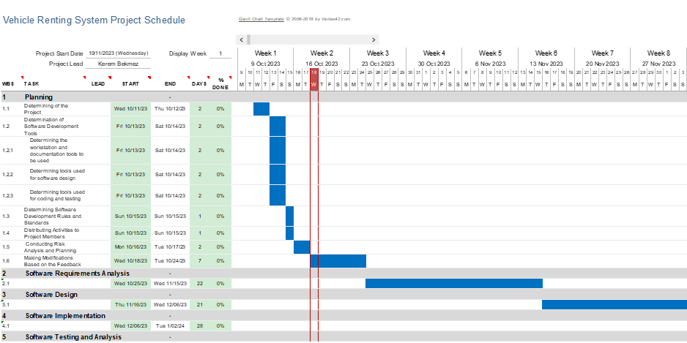

### Technical documentation

The following documentation is produced during the software development phases:

* Software specification: SRS, STP
* Software detailed conception: SDD
* Software tests phases: STR
* Software analysis: SAR

### Deliverables

The following items will be delivered at the end of the process:

* Technical documentation as outlined in Section 2.1.2
* Software and its configuration files

## Software development tools

### Workstation

Macbook Pro M1 16 GB Ram

Huawei MateBook 14 AMD Ryzen 4600H 16 GB Ram

Lenovo Ideapad Intel Core i7 16 GB Ram

Lenovo Intel Core i5 8GB Ram

Dell Vostro Intel Core i5 8GB Ram

### Requirements management and documentation

**Microsoft Word:** Word will be used for editing and sharing textual documents.

**Google Docs and Sheets**: They will be utilized for remote, simultaneous working on documents and data.

**Notion:** Notion will be used for overall project management, such as team collaboration, assignment scheduling, and tracking requirements.

### Software Design

* LucidChart for UML design.
* Visual Paradigm for UML design.

### Coding and automated tests

* IntelliJ as IDE
* VSCode as IDE
* JUnit for tests.
* MySQL or MongoDB as the DBSM
* Mockito for mock testing if necessary.
* MySQL Workbench
* Postman
* Google Chrome

### Configuration management

GitHub[1] will be used for software configuration management and tracking issues regarding the software development. A public repository will be created for this purpose.

## Software development rules and standards

UML[2] will be used for software design documentation.

The following code conventions will be used from the link below while developing the software

Link: <https://www.oracle.com/java/technologies/javase/codeconventions-contents.html>

* 3.1.3 Class and Interface Declaration
* 6 Declarations
* 9 Naming Conventions

# Responsibilities

## Activities and responsibilities

Each activity has someone responsible (although multiple project members can be involved in the activity), mandatory.

|  |  |  |
| --- | --- | --- |
| **Activity** | **Responsibility** | **Comment** |
| Project management | Kerem Bekmez |  |
| Configuration tools management | Şevval |  |
| Setting up the Development tools | Ahmet Pehlivanoglu, Mehmet Kutlutan |  |
| Database design | Azra Açıl |  |
| Unit Tests | Everyone | Tests will be written on the main computer and designed by everyone |
| System Tests | Everyone | Tests will be written on the main computer and designed by everyone. |
| System Design | Kerem Bekmez |  |

# Risk Assessment

## Risk Analysis

## 

## Risk Planning

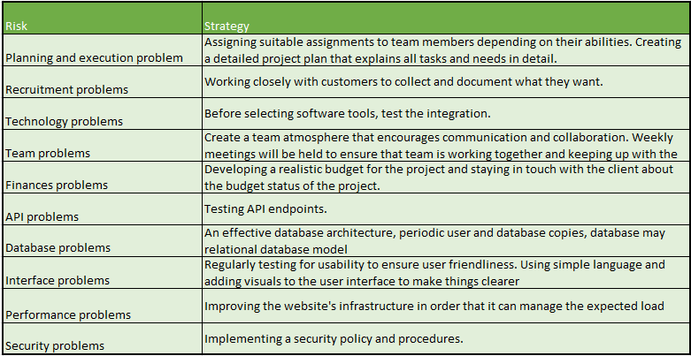

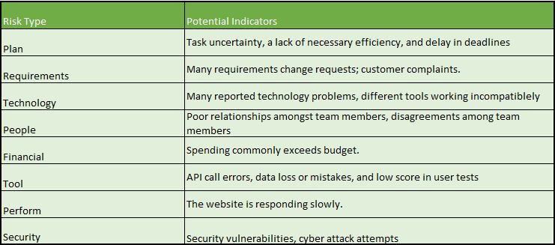

1. http://www.github.com
2. http://www.uml.org/