Revision History
Date | Version | Description | Author
4/11/23 | 1.1 | Created and added the package diagram | Kerem Bekmez
5/11/23 | 1.2 | Decided on and added the functional and non-functional requirements | Kerem Bekmez, Sevval Kurt, Azra Acil, Mehmet Kutlutan, Ahmet Pehlivanoglu
5/11/23 | 1.3 | Added admin panel’s vehicle CRUD activity diagram | Sevval Kurt
5/11/23 | 1.4 | Added the use-case diagram | Mehmet Kutlutan
6/11/23 | 1.5 | Added rental process activity & admin operations activity diagram | Azra Acil
6/11/23 | 1.6 | Added log-in & sign-up activity diagram | Ahmet Pehlivanoglu
6/11/23 | 1.7 | Filled the introduction part (1) | Kerem Bekmez
14//11/23 | 1.8 | Updated the document based on the feedback. | Kerem Bekmez, Mehmet Kutlutan, Azra Acil, Sevval Kurt, Ahmet Pehlivanoglu

TABLE OF CONTENTS
Revision History 1
1 INTRODUCTION 3
1.1 Document overview 3
1.2 System overview 3
1.3 Abbreviations 3
1.4 References 3
1.5 Conventions 3
2 REQUIREMENTS 5
2.1 User Requirements Specification 5
2.2 System Architecture 5
2.3 Use Cases and Usage Scenarios 6
2.4 System Requirements Specification 10

INTRODUCTION

Document overview

This document presents the software requirements specifications of SIS software development project. It describes functional requirements, quality requirements, constraints, use cases, and usage scenarios. It also provides an overview of the system architecture.

System overview

VRS is about simplifying the renting process for the user. VRS aims to be designed as a Web application with a simple interface for renting vehicles based on certain criteria. VRS will be getting the vehicle data from the database. On the Website, the user will be able to filter vehicles and see if they are available or occupied, and if they are occupied, the date they will be becoming free.

Abbreviations
VRS: Vehicle Renting Software
OOP: Object Oriented Programming
IDE: Integrated Development Environment
UI: User Interface
UX: User Experience
DB: Database
SQL: Structured Query Language
RDBMS: Relational Database Management System
CRUD: Create, Read, Update, Delete (database operations)
ACID: Atomicity, Consistency, Isolation, Durability (database properties)
UML: Unified Modeling Language
JDE: Integrated Development Environment
JDK: Java Development Kit
SRS: Software Requirement Specification
STP: Software Test Plan
FR: Functional Requirements
NFR: Non-Functional Requirements

References

# | Document Identifier | Document Title
[SDP] | VRS-SDP-v2.0 | VRS Software Requirement Specifications

Conventions
Requirements listed in this document are constructed according to the following structure:

SRS-VRS-001
Description of VRS-001 requirement

Every system requirement id includes the id of the corresponding user requirement as a prefix.

SRS-VRS-001.1
Description of XXX-000.1 system requirement, which is related to the user requirement XXX-000

REQUIREMENTS

User Requirements Specification
SRS-VRS-001
VRS should enable users to create a new account.

SRS-VRS-002
VRS should allow users to login to their existing accounts.

SRS-VRS-003
VRS shall allow users to be able to see their balance.

SRS-VRS-004
VRS shall enable users to be able to filter vehicles based on selected vehicle properties.

SRS-VRS-005
VRS shall enable users to see the wanted vehicle’s availability for the requested dates.

SRS-VRS-006
VRS shall enable users to see the total payment amount of the wanted vehicle for the requested number of days.

SRS-VRS-007
VRS shall enable users to rent the available vehicles.

SRS-VRS-008
VRS shall enable users to see their rental history.

SRS-VRS-009
VRS shall enable admin to add, delete and modify vehicles from the database.

SRS-VRS-010
VRS shall enable the admin to see all the rental history.

SRS-VRS-011
VRS shall enable users to remove all filters when requested.

System Architecture
The package-diagram below provides a high-level overview of the system.
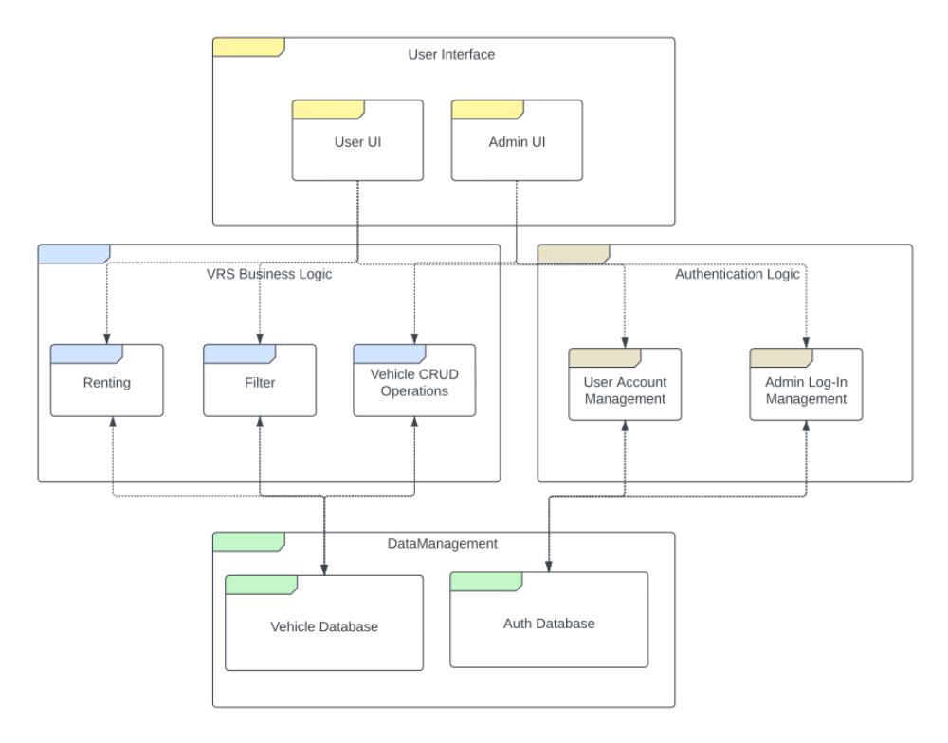

Use Cases and Usage Scenarios

UML Use Case diagram.
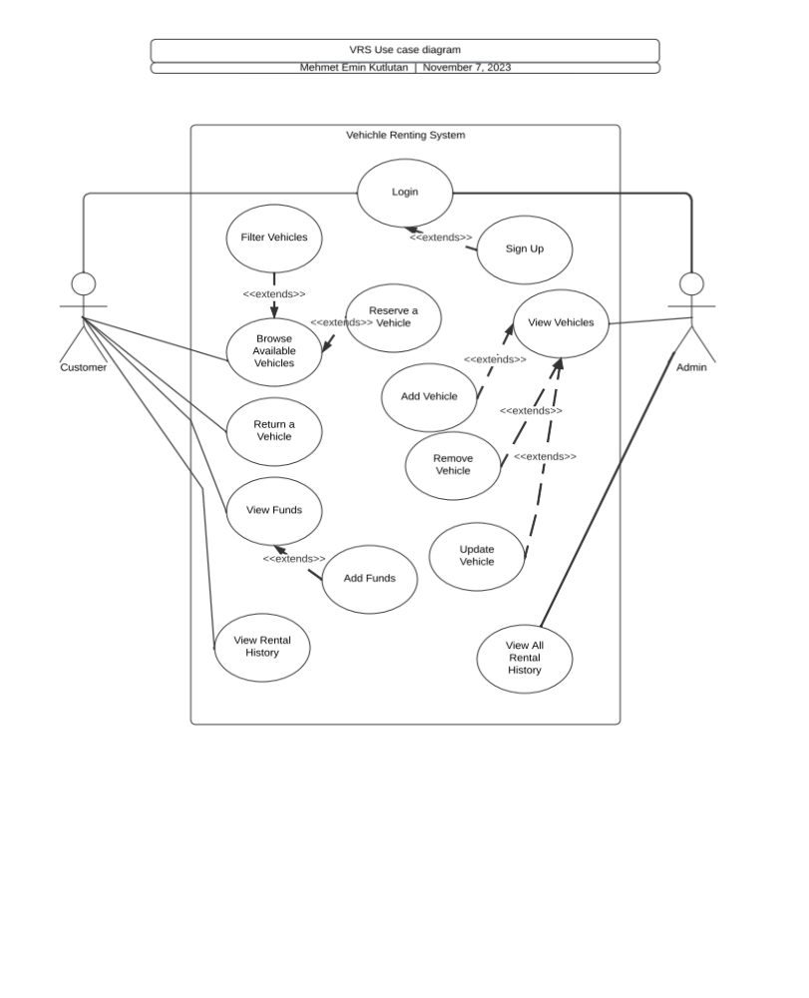

Sign-in & Sign-up UML activity diagram.
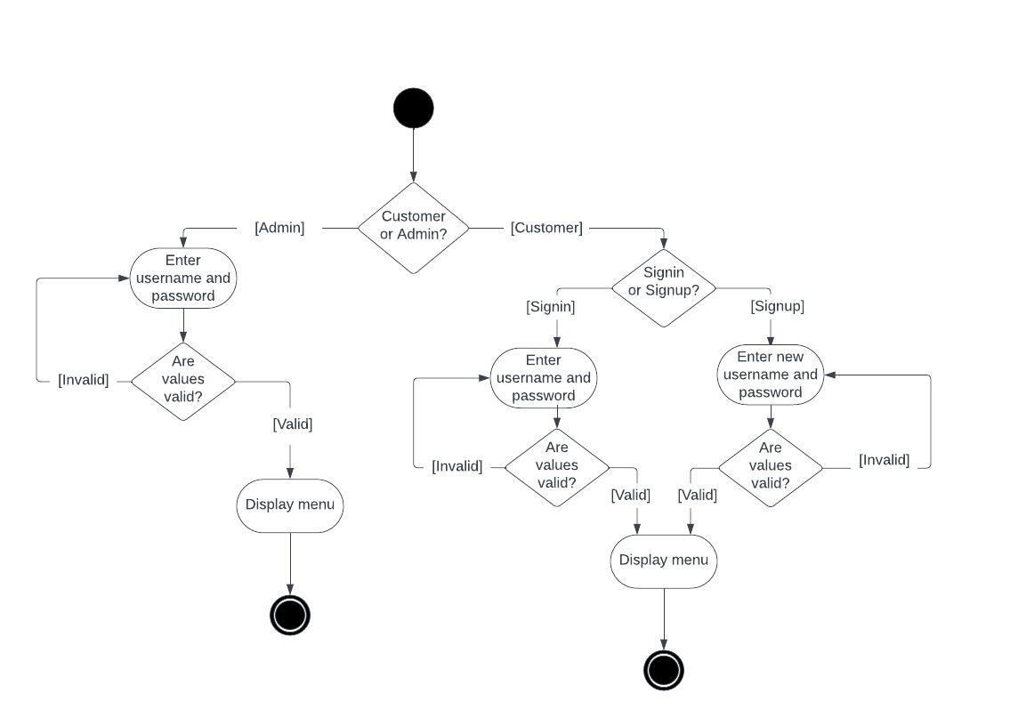
Rental process activity diagram.
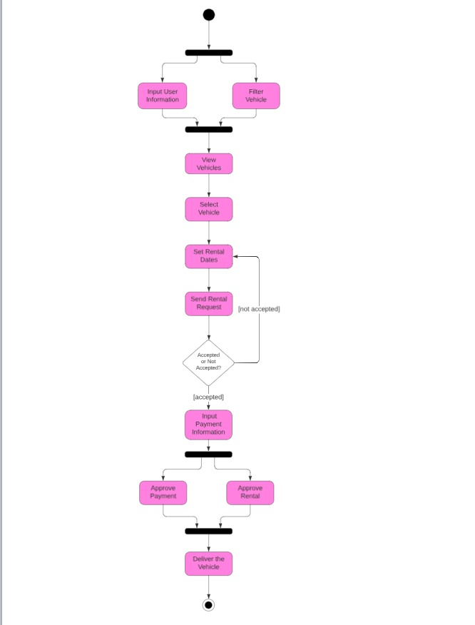
Admin panel’s vehicle CRUD activity diagram.
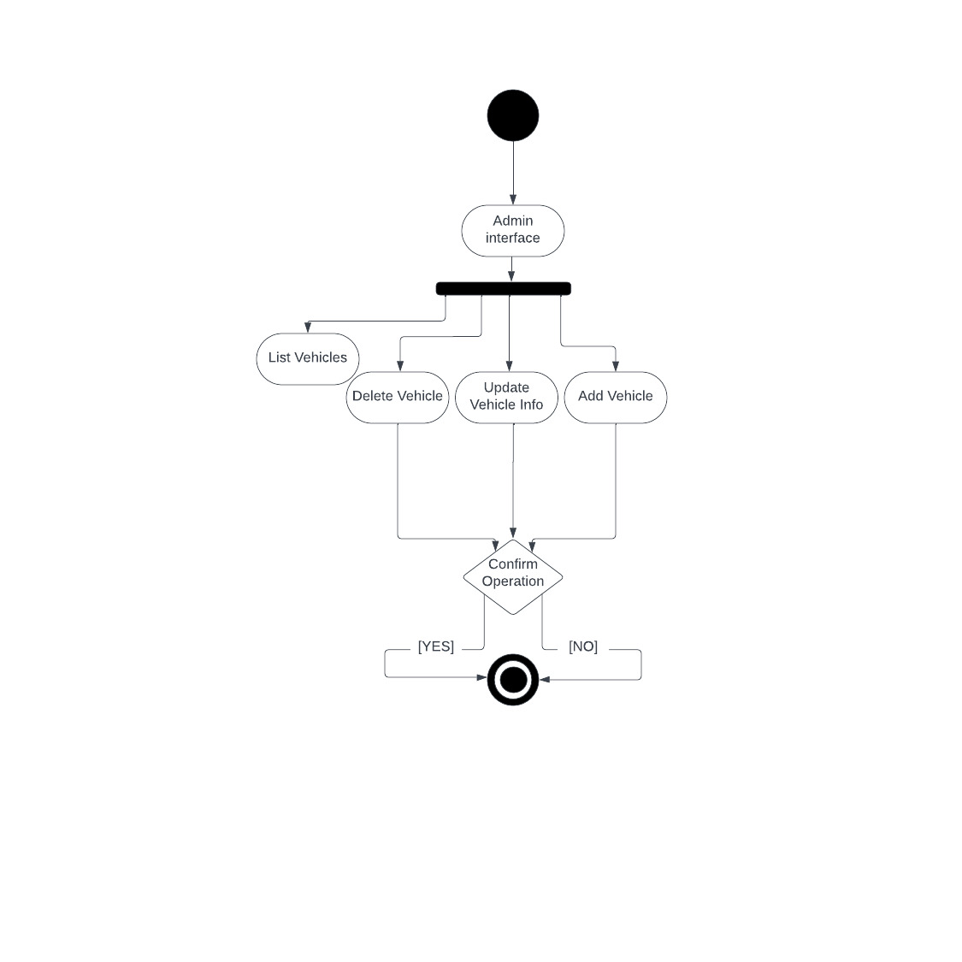

System Requirements Specification

SRS-VRS-001.1
-VRS shall enable the user to create an account with username and password, the account creation process should complete within 2 minutes.

SRS-VRS-001.2
-VRS shall return a pop-up window validating that the account has been created successfully.

SRS-VRS-002.1
-VRS shall enable the users to login to their already existing accounts when their correct password and username is given.

SRS-VRS-002.2
-VRS shall forbid user to log-in if the username or the password is wrong and should return a wrong credentials message to the user.

SRS-VRS-003.1
-VRS shall provide a green box on the right top corner of the UI that shows the balance of the user.

SRS-VRS-004.1
-VRS shall provide a filter button, once pressed it will show the attributes of the vehicles, the user should be able to select the requested attributes and then press the search button, afterwards the matching vehicles will be returned to the user.

SRS-VRS-004.2
-VRS shall ensure that irrespective of the number of filters applied, the query response time must not exceed 5 seconds.

SRS-VRS-005.1
-VRS shall force the user to give a start and end date for the rental when a vehicle is selected.

SRS-VRS-005.2
- VRS shall return available or busy by checking the requested start and end date.

SRS-VRS-006.1
-VRS shall return the multiply equivalent of the daily price of the requested vehicle and the number of days the user wants.

SRS-VRS-007.1
-VRS shall return an approval message in the case rent is successful, including the rent information.

SRS-VRS-007.2
-VRS shall deduct the user’s balance equivalent to the total payment amount.

SRS-VRS-007.3
-VRS shall let the users rent a vehicle if their amount is sufficient.

SRS-VRS-007.4
- VRS shall enable users to rent more than 1 vehicle if the user’s amount is sufficient
SRS-VRS-007.5
- VRS shall not enable users to rent if their amount is lower than total payment or the vehicle is busy for the requested dates.

SRS-VRS-008.1
-VRS shall provide a “See Rental History” button in the UI, once pressed, within 5 seconds, users shall see their rental history in a pop-up window.

SRS-VRS-009.1
-VRS shall enable the admin to modify vehicles in the DB with the usage of queries.

SRS-VRS-010.1
-VRS shall enable admin to see all rental history via a button from the admin UI.

SRS-VRS-011.1
-VRS shall provide a “Clear All Filter” button to the user UI, once pressed, all the previously chosen filters shall be removed.

