**Requirements and Steps to run the program**

1. **Installing Anaconda:** Visit the url (<https://www.anaconda.com/products/individual>). Scroll to the bottom of the page where you can see the following

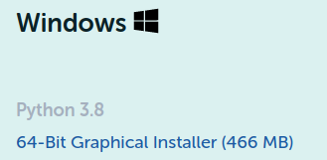

Click on “64-Bit Graphical Installer” in order to download it. Once downloaded, open it and install it.

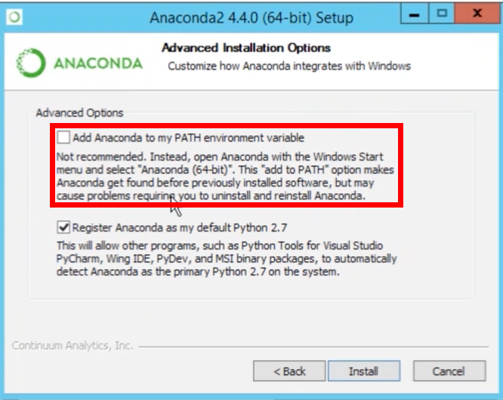

1. **Creating Conda Environment:** After the first step, you will have conda installed in your system. Open command prompt/terminal and write the following command:

**conda create -n myenv python=3.7**

Wait for it to create the environment. It will take a while.

1. **Activating the environment:** After the second step, you will have a virtual environment created in your system with the name “myenv”. In order to activate this environment, type the following command in terminal:

**conda activate myenv**

To be sure that the environment is activated, you will see “myenv” at the start of your laptop username in the command prompt.

1. **Installing dependencies:** Once you have your environment activated, extract the zip file which is provided in the delivery and open command prompt by pressing “Ctrl + L”, then type “cmd” and hit enter. Locate your terminal to the unzipped folder by executing the command “cd RecommenderSystem”. When you have your terminal opened in that directory, you can see that there is a file named “requirements.txt”. It contains all the necessary requirements needed to run the code. So you can install those requirements by giving the following command:

**pip install -r requirements.txt**

1. **Running the code:** Make sure that you have your terminal opened in that same directory after all the requirements have been installed with the virtual environment “myenv” activated. Run the following command in terminal:

**python main.py**

It will take some time (probably an hour or so) for the code to run and then it will save the output matrix in the file named “output_matrix.txt” in the same folder.