K.H.U. Faculty of Engineering and Natural Sciences

GE_IT_BG400 BACHELORS PROJECT

PROPOSAL

PROJECT TITLE : ONLINE RESTAURANT DISCOVERY GUIDE IN ISTANBUL

Project Advisor: Işıl YENİDOĞAN

Project Team: Rauf Kerem YARALI - Information Technologies

Canberk ÜRKÜP - Information Technologies

Submission Date: 11.12.2014

**ABSTRACT:**

Online restaurant discovery guide helps people to find right places for their individual preferences. This process is performed by obtaining data from the user. The user is responsible for answering the questions of a survey. The answer of questions of the survey directs the process to first a new question, then finally to the destination place. These phases will be coded in PHP programming language. The system expects answers of following questions: What type of restaurant does user want to go? , with whom? , Should the place has landscape? , What’s budget range of the user? and the last question will ask about location choice. After user finishes the survey, our system will suggest some restaurants. User can choose one of these options, and able to see the details. The system shows both detail and general information about the restaurant. General information include name of the restaurant, If there is Wi-Fi or not, address of the restaurant, and web page of the restaurant if it is available. Detail information include: If there is a special menu for children, Is restaurant suitable for disabled people (Is there a special way or ramp for them to access the restaurant?) if there is a diet menu, the favorite dishes of the restaurant if exist, and type of background music. At the end of the page user comments can be seen and shared with other users.

**AIM:**

The main goal of online restaurant discovery guide reaching the nearest appreciation point of any user. In order to achieve this, we thought that, we should collect more and detailed data and ensure that the data is correctly managed.

We searched some online restaurant guide websites([zomato.com](http://zomato.com),[yemekneredeyenir.com](http://yemekneredeyenir.com),[mekanist.net](http://mekanist.net),[tripadvisor.com.tr](http://tripadvisor.com.tr) for restaurants,papyon.com) and these found that they do not give detail information to user and restaurant’s the information about restaurants is limited. Such as: restaurant’s working days and working hours, there is a Wi-Fi or not , restaurant’s telephone number, restaurant address, type of cuisine, takeaway or not, average cost for two people. Our system gives general and detail information about restaurant. Such as, what is the eligibility status of restaurant for disabled people? Do restaurant have a game room for children to spend some time for family during their meal.

In addition, other websites also offers only category to their users. For example, Turkish food, Hotel restaurants, Istanbul views restaurants, restaurants user can go with special person and also [zomato.com](http://zomato.com) offers some filters. Such as, cuisine types, popular locations but only include popular locations (Kadıköy, Şişli , Beyoğlu etc.) and What’s user’s current budget for this meal ? Users don’t have more choice to select these filters. For example, if a user wants to go a restaurant with their family and type of restaurant is Turkish food, user don't want to go view restaurant and user budget is 50 Turkish Liras for two people and restaurant should be around in Kadıköy. These types of websites cannot meet user’s request. Our system is designed to respond user’s requests.

**METHODOLOGY:**

We will benefit from quantitative approach methodology . Data is located in the heart of this methodology. Quantitative approach methodology includes : Collecting data, analysis of data and inform people. Also, in our graduation project, we will be an expectation from users. The expectation is, answer our survey’s questions. After user complete our survey’s questions, our system do some analysis according to user’s answers. Finally, our system will inform the user. In addition, we will benefit from Need Analysis. Need Analysis focuses on human requirement and produce solutions. We will follow same analysis. We will get user’s needs by using survey and we will suggest restaurants.

**Work Break Down Structure(WBS)**

1. Analysis and Design of Web Sites

1.1 Client

1.2 Server

1. 3 Mobile

2 .Software Development and Testing

2.1 Client

2.2 Server

2.3 Mobile

3.Site Visits and Data Collection

3.1 Visit restaurants to collect data

3.2 Visit restaurant web pages

4. Improvement of Web Site and System Testing

4.1 Browser Testing and Link Control

**Analysis and Design of Web Sites**

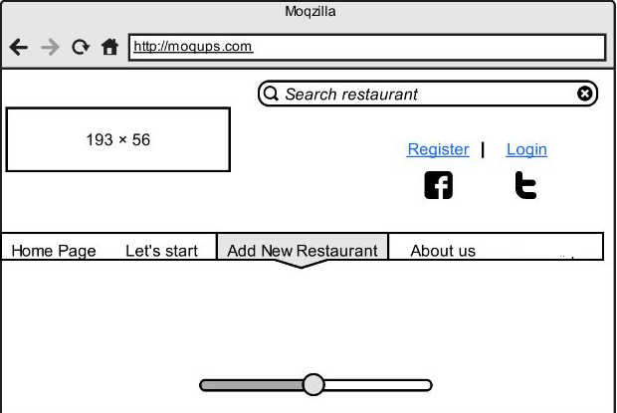

Figure1

Our Figure1, shows our home page. On the top left, we have logo which size is 193x56. If user wants to search restaurant, we have search restaurant area. At the register side, user can register our website, if user already registered our website, can click login button and login to our website. If users wants to like us on Facebook, they can click the Facebook icon. Also we will have a Twitter account, they can also follow and can write to us on Twitter.

At the middle of web page, we have some features which are:

Home page: Shows Figure1 page.

Let’s start: It means, start to do survey’s questions.

Add new restaurant: User can send their restaurant suggestion.

About us: We will try to give some information about our graduation project.

Finally ,in the middle of the page, user can see slideshow.

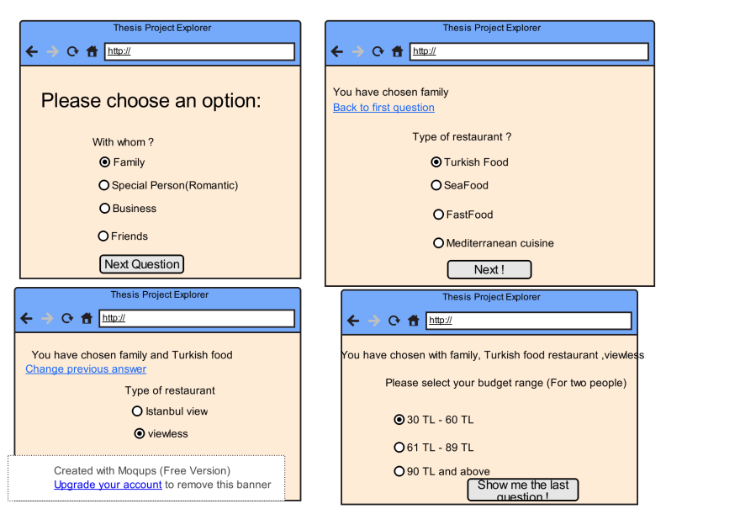 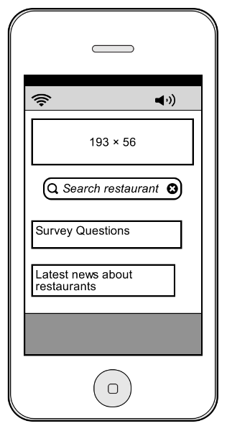

Figure2 Figure3

Figure2 shows, survey’s questions. The user responsible for answering the question of the survey. After the user answer current question, another question will come until the last question. Then, user completing survey’s question, user can see our system’s suggestions. User can click one of these and see the details of the selected restaurant. In Server Side, we will use PHP programming language. We will access the our database (MySQL) by using some techniques. PHP and database interaction: There is no object which is used pull and put types of PHP script language. That’s why, it uses HTML objects. There are submit for other function buttons in HTML. These objects will be used as a form object. There are two main method for HTML forms. Such as; GET and POST.

GET: Information which is sent by client , will be seen at web browsers address line.

POST: Information which is sent by client, will be sent without seen at address line.

Figure3 shows, our mobile application. We will do also our project in Android Programming. Our logo will be the top of our application. Under our logo, user can search a restaurant. Also, Survey’s question can be chosen by user. Finally user can choose latest news about restaurants. (Such as promotions, daily suggestions)

**Software Development and Testing:**

In client side, we have search restaurant area, if user wants to search restaurant they can use this area. Thanks to MySQL, searching results can be listed. Add new restaurant side, we have a basic from which is done by HTML, users can send their restaurant requests. After user finished the form, we will use Javascript. It will use for validation control. Such as; correct mail address control, blank control. Then restaurant information will be stored in our database. In slider side, we will use jQuery for slider. JQuery is a Javascript library. In the register side, user can face a form which is done by HTML. In this form user will create an account. To do this user will fill in the blanks. Our blanks will include: Username, password, re-password and user’s mail address.

In the server side, we will use POST method. Because user may not want to see their choice in the address bar. User’s choice will be hold by POST method, by using action in the HTML form, it sends to PHP side. It gets the user’s choice and redirects with header function. In Mobile side, we will do an application using by Android Programming language.

Testing’s main goal is reduce risk and detect errors early and remove the error. After completion of software development side, dynamic testing process should start. This testing process includes lots of testing and some test techniques. We will use white box testing techniques. White Box Testing focuses not only source code but also compiled code. Also, in white box Testing flows, conditions, elements will be tested.

**Site Visits and Data Collection**

In this part, we will do data collection. In order to collect this data, we should visit restaurants and to get their basic and detail information. After to get information , we will add information to our database. Our data collections not only include data collections, but also include their site visits. If exist , we will visit restaurant’s web pages and we will try to get the details.

**Improvement of Web Site and System Testing**

In this part, we will focus on new features to explore about our website. In testing side, the main reasons of testing include: Is our codes run correctly or can we get our expected outputs .In order to do this, we will do some testing activities. Such as, internet browser testing, broken link testing, Internet browser testing side, we will work on different browsers. Such as, Firefox, Internet Explorer, Chrome, Safari. Our codes should give correctly the same output on different browsers. Broken link testing is also very important. Our links should work and it should be directed to the correct address to the user.

**WORK PACKAGE DESCRIPTION**

Number and name of the package: 1.Analysis and design of Web Site

Start date: 02.02.2015

Finish date: 16.02.2015

Short description: Start to determine software requirements, and determine software process

Methodology: Create mockups and display all mockups stages.

Outputs: Understand software requirements and software process

Relations to other packages: Analysis and design is important phase before start coding. Also analysis and design facilitates coding

Working team members (with contributions as percentages of the work packet): Canberk Ürküp %50,Rauf Kerem Yaralı %50

Work to be done by anybody outside the team: -

**WORK PACKAGE DESCRIPTION**

Number and name of the package: 2.Software Development and Testing

Start date: 17.02.2015

Finish date: 06.04.2015

Short description: Software Development Side include : Server, Client and Mobile

Methodology: For client side: We will use HTML and CSS. Server side: We will use PHP. Mobile side, we will use Android.

Outputs: After this stage our project will be ready in the following sides: Client, Server and Mobile

Relations to other packages: Associated with in the following work packet: Improvement of website and system testing,

Working team members (with contributions as percentages of the work packet):

Client side: Canberk Ürküp %100

Server side: Rauf Kerem Yaralı %100

Mobile side: Rauf Kerem Yaralı %50, Canberk Ürküp %50

Work to be done by anybody outside the team: -

**WORK PACKAGE DESCRIPTION**

Number and name of the package: 3.Site Visits and Data Collection

Start date: 07.04.2015

Finish date: 20.04.2015

Short description: Data collection part.

Methodology: We will visit restaurants to collect their data.

Outputs: After data collection, we will ready to enter restaurant’s data to our MySQL database.

Relations to other packages: This packet ,helps to develop improvement of web site and system testing

Working team members (with contributions as percentages of the work packet):

Rauf Kerem Yaralı %50, Canberk Ürküp %50

Work to be done by anybody outside the team: -

**WORK PACKAGE DESCRIPTION**

Number and name of the package: 4.Improvement of Web Site and System Testing

Start date: 21.04.2015

Finish date: 01.05.2015

Short description: We will do some testing and add some improvements

Methodology: We will use different internet browsers (Such as; Chrome, Internet Explorer, Safari)

Outputs: Deficiencies will be corrected.

Relations to other packages: Programming errors can be resolved

Working team members (with contributions as percentages of the work packet): Rauf Kerem Yaralı %50, Canberk Ürküp %50

Work to be done by anybody outside the team: -

**CONTRIBUTIONS OF THE TEAM MEMBERS:**

|  |  |  |  |  |  |  |  |  |  |  |
| --- | --- | --- | --- | --- | --- | --- | --- | --- | --- | --- |
| Name, Surname | Work Packages | | | | | | | | Total | |
| I | | II | | III | | IV | |
| h | % | h | % | h | % | h | % | h | % |
| Rauf Kerem Yaralı | 8 | %50 | 28 | %50 | 8 | %50 | 4 | %50 | 48 | %50 |
| Canberk Ürküp | 8 | %50 | 28 | %50 | 8 | %50 | 4 | %50 | 48 | %50 |

***PROJECT TITLE: Online Restaurant Discovery Guide in Istanbul***

2015/3

2015/5

2015/4

2015/2

11

22

3

4

22

1

33

4

5

4

3

2

1

44

3

2

1

3

Work Packages

I. Analysis and Design of the Web Page

a. Client

b. Server

c.Mobile

a.

c.

.

.

II.Software Design and Testing

a. Client

b.Server

c.Mobile

.

a.

.

III. Site visits and data collection

c.

.

.

.



.

.

a.Visit restaurant collect data

b.Visit restaurant page 

IV.Improvement of website

a.Browser testing and link 

control and System Testing 

**PROJECT BUDGET:**

|  |  |  |  |  |  |
| --- | --- | --- | --- | --- | --- |
|  | Work Packages | | | |  |
|  | I | II | III | IV | TOTAL |
| Equipment | - | - | - | - |  |
| Consumable goods | - | - | - | - |  |
| Publications/Software | - | - | - |  |  |
| Transportation | - | - | 40 TL | - | 40 TL |
| Services | - | 100 TL | - | - | 100 TL |
| TOTAL |  |  |  |  |  |

Equipment:

Consumable goods:

Publications/Software:

Transportation: Visit restaurants to get information

Services: Domain and hosting

REFERENCES:

1. [www.zomato.com](http://www.zomato.com)
2. [www.yemekneredeyenir.com](http://www.yemekneredeyenir.com)
3. TripAdvisor for restaurant
4. jQuery Wikipedia
5. [www.yemekneredeyenir.com](http://www.yemekneredeyenir.com)
6. <http://bidb.itu.edu.tr/seyirdefteri/blog/2013/09/08/yaz%C4%B1l%C4%B1m-testi-ve-test-s%C3%BCre%C3%A7leri>
7. <http://en.wikipedia.org/wiki/Quantitative_research>
8. Need Analysis Wikipedia