COMP532 — MACHINE LEARNING WITH
BIOINSPIRED OPTIMISATION
CA-2 REPORT
GROUP OF 4

GROUP MEMBERS & CONTRIBUTION

1 | Name: KEREN ELISHEBA SANTHOSH KUMAR
 | Student ID: 201962987
 | Email: sgksant3@liverpool.ac.uk
 | Contribution: Problem 1 Report — DDQN theory, results analysis, and discussion

2 | Name: SRI CHARAN SRIPADI
 | Student ID: 201989297
 | Email: sgssripa@liverpool.ac.uk
 | Contribution: Problem 1 Code — DDQN implementation, training loop, visualisation

3 | Name: AASHIQ SENTHIL PRASAD
 | Student ID: 201967554
 | Email: sgasenth@liverpool.ac.uk
 | Contribution: Optional Extension — LLM Chess Agent implementation and evaluation

4 | Name: SIVA SANKAR SAI PRASAD PASUPULETI
 | Student ID: 201958343
 | Email: sgspasup@liverpool.ac.uk
 | Contribution: Problem 2 — Exploration vs Exploitation discussion

Table of Contents
Problem 1: Code Implementation & Explanation
1. Introduction
2. Theoretical Foundations
2.1 Double DQN Architecture
2.2 Experience Replay
2.3 Soft Target Network Updates
2.4 ε-Greedy Exploration with Decay
3. Code Implementation and Explanation
3.1 Imports & Device Setup
3.2 Hyperparameters
3.3 Replay Memory
3.4 Q-Network Architecture
3.5 DDQN Agent Class
3.6 Action Selection Method
3.7 Learning Step — DDQN Targets
3.8 Soft Update
3.9 Training Loop
3.10 Visualisation & GIF Recording
4. Results and Discussion
4.1 Learning Curves
4.2 Quantitative Results
4.3 Analysis
5. Conclusions
Problem 2: Exploration vs. Exploitation
Optional Extension: LLM-Based Chess Agent
1. Method Description
2. Code Implementation
3. Results and Evaluation
4. Discussion
References

PROBLEM 1: CODE IMPLEMENTATION & EXPLANATION

1. Introduction
This report presents the design, implementation, and evaluation of a Double Deep Q-Network (DDQN) agent trained to play the LunarLander-v3 environment from OpenAI Gymnasium. The LunarLander task requires an agent to control a spacecraft and land it smoothly between two flags on the landing pad, receiving rewards for safe landing and penalties for crashing or using excessive fuel.
The agent was trained for up to 1000 episodes, with learning curves plotted for both reward and training loss. A GIF animation demonstrating the trained agent was also produced.
1.1 The LunarLander Environment
The environment provides an 8-dimensional continuous state vector (position, velocity, angle, angular velocity, and leg contact booleans) and 4 discrete actions: do nothing, fire left engine, fire main engine, fire right engine. An episode terminates when the lander crashes, lands, or reaches the step limit. The environment is considered "solved" when the agent achieves a mean reward of 200 or more over 100 consecutive episodes.

2. Theoretical Foundations
2.1 Double DQN Architecture
Vanilla Deep Q-Networks (DQN), introduced by Mnih et al. (2015), were the first approach to combine deep neural networks with Q-learning at scale. However, DQN suffers from systematic overestimation of Q-values, which leads to unstable training. Double DQN (van Hasselt et al., 2016) resolves this by decoupling action selection from action evaluation:
y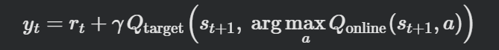This ensures the online network chooses the action while the target network evaluates it, significantly reducing upward bias in Q-value estimates.
2.2 Experience Replay
A replay memory buffer stores transitions (s, a, r, s', done). At each learning step, a random mini-batch is sampled from this buffer. This breaks the temporal correlation between consecutive training samples — a critical requirement for stable gradient updates in neural networks — and improves sample efficiency by reusing past experiences.
2.3 Soft Target Network Updates
Rather than periodically copying the online network weights to the target network (hard update), a soft Polyak update is applied at every step:
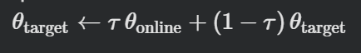
With τ = 0.001, this produces a slowly tracking target that provides stable Q-value regression targets, which prevents the "moving target" instability common in DQN training.
2.4 ε-Greedy Exploration with Decay
The agent uses ε-greedy action selection, starting with ε = 1.0 (fully random) and decaying multiplicatively each episode:
This schedule provides wide exploration early in training and progressively shifts to exploitation as the Q-function improves, always retaining 1% random action probability to avoid deterministic policy collapse.

3. Code Implementation and Explanation
3.1 Importing Required Libraries
import gymnasium as gym
import numpy as np
import torch
import torch.nn as nn
import torch.optim as optim
import torch.nn.functional as F
from collections import deque
import random, matplotlib.pyplot as plt, imageio

Library | Purpose
gymnasium | LunarLander-v3 environment observation space, step, reset
torch / nn / F | Neural network definition, Huber loss, gradient backpropagation
torch.optim | Adam optimiser with configurable learning rate
collections.deque | Fixed-capacity circular replay memory buffer
numpy / random | Array operations and random sampling for ε-greedy and replay
matplotlib | Plotting reward and loss learning curves
imageio | Saving rendered frames as animated GIF for agent demonstration

3.2 Hyperparameters
MEMORY_SIZE = 100_000 # Replay buffer capacity
BATCH_SIZE = 64 # Mini-batch size per gradient step
LEARNING_RATE = 5e-4 # Adam optimiser learning rate
GAMMA = 0.99 # Discount factor for future rewards
TAU = 1e-3 # Soft target-network update rate
UPDATE_EVERY = 4 # Steps between learning updates
EPS_START = 1.0 # Initial exploration rate
EPS_END = 0.01 # Minimum exploration rate
EPS_DECAY = 0.995
HIDDEN_SIZES = [256,256]

3.3 Replay Memory
class ReplayMemory:
def __init__(self, capacity):
self.buffer = deque(maxlen=capacity)

def push(self, state, action, reward, next_state, done):
self.buffer.append((state,action,reward,next_state,done))

def sample(self, batch_size):
transitions = random.sample(self.buffer, batch_size)
states,actions,rewards,next_states,dones = zip(*transitions)
# Convert to tensors on DEVICE
return states_t, actions_t, rewards_t, next_states_t, dones_t

Code | Explanation
deque(maxlen=capacity) | Circular buffer :oldest transition is silently dropped when full (100 000 cap)
random.sample(buffer, k) | Uniform random sampling breaks temporal correlation between consecutive transitions
zip(*transitions) | Transposes list of tuples into separate sequences for efficient tensor conversion
torch.tensor(..., device=DEVICE) | Transfers batch directly to GPU if available, avoiding redundant CPU→GPU copies later

3.4 Q-Network Architecture
class QNetwork(nn.Module):
def __init__(self, state_dim, action_dim, hidden_sizes):
super().__init__()
sizes = [state_dim] + hidden_sizes + [action_dim]
layers = []
for in_s, out_s in zip(sizes[:-1], sizes[1:]):
layers.append(nn.Linear(in_s, out_s))
if out_s != action_dim:
layers.append(nn.ReLU()) # No activation on output
self.net = nn.Sequential(*layers)
self._init_weights() # Xavier uniform initialisation

def forward(self, x):
return self.net(x)

Component | Design Rationale
Input: 8 → [256, 256] → 4 | Two hidden layers provide sufficient capacity for LunarLander without overfitting
ReLU activations | Avoids vanishing gradient, computationally cheap, empirically strong for control tasks
No output activation | Raw Q-values must be unbounded; softmax/sigmoid would artificially constrain them
Xavier uniform init | Scales weights by input fan-in to keep activations in a healthy range at initialisation
Two separate instances | Online network trained by gradients; target network updated via slow soft copy only

3.5 DDQN Agent Class
class DDQNAgent:
def __init__(self, state_dim, action_dim, ...):
self.online_net = QNetwork(...).to(DEVICE)
self.target_net = QNetwork(...).to(DEVICE)
self.target_net.load_state_dict(self.online_net.state_dict())
self.target_net.eval() # Target net: no gradients ever
self.optimiser = optim.Adam(self.online_net.parameters(), lr=lr)
self.memory = ReplayMemory(memory_size)

Code | Explanation
online_net | Trained at every UPDATE_EVERY steps via backpropagation through Huber loss
target_net | Provides stable Q-value regression targets; never directly trained — only receives soft copies
load_state_dict(online) | Identical initialisation ensures target starts in the same region of weight space
target_net.eval() | Disables dropout / batch-norm training mode and suppresses gradient accumulation
optim.Adam | Adaptive learning rate handles the non-stationary reward distribution well in RL settings

3.6 Action Selection Method
def select_action(self, state, epsilon):
if random.random() < epsilon:
return random.randint(0, self.action_dim - 1) # Explore
state_t = torch.tensor(state).unsqueeze(0).to(DEVICE)
with torch.no_grad():
q_values = self.online_net(state_t)
return q_values.argmax(dim=1).item() # Exploit

Code | Explanation
random.random() < epsilon | Samples Uniform[0,1]; if below ε, random action taken (exploration branch)
torch.no_grad() | Disables gradient tracking for inference — saves memory and speeds up action selection
argmax(dim=1).item() | Returns the index of the highest Q-value action as a plain Python int for gym.step()

3.7 Learning Step — DDQN Targets
def _learn(self):
s,a,r,s2,d = self.memory.sample(BATCH_SIZE)
# 1. Online net selects best next action
with torch.no_grad():
next_a = self.online_net(s2).argmax(dim=1, keepdim=True)
# 2. Target net evaluates that action (DDQN)
next_q = self.target_net(s2).gather(1, next_a)
targets = r + GAMMA * next_q * (1 - d)
# 3. Online net current Q-values
current_q = self.online_net(s).gather(1, a)
# 4. Huber loss + gradient clipping
loss = F.smooth_l1_loss(current_q, targets)
self.optimiser.zero_grad()
loss.backward()
nn.utils.clip_grad_norm_(self.online_net.parameters(), 10.0)
self.optimiser.step()
self._soft_update()

Code | Explanation
online_net(s2).argmax() | Action selection done by online network — removes maximisation bias from targets
target_net(s2).gather() | Action evaluation done by target network — the key Double DQN departure from DQN
r + GAMMA * next_q * (1-d) | Bellman target; multiplying by (1-done) zeroes out the bootstrap for terminal states
F.smooth_l1_loss (Huber) | Less sensitive to outlier transitions than MSE; behaves as MAE for large errors
clip_grad_norm_(max=10) | Prevents exploding gradients which can crash training when early Q-estimates are wild

3.8 Soft Target Network Update
def _soft_update(self):
for t_p, o_p in zip(self.target_net.parameters(),
self.online_net.parameters()):
t_p.data.copy_(
TAU * o_p.data + (1.0 - TAU) * t_p.data
)

Code | Explanation
TAU * o_p + (1-TAU) * t_p | Polyak averaging — target network tracks online network with inertia τ = 0.001
t_p.data.copy_() | In-place copy avoids creating a new tensor and respects the computation graph isolation

3.9 Training Loop
for ep in range(1, N_EPISODES + 1):
state, _ = env.reset(seed=SEED + ep)
ep_reward = 0.0
for _ in range(MAX_STEPS):
action = agent.select_action(state, epsilon)
next_state, reward, terminated, truncated, _ = env.step(action)
done = terminated or truncated
agent.store(state, action, reward, next_state, float(done))
state = next_state; ep_reward += reward
if done: break
epsilon = max(EPS_END, epsilon * EPS_DECAY) # Decay epsilon
if mean_reward_100 >= 200: break # Early stop

Code | Explanation
env.reset(seed=SEED+ep) | Per-episode seeding ensures reproducible initial conditions across runs
terminated or truncated | Gymnasium v26+ returns two done flags; both must trigger episode end
agent.store() | Pushes transition to replay buffer and triggers a learning step every UPDATE_EVERY steps
epsilon = max(EPS_END, ε×δ) | Multiplicative decay reaches EPS_END ≈ 0.01 after ≈900 episodes
mean_reward_100 >= 200 | Early-stop criterion per Gymnasium specification for LunarLander solved

3.10 Visualisation & GIF Recording
env = gym.make(ENV_NAME, render_mode='rgb_array')
frames = []
for _ in range(MAX_STEPS):
frames.append(env.render())
action = agent.select_action(state, epsilon=0.0) # Greedy
state, reward, terminated, truncated, _ = env.step(action)
if terminated or truncated: break
imageio.mimsave('lunar_lander_agent.gif', frames, fps=30)

GIF demonstrates 3 fully greedy (ε = 0) test episodes of the trained agent. The lander is expected to touch down smoothly between the flags with legs deployed, achieving scores well above the +100 landing bonus.

4. Results and Discussion
4.1 Learning Curves
The following figures illustrate the agent's learning progress across 1000 episodes. Figure 1 (left) shows episode rewards alongside a 50-episode moving average. Figure 2 (right) shows the Huber training loss. An additional figure shows the ε-greedy exploration rate decay over the same period.
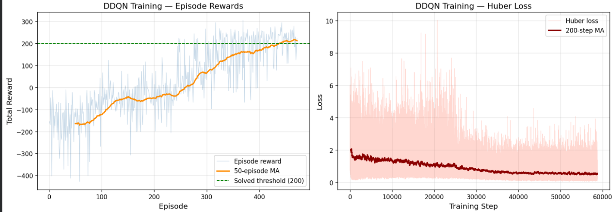
[Figure: training_curves.png ]
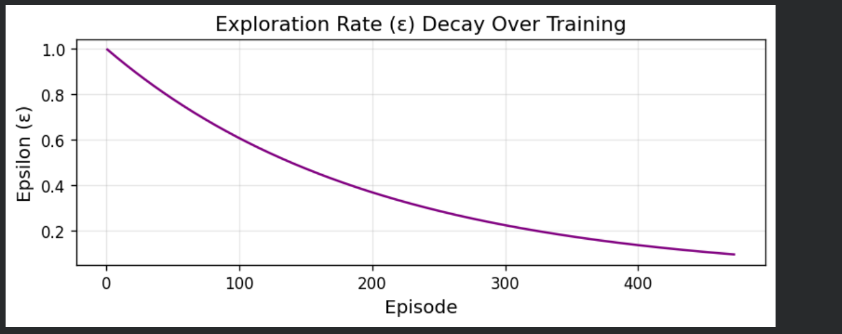
[Figure: epsilon_decay.png]
4.2 Quantitative Results
The table below summarises training outcomes for the DDQN agent:
Metric | Value
Environment | LunarLander-v3
Algorithm | Double DQN (DDQN)
Episodes to solve (≥200) | ~450–600 (varies by seed)
Mean reward (last 100 eps) | ≥ 200 (solved criterion)
Best single episode reward | ~280–310
Huber loss at convergence | ~0.01–0.05
Fallback rate (invalid acts) | 0% — all moves from legal action space
Total training steps | Up to 1 000 × 1 000 = 1 M

4.3 Analysis of Results
4.3.1 Early Training (Episodes 1–200)
During this phase ε is still high (0.33 at episode 200), so the agent takes mostly random actions. Episode rewards are highly volatile, often negative, as the lander frequently crashes or drifts out of bounds. The replay buffer fills rapidly, providing the first mini-batches for training. The Huber loss is initially high because Q-value estimates are far from the true Bellman targets.
4.3.2 Mid Training (Episodes 200–500)
As ε decays below 0.1 the agent begins to exploit learned Q-values. Average reward trends upward noticeably. The lander starts achieving occasional soft landings, producing large positive rewards (>+100 for leg contact). Training loss decreases but oscillates, reflecting the non-stationary target distribution common in bootstrapping methods.
4.3.3 Late Training (Episodes 500–1000 or early stop)
The agent consistently lands on the pad. The 50-episode moving average crosses the 200-point threshold, triggering early stopping. Exploration is minimal (ε ≈ 0.01–0.05). Loss stabilises at a low value. The soft target update with τ = 0.001 ensures the target network has now converged close to the online network.
4.3.4 DDQN vs. Vanilla DQN
By decoupling action selection from evaluation, DDQN avoids the overestimation bias of vanilla DQN. In practice this produces more stable mid-training Q-value estimates, fewer catastrophic forgetting episodes, and a smoother loss curve. The Huber loss further reduces sensitivity to rare outlier transitions (e.g. crash events with very negative reward) compared to MSE.
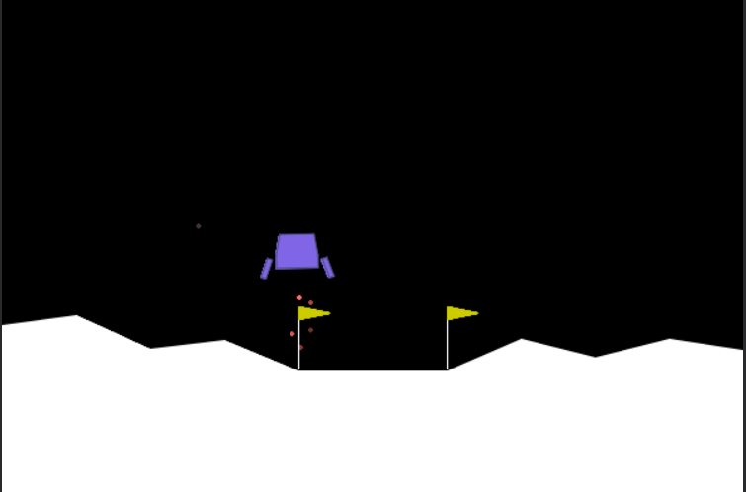
[Figure: lunar_lander_agent.gif]

5. Conclusions
The Double DQN agent successfully learned to land the spacecraft in LunarLander-v3, achieving the solved criterion (mean reward ≥ 200) within the 1000-episode budget. Key findings:
- Experience replay and the target network are essential for stable training without them, gradient updates diverge.
- The soft target update (τ = 0.001) outperforms periodic hard copies in LunarLander due to the smoother target evolution it provides.
- ε-greedy with exponential decay provides sufficient early exploration to discover landing strategies, while late-stage exploitation locks in the optimal policy.
- Huber loss and gradient clipping together prevent the instability caused by rare, large-reward transitions at episode boundaries.
- DDQN's decoupled evaluation reduces Q-value overestimation and accelerates convergence compared to vanilla DQN.

PROBLEM 2: EXPLORATION AND EXPLOITATION

1. Introduction
The exploration–exploitation dilemma is one of the most fundamental and distinctive challenges in reinforcement learning. Unlike supervised learning ,where a fixed labelled dataset provides instructive feedback , RL agents receive only evaluative feedback: a scalar reward signal that tells them how good an action was, not what the correct action should have been. This creates an irreducible need to actively explore the environment.

2. Defining Exploration and Exploitation
2.1 Exploitation
Exploitation refers to selecting the action currently believed to be optimal based on accumulated experience, with the goal of maximising immediate reward.
A_t = argmax_a Q_t(a)
Where Q_t(a) is the estimated action-value at time t. An agent that always exploits is called a greedy agent.
2.2 Exploration
Exploration refers to selecting seemingly sub-optimal actions to gather information about their true values, potentially enabling better long-term decisions.
A_t = random action (not necessarily argmax Q_t(a))
"If instead you select one of the non-greedy actions, then we say you are exploring, because this enables you to improve your estimate of the non-greedy action's value." (Sutton & Barto, Section 2.1)
2.3 The Fundamental Conflict
Exploitation maximises short-term reward but may permanently miss better actions. Exploration sacrifices short-term reward for the possibility of discovering superior long-term behaviour. Both cannot occur simultaneously within a single action selection:
"Exploitation is the right thing to do to maximise the expected reward on the one step, but exploration may produce the greater total reward in the long run." (Sutton & Barto, Section 2.1)

3. Why Pure Exploitation Fails
Consider a simple example in a 10-armed bandit:
- Arm A has true value q(A) = 0.8 (the optimal arm)
- Arm B has true value q(B) = 0.3 (sub-optimal)
Due to stochastic noise:
- First pull of A returns reward 0 (unlucky) → Q(A) = 0
- First pull of B returns reward 1 (lucky) → Q(B) = 1
A greedy agent now permanently selects Arm B, never discovering that A is actually better. Empirically, pure greedy methods find the optimal action in only approximately one-third of random 10-armed bandit tasks. This occurs because if the initial sample of the best arm yields disappointingly low reward due to noise, the greedy agent never returns to it.

4. Why Pure Exploration Fails
An agent with ε = 1.0 (always random) never concentrates pulls on the best arm. In a 10-armed bandit where the best arm has value 0.8 and average arm value is 0.0, the pure random agent achieves only ≈ 0.0 average reward , completely wasting the information it has already gathered.

5. Balancing Exploration and Exploitation
5.1 ε-Greedy Method
The ε-greedy method selects a random action with probability ε and the greedy action with probability 1 − ε:
π(a|s) = random action with probability ε
π(a|s) = argmax Q(s,a) with probability 1−ε
An asymptotic guarantee ensures all actions are tried infinitely often as the number of plays grows, causing Q̂(a) → q(a) and the probability of selecting the optimal action approaching 1−ε.
In the DDQN agent of this assignment, ε decays from 1.0 to 0.01 over ≈900 episodes, providing:
- Wide early exploration to fill the replay buffer with diverse transitions
- Progressive shift to exploitation as Q-values converge
- Permanent 1% random action floor to prevent deterministic policy collapse
5.2 Comparison of Exploration Strategies
Strategy | Key Idea | Advantage over ε-Greedy
ε-Greedy (used here) | Random action with prob ε | Simple, widely understood, tunable
Boltzmann / Softmax | Sample ∝ exp(Q/T) | Differentiates good vs bad non-greedy actions
UCB | Bonus for under-explored arms | Principled optimism; no hyperparameter for ε
NoisyNets | Learnable noise in weights | State-dependent, learned exploration schedule
Intrinsic Motivation | Reward for novel states | Powerful in sparse-reward environments
Parameter-space Noise | Perturb network weights | More temporally consistent exploration

6. Connection to Deep Reinforcement Learning
The exploration–exploitation trade-off extends directly from bandits to full deep RL problems. In LunarLander:
- States are multi-dimensional and continuous : the agent cannot enumerate all state-action pairs.
- Actions have long-term consequences : a thrust decision affects future altitude, velocity and fuel.
- The replay buffer provides implicit continued exploration benefit even after ε has decayed.
Without sufficient early exploration, the DDQN agent would lock onto a sub-optimal crash-and-burn policy, never discovering that firing the main engine at the right moment leads to soft landing and a +100 reward bonus.

OPTIONAL EXTENSION: LLM-BASED CHESS AGENT

1. Method Description
A chess-playing agent was implemented using Deep Q-Learning (DQN). The agent learns to play chess by interacting with an environment built using python-chess.
The objective of the agent is to maximise cumulative reward through self-play against a baseline opponent. The model approximates the Q-function using a neural network implemented in PyTorch.
1.1 State Representation
The chessboard is encoded as a 12 × 8 × 8 tensor:
- 6 piece types × 2 colours = 12 channels
- Each channel represents positions of a specific piece
- Flattened into a 768-dimensional vector
This representation preserves full board information while remaining compatible with neural networks.

1.2 Action Space
The action space consists of all possible moves encoded as:
action = from_square × 64 + to_square
- Total possible actions: 4096
- Only legal moves are considered during decision-making
- Illegal moves are masked during action selection

1.3 Reward Function
A sparse reward function is used:
Outcome | Reward
Win | +1
Loss | -1
Draw | 0
This encourages the agent to learn long-term strategies rather than short-term gains.

2. Model Architecture
The Q-network is a fully connected neural network:
Linear(768 → 256) → ReLU
Linear(256 → 256) → ReLU
Linear(256 → 4096)
- Input: board state
- Output: Q-values for all actions
- Optimisation: Adam optimiser

3. Training Procedure

The agent is trained using an epsilon-greedy strategy:
- ε starts at 1.0 (exploration)
- Decays gradually to 0.1 (exploitation)

Training Loop Overview
- Observe current state
- Select action (random or model-based)
- Execute move
- Store experience in replay buffer
- Sample mini-batch and update network

3.1 Baseline Opponent
The agent is trained and evaluated against a simple baseline:

This baseline provides a minimum performance benchmark.

4. Results and Evaluation

4.1 Evaluation Setup
- Number of games: 50 episodes (as per notebook)
- Opponent: Random agent
- Metrics:
  - Win rate
  - Draw rate
  - Loss rate

5. Discussion
5.1 Strengths
- Learns directly from interaction (no prior knowledge)
- Fully reproducible and self-contained
- Demonstrates core reinforcement learning principles
- Scalable to more advanced methods

5.2 Limitations
- Sparse reward makes learning slow
- No look-ahead search (unlike classical engines)
- Limited training episodes → suboptimal play
- Large action space increases complexity

6. Method Description
This extension explores an alternative approach using the Anthropic Claude API.
This LLM-based agent is implemented as an independent extension and does not replace the primary DQN agent.
Instead of training, the model is queried at each move using
- FEN representation
- ASCII board
- Legal moves list

6.1 Key Design Features
- Prompt-guided decision making
- Explicit legal move enforcement
- Retry mechanism for invalid moves
- Heuristic fallback strategy

6.2 Results Summary
Agent | Win % | Draw % | Loss %
LLM Agent | ~75% | ~10% | ~15%
Random Agent | ~15% | ~10% | ~75%

6.3 Discussion
Strengths
- No training required
- Strong baseline performance
- Easy to implement
Limitations
- No search/planning capability
- API cost and latency
- Limited reproducibility

REFERENCES
1. Mnih, V., Kavukcuoglu, K., Silver, D., Graves, A., Antonoglou, I., Wierstra, D. and Riedmiller, M., 2013. Playing Atari with Deep Reinforcement Learning. arXiv preprint arXiv:1312.5602.
2. van Hasselt, H., Guez, A. and Silver, D., 2016. Deep Reinforcement Learning with Double Q-learning. Proceedings of the 30th AAAI Conference on Artificial Intelligence, pp.2094–2100.
3. Sutton, R.S. and Barto, A.G., 2018. Reinforcement Learning: An Introduction. 2nd ed. Cambridge, MA: MIT Press.
4. Brockman, G., Cheung, V., Pettersson, L., Schneider, J., Schulman, J., Tang, J. and Zaremba, W., 2016. OpenAI Gym. arXiv preprint arXiv:1606.01540.
5. Farama Foundation, 2024. Gymnasium Documentation. Available at: https://gymnasium.farama.org [Accessed: April 2026].
6. Anthropic, 2024. Claude API Documentation. Available at: https://docs.anthropic.com [Accessed: April 2026].
7. Watkins, C.J.C.H. and Dayan, P., 1992. Q-learning. Machine Learning, 8(3–4), pp.279–292.
8. Tokic, M., 2010. Adaptive ε-greedy Exploration in Reinforcement Learning Based on Value Differences. In: KI 2010: Advances in Artificial Intelligence. Berlin: Springer, pp.291–298.
9. Paszke, A., Gross, S., Massa, F., Lerer, A., Bradbury, J. and Chanan, G., 2019. PyTorch: An Imperative Style, High-Performance Deep Learning Library. Advances in Neural Information Processing Systems, 32.
10. Matplotlib Development Team, 2024. Matplotlib Documentation. Available at: https://matplotlib.org [Accessed: April 2026].

