YABEE How To
Features 1
Installation 1
Exporting 1
Options 2
Materials & Textures: Principled Shader Support 3

Features
YABEE r13.0 beta
Exports:
- Meshes
- UV layers
- Materials and textures (Initial PBR) via EEVEE/Cycles
- Vertex colors
- Armature (skeleton) animation
- ShapeKeys (morph) animation
- Non-cyclic NURBS Curves

Installation
You can install YABEE in two ways.
The first way: unpack it to <blender_dir>/<blender_version>/scripts/addons. Run Blender.
The second way: Run Blender, then press Ctrl+Alt+U -> select “Addons” -> press “Install from File” -> select the downloaded *.zip file with YABEE -> “Install from File”. In this case YABEE will be installed in the user's home directory.
After installation you can find “Import-Export: Panda3d EGG format” in “Addons”. You must check the box to use it. In order that you don't have to check the box every time you start Blender press the “Save as default” button. Note: pressing this button will also save the current scene as the default scene.

Exporting
To export a simple model, in the 3d view select the objects to be exported, then press “File” -> “Export” -> “Panda3D (.egg)”. In the window that opens you can select a directory and name for your file and set advanced export options. To export an animated model you should select a mesh that has the “Armature” modifier (but don't select the armature itself) or that has shape keys.

Options
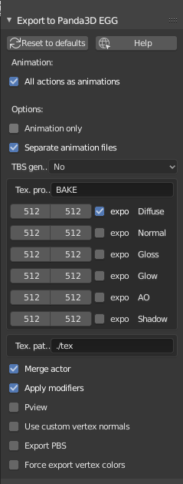
All actions as animations: All actions related to the animated model, which can be set in the action editor will be exported as separate animations.
Animation: Each item in the list can be exported as a separate file with animation data. YABEE uses the main Blender timline to export animation – you should make a series of animations, than add entries into the Animation list. For each you can specify the start and end frame on the timeline. The FPS option is written directly into the animation egg file, and can be used to change the animation speed.
TBS generation (No; Blender; Panda): Generates tangent space vectors for use in shaders like normal- or parallax- mapping. You should have egg-trans from Panda3D SDK installed to use this feature with the “Panda” option. YABEE uses the PATH variable to find egg-trans. If “Blender” is selected, YABEE tries to use blenders tangent space vector creation.
Tex. Processing (Bake): This option affects how your materials and textures will be exported.
In “Bake” mode YABEE tries to use Blender's bake render to merge all materials and textures into 1-4 (depending on which boxes are checked) final textures – diffuse, normal, gloss and glow.
In “Raw” mode YABEE tries to export all textures and materials as-is.
Copy texture files: YABEE tries to copy all exported textures to the given path, defined relative to the exported egg file.
Merge actor: If your rigged actor contains several parts, then YABEE merges it into a single model before exporting; otherwise the exported file will contain several actors. It is possible that this behaviour will be changed in the future.
Pview: YABEE tries to open the exported egg file with Pview after the export was successful.
Export PBS: YABEE tries to export physically based shading related data which can be used for the Physically based shading panel of the Panda3D BAM Exporter.

Materials & Textures: Principled Shader Support
With the addition of the the principled shader in Blender and the upcomming support for physically based materials in Panda3D it was possible to extend YABEE to improve the workflow for artists when working in a PBR environment.
Since Panda3D does not yet fully support all features offered by Blender Node System, a special Nodegroup was crafted to give easy access to the already supproted features.
The group was given the special name Panda3D_PBR (former Panda3D_RP_Diffuse_mat), this is important as YABEE will try to find this name inside the material nodes and gather its inputs. Correct names of the group input are important too (red arrows).
Group and usage as shown below:
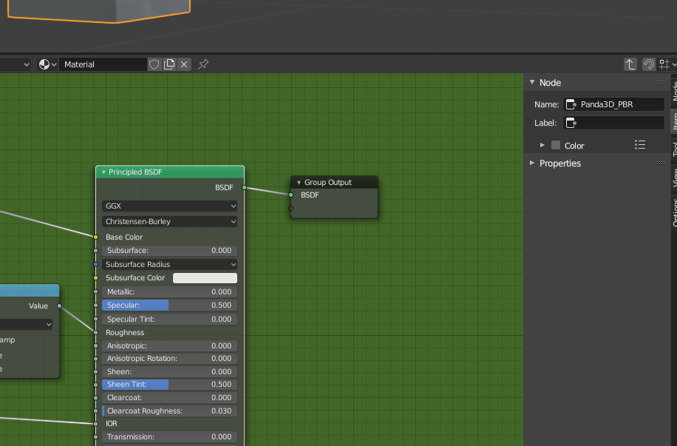Panda3D_PBR NodeGroup

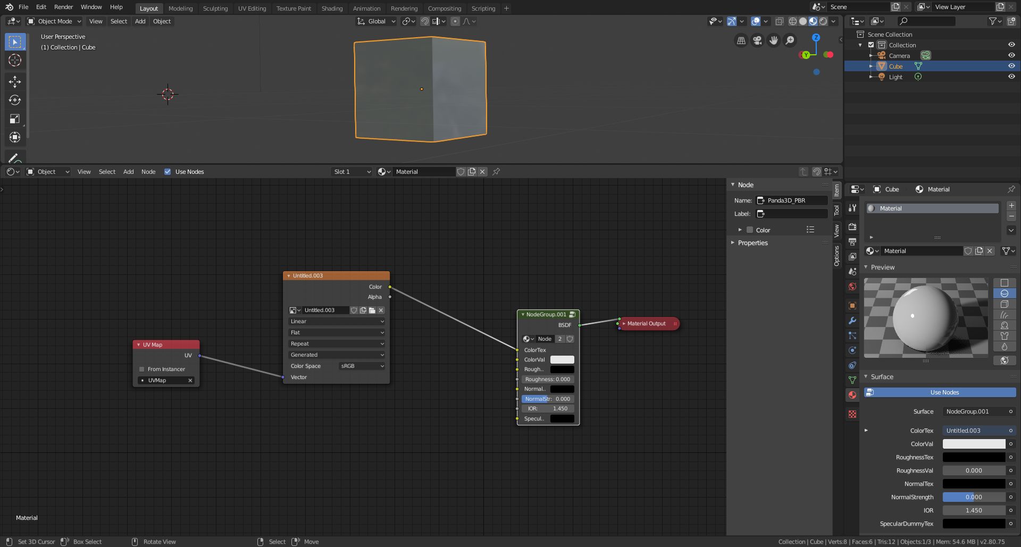
To use it, you have to switch blenders renderer to cycles, create a material for your mesh, set up the „Panda3D_PBR NodeGroup“ and connect the inputs you need as shown in the pictures. Select your model and export with YABEE. There is no need to manually select the PBR-Option. If the material uses Nodes and the nodegroup is present YABEE will automatically export in PBR mode.
Be sure to connect all the required texture inputs, each with a UV-Map input.
If you do not have the required texture for the input, use the Empty*.png image delivered with YABEE.
The PBR node support is still work in progress, if you find important features missing please contact the developers.

