Lab 4 Submission
Course: Backend Development
Lab: Lab 4 – PostgreSQL & SQLModel: Your First Database
Name: KIBET KERICH
Admission Number: C027-01-0917/2024

GitHub Repository
Repository URL:
https://github.com/kerichkibet24-web/library-api-lab4

Screenshots
Screenshot 1: Swagger UI
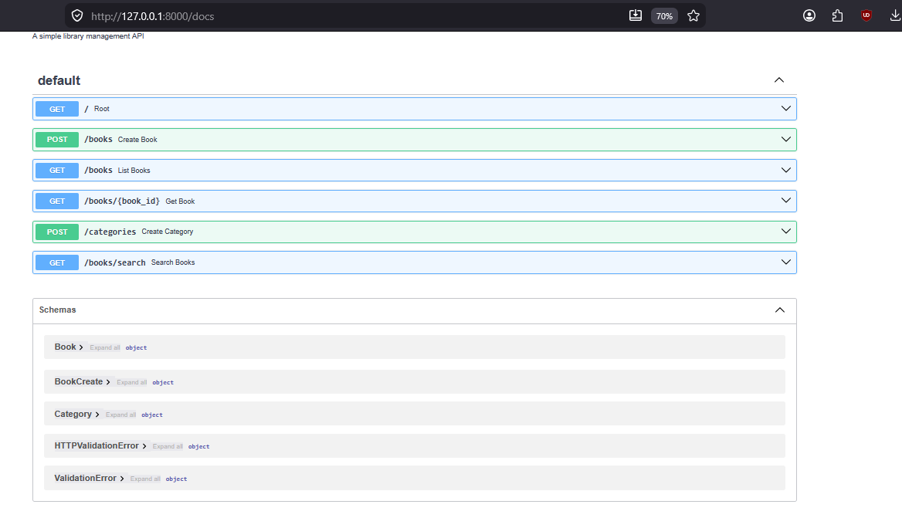
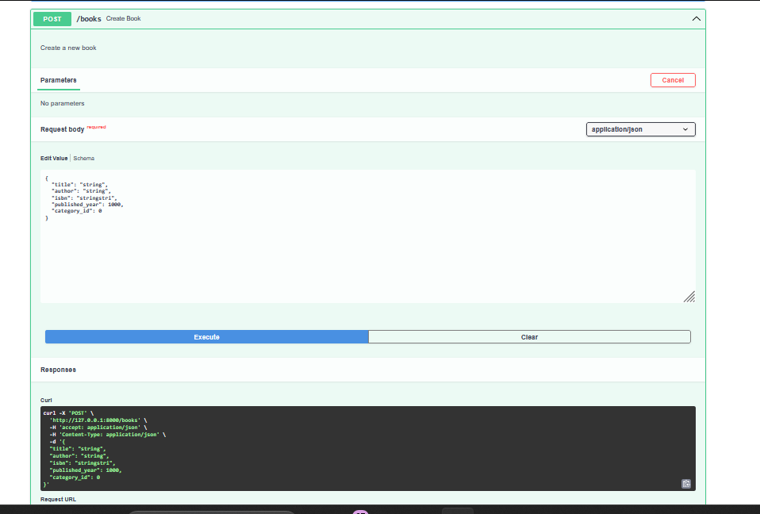
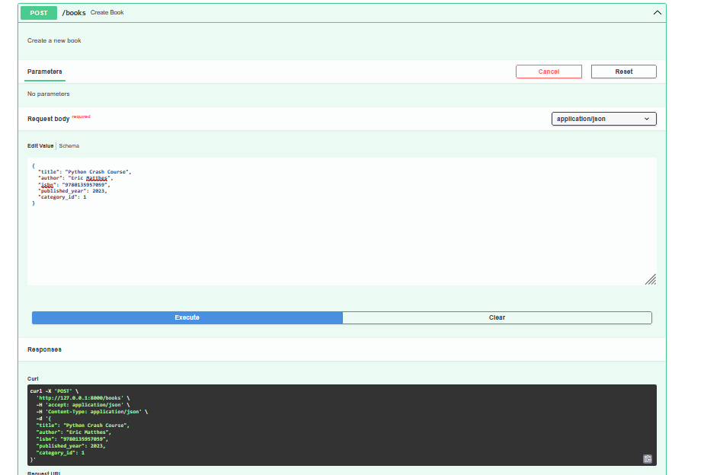
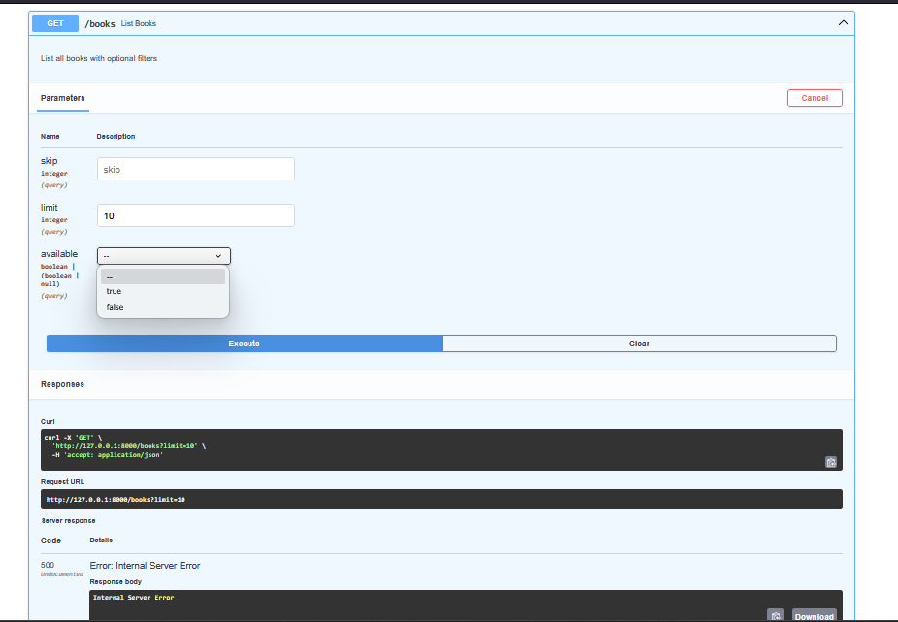
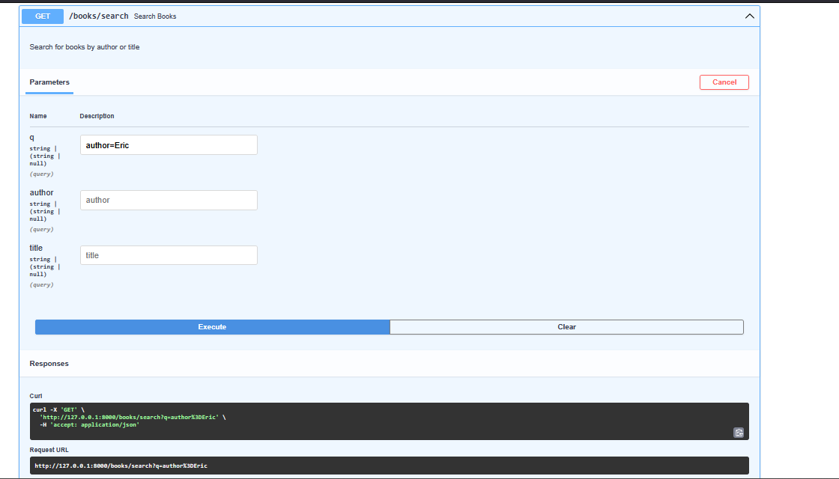
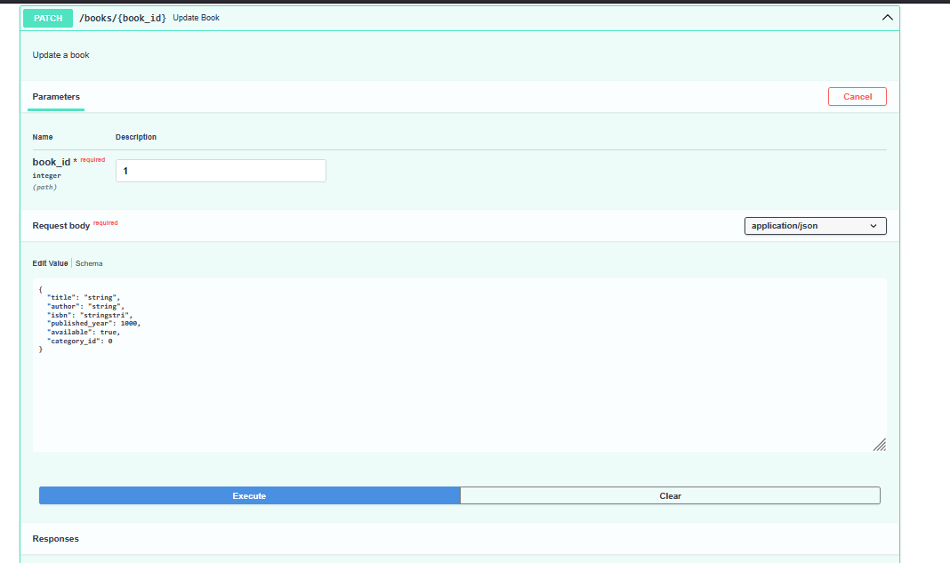

Screenshot 2: PostgreSQL Books Table
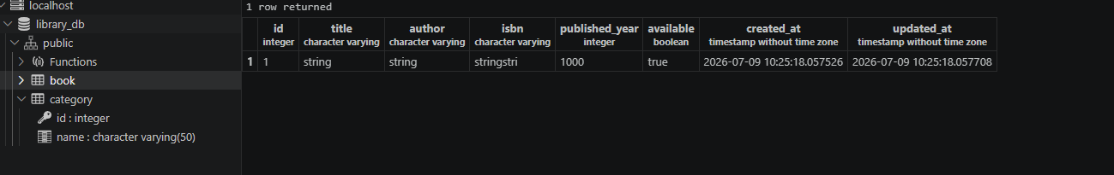
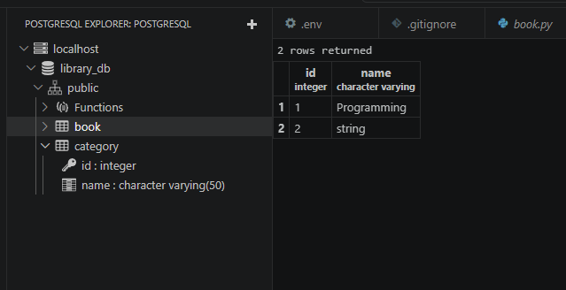
Exercise 1: Category Model
Implemented a Category model using SQLModel with a one-to-many relationship between Category and Book.
Features implemented:
- Category model with id and name
- Relationship between Category and Book
- Foreign key (category_id) added to the Book model
- Endpoint to create categories
- Endpoint to list categories

#models/category.py
from sqlmodel import SQLModel, Field, Relationship
from typing import Optional, List

class Category(SQLModel, table=True):
id: Optional[int] = Field(default=None, primary_key=True)
name: str = Field(
unique=True,
index=True,
min_length=2,
max_length=50
)

books: List["Book"] = Relationship(back_populates="category")

class CategoryCreate(SQLModel):
name: str = Field(
min_length=2,
max_length=50
)

#Changes made to models/book.py
category_id: Optional[int] = Field(
default=None,
foreign_key="category.id"
)

category: Optional["Category"] = Relationship(
back_populates="books"
)

#Category Endpoints (main.py)
@app.post("/categories", response_model=Category)
def create_category(
category: CategoryCreate,
session: Session = Depends(get_session)
):
db_category = Category(**category.model_dump())

session.add(db_category)
session.commit()
session.refresh(db_category)

return db_category

@app.get("/categories", response_model=List[Category])
def list_categories(session: Session = Depends(get_session)):
categories = session.exec(select(Category)).all()
return categories

Exercise 2: Search Endpoint
Implemented a search endpoint that allows users to search books by:
- Author
- Title
- Author and Title together
Endpoint:
GET /books/search
Example requests:
- /books/search?author=Fitzgerald
- /books/search?title=Gatsby

@app.get("/books/search", response_model=List[Book])
def search_books(
q: Optional[str] = None,
author: Optional[str] = None,
title: Optional[str] = None,
session: Session = Depends(get_session)
):
query = select(Book)

if author:
query = query.where(Book.author.contains(author))

if title:
query = query.where(Book.title.contains(title))

return session.exec(query).all()

Exercise 3: Update Endpoint
Implemented a PATCH endpoint for updating book details.
Endpoint:
PATCH /books/{book_id}
Supported updates include:
- Title
- Author
- ISBN
- Published Year
- Availability
- Category
The endpoint updates only the fields supplied in the request while preserving the remaining information.

@app.patch("/books/{book_id}", response_model=Book)
def update_book(
book_id: int,
book_update: BookUpdate,
session: Session = Depends(get_session)
):
book = session.get(Book, book_id)

if not book:
raise HTTPException(status_code=404, detail="Book not found")

update_data = book_update.model_dump(exclude_unset=True)

for field, value in update_data.items():
setattr(book, field, value)

book.updated_at = datetime.utcnow()

session.commit()
session.refresh(book)

return book

Conclusion
The Library API was successfully connected to a PostgreSQL database using SQLModel.
The application supports:
- Creating books
- Listing books
- Retrieving a book by ID
- Updating books
- Creating categories
- Listing categories
- Searching books by author and title
All required endpoints were tested successfully using Swagger UI, and the database tables were verified in PostgreSQL.

