Thursday, 30 November 2023

Title

Group members:

* Mahri Ilmedova
* Muneeb Ahmed
* Kerim Amansaryyev

Question 1:

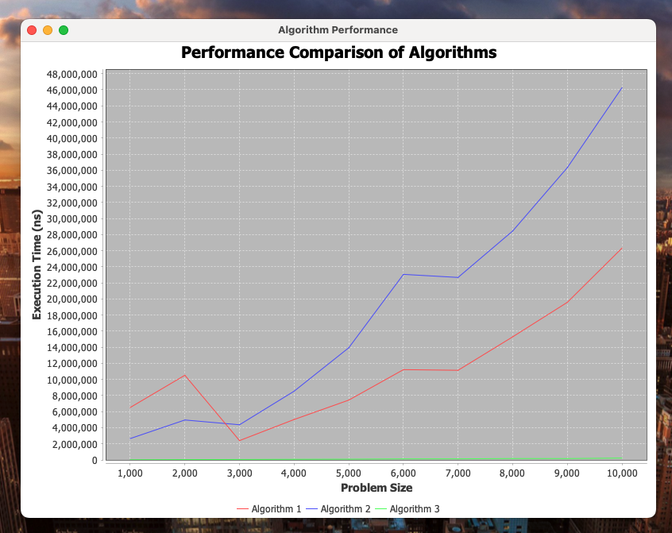

From this graph we can see

* Algorithm 3 executes linearly since it has O(n) time complexity
* Algorithm 1 and Algorithm 2 have curves with similar tendency, however, Algorithm 1 is more performant with larger array sets since it extracts all even numbers in a separate array and O(n^2) time complexity is applied to a smaller subset of an array whereas the same time complexity is applied for a whole array in case of Algorithm 2.

Question2

Let F(n) denote the nth Fibonacci number. Prove F(n) > (4/3)^n for n > 4.

Hints: Use the fact F(n) = F(n-1) + F(n-2). Since you are using two values, you must prove the two base

cases: n = 5 and n = 6.

So, let’s prove it applying the base cases:

F(5) = 5, and (4/3)^5 = 128/243 > 5. True.

For n = 6:

F(6) = 8, and (4/3)^6 = 256/729 > 8. True.

Making an induction hypothesis we get following:

Assume n=k and k>=5 so then F(k) > (4/3)^k.

Applying an induction step:

We want to prove that if n=k+1 then F(k+1) > (4/3)^k+1. Recalling the fibonacci numbers we get:

F(k+1) = F(k) + F(k-1)

By the induction hypothesis, we know that:

F(k) > (4/3)^k

F(k - 1) > (4/3)^(k - 1)

Then we can write following statement:

F(k+1) > (4/3)^(k+1), therefore

(4/3)^k + (4/3)^(k - 1) > (4/3)^(k+1)

((4/3)^(k-1))\*((4/3)+1) > (4/3)^(k+1)

((4/3)^(k-1))\*(7/3) > (4/3)^(k+1)

(7/3) > ((4/3)^(k+1))\*(4/3^(1-k))

(7/3) > 16/9. True

Therefore, we have proven that F(k + 1) > (4/3)^(k + 1).