Kerim Demir Step 4:

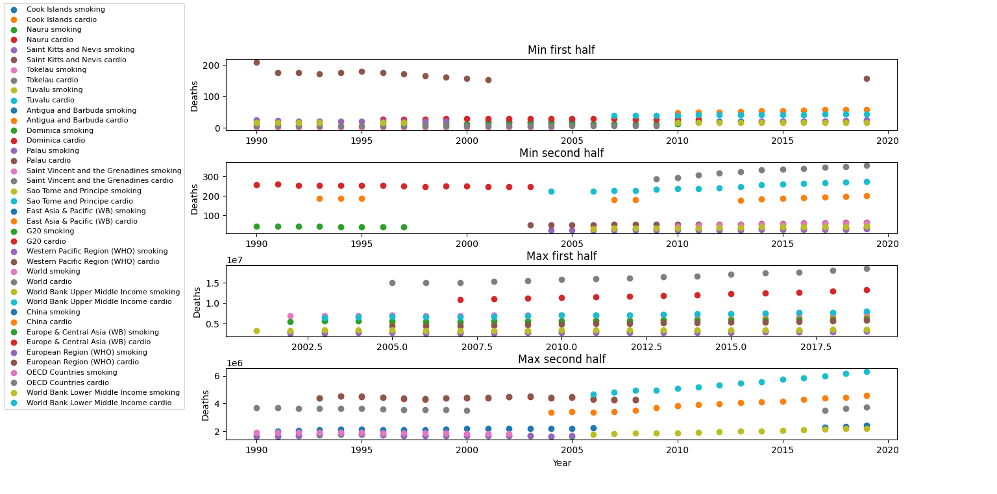

In my visual, I tried to picture the correlation between the number of cardiovascular diseases and the number of deaths caused by smoking. Although, it is a hard to differentiate the scatter plots from the graph, when examined individually it can be seen that the patterns of the plots (cardiovascular-smoking) are similar, what I mean is that they follow the same flow on the graph at the same time. I extracted 10 countries with minimum and maximum deaths or diseases each with respect to their Sum() values. Also, the list of countries was extracted by taking the ones with a higher rate than their Avg() number disease or deaths.