Cloud Computing Project Draft Report

Group Members: Kerim Demir, Egemen Kılıç, Batu Onart, Altuğ Yalım

Github repo: https://github.com/kerimdemir9/Cs436-Cloud-Project

There will be a BackEnd Service that mimics a bank apps transactions (ex: money wiring). Currently there are 3 models in the service that are customers, transactions, and operation logs. Moreover, our Cloud architecture will be something like this:

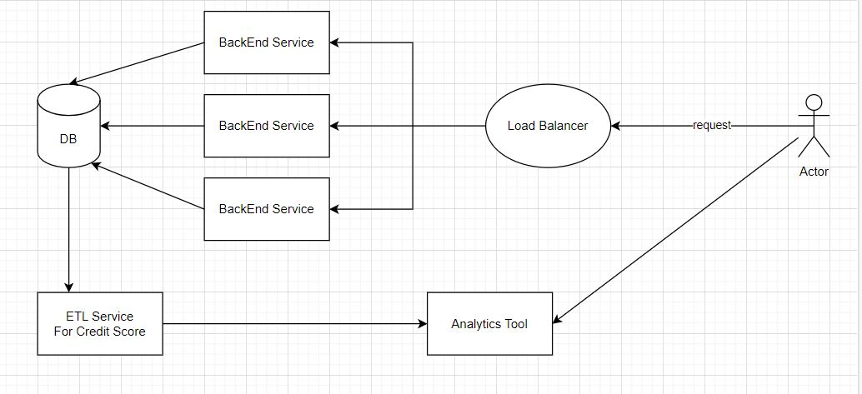

ETL service is going to be used to calculate the credit score of customers and transfer it to the analytics tool for the officials of the bank to consider. Our next step will be developing the ETL service and find an analytics tool to display the result of the calculations. Also, additional components can be added to the BackEnd service as well.