|  |  |  |
| --- | --- | --- |
|  | **KATOWICE INSTITUTE OF TECHNOLOGIES**  **INFORMATION TECHOLOGY** |  |

**IT SYSTEM DESIGN**

**PREVIEW DESIGN REPORT**

**SUBJECT**

The Web Application for Patients, Lab Technicians and Doctors

To Manage and Access Pathological and Diagnostic Reports

**PREPARER**

09466

Kerim Senturk

**CONSULTANT**

Mr. Jacek Żywczok

1. PROJECT SCOPE
   1. What is The Project?

This project contains an web information management system to store, manage and present pathological and diagnostics results of patients. We have 3 types of user;

*Patient*: Who is want to see pathological and diagnostic results of him

*Lab* Techinician: Who is entering the pathological results to system.

*Doctor*: Who is review the pathological results and creating diagnostic reports.

* 1. **What is The Purpose of Project?**
* Managing pathological and diagnostic reports of patients.
* To get easier and be faster the accessing the patient results.
* Taking to digital place the patient diseases.
  1. **What are The Components of Project?**
* Database
* Web API
* Web Interface

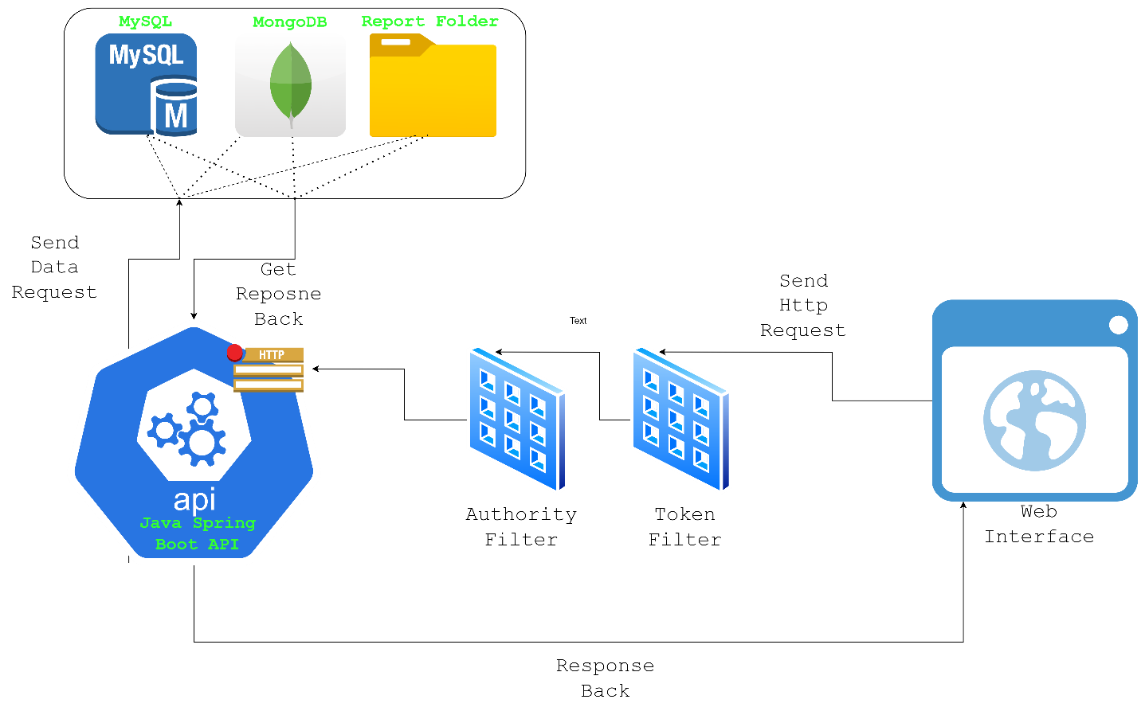

* 1. **What are The Functionalities of Project?**
* Create Patient/Lab Technician/Doctor User
* Update Patient/Lab Technician/Doctor Informations
* User Identification by Login/Logout
* User Authorization
* Create, Update, Delete, View pathologic and diagnostic results of patients.
* Download Patient Results as .pdf file
* Logging user actions to MongoDB like create, delete, show, login, logout etc. (Optional)
* View user actions by log data.
* Managing diseases for patients.
* Contact with Doctor on system. (Optional)

*** Some of these functionalities can be perform only by who has authority. For more information check the “USER AUTHORIZATION”.

1. **COMPONENTS**
   1. Database
      1. Entities
         1. Disease

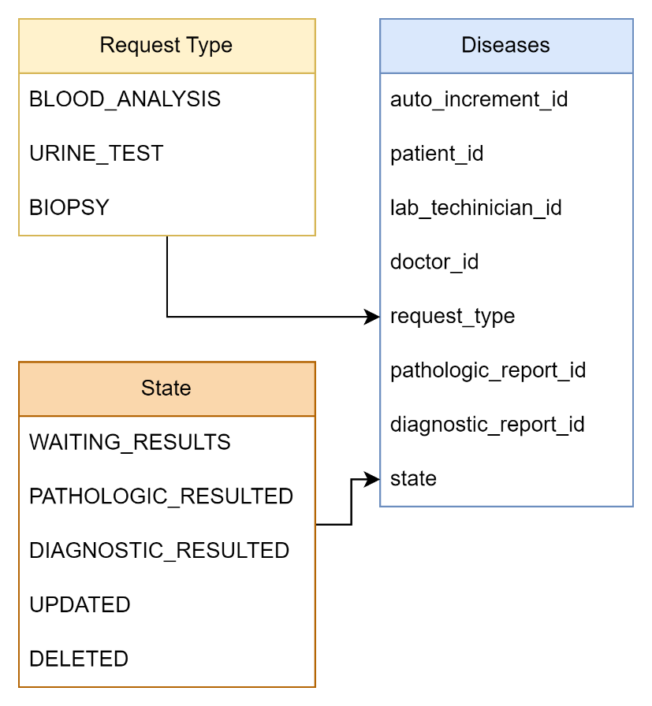

* + - 1. Report

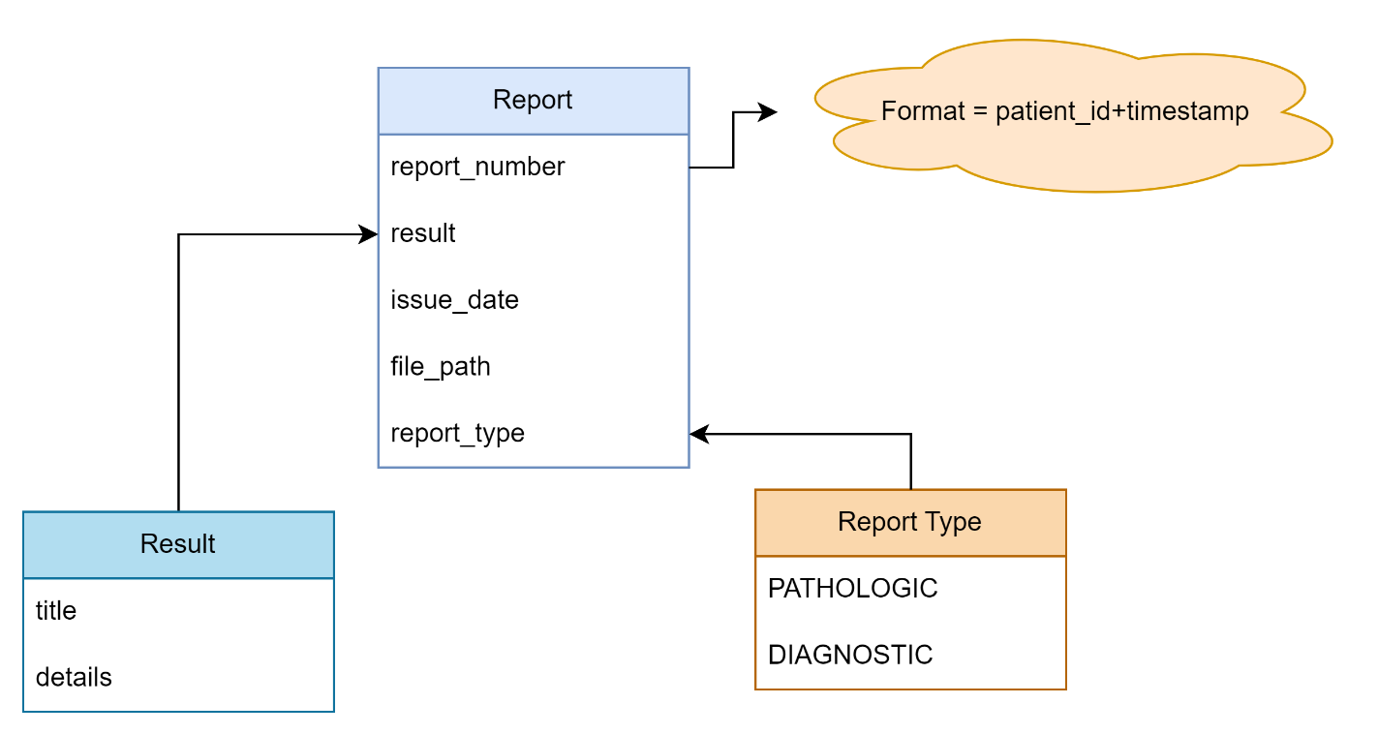

* + - 1. User

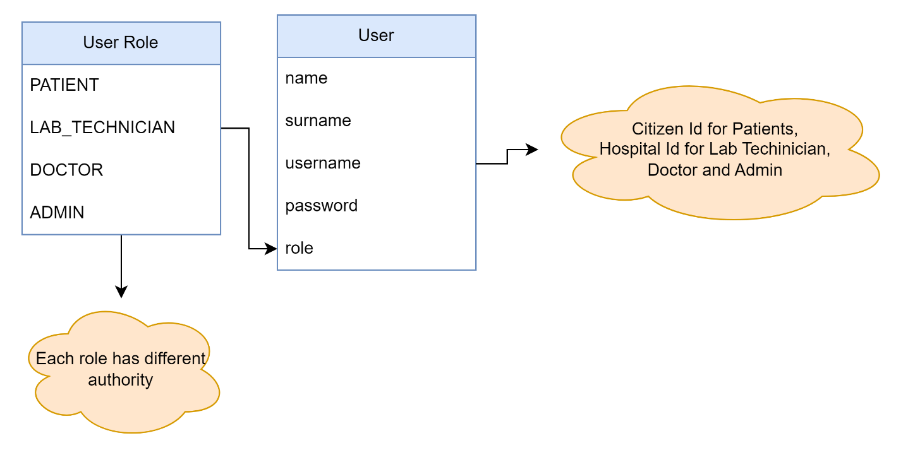

* + - 1. Report File

This report file creating by using disease and report entities. It has following properties;

* Report_number
* Result (title, details)
* Issue_Date
* Report_type
* Patient_id
* Doctor_name
* Lab_Techinician_name

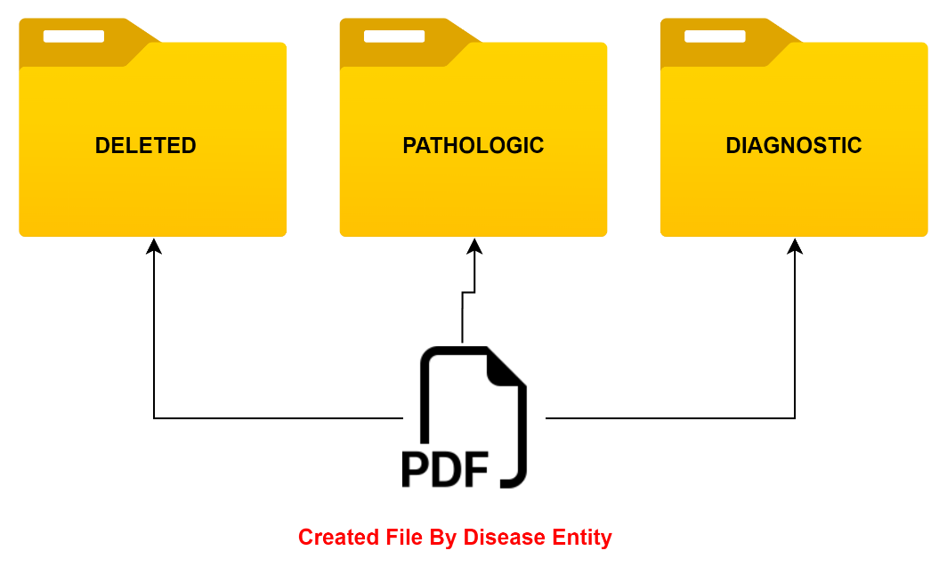

* + 1. Logs (Optional)
    2. Developing Tools
       1. MySQL

Patient, doctor and lab techinican informations stores here.

* + - 1. MongoDB

Log data stores here.

* 1. Web API
     1. User Service

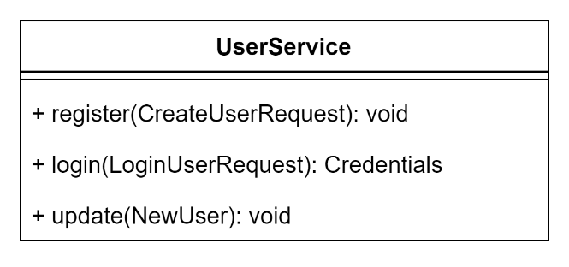

* + 1. Disease Service

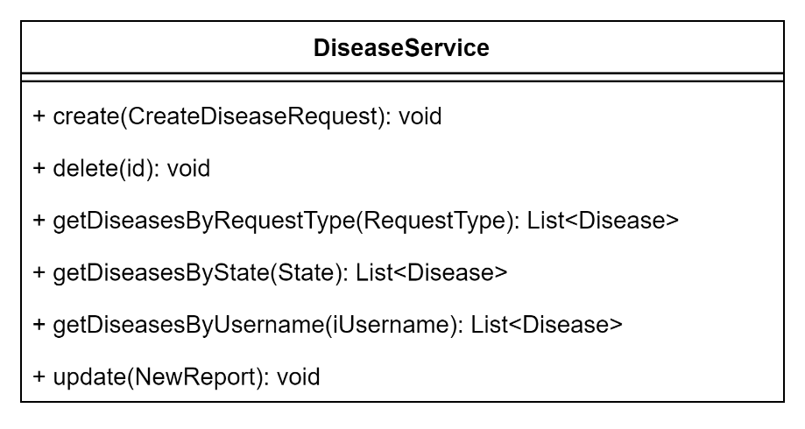

* + 1. Report Service

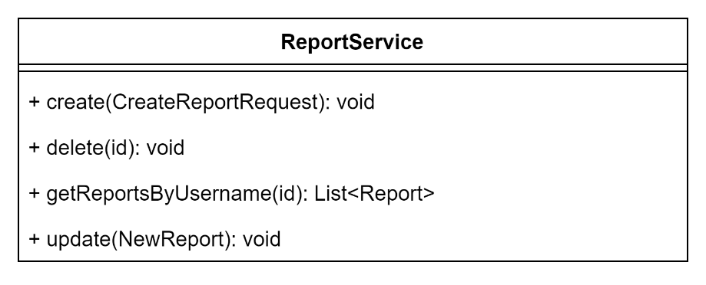

* + 1. Report File Manager

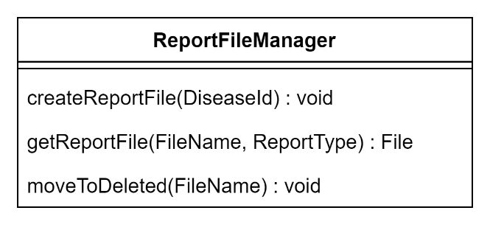

* + 1. Logger (Optional)
    2. Authentication

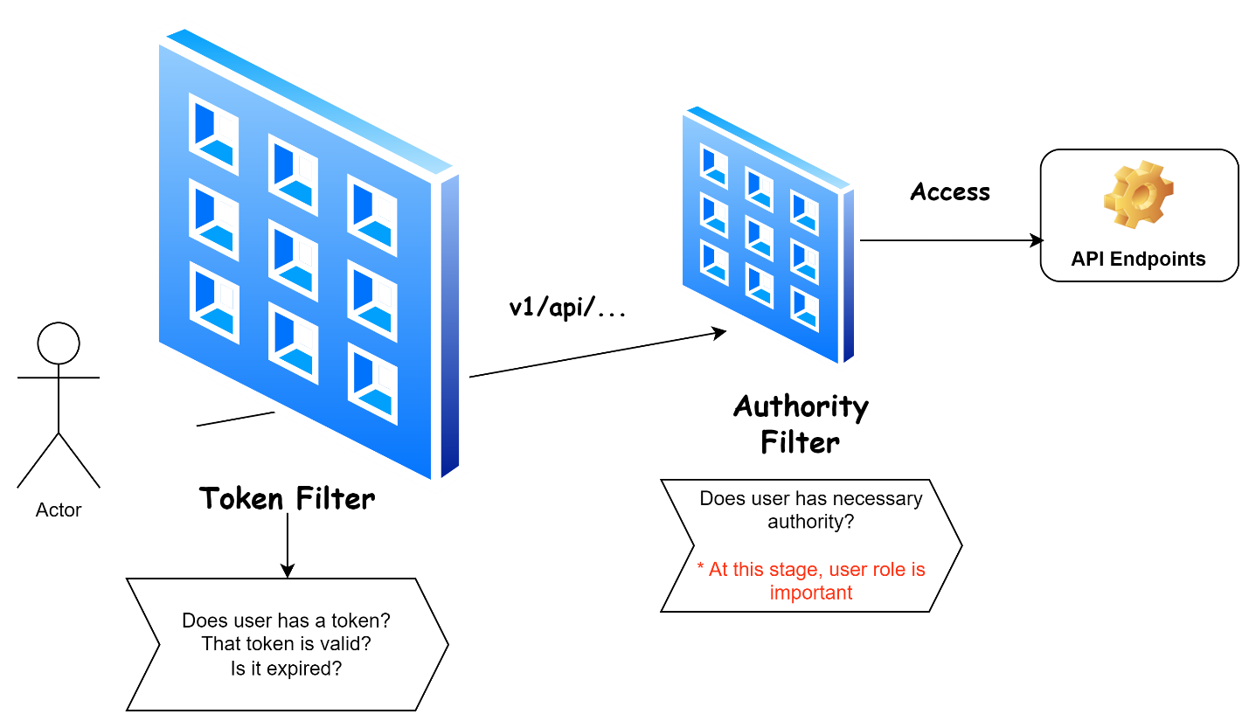

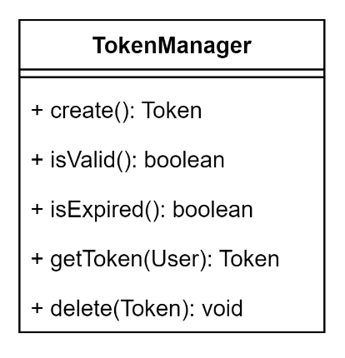

* + 1. Developing Tools
       1. Java 19

This language is the core of the Web API. Whole programming will do by this OOP lang.

* + - 1. Spring Boot

Spring Boot is a Java based framework to develop web projects. It has various module inside to create a web project. Spring-test, spring-web, spring-security, spring-aop, spring-jpa, spring-messging, spring-webmvc, spring-jdbc are some of these modules.

* + - 1. OpenAPI

OpenAPI is a tool to document endpoints of an API. In this way we can easily test and view our endpoints.

* + - 1. Maven

Maven is a dependency manager. Sometimes we need some libraries. At this stage maven downloads the needed libraries from Maven Repository and adds it to project for us.

* + - 1. IntelliJ IDEA

Intellij IDEA is a famous IDE for programming Java. It has various tools inside. Version Control System is one of these.

* 1. **Web Interface**
     1. Pages
        1. Login-Register

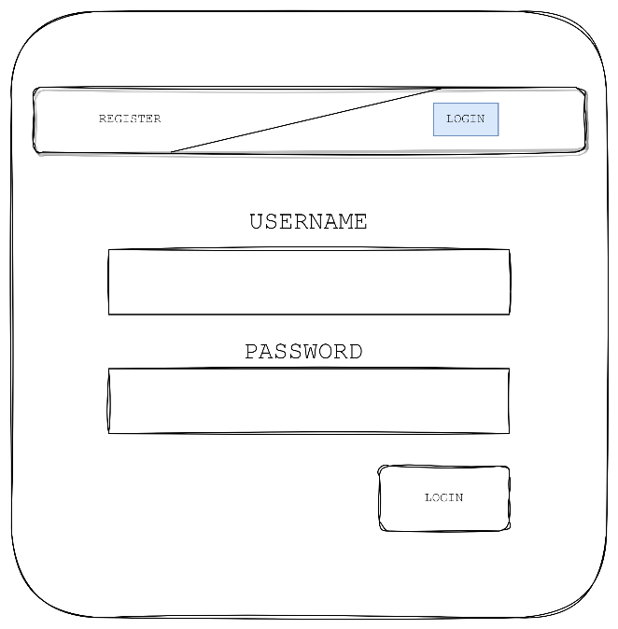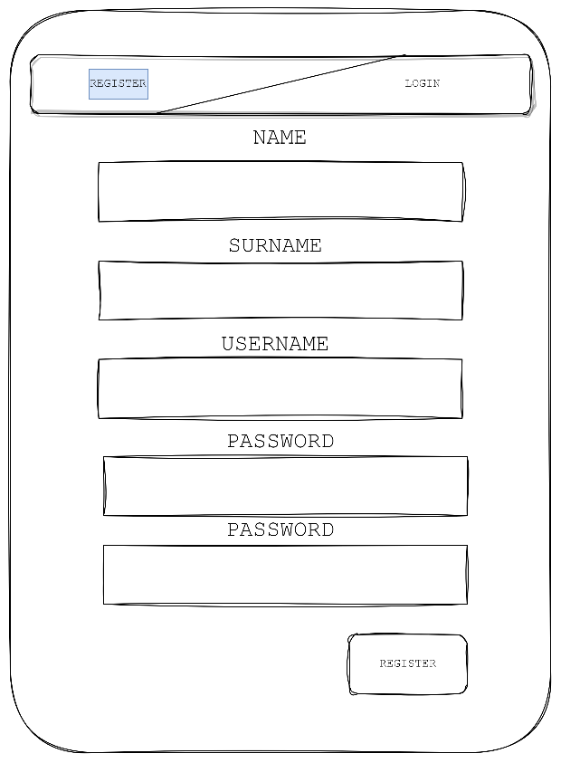

* + - 1. Patient Dashboard

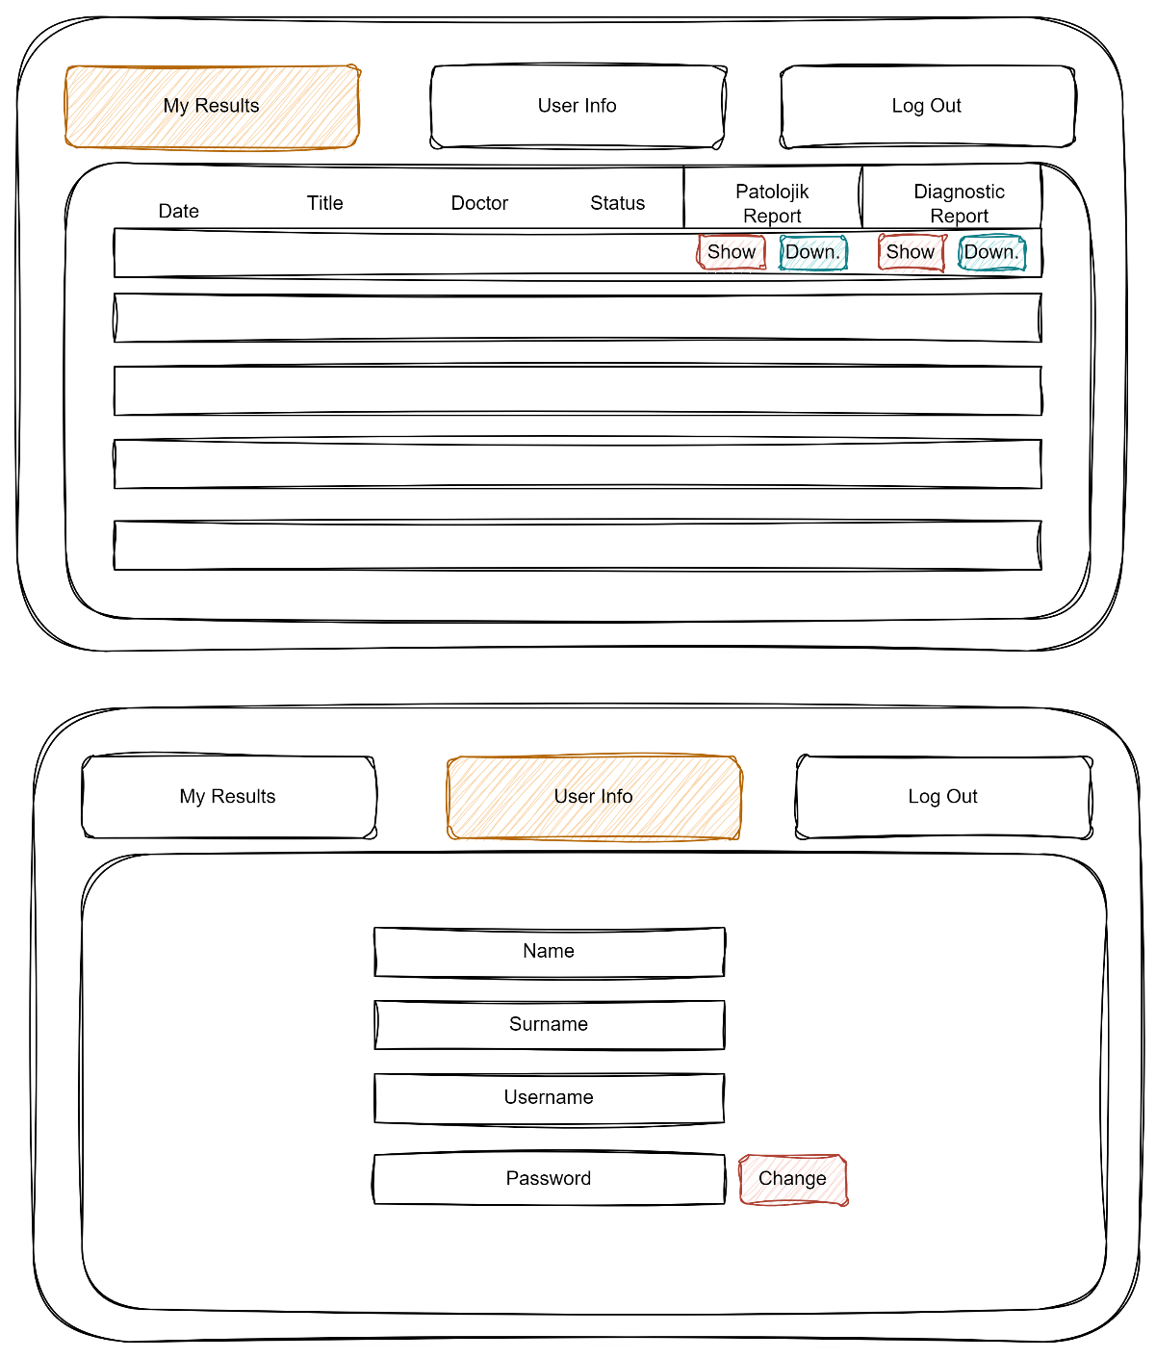

* + - 1. Doctor Dashboard

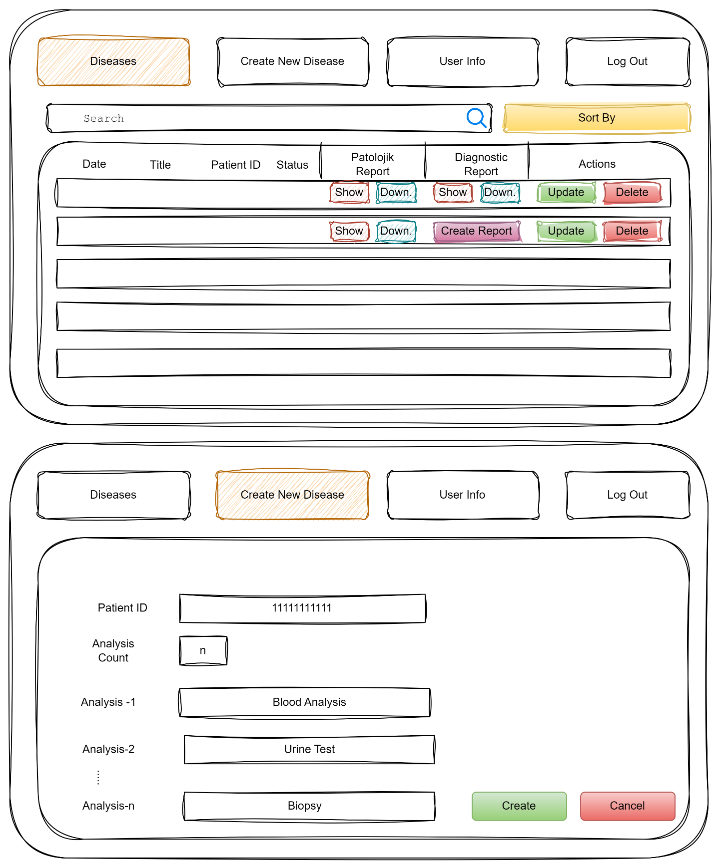

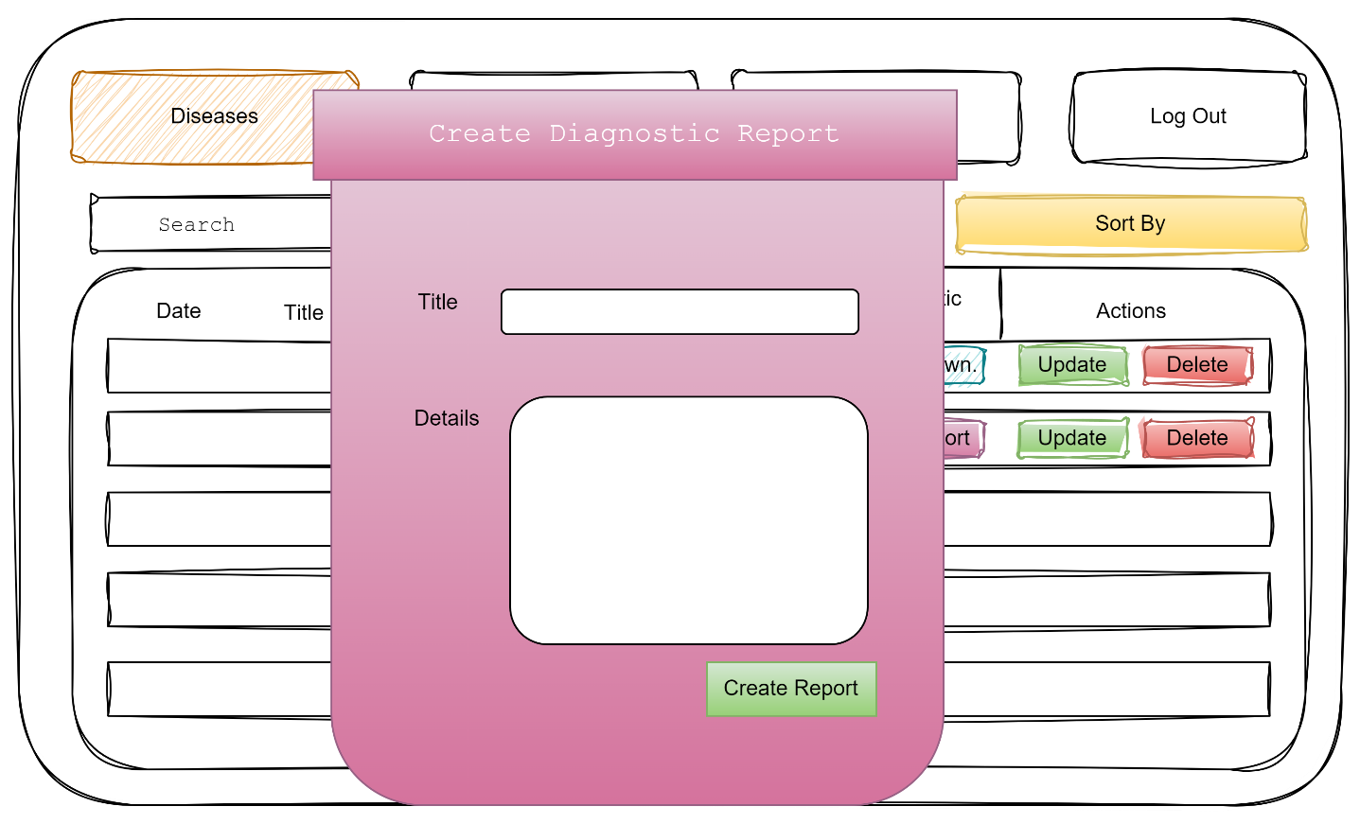

* + - 1. Lab Techinician Dashboard

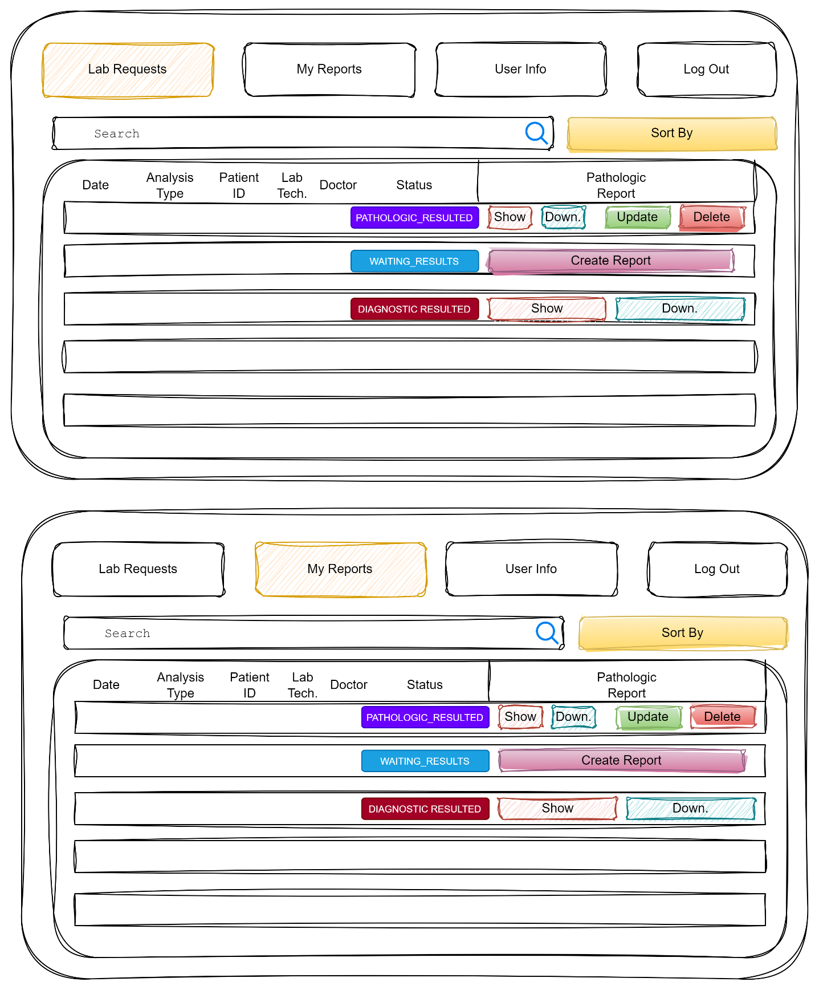

* + - 1. Admin Dashboard

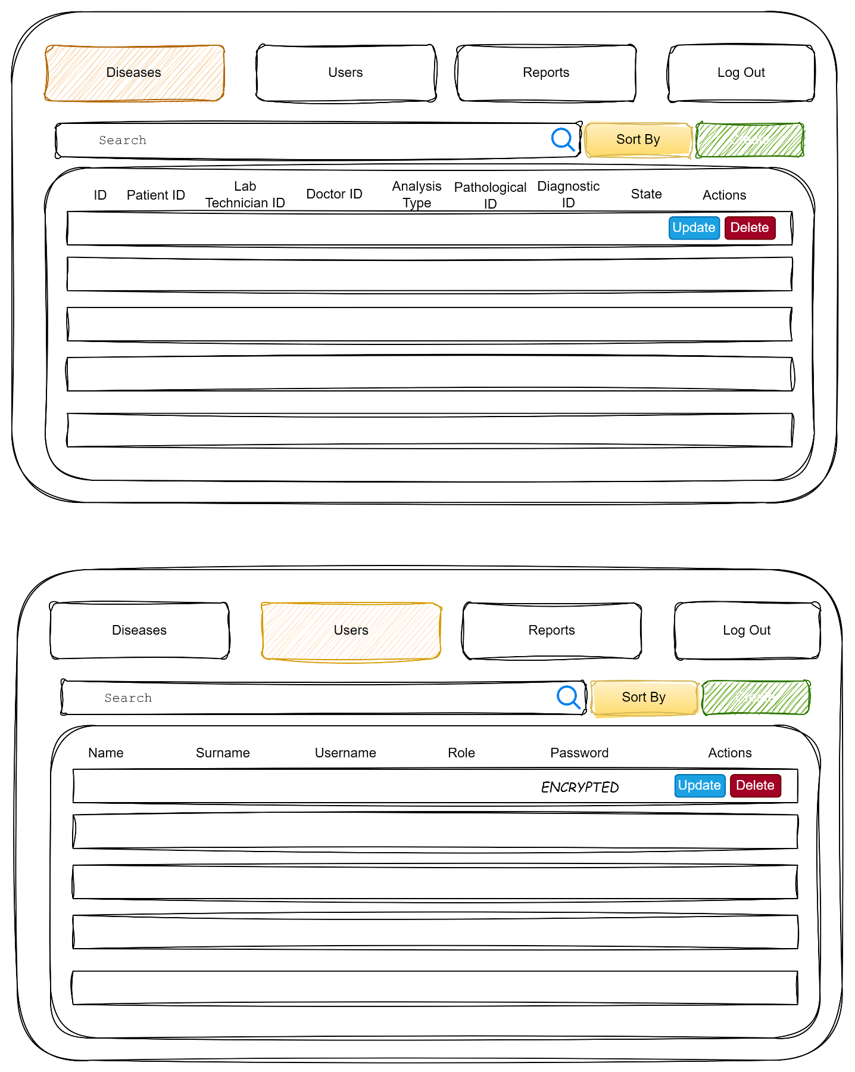

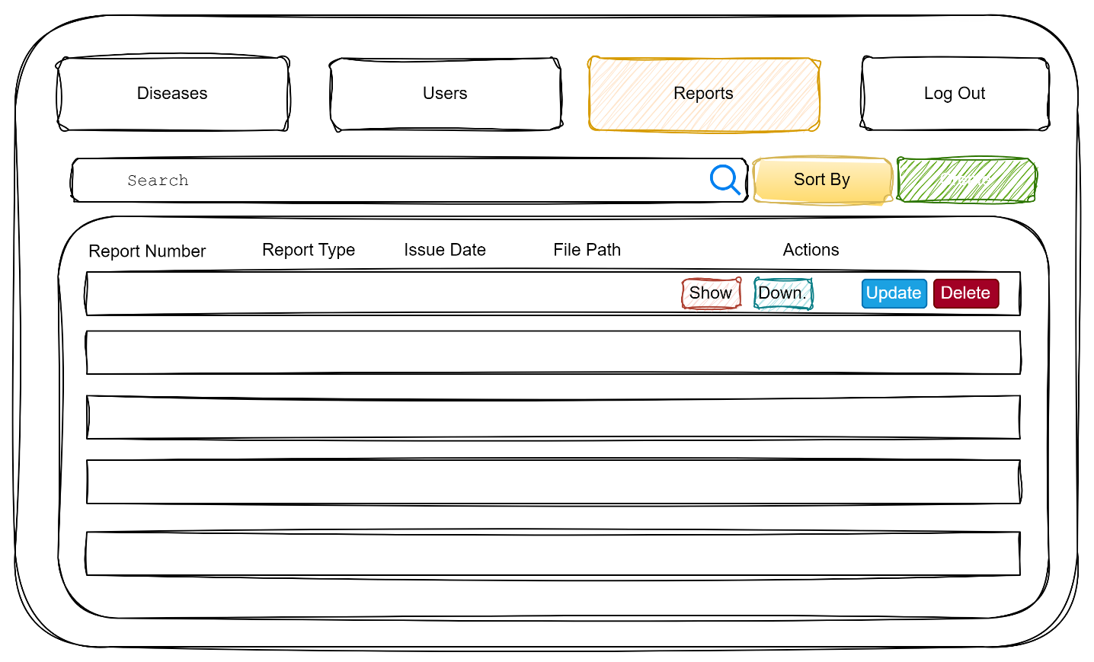

* + 1. Developing Tools
       1. Javascript

Javascript is a interpreted programming language and has plenty frameworks and libs. It is mostly using on web programming. I am going to use it to communicate with my Web API.

* + - 1. React.js

React is a Javascript based web and mobile framework. I am going to use it to develop web-frontend side of this project.

* + - 1. VsCode Editor

VsCode is an editor to type whatever you want. I am going to use it to code React.js

* + - 1. Bootstrap

Bootstrap is a Javascript based CSS library. We can design the html objects just giving them class name through this library.

* + - 1. Flaticon

Flaticon is web site providing a lot of free icon. I am going to use this web site to desing my interfaces.

1. **USER AUTHORIZATION**

