

BIT4138: ADVANCED CRYPTOGRAPHY
Practical Logbook — Weeks 1 to 5

Student Name | Eddy Kering
Admission Number | BSCCS/2024/61947
Course / Class | Computer Science
Unit Code | BIT4138
Unit Name | Advanced Cryptography
Lecturer Name | Michael Nyoro
Semester / Academic Year | 2026

Project Details
Project Title | BIT4138 Advanced Cryptography — Classical, Stream, Block and Asymmetric Cipher Implementations
Selected Technologies | Python 3, VS Code, Cryptography Library, PyCryptodome, OpenSSL, Git, GitHub
GitHub / Portfolio Link | https://github.com/keringyegon-byte/BIT4138-Cryptography

TABLE OF CONTENTS

Cover Page 1

Week 1: Cryptography Environment Setup 2
1.1 Overview 2
1.2 Required Evidence 2
1.3 Screenshots 3
Fig 1: Installation of Python and VS Code 3
Fig 2: Installation of Cryptography Libraries 3
Fig 3: OpenSSL Installation Test 3
Fig 4: Local Encryption Script Execution 4
Fig 5: GitHub Repository Initialization 4
Student Reflection 4

Week 2: Classical Cryptography and Cipher Design 5
2.1 Overview 5
2.2 Caesar Cipher vs Vigenere Cipher Comparison 5
2.3 Required Evidence 5
Fig 1: Caesar Cipher Implementation 6
Fig 2: Vigenere Cipher Encryption Process 6
Fig 3: Encryption and Decryption Output 6
Fig 4: User Input Validation Interface 7
Fig 5: Cipher Testing Results 7
Student Reflection 7

Week 3: Stream Ciphers and Randomness Testing 8
3.1 Overview 8
3.2 Key Concepts Applied 8
3.3 Required Evidence 8
Fig 1: LFSR Generator Implementation 9
Fig 2: Pseudorandom Sequence Output 9
Fig 3: Statistical Randomness Testing 9
Fig 4: RC4 Stream Cipher Simulation 10
Fig 5: Encryption Performance Results 10
Student Reflection 10

Week 4: Block Cipher Design and AES 11
4.1 Overview 11
4.2 Key Concepts Applied 11
4.3 Required Evidence 11
Fig 1: AES Encryption Script 12
Fig 2: Key Generation Process 12
Fig 3: File Encryption Demonstration 12
Fig 4: Decryption Results 13
Fig 5: AES Performance Testing 13
Student Reflection 13

Week 5: Public Key Cryptography (RSA) 14
5.1 Overview 14
5.2 Symmetric vs Asymmetric Encryption Comparison 14
5.3 CAT 1 Task: Feistel Cipher Simulation 14
5.4 Required Evidence 14
Fig 1: RSA Key Pair Generation 15
Fig 2: Public Key Encryption Process 15
Fig 3: Private Key Decryption Results 15
Fig 4: Feistel Cipher Simulation (CAT 1) 16
Fig 5: RSA Testing and Validation 16
Student Reflection 16

Week 1: Cryptography Environment Setup
Installation and Configuration of Cryptography Development Environment

Overview
This week focused on setting up the complete cryptography development environment needed for all practical tasks. Tools installed include Python, VS Code, the Python Cryptography library, OpenSSL, and a GitHub repository for version control and portfolio documentation.

Required Evidence

Fig 1: Installation of Python and VS Code
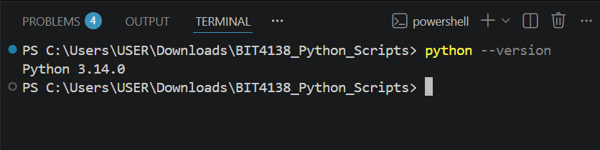Fig 1: Successful installation of Python 3.x and VS Code IDE on the development machine

Fig 2: Installation of Cryptography Libraries
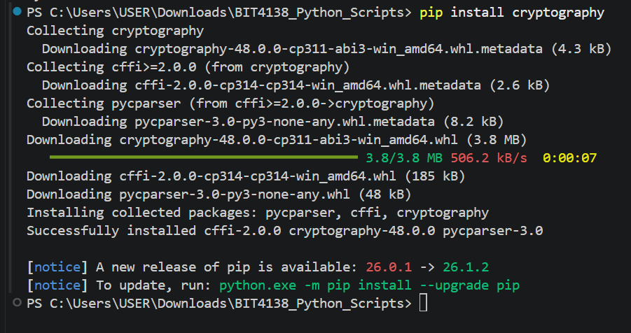Fig 2: Terminal output confirming successful pip installation of the cryptography library

Fig 3: OpenSSL Installation Test
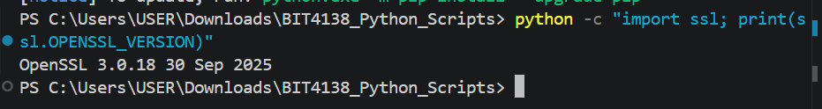Fig 3: OpenSSL version command output confirming successful installation and readiness for key and certificate generation

Fig 4: Local Encryption Script Execution
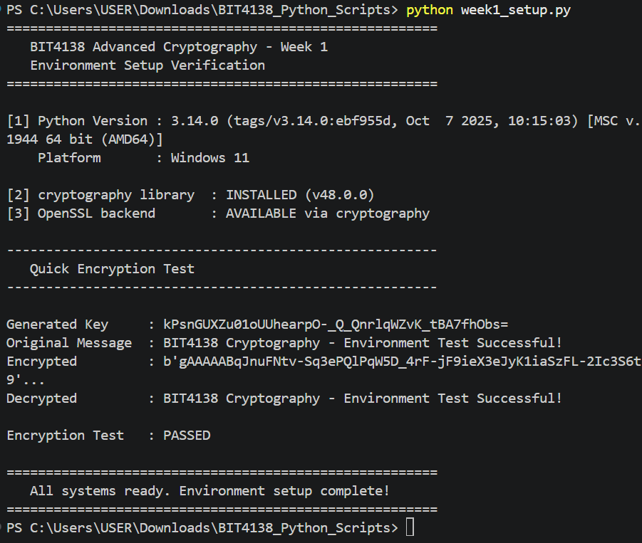Fig 4: Python encryption script running successfully in VS Code terminal, confirming the environment is fully operational

Fig 5: GitHub Repository Initialization
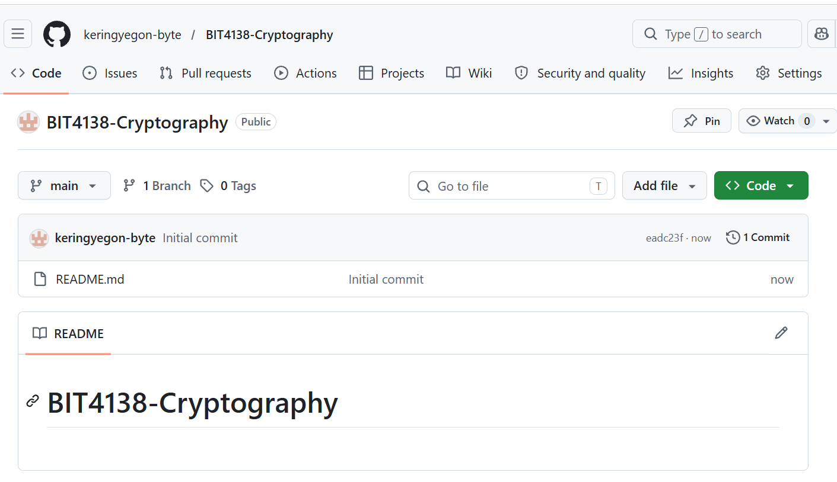Fig 5: GitHub repository showing first project commit, confirming version control setup and initial project structure

Student Reflection (Max 50 Words)
This week I installed Python, VS Code, the cryptography library, and OpenSSL — the core tools for all upcoming practical tasks. Fig 3 confirms OpenSSL is ready for key generation and certificate management. The GitHub repository was initialized to maintain version control and document project progress professionally throughout the unit.

Weekly Summary (Max 50 Words)
The development environment was fully configured this week. Python, VS Code, cryptography libraries, and OpenSSL were installed and verified. A GitHub repository was created and initialized with the first commit. All tools are tested and operational, providing a secure and professional foundation for cryptographic implementation tasks in the weeks ahead.

Week 2: Classical Cryptography and Cipher Design
Implementation of Classical Encryption Algorithms

Overview
This week involved implementing the Caesar Cipher and Vigenere Cipher in Python. Tasks focused on understanding substitution cipher mechanics, the role of keys in encryption security, and identifying weaknesses in classical cryptographic methods through testing and comparison.

Caesar Cipher vs Vigenere Cipher — Comparison
Criteria | Caesar Cipher | Vigenere Cipher
Type | Monoalphabetic substitution | Polyalphabetic substitution
Key | Single integer shift (e.g. shift 3) | A keyword (e.g. KEY)
Security Level | Very weak — only 25 possible keys | Stronger — resists simple brute-force
Main Weakness | Vulnerable to brute-force and frequency analysis | Vulnerable if keyword is short or repeated
Modern Relevance | Educational only | Basis for understanding stream cipher concepts

Required Evidence

Fig 1: Caesar Cipher Implementation
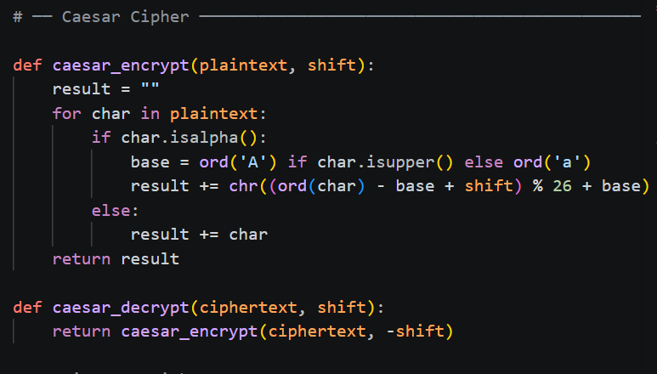Fig 1: Python source code for the Caesar Cipher showing the shift-based encryption and decryption logic

Fig 2: Vigenere Cipher Encryption Process
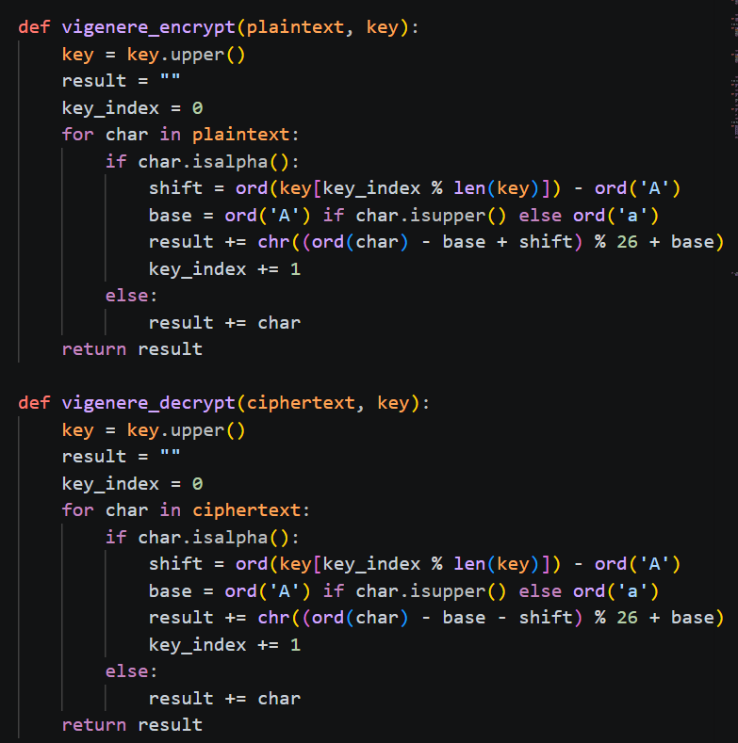Fig 2: Python implementation of the Vigenere Cipher demonstrating polyalphabetic encryption using a repeating keyword

Fig 3: Encryption and Decryption Output
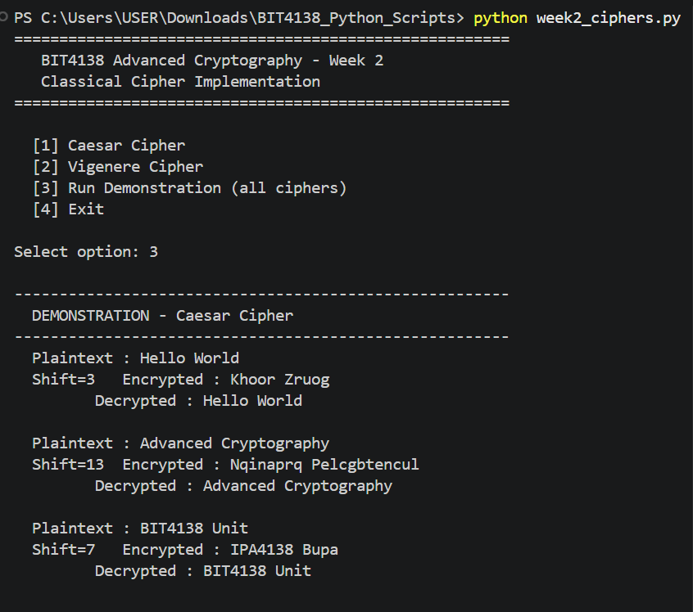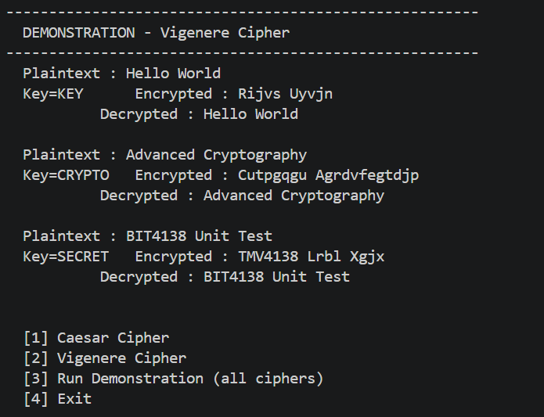Fig 3: Terminal output showing both ciphers encrypting and correctly decrypting a test message

Fig 4: User Input Validation Interface
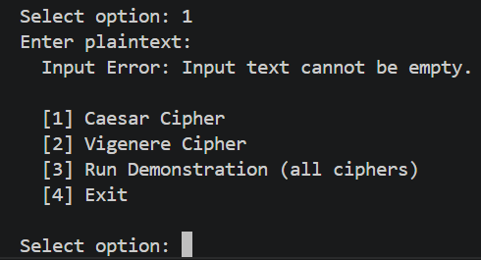Fig 4: Program interface accepting plaintext and keys, and validating user input before encryption

Fig 5: Cipher Testing Results
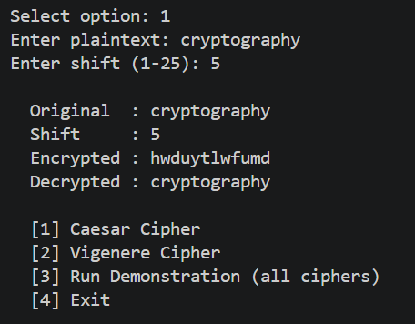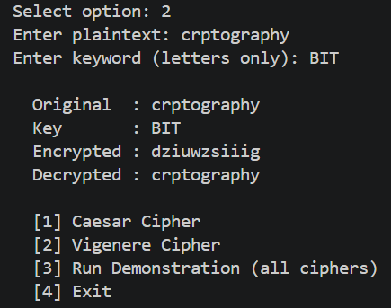
Fig 5: Results from testing both ciphers with multiple inputs, showing correct outputs and identified weaknesses

Student Reflection (Max 50 Words)
Implementing the Caesar and Vigenere Ciphers demonstrated how key length and complexity directly affect encryption security. The Caesar Cipher's 25-key space makes it trivially breakable, while the Vigenere Cipher resists simple brute-force due to its polyalphabetic nature. Input validation in the interface prevented encryption errors caused by invalid characters.

Weekly Summary (Max 50 Words)
This week I implemented two classical substitution ciphers in Python. The Caesar Cipher used a fixed numerical shift while the Vigenere Cipher applied a repeating keyword. Both encryption and decryption were tested successfully. The comparison revealed that key complexity is critical to cipher strength, forming a foundation for modern cryptographic design.

Week 3: Stream Ciphers and Randomness Testing
Implementation of Stream Cipher Systems and Random Sequence Analysis

Overview
This week focused on stream cipher design and the critical role of pseudorandomness in cryptographic security. Tasks included implementing a Linear Feedback Shift Register (LFSR) generator, simulating the RC4 stream cipher, and performing statistical randomness tests to evaluate the quality of generated sequences.

Key Concepts Applied
- Stream ciphers encrypt one bit or character at a time: Ciphertext = Plaintext XOR Keystream
- LFSR generators produce pseudorandom sequences based on linear recurrence relations
- RC4 generates a keystream using a variable-length key for XOR-based encryption
- Statistical tests (Frequency, Runs, Mean, Chi-Square) detect patterns and biases in generated sequences

Required Evidence

Fig 1: LFSR Generator Implementation
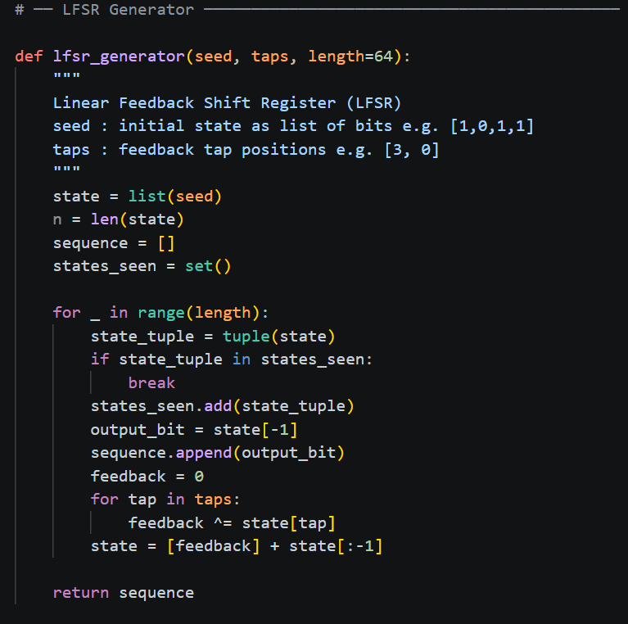Fig 1: Python source code for the LFSR generator showing feedback polynomial and shift register logic

Fig 2: Pseudorandom Sequence Output
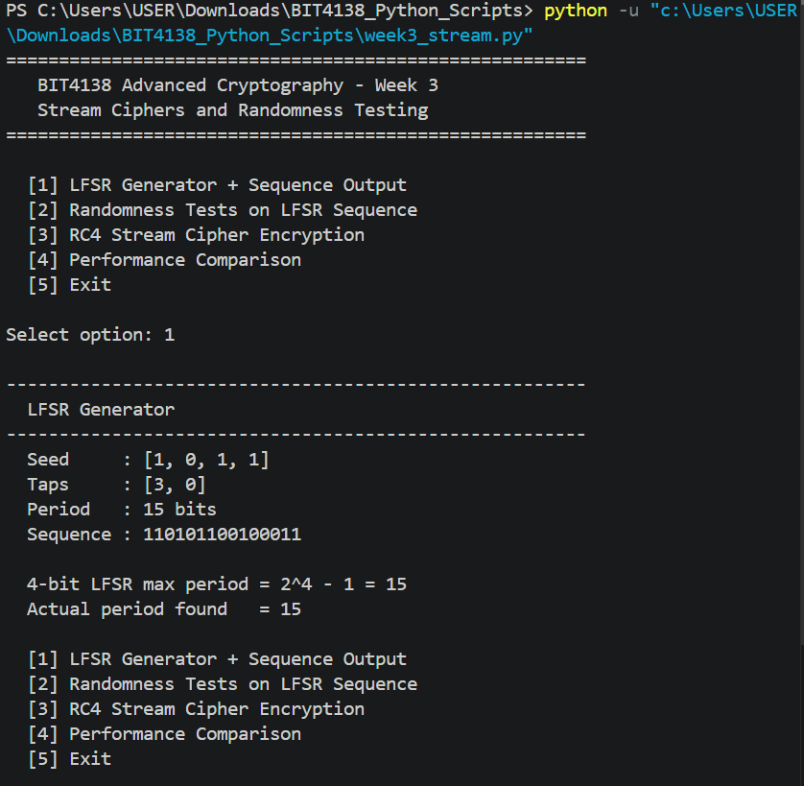Fig 2: Output of the LFSR generator displaying the generated pseudorandom binary sequence and its calculated period

Fig 3: Statistical Randomness Testing
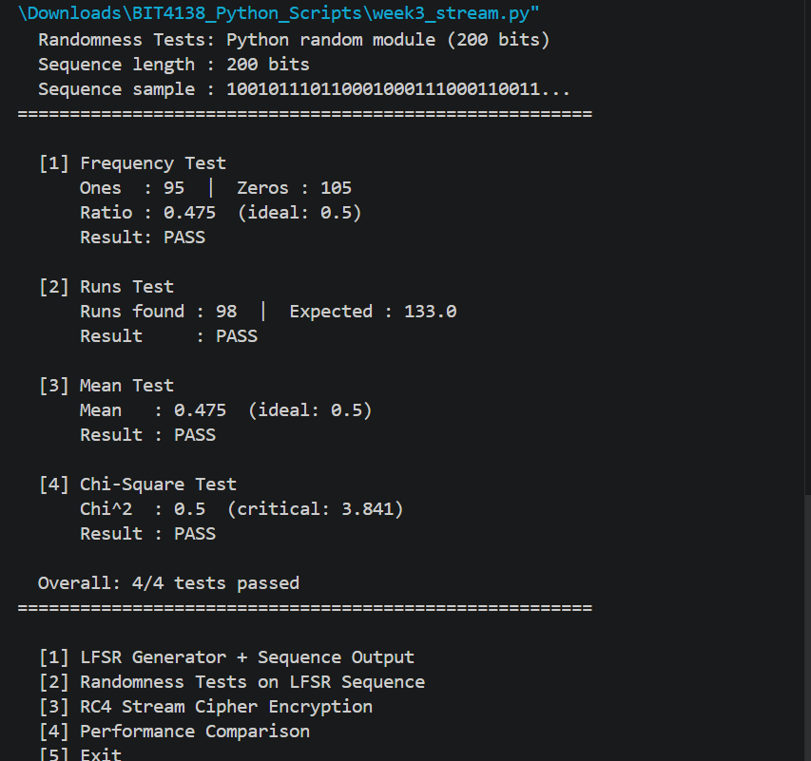
Fig 3: Results of Frequency, Runs, Mean, and Chi-Square tests applied to the generated sequence with interpretations

Fig 4: RC4 Stream Cipher Simulation
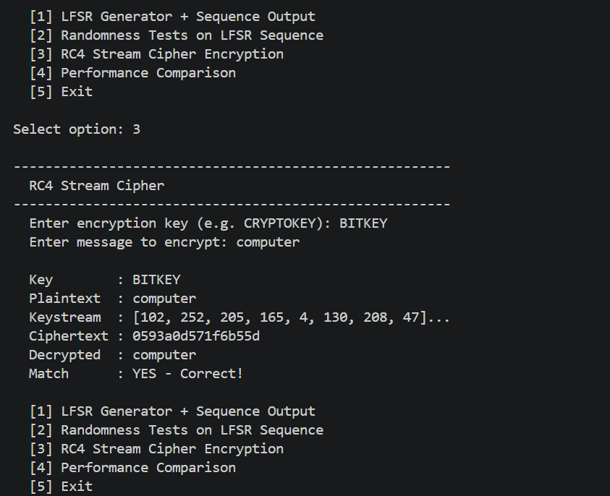Fig 4: Python implementation and output of RC4, demonstrating keystream generation and XOR-based encryption of a test message

Fig 5: Encryption Performance Results
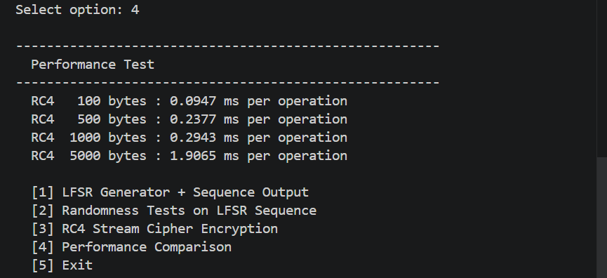Fig 5: Performance results showing encryption speed and sequence quality across different generator configurations

Student Reflection (Max 50 Words)
Randomness is fundamental to stream cipher security — a predictable keystream completely compromises encryption. The LFSR implementation showed how sequence period is determined by the feedback polynomial. Statistical tests on the RC4 output confirmed good randomness distribution. The Debian OpenSSL bug case study highlighted how weak random generators have caused real-world cryptographic failures.

Weekly Summary (Max 50 Words)
This week I implemented an LFSR pseudorandom generator and an RC4 stream cipher simulation in Python. Statistical randomness tests including Frequency, Runs, and Chi-Square tests were applied to evaluate sequence quality. Results confirmed the importance of high linear complexity and long periods in producing cryptographically secure keystreams for reliable stream encryption.

Week 4: Block Cipher Design and AES
Advanced Encryption Standard (AES) and Block Cipher Operations

Overview
This week covered block cipher design principles and the implementation of AES (Advanced Encryption Standard). Unlike stream ciphers that process one bit at a time, block ciphers encrypt fixed-size data blocks using multiple transformation rounds. Stream cipher cryptanalysis was also explored through the Berlekamp-Massey Algorithm applied to LFSR sequences.

Key Concepts Applied
- AES operates on 128-bit blocks using 10, 12, or 14 rounds depending on key size (128, 192, or 256 bits)
- Symmetric encryption: the same key is used for both encryption and decryption
- The Berlekamp-Massey Algorithm finds the shortest LFSR that could reproduce a given binary sequence
- Secure key generation and storage are critical — a compromised key breaks the entire encryption system

Required Evidence

Fig 1: AES Encryption Script
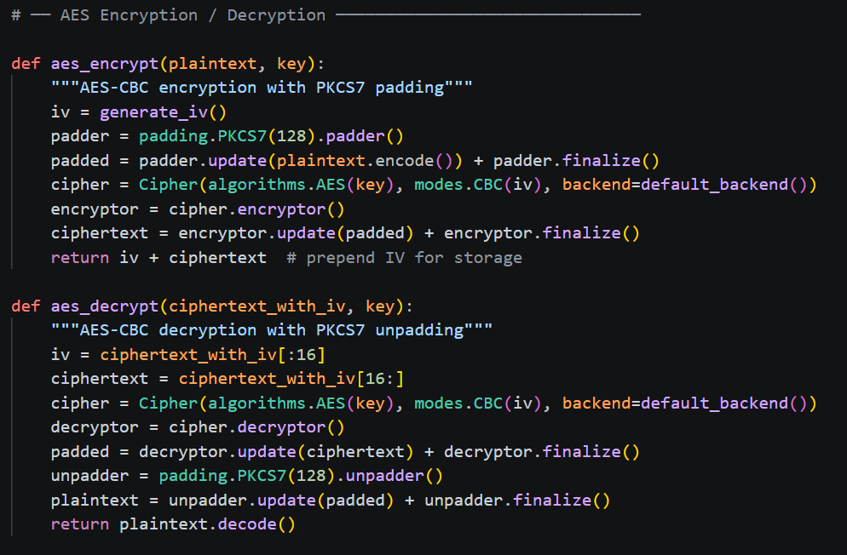Fig 1: Python source code implementing AES encryption using the cryptography library with key setup, padding, and mode configuration

Fig 2: Key Generation Process
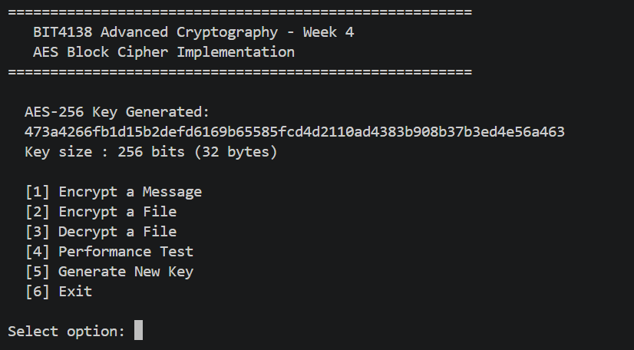Fig 2: Secure AES key generation output showing the randomly generated 256-bit symmetric key in hexadecimal representation

Fig 3: File Encryption Demonstration
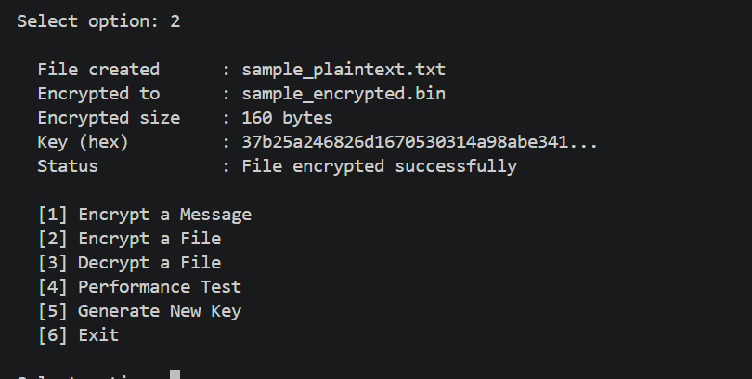Fig 3: Terminal output showing a plaintext file being successfully encrypted to ciphertext using the generated AES key

Fig 4: Decryption Results
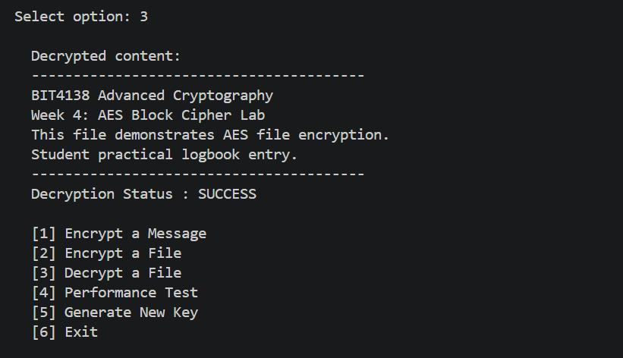Fig 4: Successful decryption of the AES-encrypted file back to its original plaintext, confirming correct key usage and cipher operation

Fig 5: AES Performance Testing
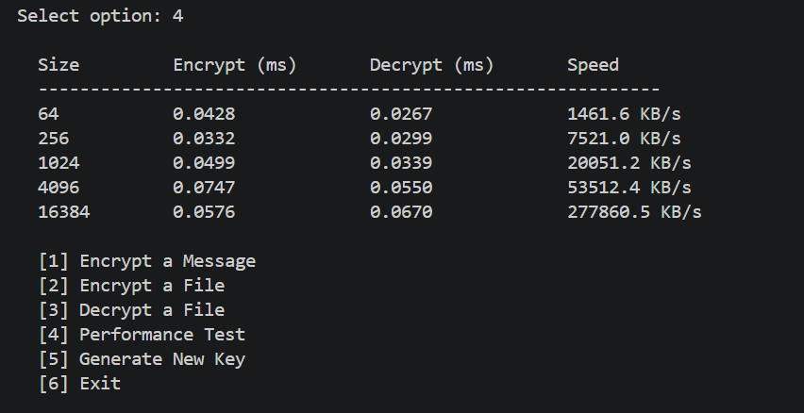Fig 5: Performance test results comparing AES encryption and decryption times across different file sizes or key lengths

Student Reflection (Max 50 Words)
AES encryption demonstrated the power of symmetric block ciphers for securing file data. The key generation process highlighted that encryption security depends entirely on key secrecy and randomness — a weak or reused key makes AES trivially breakable. Performance tests showed AES is fast enough for real-world bulk data encryption, explaining its widespread industry adoption.

Weekly Summary (Max 50 Words)
This week I implemented AES encryption and decryption in Python using the cryptography library. A secure 256-bit key was generated and used to encrypt and successfully decrypt a test file. Performance testing confirmed AES efficiency across varying data sizes. Key management was identified as the most critical aspect of maintaining strong symmetric encryption security.

Week 5: Public Key Cryptography (RSA)
Implementation of RSA Encryption and Key Management

Overview
This week introduced asymmetric (public key) cryptography through RSA (Rivest-Shamir-Adleman) implementation. Unlike symmetric systems such as AES, RSA uses mathematically linked key pairs — a public key for encryption and a private key for decryption. The Feistel cipher simulation was also completed as the CAT 1 practical requirement.

Symmetric vs Asymmetric Encryption — Comparison
Criteria | Symmetric (AES) | Asymmetric (RSA)
Keys Used | One shared secret key | Public key + Private key pair
Speed | Fast — suitable for bulk data | Slow — suited for small data / key exchange
Key Distribution | Difficult — key must be shared securely | Easy — public key can be freely distributed
Use Case | File encryption, disk encryption | Secure messaging, digital signatures, TLS
Example | AES-256 | RSA-2048

CAT 1 Task: Feistel Cipher Simulation
A Feistel cipher structure was implemented in Python for CAT 1. The design divides a plaintext block into left and right halves and applies multiple XOR-based rounds using subkeys. The avalanche effect was tested by changing a single character in the plaintext and comparing ciphertext outputs.

Feistel Round Formula: L_i = R_(i-1) | R_i = L_(i-1) XOR F(R_(i-1), K_i)

Required Evidence

Fig 1: RSA Key Pair Generation
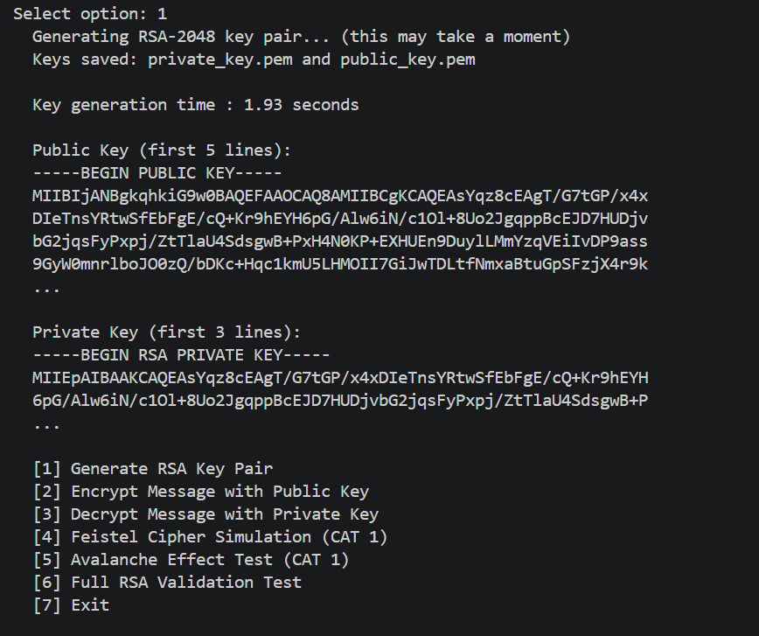
Fig 1: Python output showing generation of RSA-2048 public and private key pair, including key export to PEM format

Fig 2: Public Key Encryption Process
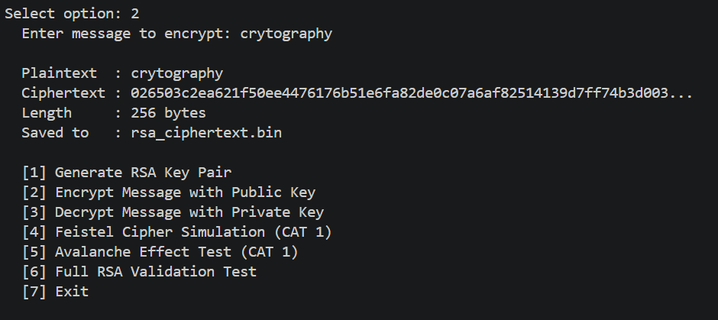
Fig 2: Encryption of a plaintext message using the RSA public key, producing ciphertext decryptable only with the private key

Fig 3: Private Key Decryption Results
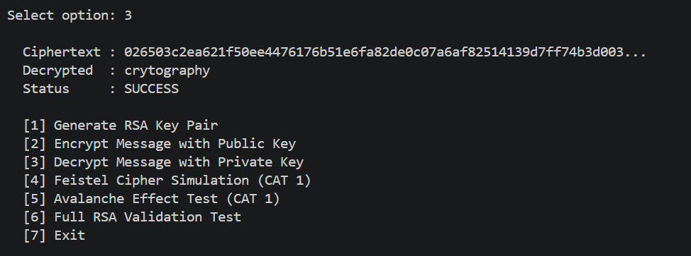Fig 3: Successful decryption of the RSA ciphertext using the private key, recovering the original plaintext message

Fig 4: Feistel Cipher Simulation (CAT 1)
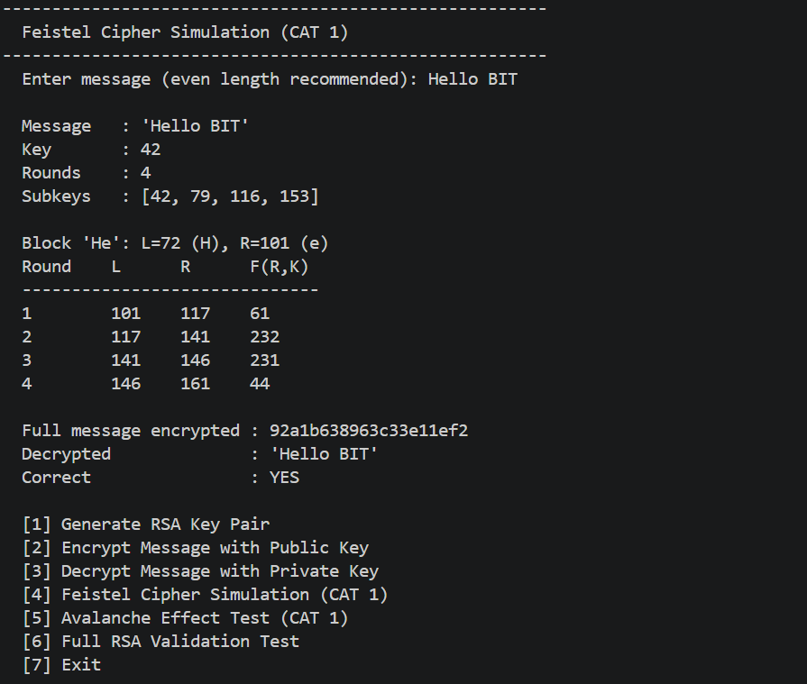Fig 4: Python implementation of the Feistel cipher showing multiple XOR-based rounds and avalanche effect test results

Fig 5: RSA Testing and Validation
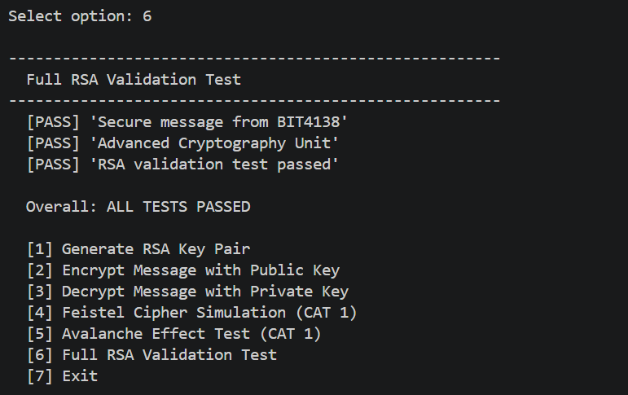
Fig 5: Final validation test showing RSA encryption and decryption working correctly across multiple messages and configurations

Student Reflection (Max 50 Words)
RSA demonstrated how asymmetric encryption solves the key distribution problem inherent in symmetric systems — the public key can be shared openly without compromising security. The Feistel simulation revealed how confusion and diffusion are achieved through repeated XOR rounds. The avalanche effect confirmed that a single bit change radically alters the entire ciphertext output.

Weekly Summary (Max 50 Words)
RSA encryption was implemented using Python, generating a 2048-bit key pair for secure message encryption and decryption. A Feistel cipher was also built for CAT 1, demonstrating block cipher design through multiple XOR-based rounds. Avalanche effect testing confirmed that small plaintext changes produce significantly different ciphertext outputs, validating strong diffusion properties.

