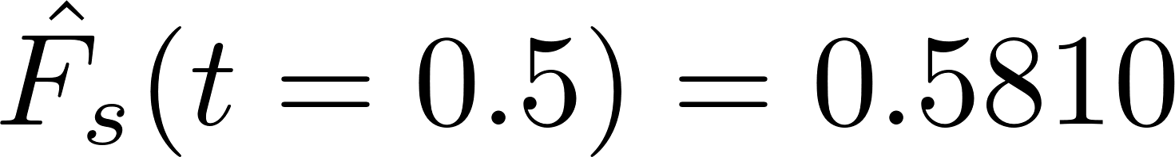
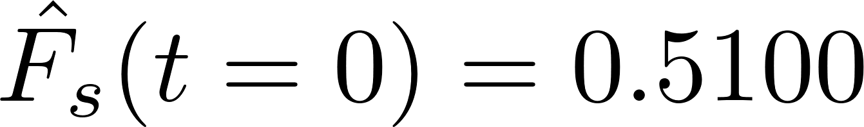
Random Process hw1
A071547
鄭澄遠

- 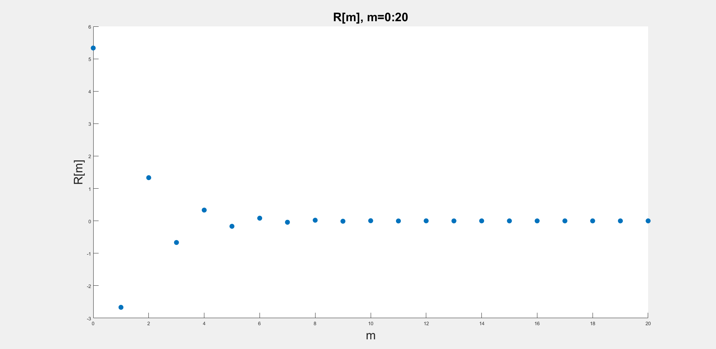
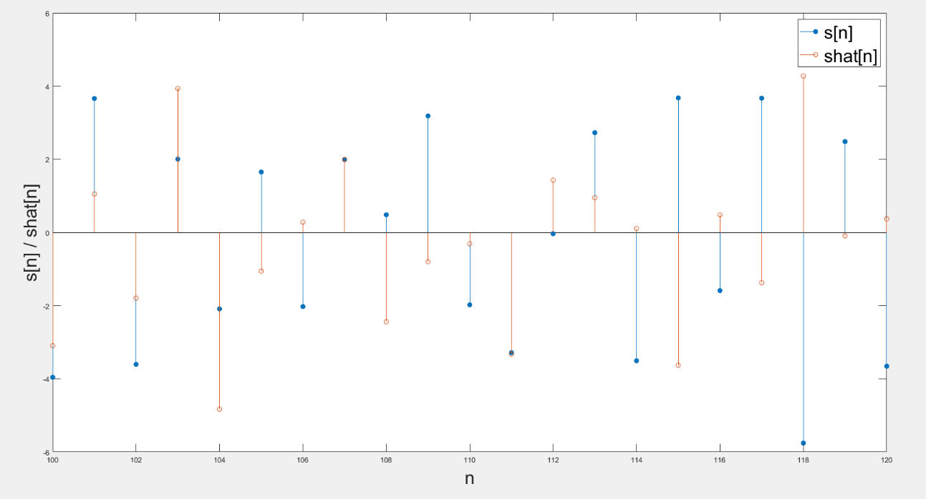

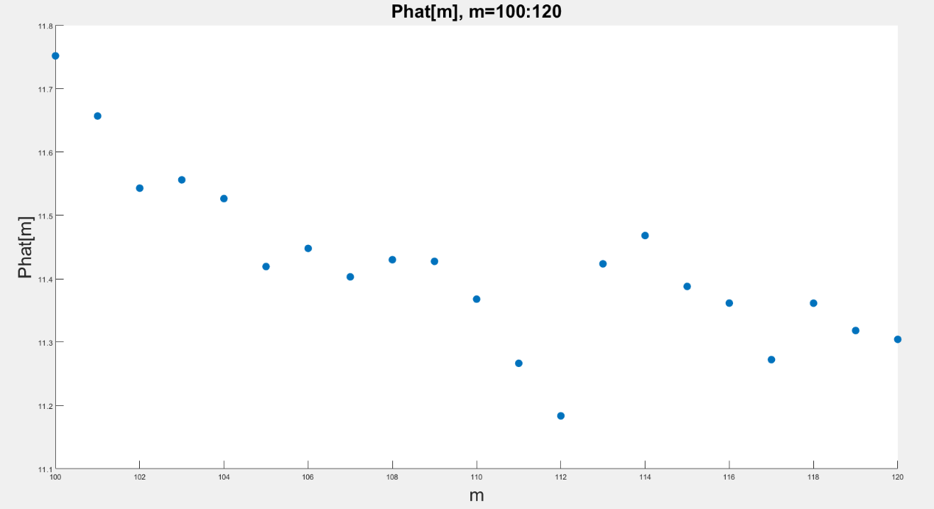

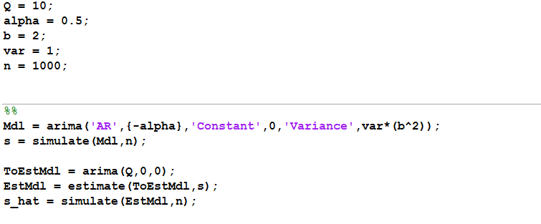
Initially set all parameters. I use “arima” function which is built in Matlab, and use this function to generate sequence s[m]. After generating sequence s[m], I define another AR model which has lag 10, and take sequence s[m] as input. Finally use the input to estimate s_hat[m] sequence, then numbers I need are all computed.
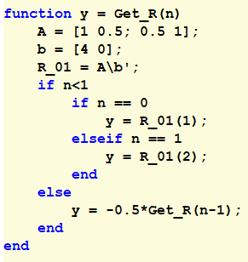
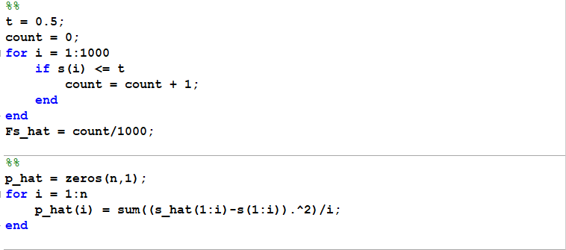
This part I use Yule-Walker equation to computed R[m]’s. R[0] and R[1] particularly computed by matrix multiplication. For R[m], m>1, I use Yule-Walker equation and recursive call to compute.
This part computes problem (1), (4) base on the sequences I get from previous part, is trivial.

