**Syllabus**

**UNIT –I**

Swings, JavaFX and Event Handling: Swing: Introduction to swings, Comparison with AWT, Exploring Swing Components: JTextField, Jlabel, Swing buttons, JPasswordField, JTable, JComboBox, JList, JTree, JColorChooser, Dialogs and Swing Menus. Event Handling- The Delegation event model- Events, Event sources, Event Listeners, Event classes, Handling action ,mouse and keyboard events, Adapter classes, Inner classes, Anonymous Inner classes. GUI programming with JavaFX: JavaFX basic concepts, JavaFX Application Structure, JavaFX Controls and Event handling.

**UNIT –II**

Networking and Collection frame work: Networking: Networking API, Inet address, TCP/IP client sockets, URL, URL connection, HttpURL connection, Cookies, TCP/IP server sockets, Datagrams. Collections Frame work: Collection Interfaces, Collection Classes: Array Class,Vector Class, Stack Class, Dictionary class, Hash table Class. accessing using iterators, working with maps, comparators.

**UNIT – III**

Java Database Connectivity (JDBC): Introduction, JDBC Drivers, JDBC Architecture, JDBC Classes and Interfaces, Loading a Driver, Making a Connection, Execute SQL Statement, statement, prepared statement, callable statement, Retrieving Result, Getting Database Information, Scrollable and Updatable Resultset, Result Set Metadata.

**UNIT –IV**

Servlets: Servlet: Server-Side Java, Servlet Alternatives, Servlet Strengths, Servlet Architecture, Servlet Life Cycle, GenericServlet, HttpServlet, Exploring Servlet API, Handling HTTP Requests and Responses, Passing Parameters to Servlets, Retrieving Parameters, Session Tracking, Filters.

**UNIT – V**

Java Server Pages(JSP): Problem with Servlets, Life Cycle of JSP Page, JSP Processing, JSP Application Design with MVC, Setting Up the JSP Environment. JSP Directives, JSP Action elements, JSP Implicit Objects, JSP Form Processing, JSP Session and Cookies Handling, JSP Session Tracking JSP Database Access, JSP Standard Tag Libraries,JSP Custom Tag,JSP Expression Language, JSP Exception Handling, JSP XML Processing, JSTL.

**Introduction to GUI programming in Java:**

GUI applications are user friendly applications and they allow users to easily interact and use the application with out any external or specific training. The Java supports to develop GUI applications. There are two ways that we can develop GUI applications in java as follows

1. AWT

2. Swing

The AWT package comes with a collection of GUI components like label, button, text filed, text area, canvas, menubar etc…and the containers like panel, frame, Dialog etc… But due to the limitations of AWT java supposed to develop a new mechanism to build GUI applications which is known as Swings.

**Limitations of AWT:**

1. Platform dependent

2. Limited GUI Components

3. poor customization

4. complex layout management

5. performance issues

**Swings in Java:** The swing is a GUI toolkitthat is a part of theJava Foundation Classes (JFC). It is a lightweight toolkit. It has a rich set of controls and allows us to develop stand-alone applications or window-based applications.

**Features of Swings:**

**1.** **Platform Independent:** the swing components does not relay on OS GUI components and are written completely in java. The swing components behave consistently across different operating systems.

**2. Lightweight:** As the swing components are completely written in Java, they are lightweight and they don’t use any native system resources hence these components are light weight and fast in performance.

**3. MVC Architecture:** Swing components follows MVC (Model, View and Controller) Architecture which separates data, user interface and interaction or business logic.

**4. Layout managers:** The swings support additional GUI layouts like borderlayout, flowlayout, GridLayout etc… to build more beautiful GUI applications.

**5. Rich set of GUI controls:** The swings in java provides a wide range of controls like JButton, JTextField, Jpanel etc…

Package used for Swings in java: javax.swing

**Differences between AWT and Swing Components:**

|  |  |  |
| --- | --- | --- |
| **SNO** | **AWT** | **SWING** |
| **01** | **Platform Dependent** | **Platform Independent** |
| **02** | **Heavy Weight** | **Light Weight** |
| **03** | **Does not support pluggable look and feel** | **Supports pluggable look and feel** |
| **04** | **Less components** | **Rich set of components** |
| **05** | **Less controlling on UI** | **Flexibility in controlling UI** |
| **06** | **Does not follow MVC** | **Follows MVC** |
| **07** | **It is an API and part of AWT** | **It is part of JFC** |
| **08** | **Java.awt package is used** | **Javax.swing package is used** |
| **09** | **More code is needed to implement AWT Controls** | **Less code is enough to implement swing controls** |
| **10** | **Execution time is high compared with Swing** | **Execution time is less compared with Swing** |
| **11** | **Not suitable for user friendly applications** | **Suitable for user friendly applications** |
| **12** | **Low performance** | **High performance** |

**Exploring Javax.Swing:**

The javax.swing package is used for GUI applications and it has a rich set of classes, interface, enums. The most frequently useful classes, interface are as follows

|  |  |  |  |  |
| --- | --- | --- | --- | --- |
| **Classes** | | | | |
| BoxLayout | ButtonGroup | GroupLayout | ImageIcon | InputMap |
| InputVerifier | JApplet | JButton | JCheckBox | JCheckBoxMenuItem |
| JColorChooser | JComboBox | JComponent | JDialog | JEditorPane |
| JFileChooser | JFormattedTextField | JFrame | JLabel | JList |
| JMenu | JMenubar | JOptionPane | JPanel | JPasswordField |
| JPopupMenu | JProgressBar | JRadioButton | JScrollBar | JSlider |
| JSpinner | JTabbedPane | JTable | JTextArea | JTextField |
| JToolTip | JTree | JWindow |  |  |

The class hierarchy of containers, components in swings is as shown in below figure

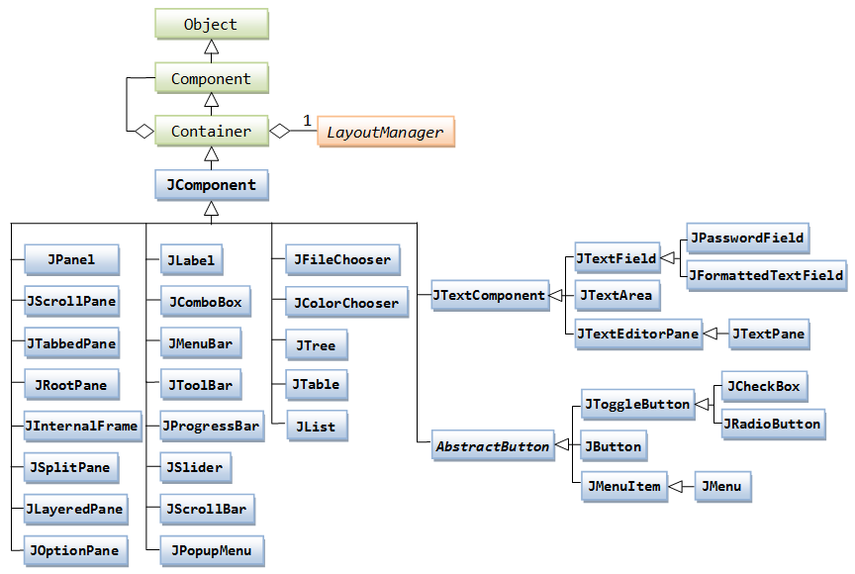

1. All the controls like JPanel, JLabel etc… are derived from JComponent class

2. JComponent is derived from Container

3. The Container is itself a component that can hold and organize other components

4. All the containers in swing are sub classes of JComponent

5. the package name is javax.swing.JComponent

**Containers:** In Swings we have different type of containers to hold controls as follows

**1. JFrame:** It is a main application window

**2.** **JDialog:** It gives a popup window

**3.** **JApplet:** Applet Container

**4. JPanel:** Which is generic lightweight container used with in top level containers