GROBID manual

1. Overview 1
2. Build and set up environment for local deployment 1
3. Build and set up environment for remote deployment 1
4. Use of grobid-service console 2
5. grobid-service REST API 5
6. Examples with curl 9

Authors: Damien Ridereau, Patrice Lopez
Contact: patrice.lopez@inria.fr

Overview
The project grobid-service is a RESTful service implementation for accessing the grobid system. grobid-service is an open source project under the Apache License 2.0. It comes as a war file for deploying on a web container e.g. tomcat. The project also contains the libraries of grobid-core, doing the extraction work.

Build and set up environment for local deployment
To build grobid for local deployment, you just have to go to the root of the project and run the following command:
mvn clean install

Then deploy the generated war to the server. The artifact is in:
grobid-service/target/grobid-service-<version>.war

Build and set up environment for remote deployment

Logs
Grobid uses Apache log4j as logging library. By default, the log are written in a file grobid.log in the current directory where the application is launched. This is of course not adapted to a deployment in production. In order to set the path and filename for logging, edit the file under grobid/grobid-core/src/resources/log4j.xml and change the following line according to your production logging policy:
<param name="file" value="./grobid.log" />
you can indicate the wished log path, for instance for Tomcat:
<param name="file" value="${catalina.base}/logs/grobid.log" />
Be sure that the Tomcat or JBoss has the write authorization in the indicated log path.

Parameters set up
In grobid-service-<version>.war, the file web.xml has 3 parameters to set before starting the server:
org.grobid.property: path to grobid.property
org.grobid.property.service: path to grobid_service.properties
org.grobid.home: path to grobid_home
These properties are filled by the following variables: _GROBID_PROPERTY, _GROBID_SERVICE_PROPERTY, and _GROBID_HOME so that it is possible to fill these values with a script given the environment. It is also possible to set manually these variables before building the war artefact.

Build
To build grobid for remote deployment, you have to go to the root of the project and run the following command:
mvn clean install -PgenericBuild

It will generate 2 artifacts, 1 in grobid-home, 1 in grobid-service:
grobid-home/target/grobid-home-<version>.zip
grobid-service/target/grobid-service-<version>.war
Copy these 2 artifacts to your remote server.

grobid-home-<version>.zip contains the needed native libraries, the models, lexicons and a config directory that contains 2 properties files grobid.properties and grobid_service.properties.
You have to unzip grobid-home wherever you want on your server.
unzip grobid-home-<version>.zip

Use of grobid-service console
Welcome page is available at http://<server instance name>/<root context name> (i.e: for local tomcat http://localhost:8080/<name of the war deploy in webapp>). From there you can access to about grobid (Fig 4.1), process some conversion from the interface "Test Rest Interface" (Fig 4.2) and access the administration parameters contained in grobid.properties and grobid_service.properties (Fig 4.3):
Fig 4.1: About

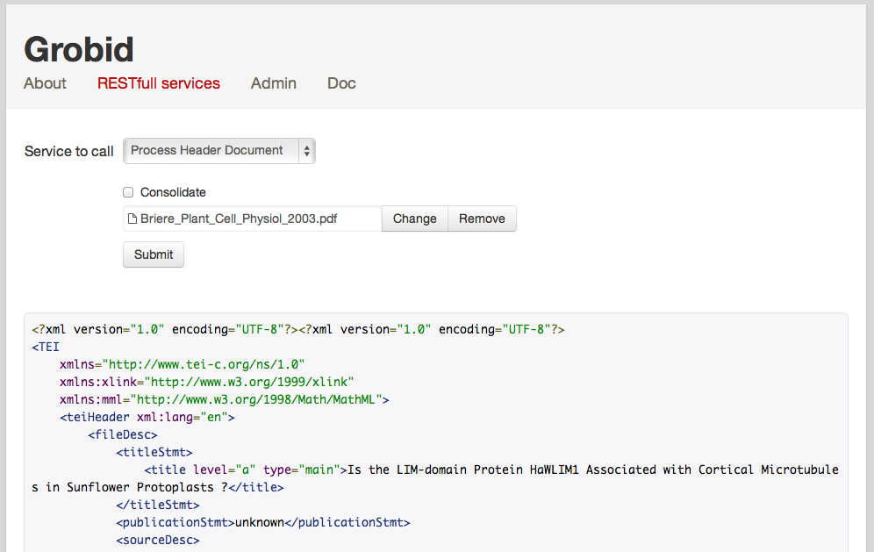Fig 4.2: Test Rest Interface

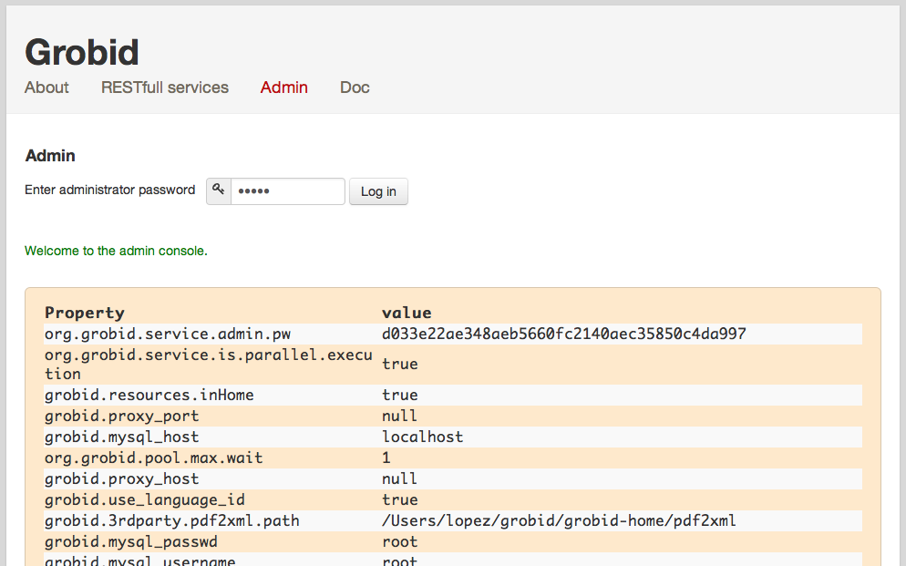Fig 4.3: Service administration
The web page "Test Rest Interface" (Fig. 4.2) allows you to test the different REST requests quickly and easily. For technical look in the code, GrobidRestService class is the entry point for each rest service of Grobid.

grobid-service REST API
The table below shows the provided resources corresponding to the HTTP verbs, to use the grobid-service. All url described bellow are relative path, the root url is http://<server instance name>/<root context>.
The consolidation parameters (consolidateHeader and consolidateCitations) indicate if GROBID should try to complete the extracted metadata with an additional external call to CrossRef API. The CrossRef look-up is realized based on the reliable subset of extracted metadata which are supported by this API.

Type of request | URL | Parameter name |  |  |  | Requesting type |  |  |  | MIME Type |  |  |  |  |  |  | Description
Type of request |  |  |  |  |  |  |  |  | Request input type | Response output type
Administration | /admin |  | sha1 |  | POST |  |  | application/x-www-form-urlencoded |  |  |  |  |  |  | text/html |  |  |  | Request to get parameters of grobid.properties and grobid_service.properties formatted in html table.
Administration |  | /admin?sha1=<pwd> |  |  |  |  |  |  |  |  |  | GET | String
 |  | /sha1 |  | sha1 |  |  | POST |  |  |  |  |  |  | application/x-www-form-urlencoded |  |  |  | text/html | Request to get an input string hashed using sha1.
 |  | /sha1?sha1=<input string> |  |  |  |  |  |  |  |  |  | GET | String
 |  | /allProperties |  | sha1 |  |  | POST |  |  |  |  |  |  | application/x-www-form-urlencoded |  |  |  | text/xml | Request to get all properties key/value/type as xml. Sent xml follow the following schema:  <properties>  <property>  <key>key</key>  <value>value</value>  <type>type</type>  </property>  <property>...</property>  </properties>
 |  | /allProperties?sha1=<password> |  |  |  |  |  |  |  |  |  | GET | String
 |  | /changePropertyValue |  | xml |  |  | POST |  |  |  |  |  |  | application/x-www-form-urlencoded |  |  |  | text/xml | Change the property value from the property key passed in the xml input. Xml input has to follow the following schema:  <changeProperty>  <password>pwd</password>  <property>  <key>key</key>  <value>value</value>  <type>type</type>  </property>  </changeProperty>
 |  | /changePropertyValue?xml=<some xml> |  |  |  |  |  |  |  |  |  | GET | String
General | /grobid | N/A |  |  |  | GET |  |  |  | N/A |  |  | text/html |  |  |  | Gives a very brief description about grobid.
Pdf to tei.xml conversion | /processHeaderDocument |  | input  consolidateHeader |  | POST, PUT |  |  |  | multipart/form-data |  |  |  |  | application/xml |  |  |  | Extract the header of the input PDF document, normalize it and convert it into a TEI format.  consolidateHeader is a string of value 0 (no consolidation) or 1 (consolidate).
Pdf to tei.xml conversion |  | /processFulltextDocument |  | input  consolidateHeader  consolidateCitations |  |  |  | POST, PUT |  |  |  |  | multipart/form-data |  |  |  | application/xml |  | Convert the complete input document into tei.xml format (header, body and bibliographical section).  consolidateHeader and consolidateCitations are string of value 0 (no consolidation) or 1 (consolidate).
 |  | /processFulltextAssetDocument |  | input  consolidateHeader  consolidateCitations |  |  |  | POST, PUT |  |  |  |  | multipart/form-data |  |  |  | application/zip
Convert the complete input document into tei.xml format (header, body and bibliographical section).

consolidateHeader and consolidateCitations are string of value 0 (no consolidation) or 1 (consolidate).

The result is a ZIP archive containing the TEI fulltext and the embedded images (the document assets) converted in PNG.
 |  | /processReferences |  | input  consolidateCitations |  |  |  | POST, PUT |  |  |  |  | multipart/form-data |  |  |  | application/xml |  | Extract and convert all the references present in the input document into tei.xml format  consolidateCitations is a string of value 0 (no consolidation) or 1 (consolidate).
Parse/normalize data | /processDate |  | date | POST, PUT |  |  | application/x-www-form-urlencoded |  |  |  | application/xml |  |  |  |  | Parse a raw date and return the corresponding normalized date in ISO 8601 embedded in a TEI fragment.
Parse/normalize data |  | /processHeaderNames | names |  |  | POST, PUT |  |  |  | application/x-www-form-urlencoded |  |  |  |  | application/xml |  |  |  | Parse a raw sequence of names from a header section and return the corresponding normalized authors in TEI format.
 |  | /processCitationNames | names |  |  | POST, PUT |  |  |  | application/x-www-form-urlencoded |  |  |  |  | application/xml |  |  |  | Parse a raw sequence of names from a header section and return the corresponding normalized authors in TEI format..
 |  | /processAffiliations | affiliations |  |  | POST, PUT |  |  |  | application/x-www-form-urlencoded |  |  |  |  | application/xml |  |  |  | Parse a raw sequence of affiliations and return the corresponding normalized affiliations with address in TEI format..
 |  | /processCitations | citations  consolidateCitations |  |  | POST, PUT |  |  |  | application/x-www-form-urlencoded |  |  |  |  | application/xml |  |  |  | Parse a raw citation and return the corresponding normalized citations in TEI format.  consolidateCitations is a string of value 0 (no consolidation) or 1 (consolidate).
Citation extraction and normalization from patents | /processCitationPatentTEI |  | input  consolidateCitations | POST, PUT |  |  | multipart/form-data |  |  |  | application/xml |  |  |  |  | Extract and parse the patent and non patent citations in the description of a patent encoded in TEI. Results are added to the original document as TEI stand-off annotations.  consolidateCitations is a string of value 0 (no consolidation) or 1 (consolidate).
Citation extraction and normalization from patents |  | /processCitationPatentST36 | input  consolidateCitations |  |  | POST, PUT |  |  |  | multipart/form-data |  |  |  |  | application/xml |  |  |  | Extract and parse the patent and non patent citations in the description of a patent encoded in ST.36. Results are returned as a lits of TEI citations.  consolidateCitations is a string of value 0 (no consolidation) or 1 (consolidate).
 |  | /processCitationPatentTXT | text  consolidateCitations |  |  | POST, PUT |  |  |  | application/x-www-form-urlencoded |  |  |  |  | application/xml |  |  |  | Extract and parse the patent and non patent citations in the description of a patent sent as UTF-8 text. Results are returned as a lits of TEI citations.  consolidateCitations is a string of value 0 (no consolidation) or 1 (consolidate).
 |  | /processCitationPatentPDF | input  consolidateCitations |  |  | POST, PUT |  |  |  | multipart/form-data |  |  |  |  | application/xml |  |  |  | Extract and parse the patent and non patent citations in the description of a patent sent as PDF. Results are returned as a lits of TEI citations.  consolidateCitations is a string of value 0 (no consolidation) or 1 (consolidate).

Examples with curl

Here are examples of command lines calling the Grobid service using curl. The server instance name here is localhost using the port 8080.

- header extraction of a PDF file in the current directory:
> curl -v --form input=@./thefile.pdf localhost:8080/processHeaderDocument

- fulltext extraction of a PDF file in the current directory with consolidation of the citations:
> curl -v --form consolidateCitations=1 --form input=@./thefile.pdf localhost:8080/processFulltextDocument

- parsing of a raw reference string in isolation with default consolidation (by default header metadata are consolidated, but bibliographical references are not):
> curl -X POST -d "citations=Graff, Expert. Opin. Ther. Targets (2002) 6(1): 103-113" localhost:8080/processCitation

- extraction and parsing of all references in a PDF with default consolidation (by default bibliographical references are not consolidated):
> curl -v --form --form input=@./thefile.pdf localhost:8080/processReferences

