

Worksheet No- 1
Name - Arnab Lala UID – 25MCI10232
Branch – MCA Section – MAM-1(A)
Semester – 2nd Date of performance – 6th Jan,2026
Subject - Technical Training Subject Code - 25CAP-652

Aim / Overview of the Practical
To design and implement a sample organizational database system using SQL commands, including Data Definition Language (DDL), Data Manipulation Language (DML), and Data Control Language (DCL).
The practical demonstrates database creation, table relationships using foreign keys, data insertion and modification, schema alteration, and role-based access control to ensure data integrity and secure access for authorized users.

Software Requirements
- PostgreSQL (Database Server)
- pgAdmin
- Windows Operating System

Objective
- To understand and apply DDL commands such as CREATE, ALTER, and DROP
- To perform DML operations like INSERT, UPDATE, DELETE, and SELECT
- To implement DCL commands including CREATE ROLE, GRANT, and REVOKE
- To enforce referential integrity using primary keys and foreign keys
- To provide controlled and secure access using role-based privileges
- To gain hands-on experience using PostgreSQL in a real database environment

Input / Apparatus Used
- PostgreSQL (Database Server)
- pgAdmin (Graphical User Interface)
- SQL Queries (DDL, DML, DCL commands)

procedure for experiemnt
CREATE TABLE Department
(
dept_id INT PRIMARY KEY, dept_name VARCHAR(30) UNIQUE NOT NULL
);
CREATE TABLE Employee ( emp_id INT PRIMARY KEY, emp_name VARCHAR(30) NOT NULL, emp_email VARCHAR(40) UNIQUE NOT NULL, emp_phone VARCHAR(15) UNIQUE NOT NULL, emp_address VARCHAR(50),
dept_id INT,
FOREIGN KEY (dept_id) REFERENCES Department(dept_id)
ON UPDATE CASCADE
ON DELETE SET NULL
);
CREATE TABLE Project ( project_id INT PRIMARY KEY, project_name VARCHAR(30) NOT NULL, start_date DATE NOT NULL, end_date DATE NOT NULL, assigned_emp INT,
FOREIGN KEY (assigned_emp) REFERENCES Employee(emp_id)
ON UPDATE CASCADE
ON DELETE SET NULL
);
INSERT INTO Department VALUES
(10, 'Research'),
(20, 'Development'),
(30, 'Sales'),
(40, 'Operations');
INSERT INTO Employee VALUES
(201, 'Arjun Das', 'arjun@gmail.com', '9001112222', 'Kolkata', 20),
(202, 'Meera Roy', 'meera@gmail.com', '9003334444', 'Delhi', 20),
(203, 'Sahil Khan', 'sahil@gmail.com', '9005556666', 'Mumbai', 30),
(204, 'Nina Paul', 'nina@gmail.com', '9007778888', 'Chennai', 10), (205, 'Vikram Jain', 'vikram@gmail.com', '9009990000', 'Pune', 40);
INSERT INTO Project VALUES
(1, 'Inventory System', '2026-01-05', '2026-06-30', 201),
(2, 'CRM Software', '2026-02-10', '2026-07-15', 202),
(3, 'Sales Dashboard', '2026-03-01', '2026-05-31', 203),
(4, 'Research Portal', '2026-01-20', '2026-04-25', 204),
(5, 'Ops Automation', '2026-02-01', '2026-08-01', 205);

SELECT * FROM Department;
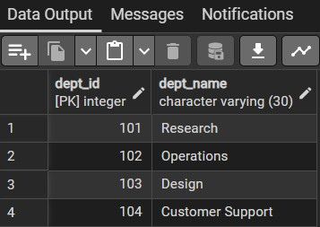
SELECT * FROM Employee;
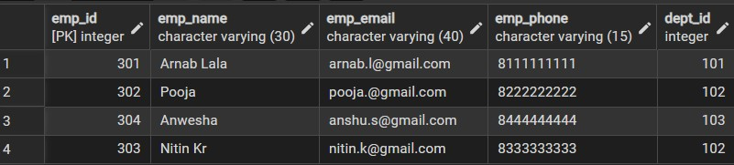
SELECT * FROM Project;
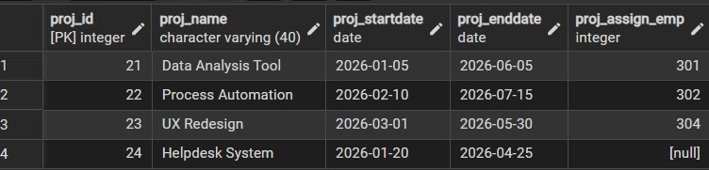
UPDATE Employee
SET dept_id = 40
WHERE emp_id = 203;
SELECT * FROM Department;
SELECT * FROM Employee;
SELECT * FROM Project;
DELETE FROM Employee WHERE emp_id = 205;
CREATE ROLE HR LOGIN PASSWORD 'HR';
GRANT SELECT, INSERT, UPDATE ON Employee TO HR;
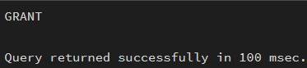
GRANT SELECT ON Department TO HR;
GRANT SELECT, INSERT, UPDATE ON Project TO HR;
REVOKE INSERT ON Employee FROM HR;
REVOKE UPDATE ON Department FROM HR;
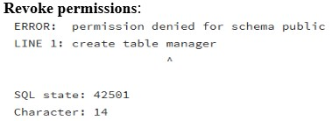
Learning Outcomes:
- Understand how to design a relational database using multiple tables with proper relationships.
- Learn to apply constraints to maintain data integrity and consistency.
- Perform basic data manipulation operations such as INSERT, UPDATE, and DELETE.
- Implement database security by managing users, roles, and access privileges.

