

Worksheet No- 3
Name - Arnab Lala UID – 25MCI10232
Branch – MCA Section – MAM-1(A)
Semester – 2nd Date of performance – 27th Jan,2026
Subject - Technical Training Subject Code – 25CAP-652_25MAM_KAR-1_A

Aim / Overview of the Practical

To implement conditional decision-making logic in PostgreSQL using IF–ELSE constructs and CASE expressions for classification, validation, and rule-based data processing.

Software Requirements
● PostgreSQL
Objectives

To understand conditional execution in SQL

To implement decision-making logic using CASE expressions

To simulate real-world rule validation scenarios

To classify data based on multiple conditions

To strengthen SQL logic skills required in interviews and backend system

Theory

In real-world database systems, data often needs to be validated, categorized, or transformed based on business rules. Conditional logic allows the database to make decisions dynamically instead of relying solely on application-layer logic.

PostgreSQL supports conditional logic mainly through:

CASE Expressions (used inside SELECT, UPDATE, INSERT)

IF–ELSE constructs (used inside PL/pgSQL blocks such as functions and procedures)

CASE Expression

Evaluates conditions sequentially

Returns a value based on the first true condition

Can be used in SELECT, UPDATE, ORDER BY, and WHERE clauses

Types of CASE

Simple CASE → compares expressions

Searched CASE → evaluates boolean conditions

Conditional logic is heavily used in:

Data classification (grades, salary slabs)

Violation detection

Status mapping

Business rule enforcement

Companies like Amazon, SAP, Oracle, and Adobe frequently test CASE-based logic in SQL interviews.

Experiment / Practical Steps
Prerequisite Understanding
Students should first create a table that stores:
- A unique identifier
- A schema or entity name
- A numeric count representing violations or issues
Populate the table with multiple records having different violation counts.
Step 1: Classifying Data Using CASE Expression
Task for Students:
- Retrieve schema names and their violation counts.
- Use conditional logic to classify each schema into categories such as:
  - No Violation
  - Minor Violation
  - Critical Violation
Learning Focus:
- Using searched CASE
- Sequential condition checking
- Real-world compliance reporting logic
Step 2: Applying CASE Logic in Data Updates
Task for Students:
- Add a new column to store approval status.
- Update this column based on violation count using conditional rules such as:
  - Approved
  - Needs Review
  - Rejected
Learning Focus:
- Automating decisions inside the database
- Reducing application-side logic
- Using CASE inside UPDATE statements
Step 3: Implementing IF–ELSE Logic Using PL/pgSQL
Task for Students:
- Use a procedural block instead of a SELECT statement.
- Declare a variable representing violation count.
- Display different messages based on the value of the variable using IF–ELSE logic.
Learning Focus:
- Understanding procedural SQL
- ELSE-IF ladder execution
- Backend validation logic in stored procedures
Step 4: Real-World Classification Scenario (Grading System)
Task for Students:
- Create a table to store student names and marks.
- Classify students into grades based on their marks using conditional logic.
Learning Focus:
- Common interview use case
- Data categorization
- Rule-based evaluation
Step 5: Using CASE for Custom Sorting
Task for Students:
- Retrieve schema details.
- Apply conditional priority while sorting records based on violation severity.
Learning Focus:
- Advanced CASE usage
- Custom ordering logic and Dashboard and reporting scenarios

Practical / Experiment Steps

CREATE TABLE SCHEMA_ANALYSIS(

report_id INT PRIMARY KEY,

entity_name VARCHAR(50) NOT NULL,

violation_count INT NOT NULL

);

INSERT INTO SCHEMA_ANALYSIS VALUES

(1, 'User_Schema', 0),

(2, 'Order_Schema', 2),

(3, 'Payment_Schema', 4),

(4, 'Inventory_Schema', 2),

(5, 'Audit_Schema', 15);

SELECT*FROM SCHEMA_ANALYSIS;

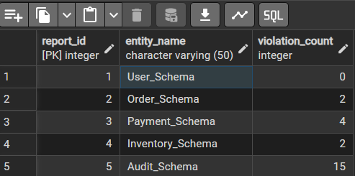

-- EXAMPLE 1 : CLASSIFYING DATA USING CASE EXPRESSION
SELECT *,
CASE
WHEN violation_count = 0 THEN 'NO VIOLATION'
WHEN violation_count BETWEEN 1 AND 2 THEN 'MINOR VIOLATION'
ELSE 'CRITICAL VIOLATION'
END AS VIOLATION_CATEGORY
FROM SCHEMA_ANALYSIS;
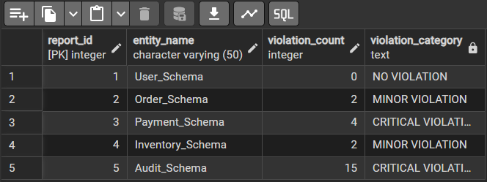

-- Example 2: Applying CASE Logic in Data Updates

ALTER TABLE SCHEMA_ANALYSIS

ADD COLUMN approval_status VARCHAR(20);
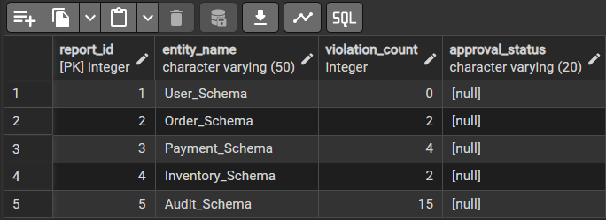
SELECT*FROM SCHEMA_ANALYSIS;
UPDATE SCHEMA_ANALYSIS
SET approval_status =
CASE
WHEN violation_count = 0 THEN 'Approved'
WHEN violation_count BETWEEN 1 AND 2 THEN 'Review'
ELSE 'Rejected'
END;
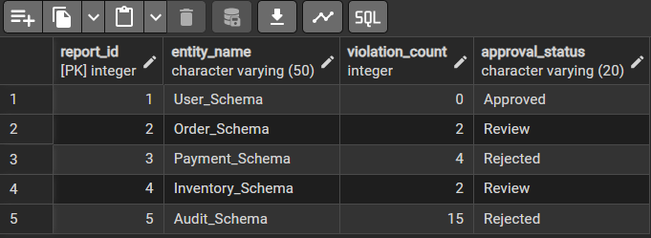
-- Example 3: Implementing IF–ELSE Logic Using PL/pgSQL
DO $$
DECLARE
v_violation_count INT := 0; -- change value to test
BEGIN
IF v_violation_count = 0 THEN
RAISE NOTICE 'Status: Approved (No Violations)';
ELSIF v_violation_count BETWEEN 1 AND 2 THEN
RAISE NOTICE 'Status: Review (Minor Violations)';

ELSE

RAISE NOTICE 'Status: Rejected (Critical Violations)';

END IF;

END $$;

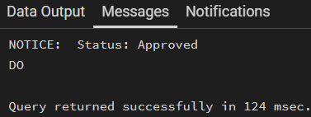
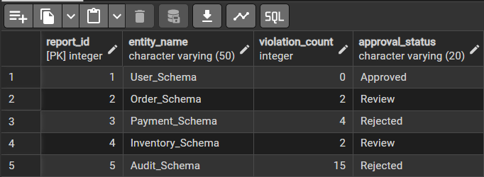

5. Learning Outcome
This experiment demonstrates how conditional logic is implemented in PostgreSQL using CASE expressions and IF–ELSE constructs.
Students gain strong command over rule-based SQL logic, which is essential for:
- Backend systems
- Analytics
- Compliance reporting
- Placement and technical interviews

