
WorkSheet - 5
Student Name: Arnab Lala UID: 25MCI10232
Branch: M.C.A(A.l & M.L) Section/Group: MAM-1 A
Semester: SEM II Date of Performance:24/02/2026
Subject Name: TECHINCAL SKILLS Subject Code: 25CAP-652_25MAM_KAR-1(A)
AIM: To gain hands-on experience in creating and using cursors for row-by-row processing in a database, enabling sequential access and manipulation of query results for complex business logic. (Company Tags: Infosys, Wipro, TCS, Capgemini)
S/W Requirement: Oracle Database Express Edition and pgAdmin
OBJECTIVES:
- Sequential Data Access: To understand how to fetch rows one by one from a result set using cursor mechanisms.
- Row-Level Manipulation: To perform specific operations or calculations on individual records that require conditional procedural logic.
- Resource Management: To learn the lifecycle of a cursor: Declaring, Opening, Fetching, and importantly, Closing and Deallocating to manage system memory.
- Exception Handling: To handle cursor-related errors and performance considerations during large-scale data iteration.
Practical / Experiment Steps
/* -----------------------------------------------------------
Create Staff Table
----------------------------------------------------------- */

CREATE TABLE Staff (
staff_id SERIAL PRIMARY KEY,
staff_name VARCHAR(60),
base_pay NUMERIC(10,2),
years_of_service INT,
client_rating INT -- Rating out of 5
);

INSERT INTO Staff (staff_name, base_pay, years_of_service, client_rating) VALUES
('Arjun', 50000, 3, 4),
('Meera', 82000, 9, 5),
('Dev', 45000, 2, 3),

('Sneha', 92000, 12, 5),
('Ishaan', 28000, 1, 2);
SELECT * FROM Staff;
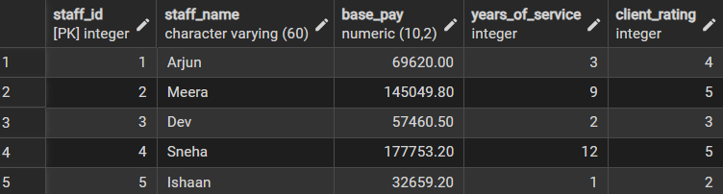
/* -----------------------------------------------------------
STEP 1: Cursor to Display Staff Details
Step 1: Implementing a Simple Forward-Only Cursor
----------------------------------------------------------- */
DO $$
DECLARE
staff_rec RECORD;
staff_cursor CURSOR FOR
SELECT staff_id, staff_name, base_pay
FROM Staff;
BEGIN
OPEN staff_cursor;
LOOP
FETCH staff_cursor INTO staff_rec;
EXIT WHEN NOT FOUND;
RAISE NOTICE
'Staff ID: %, Name: %, Base Pay: %',
staff_rec.staff_id,
staff_rec.staff_name,
staff_rec.base_pay;
END LOOP;
CLOSE staff_cursor;
END $$;
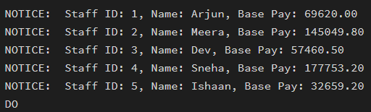
Step 2: Complex Row-by-Row Manipulation
DO $$

DECLARE
staff_rec RECORD;
staff_cursor CURSOR FOR
SELECT staff_id, base_pay, years_of_service, client_rating
FROM Staff;
bonus_percent NUMERIC;
updated_pay NUMERIC;
BEGIN
OPEN staff_cursor;
LOOP
FETCH staff_cursor INTO staff_rec;
EXIT WHEN NOT FOUND;
/* Correct ROUND usage */
bonus_percent :=
ROUND(
(staff_rec.years_of_service * 2) +
(staff_rec.client_rating * 3),
2);
updated_pay :=
ROUND(
staff_rec.base_pay +
(staff_rec.base_pay * bonus_percent / 100),
2);
UPDATE Staff
SET base_pay = updated_pay
WHERE staff_id = staff_rec.staff_id;
RAISE NOTICE
'Staff ID: %, Bonus: %%%, Updated Pay: %',
staff_rec.staff_id,
bonus_percent,
updated_pay;
END LOOP;
CLOSE staff_cursor;
END $$;

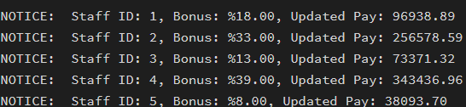
STEP 3 — Exception Handling (Different Condition)
/* -----------------------------------------------------------
STEP 3: Exception Handling Example
----------------------------------------------------------- */
DO $$
DECLARE
staff_rec RECORD;
staff_cursor CURSOR FOR
SELECT staff_id, client_rating
FROM Staff;
BEGIN
OPEN staff_cursor;
LOOP
FETCH staff_cursor INTO staff_rec;
EXIT WHEN NOT FOUND;
-- Raise exception if rating is extremely poor
IF staff_rec.client_rating < 2 THEN
RAISE EXCEPTION
'Unacceptable performance for Staff ID: %',
staff_rec.staff_id;
END IF;
RAISE NOTICE
'Checked Staff ID: %, Rating: %',
staff_rec.staff_id,
staff_rec.client_rating;
END LOOP;
CLOSE staff_cursor;
EXCEPTION
WHEN OTHERS THEN
RAISE NOTICE 'Error handled successfully.';
RAISE NOTICE 'Reason: %', SQLERRM;

RAISE NOTICE 'Process terminated safely.';
END $$;
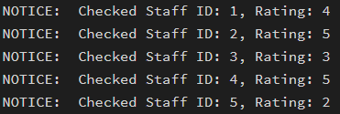
Outcomes:
- Cursor Implementation: Students will be able to design, implement, and manage cursors to solve row-wise processing problems.
- Lifecycle Mastery: Students will demonstrate the correct syntax for declaring, opening, fetching, and closing cursors.
- Error Prevention: Students will understand how to properly handle row-by-row processing exceptions and prevent memory leaks via deallocation.
- Analytical Thinking: Students will be able to apply cursor-based logic to solve real-world scenarios like multi-level payroll adjustments or data migrations.

