

Worksheet No- 4
Name - Arnab Lala UID – 25MCI10232
Branch – MCA Section – MAM-1(A)
Semester – 2nd Date of performance – 3rd feb,2026
Subject - Technical Training Subject Code – 25CAP-652_25MAM_KAR-1_A

Aim / Overview of the Practical

To understand and implement iterative control structures in PostgreSQL conceptually, including FOR loops, WHILE loops, and basic LOOP constructs, for repeated execution of database logic.

Software Requirements
● PostgreSQL
Objectives

To understand why iteration is required in database programming

To learn the purpose and behaviour of FOR, WHILE, and LOOP constructs

To understand how repeated data processing is handled in databases

To relate loop concepts to real-world batch processing scenarios

To strengthen conceptual knowledge of procedural SQL used in enterprise systems
Theory
In database applications, some tasks must be repeated on multiple records, such as updating marks, checking attendance, or generating results. While SQL handles single queries well, repeated logic needs procedural control.
PostgreSQL provides PL/pgSQL, which supports loop structures to execute statements multiple times based on conditions.
These loops are commonly used inside:
- Functions
- Stored procedures
- Anonymous blocks (DO $$)
Types of Loops in PostgreSQL
1. FOR Loop (Range-Based)
- Executes a fixed number of times
- Useful when the number of iterations is known in advance
- Commonly used for counters, testing, and batch execution
2. FOR Loop (Query-Based)
- Iterates over rows returned by a query
- Processes one row at a time
- Frequently used for reporting, audits, and row-wise calculations
3. WHILE Loop
- Executes repeatedly as long as a condition remains true
- Suitable for condition-controlled execution
- Often used in retry logic or threshold-based processing
4. LOOP with EXIT Condition
- Executes indefinitely until explicitly stopped
- Provides maximum control over execution flow
- Used in complex workflows where exit conditions are custom-defined
Experiment Steps
Example 1: FOR Loop – Simple Iteration
- The loop runs a fixed number of times
- Each iteration represents one execution cycle
- Useful for understanding basic loop behaviour
Application: Counters, repeated tasks, batch execution
Example 2: FOR Loop with Query (Row-by-Row Processing)
- The loop processes database records one at a time
- Each iteration handles a single row
- Simulates cursor-based processing
Application: Employee reports, audits, data verification
Example 3: WHILE Loop – Conditional Iteration
- The loop runs until a condition becomes false
- Execution depends entirely on the condition
- The condition is checked before every iteration
Application: Retry mechanisms, validation loops
Example 4: LOOP with EXIT WHEN
- The loop does not stop automatically
- An explicit exit condition controls termination
- Gives flexibility in complex logic
Application: Workflow engines, complex decision cycles
Example 5: Salary Increment Using FOR Loop
- Employee records are processed one by one
- Salary values are updated iteratively
- Represents real-world payroll processing
Application: Payroll systems, bulk updates
Example 6: Combining LOOP with IF Condition
- Loop processes each record
- Conditional logic classifies data during iteration
- Demonstrates decision-making inside loops
Application: Employee grading, alerts, categorization logic
RESULT:
This experiment helps students understand how iterative control structures work in PostgreSQL at a conceptual level. Students learn where and why loops are used in database systems and gain foundational knowledge required for writing procedural logic in enterprise-grade applications.
Coding and Output :
CREATE TABLE students (
stud_id INT PRIMARY KEY,
stud_name VARCHAR(50),
marks INT,
attendance INT
);
INSERT INTO students VALUES
(101, 'Amit', 78, 92),
(102, 'Neha', 65, 85),
(103, 'Rohit', 55, 60),
(104, 'Pooja', 48, 72),
(105, 'Karan', 82, 95);
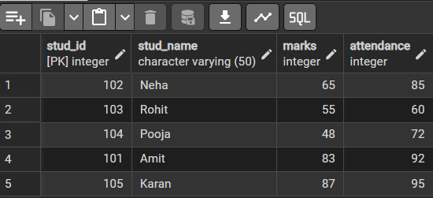
-- Example 1 — FOR Loop (Simple Counter)
DO $$
DECLARE
i INT;
BEGIN
FOR i IN 1..4 LOOP
RAISE NOTICE 'Iteration number: %', i;
END LOOP;
END $$;
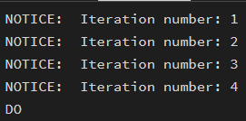
-- Example 2 — FOR Loop with Query
DO $$
DECLARE
rec RECORD;
BEGIN
FOR rec IN SELECT stud_id, stud_name FROM students LOOP
RAISE NOTICE 'Student ID: %, Name: %', rec.stud_id, rec.stud_name;
END LOOP;
END $$;
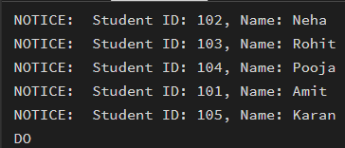
-- Example 3 — WHILE Loop
DO $$
DECLARE
cnt INT := 1;
BEGIN
WHILE cnt <= 3 LOOP
RAISE NOTICE 'While loop count: %', cnt;
cnt := cnt + 1;
END LOOP;
END $$;
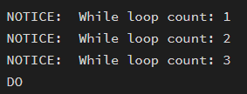
-- Example 4 — LOOP with EXIT WHEN
DO $$
DECLARE
num INT := 1;
BEGIN
LOOP
RAISE NOTICE 'Loop cycle: %', num;
num := num + 1;
EXIT WHEN num > 5;
END LOOP;
END $$;
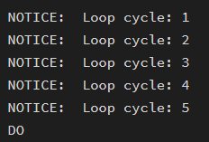
-- Example 5 — Give Bonus Marks Based on Attendance
DO $$
DECLARE
rec RECORD;
BEGIN
FOR rec IN SELECT stud_id, attendance FROM students LOOP
IF rec.attendance > 90 THEN
UPDATE students
SET marks = marks + 5
WHERE stud_id = rec.stud_id;

RAISE NOTICE 'Grace marks added for Student ID %', rec.stud_id;
END IF;
END LOOP;
END $$;
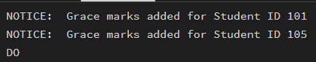
-- Example 6 — Result Classification Using IF inside LOOP
DO $$
DECLARE
rec RECORD;
BEGIN
FOR rec IN SELECT stud_name, marks FROM students LOOP
IF rec.marks >= 75 THEN
RAISE NOTICE '% -> Result: Excellent', rec.stud_name;
ELSIF rec.marks >= 60 THEN
RAISE NOTICE '% -> Result: Good', rec.stud_name;
ELSIF rec.marks >= 50 THEN
RAISE NOTICE '% -> Result: Average', rec.stud_name;
ELSE
RAISE NOTICE '% -> Result: Needs Improvement', rec.stud_name;
END IF;
END LOOP;
END $$;
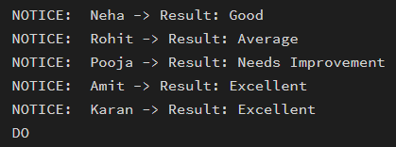
Learning Outcome
- Understand the need for iteration in database programming
- Learn the use of FOR, WHILE, and LOOP constructs in PostgreSQL
- Perform row-by-row processing using query-based FOR loops
- Use RECORD and scalar variables correctly in loops
- Apply conditional logic inside loops
- Execute batch operations such as salary updates
- Understand control flow using EXIT conditions
- Gain basic proficiency in PL/pgSQL programming

