
WorkSheet -7
Student Name: Arnab Lala UID: 25MCI10232
Branch: M.C.A(A.l & M.L) Section/Group: MAM-1 A
Semester: Sem -2 Date of Performance:31/03/2026
Subject Name: TECHINCAL SKILLS Subject Code: 25CAP-652
Aim: Implementation of jOINS in PostgreSQL
S/W Requirement: Oracle Database Express Edition and pgAdmin
Objectives:
- To understand how relational tables are connected using different types of SQL joins.
- To implement INNER, LEFT, RIGHT, and CROSS JOIN operations on multiple tables.
- To analyze relationships between students, courses, and departments using SQL queries.
- To identify unmatched records using LEFT and RIGHT JOIN techniques.
- To explore many-to-many relationships through a bridge (junction) table.
- To generate meaningful insights by combining data from multiple tables.
Practical / Experiment Steps:
Step 0 Setup (Creation of Tables)
CREATE TABLE Studentss (
student_id INT PRIMARY KEY,
student_name VARCHAR(50),
department_id INT
);
INSERT INTO Studentss VALUES (1, 'Arjun', 101);
INSERT INTO Studentss VALUES (2, 'Neha', 102);
INSERT INTO Studentss VALUES (3, 'Kabir', 103);
INSERT INTO Studentss VALUES (4, 'Meera', NULL);
INSERT INTO Studentss VALUES (5, 'Rohan', 101);
select * from Studentss;
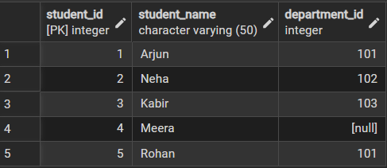
CREATE TABLE Courses (
course_id INT PRIMARY KEY,
course_name VARCHAR(50));
INSERT INTO Courses VALUES (201, 'Database Systems');
INSERT INTO Courses VALUES (202, 'Artificial Intelligence');
INSERT INTO Courses VALUES (203, 'Computer Networks');
INSERT INTO Courses VALUES (204, 'Cloud Computing');
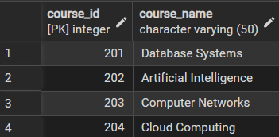
CREATE TABLE Enrollments (
student_id INT,
course_id INT,
PRIMARY KEY (student_id, course_id),
FOREIGN KEY (student_id) REFERENCES Studentss(student_id),
FOREIGN KEY (course_id) REFERENCES Courses(course_id)
);
INSERT INTO Enrollments VALUES (1, 201);
INSERT INTO Enrollments VALUES (1, 202);
INSERT INTO Enrollments VALUES (2, 203);
INSERT INTO Enrollments VALUES (3, 201);
INSERT INTO Enrollments VALUES (3, 204);
INSERT INTO Enrollments VALUES (5, 202);
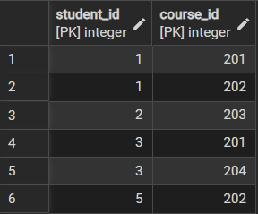
CREATE TABLE Departmentss (
department_id INT PRIMARY KEY,
department_name VARCHAR(50)
);
INSERT INTO Departmentss VALUES (101, 'Computer Engineering');
INSERT INTO Departmentss VALUES (102, 'Data Science');
INSERT INTO Departmentss VALUES (103, 'Electronics & Communication');
INSERT INTO Departmentss VALUES (104, 'Mechanical');
select * from Departmentss;
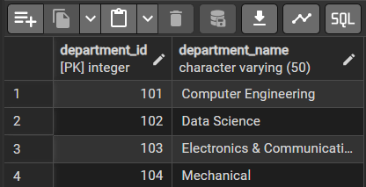

Step 1. Write queries to list students with their enrolled courses (INNER JOIN).
select s.student_name , c.course_name
from Studentss s
inner join Enrollments e
on s.student_id = e.student_id
inner join Courses c
on c.course_id = e.course_id;
Output:
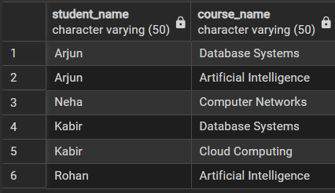
Step 2. Find students not enrolled in any course (LEFT JOIN).
select s.student_name
from Studentss s
left join Enrollments e
on s.student_id = e.student_id
where e.course_id is Null;
Output:
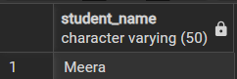
Step 3. Display all courses with or without enrolled students
select distinct c.course_name
from courses c
join Enrollments e
on c.course_id= e.course_id;
Output:
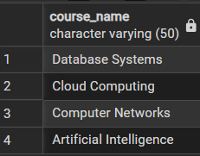
Step 4. Show students with department info using SELF JOIN or multiple joins.
select s.student_name, d.department_id, d.department_name
from Studentss s
join Departmentss d
on s.department_id = d.department_id
Output:
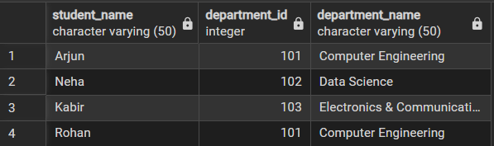
Step 5. Display all possible student-course combinations (CROSS JOIN). (Oracle, SAP, IBM, Microsoft)
Output:
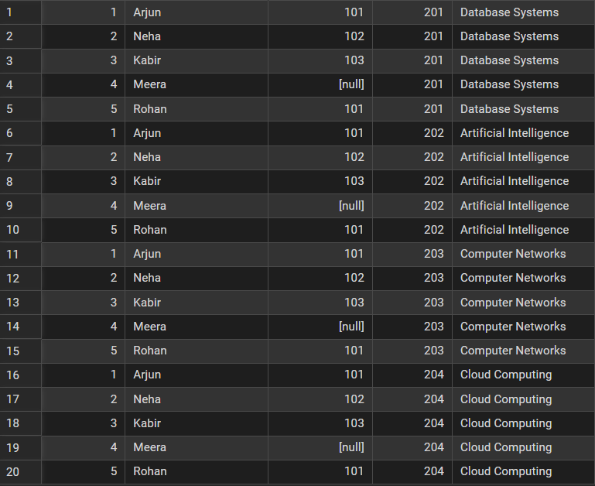
Outcomes:
- Ability to write SQL queries using different types of joins effectively.
- Understanding of how to manage and query relational data across multiple tables.
- Skill in identifying relationships like one-to-many and many-to-many in databases.
- Capability to retrieve both matching and non-matching records using appropriate joins.
- Improved problem-solving skills in designing and querying structured database systems.

