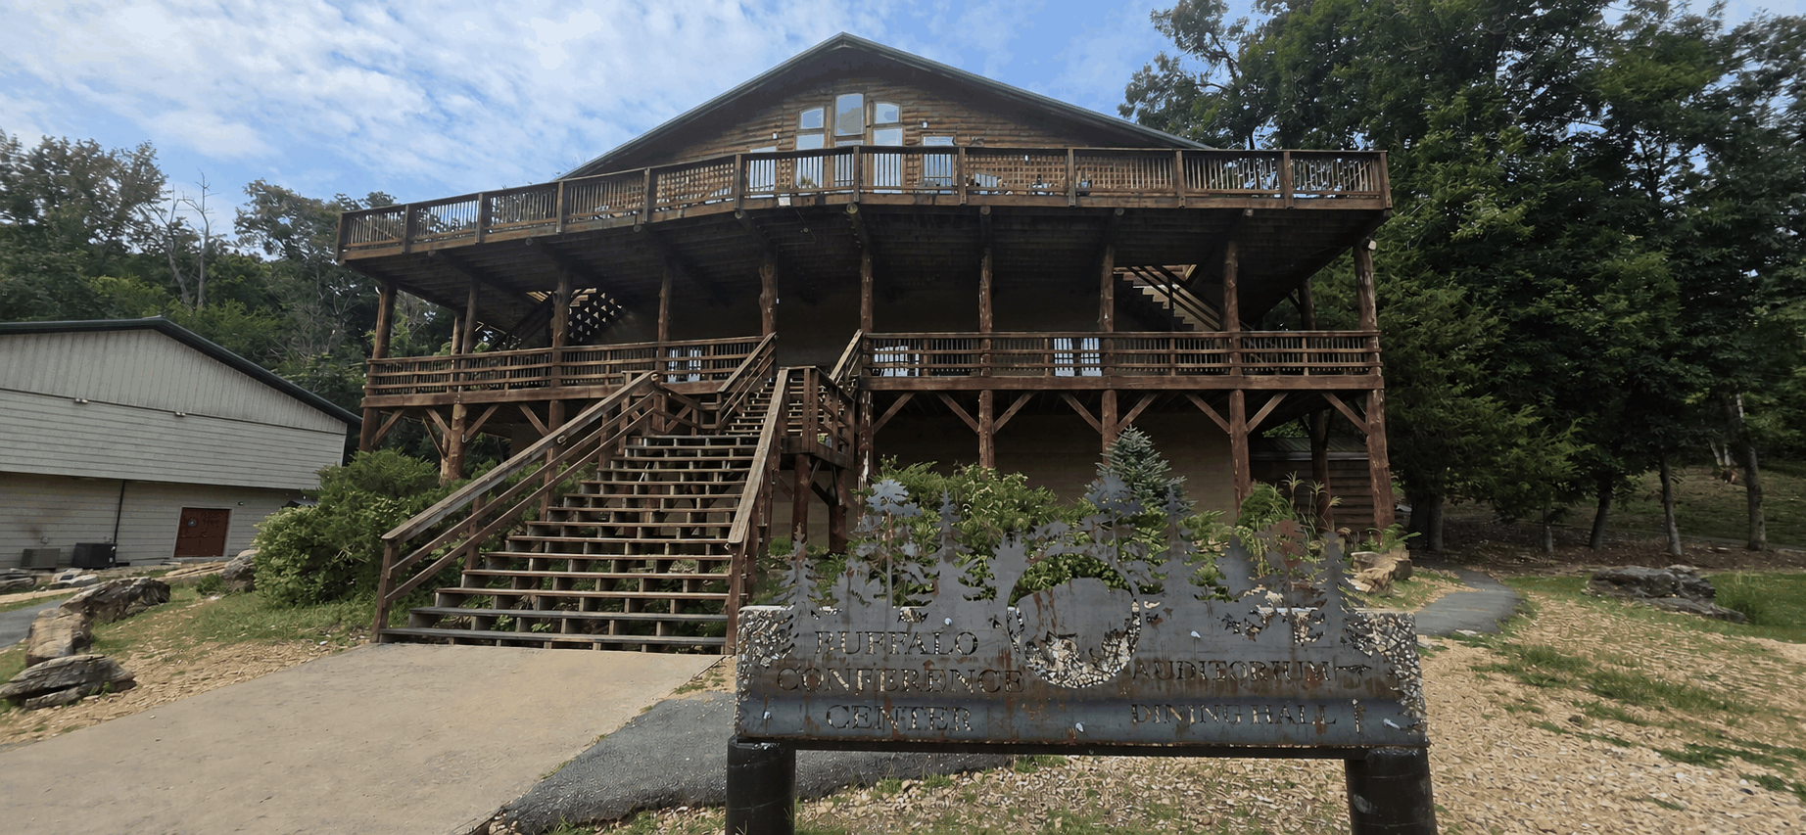
BEGIN THE CONVERSATION

Where might hope lead you?
Tell us what is stirring - joining a team, bringing a group, exploring an internship, or building a ministry partnership.
Explore. Ask. Imagine.
Current journeys, developing opportunities, giving information, and the easiest way to start a conversation are all at:
HopeSojourns.com
BOOK A CONVERSATION
calendly.com/brent-kern

Hope Sojourns works with Christian Steps Ministries to create purposeful opportunities for faith, service, learning, and partnership.
GO WITH HOPE. SERVE WITH FAITH.

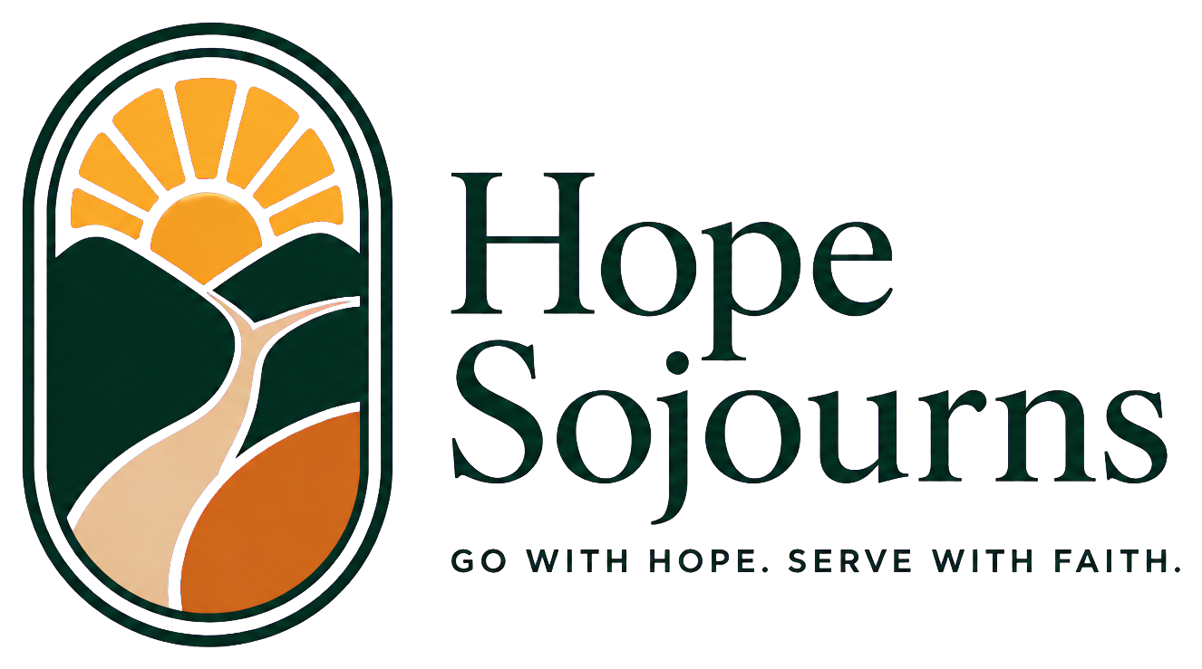
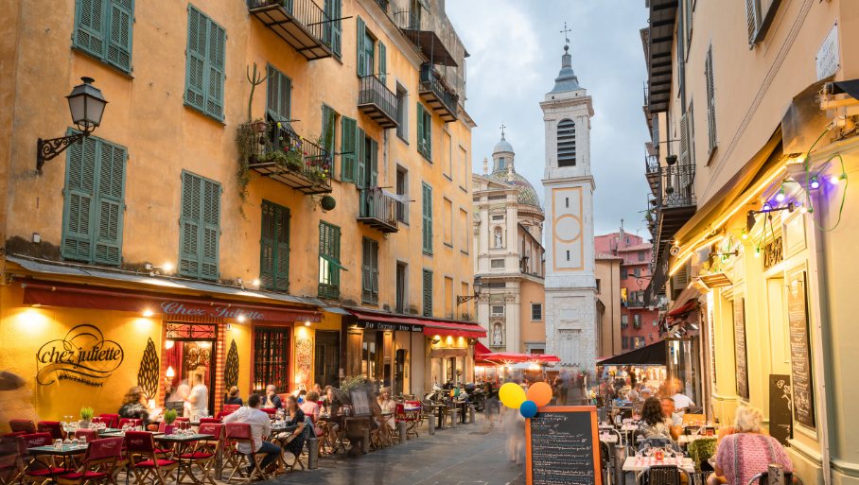
AN OPEN INVITATION

You are invited
to sojourn with us.
Travel with purpose. Serve with humility. Return home seeing the world - and your place in it - differently.
HopeSojourns.com


A DIFFERENT WAY TO GO

Not mission tourism. Meaningful partnership.
The best service begins with humility. Hope Sojourns brings willing people alongside trusted local leaders and the good work already underway.
LISTEN FIRST
Learn the people, place, strengths, and priorities before deciding what help should look like.
SERVE PRACTICALLY
Bring useful skills and willing hands to work identified by local ministry partners.
CARRY IT HOME
Reflect, tell stories with dignity, keep relationships, and let the journey reshape everyday service.
Come as an individual, church, school, ministry team, or organization.
MISSION JOURNEYS | INTERNSHIPS | GROUP TRIPS
HopeSojourns.com


OUR MISSION

Go farther. Serve closer.
Hope Sojourns brings willing people alongside trusted local ministries - creating room to listen, learn, encourage, and meet practical needs.
We create well-organized opportunities for people to serve communities and strengthen effective local ministries through short-term journeys, extended placements, and group partnerships.
PARTNER-LED
Local leaders identify real priorities and shape the work.
PREPARED
Teams receive thoughtful planning, spiritual preparation, and practical expectations.
DIGNITY-CENTERED
People are neighbors with names, agency, gifts, and stories - never projects or photo opportunities.
BUILT TO CONTINUE
The journey becomes a beginning for reflection, relationship, and service at home.

FEATURED JOURNEYS

Already taking shape.
Join a planned journey - and check the website for new dates, openings, and developing destinations.
ATHENS, GREECE
July 2-13, 2027
TEAM CONFIRMED | Additional spots available
ATHENS, GREECE
June 26-July 2, 2027
SCHEDULED | Spots available | Pastoral planning
NICE, FRANCE
July 15-26, 2027
SCHEDULED | Spots available
MEXICO CITY, MEXICO
October 5-10
TEAM CONFIRMED | Public year being finalized
AND THERE IS MORE
Belize in March or April 2027, Shepherd of the Ozarks in November 2027, six developing Mexico City journeys in 2027, Kenya, internships, and future partner-led opportunities.
Dates, availability, costs, roles, and partner plans are confirmed before enrollment or payment.

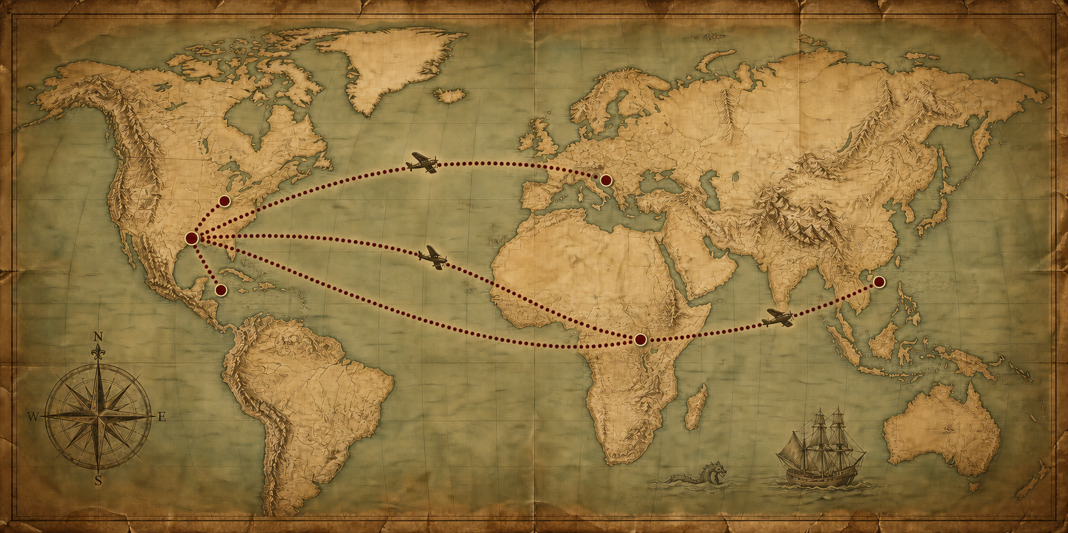
PLANNED + CUSTOM

One invitation. A world of possibilities.
100+
countries available for additional trip planning
Choose one of our preplanned journeys, or ask Hope Sojourns to shape an additional opportunity around your group, calling, skills, and a trusted local partner.
International + domestic
Custom journeys can be organized in more than 100 countries, along with domestic service opportunities across the United States.
BRING YOUR GROUP
Churches, schools, ministries, teams, and organizations can begin with a conversation.
BRING YOUR GIFTS
We help connect practical skills and willing service with needs identified by local leaders.
Start at HopeSojourns.com
calendly.com/brent-kern

