  HALIFAX, ENGLAND  A DIFFERENT WAY TO GO  Not mission tourism. Meaningful partnership.  The best service begins with humility. Hope Sojourns brings willing people alongside trusted local leaders and the good work already underway.  LISTEN FIRST  Learn the people, place, strengths, and priorities before deciding what help should look like.  SERVE PRACTICALLY  Bring useful skills and willing hands to work identified by local ministry partners.  CARRY IT HOME  Reflect, tell stories with dignity, keep relationships, and let the journey reshape everyday service.  Come as an individual, church, school, ministry team, or organization.  HopeSojourns.com  WAYS TO JOIN THE WORK  A place for willing hands.  No single skill defines a sojourner. Opportunities are shaped with trusted local partners and may include:  Hospitality, outreach, and encouragement.  Children, youth, and community activities.  Practical projects, communications, and ministry support.  Individuals and teams are equally welcome.  You do not need every detail settled before beginning the conversation.  Your presence should strengthen - never replace - local leadership.  COME READY TO LISTEN, LEARN + SERVE. | 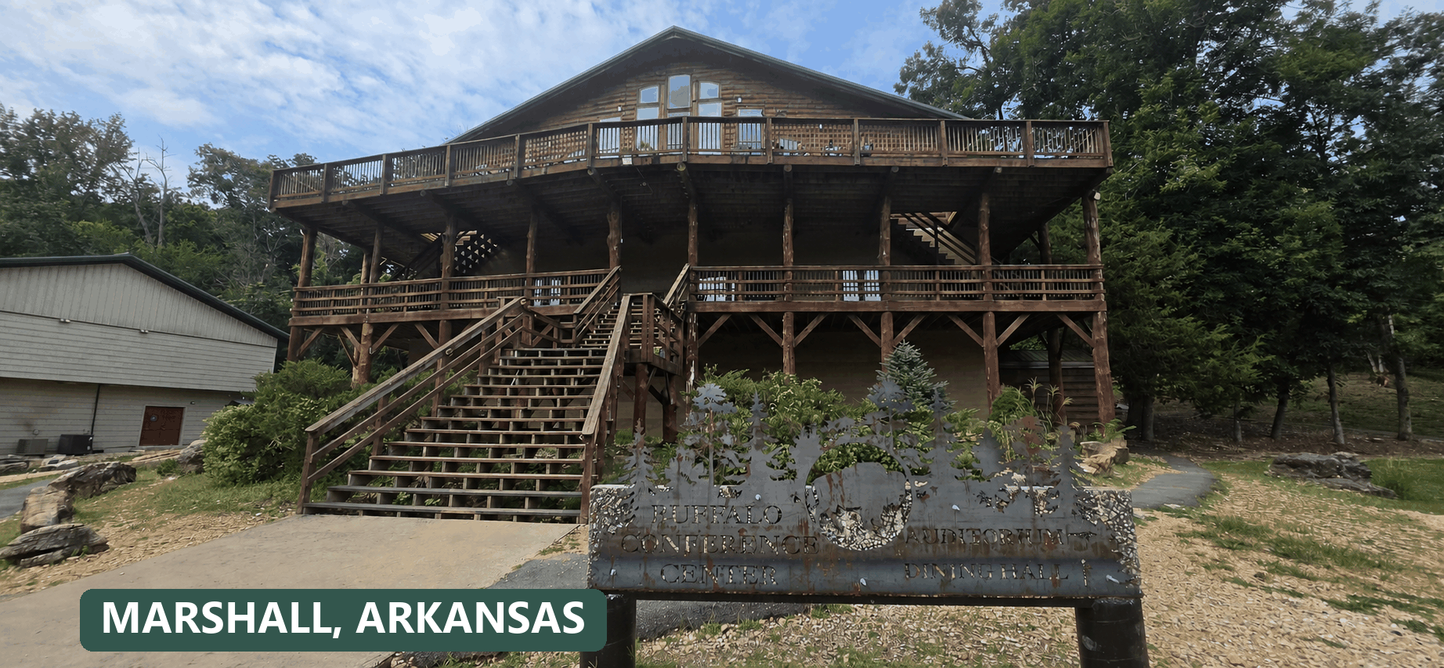  BEGIN THE CONVERSATION  Where might hope lead you?  Tell us what is stirring - joining a team, bringing a group, exploring an internship, or building a ministry partnership.  Explore. Ask. Imagine.  Current journeys, developing opportunities, giving information, and the easiest way to start a conversation are all online:  HopeSojourns.com  SCHEDULE A CONVERSATION  HopeSojourns.com/schedule/    Hope Sojourns works with Christian Steps Ministries to create purposeful opportunities for faith, service, learning, and partnership.  GO WITH HOPE. SERVE WITH FAITH.  SUPPORT THE JOURNEY  Donate to Hope Sojourns and help equip purposeful, partner-led journeys of faith, service, and lasting relationship.  HopeSojourns.com/giving/ | 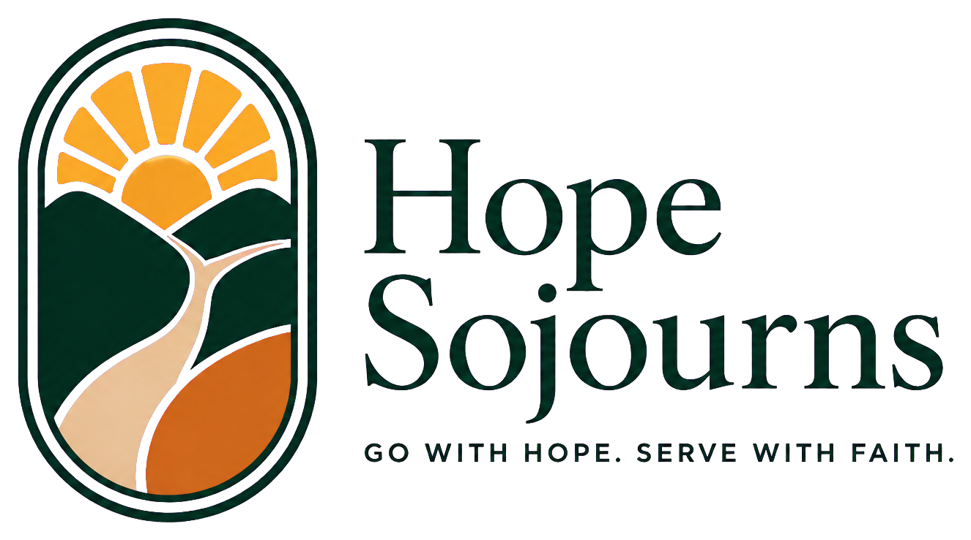  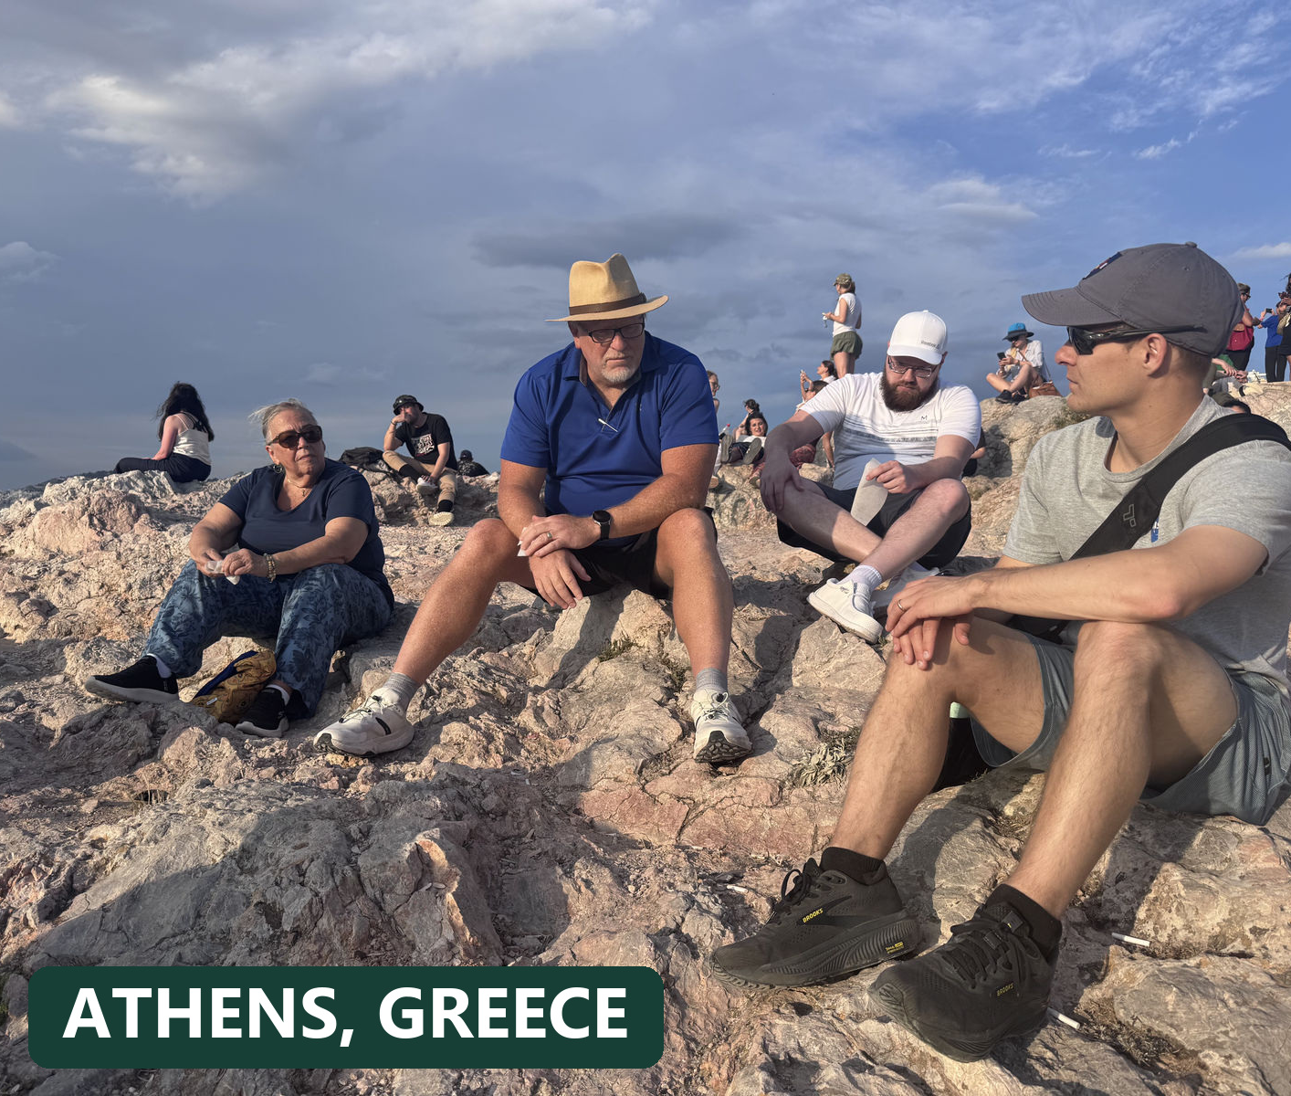  AN OPEN INVITATION  You are invited  to sojourn with us.  Travel with purpose. Serve with humility. Return home seeing the world - and your place in it - differently.  HopeSojourns.com  MISSION JOURNEYS | INTERNSHIPS | GROUP TRIPS  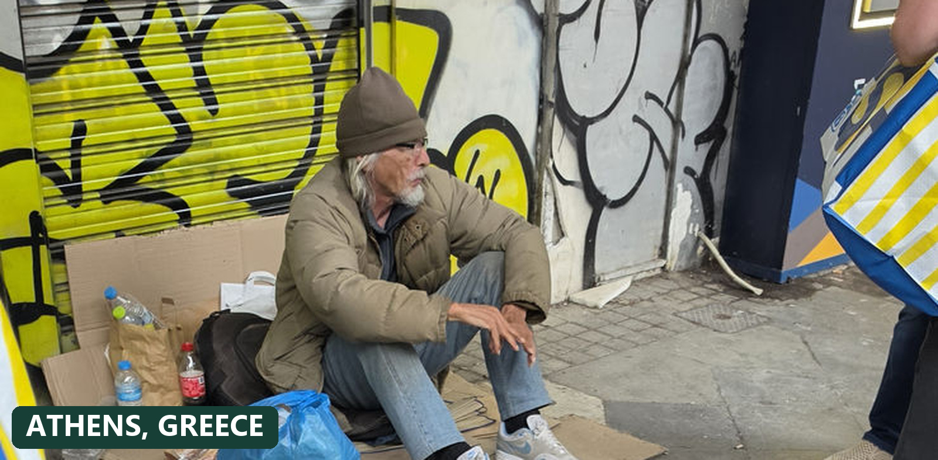
   | 
  OUR MISSION  Go farther. Serve closer.  Hope Sojourns brings willing people alongside trusted local ministries - creating room to listen, learn, encourage, and meet practical needs.  We create well-organized opportunities for people to serve communities and strengthen effective local ministries through short-term journeys, extended placements, and group partnerships.  PARTNER-LED  Local leaders identify real priorities and shape the work.  PREPARED  Teams receive thoughtful planning, spiritual preparation, and practical expectations.  DIGNITY-CENTERED  People are neighbors with names, agency, gifts, and stories - never projects or photo opportunities.  BUILT TO CONTINUE  The journey becomes a beginning for reflection, relationship, and service at home.  "The best service begins with humility."  BEFORE, DURING + AFTER  Thoughtfully prepared.  BEFORE: Clear roles, costs, expectations, and spiritual preparation.  DURING: Serve under local direction with flexibility and cultural humility.  AFTER: Reflect, share stories with dignity, and keep serving where you live. | FEATURED JOURNEYS  Already taking shape.  Join a planned journey - and check the website for new dates, openings, and developing destinations.  ENGLAND  October 10 - 17, 2026  DISCOVERY TRIP  MEXICO CITY, MEXICO*  January 9 - 14, 2027  TEAM CONFIRMED  March 13 - 18, 2027  Spots available  ATHENS, GREECE  June 26-July 6, 2027  SCHEDULED | Spots available | Pastoral planning  ATHENS, GREECE  July 10-20, 2027  TEAM CONFIRMED | Additional spots available  AND THERE IS MORE  Shepherd of the Ozarks in November 2027, six developing Mexico City journeys in 2027, Kenya, internships, and future partner-led opportunities.  * Mexico City journeys leave from DFW.  Dates, availability, costs, roles, and partner plans are confirmed before enrollment or payment.  SCHEDULE A CONVERSATION  HopeSojourns.com/schedule/  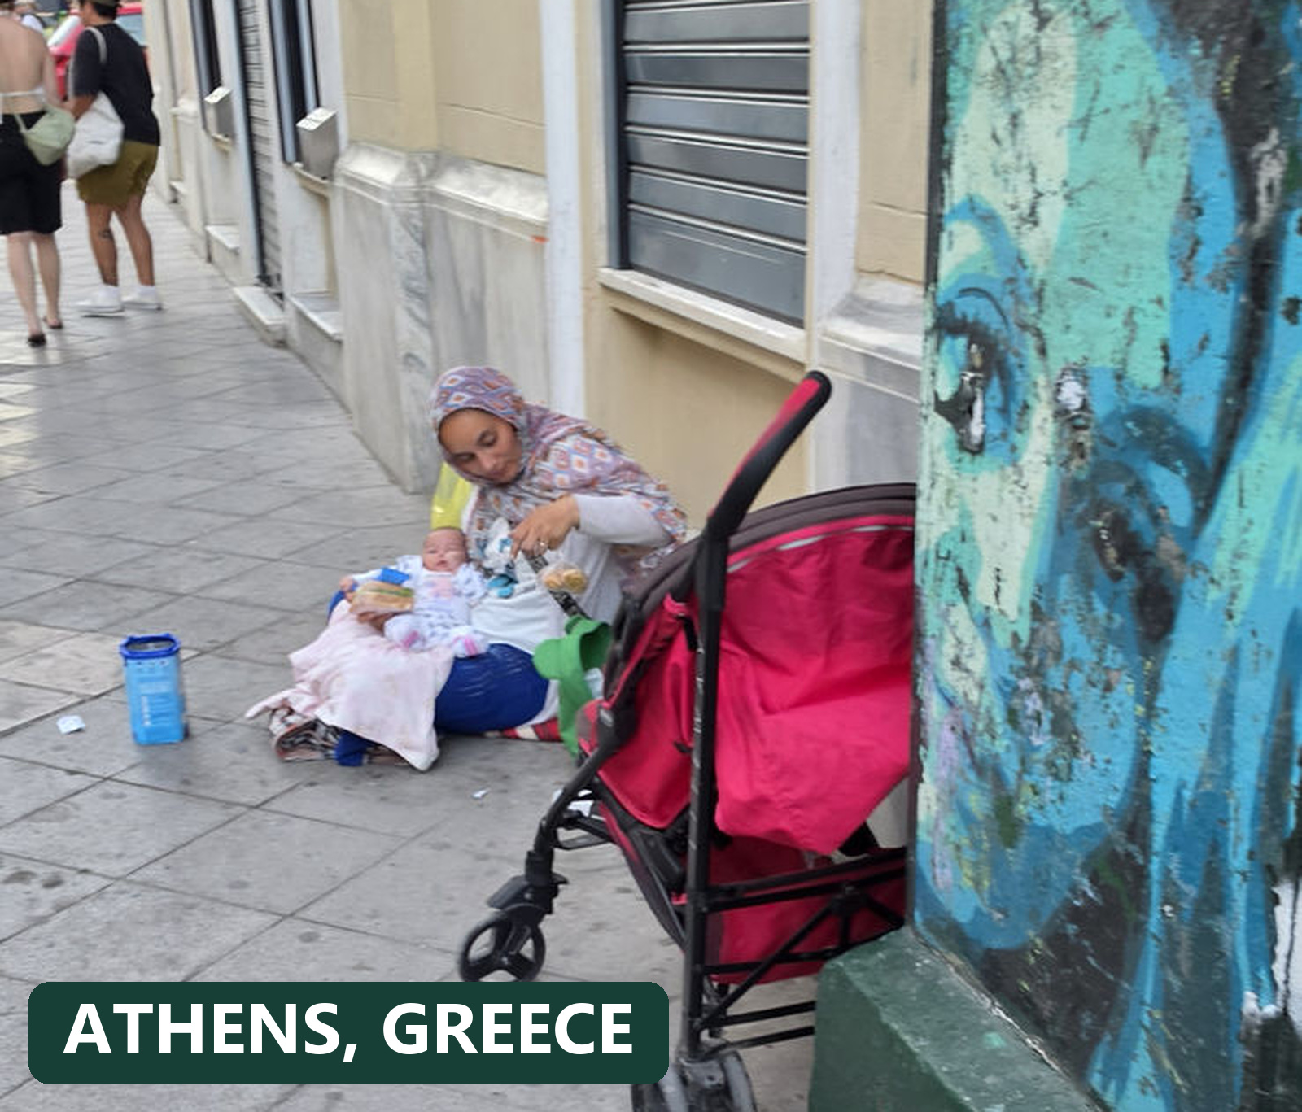 | 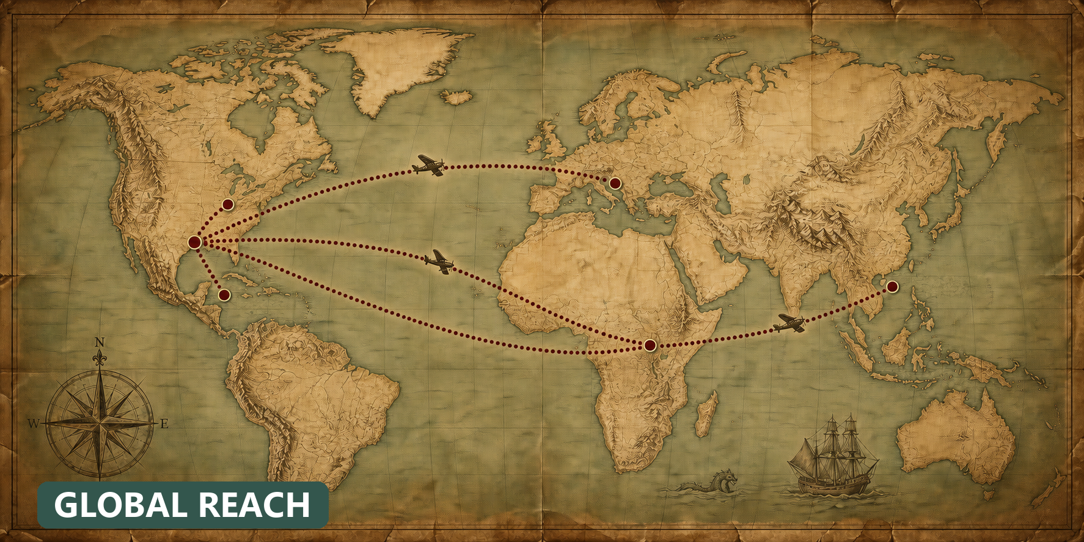  PLANNED + CUSTOM  One invitation. A world of possibilities.  100+  countries available for additional trip planning  Choose one of our preplanned journeys, or ask Hope Sojourns to shape an additional opportunity around your group, calling, skills, and a trusted local partner.  International + domestic  Custom journeys can be organized in more than 100 countries, along with domestic service opportunities across the United States.  BRING YOUR GROUP  Churches, schools, ministries, teams, and organizations can begin with a conversation.  BRING YOUR GIFTS  We help connect practical skills and willing service with needs identified by local leaders.  Start at HopeSojourns.com  HopeSojourns.com/schedule/  FAITHFUL STEWARDSHIP  Transparent stewardship.  Hope Sojourns is committed to complete transparency about all funds collected and spent.  Trip payments, donations, partner support, travel costs, and administrative expenses are recorded separately and explained clearly. Questions are always welcome.

