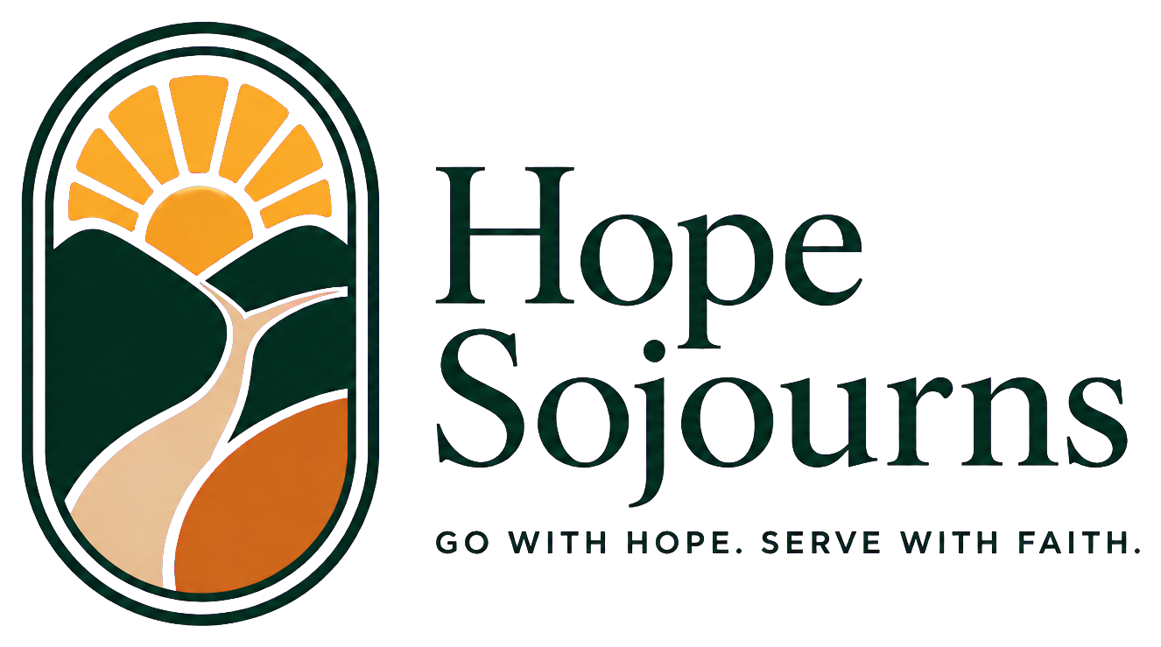
9408 Harrell Dr | McKinney, TX 75072 | 972-505-0171 | kernbrent@gmail.com
HopeSojourns.com
August 11, 2026
Dear Friend,
If you have known me for any length of time, you know that I bring my whole heart, energy, and experience to whatever the Lord places before me. Today I want to share an endeavor that brings together 32 years of church service, more than 28 years of leadership in business, and a lifetime of travel and relationship-building: Hope Sojourns.
Hope Sojourns brings willing people alongside trusted local ministries - creating room to listen, learn, encourage, and meet practical needs. This is not mission tourism. Each journey begins with the priorities of people already serving their communities. We prepare teams to arrive with humility, serve under local leadership, and carry what they learn into a lifetime of faithful service.
This vision is already taking shape. A 2027 Athens journey will build on mission trips completed in 2025 and 2026, serving alongside ministries caring for people experiencing homelessness, displacement, and exploitation. We are also helping develop six Mexico City mission opportunities for 2027, including collaboration with Metro Relief of Dallas and its trusted sister ministry serving neighbors experiencing homelessness. Additional opportunities include Vacation Bible School ministry in Belize and Nice, as well as service in Kenya and Arkansas.
To build Hope Sojourns responsibly, I need partners who believe in this calling. Gifts will help me devote the time and leadership needed to develop trustworthy partnerships, prepare teams and interns, create training resources, provide scholarships, and respond to needs identified by local leaders. We are committed to honest administration and clear stewardship of every gift.
Would you prayerfully consider making a one-time gift or becoming a monthly supporter at any level? You can give securely at HopeSojourns.com/giving/. You may also mail a check to 9408 Harrell Dr, McKinney, TX 75072. Donations are received and controlled by Christian Steps Ministries, a registered 501(c)(3), and are tax-deductible to the extent allowed by law.
Your partnership can also take the form of prayer, sharing Hope Sojourns with others, or introducing me to a pastor or missions leader. I would be glad to talk personally about the vision and the opportunities ahead.
Thank you for the ways you have already been part of my life, work, and ministry. I would be grateful to have you beside me in this next chapter.

WitLooL,
Brent Kern
Founder, Hope Sojourns
P.S. Your gift helps Hope Sojourns build responsible, lasting partnerships that connect willing people with trusted ministries. To learn more or give, visit HopeSojourns.com.

