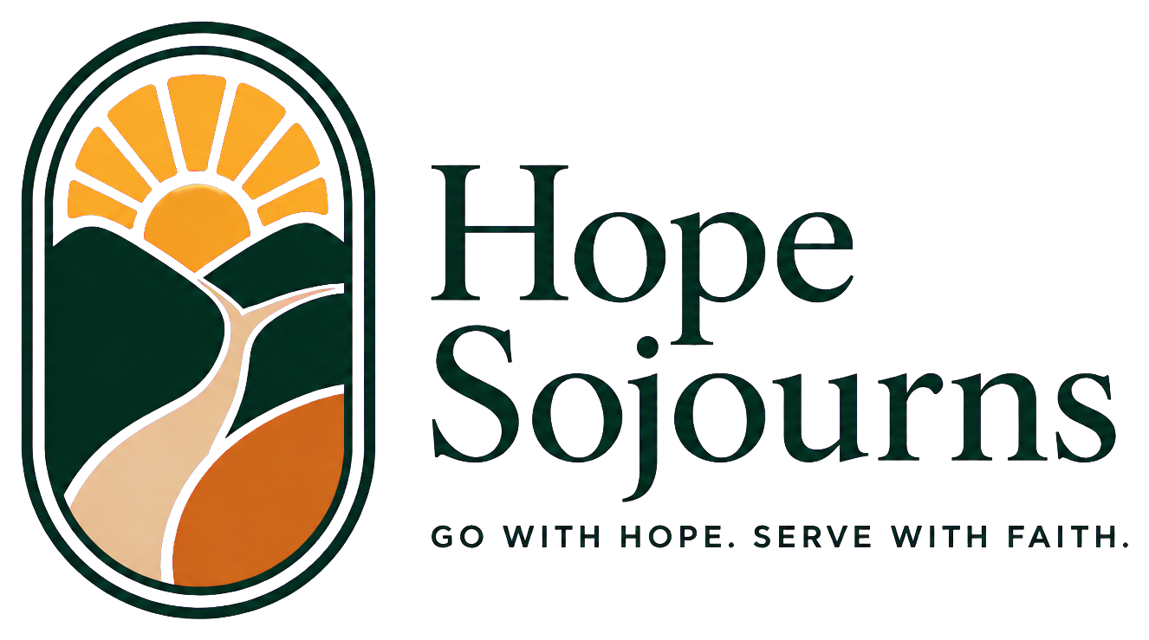 | OFFICIAL CONTRIBUTION RECEIPT  [[TAX_YEAR]] GIVING STATEMENT  HopeSojourns.com

[[DONOR_NAME]]  [[ADDRESS_LINE_1]]  [[ADDRESS_LINE_2_OPTIONAL]]  [[CITY_STATE_ZIP]] | Letter date  [[LETTER_DATE]]  Receipt number  [[RECEIPT_NUMBER]]
Dear [[GREETING_NAME]],
Thank you for your generous support of Hope Sojourns. Your partnership helps prepare people to serve, strengthen trusted ministry relationships, create training resources, and respond responsibly to needs identified by local leaders.
Christian Steps Ministries receives and processes charitable gifts made in support of Hope Sojourns. Christian Steps Ministries is a tax-exempt organization recognized under Section 501(c)(3) of the Internal Revenue Code (EIN 81-1678503).
TOTAL CHARITABLE GIVING | [[TOTAL_GIFT_AMOUNT]]
CONTRIBUTION DETAILS
Date | Amount | Designation | Payment method
[[GIFT_DATE]] | [[GIFT_AMOUNT]] | [[DESIGNATION]] | [[PAYMENT_METHOD]]
Tax statement: No goods or services were provided in exchange for these charitable contributions. Please retain this statement with your tax records.
With gratitude,
Hope Sojourns
in partnership with Christian Steps Ministries

