Logs for the HELLOWORLD kernel driver and PROC file creation:

1) sudo insmod hello.ko
inserts the helloworld kernel
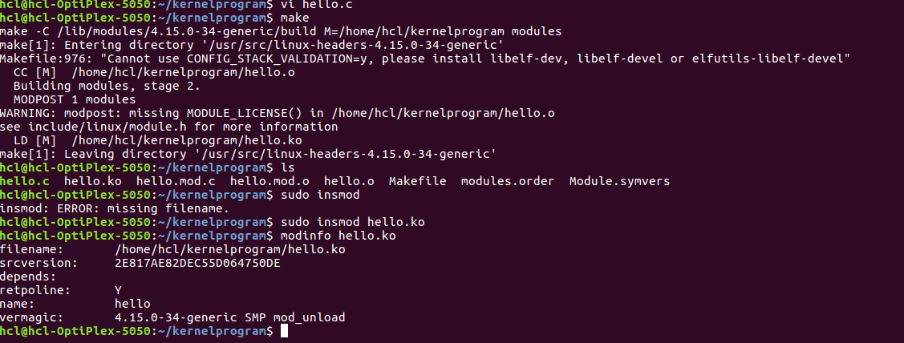
2) sudo modinfo hello.ko
displays info about the kernel inserted

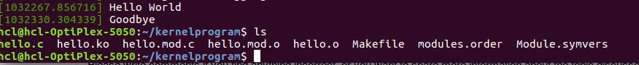

3) sudo dmesg
displays printk message
4) sudo rmmod hello.ko
removes helloworld kernel (prints mesasge goodbye)

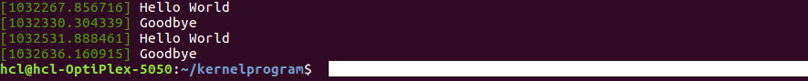

Create Proc file and compile

5) sudo insmod hello.ko
--creates proc file under /proc (mydrive)

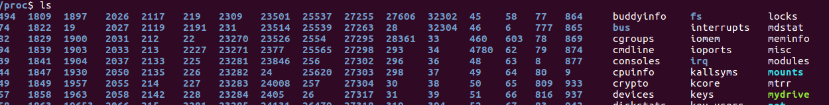
6) dmesg | tail -2
displays printk messages

