# 📝 Full-Stack Task Manager (Spring Boot + React)

A modern, robust Task Manager application built with a **Spring Boot** backend and a **React (Vite)** frontend. It features a sleek "Midnight Dark" UI, persistent file-based storage, and full CRUD capabilities.

![Project Screenshot]

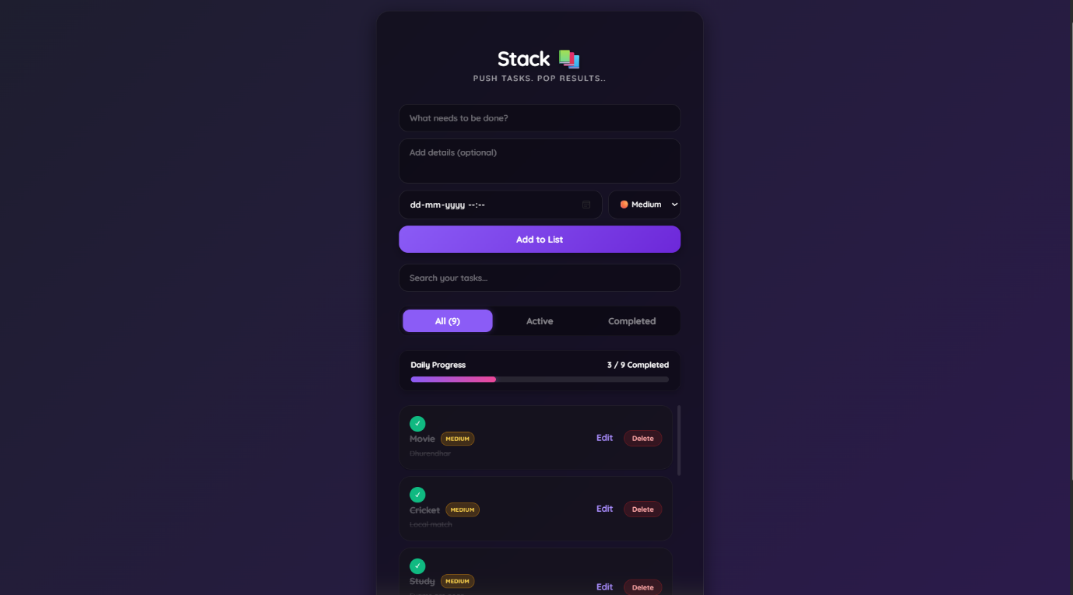

## 🚀 Features

* **Create Tasks**: Add new tasks with titles and optional descriptions.
* **Search**: Real-time filtering of tasks by title or description.
* **Smart Filters**: View "All", "Active", or "Completed" tasks.
* **Inline Editing**: Click any task to edit its title instantly.
* **Persistence**: Uses H2 file-based storage so data survives server restarts.
* **Bulk Actions**: "Clear All" button to remove all tasks at once.
* **Responsive UI**: Fully styled with a custom "Midnight Dark" CSS theme.

---

## 🛠️ Tech Stack

### **Frontend**
* **React (Vite)**: Fast, modern frontend build tool.
* **JavaScript (ES6+)**: Component logic.
* **Axios**: HTTP client for API requests.
* **CSS3**: Flexbox & Grid for the custom dark theme.

### **Backend**
* **Spring Boot 3**: REST API development.
* **Spring Data JPA**: Database abstraction layer.
* **H2 Database**: File-based SQL database (`jdbc:h2:file:./data/todo_db`).
* **Java 17+**: Core language.

---

## 📂 Project Structure

root/
├── todo-backend/ # Spring Boot Application
│ ├── src/main/java/ # Controllers, Services, Repositories, Entities
│ ├── src/main/resources/ # application.properties (DB config)
│ └── data/ # Auto-generated database file (todo_db.mv.db)
│
└── todo-frontend/ # React Application
├── src/
│ ├── services/ # API connection logic (TodoService.js)
│ ├── App.jsx # Main UI Logic
│ └── App.css # Midnight Dark Theme Styles
├── package.json # Dependencies
└── vite.config.js # Build configuration

⚙️ Getting Started
Follow these steps to run the project locally.
Prerequisites
- Java JDK 17 or higher.
- Node.js & npm (for the frontend).
- IntelliJ IDEA (recommended for Backend) or VS Code.
1. Setup the Backend
- Open the todo-backend folder in IntelliJ IDEA.
- Allow Maven to download dependencies.
- Navigate to src/main/resources/application.properties and verify the database setting:
Properties
spring.datasource.url=jdbc:h2:file:./data/todo_db
- Run the TodoBackendApplication.java file.
- The server will start on http://localhost:8080.
2. Setup the Frontend
- Open the todo-frontend folder in VS Code.
- Open the terminal (Ctrl + `) and install dependencies:
---npm install
- Start the development server:
---npm run dev
- Open your browser to http://localhost:5173.

🔌 API Reference
The backend exposes the following REST endpoints:
Method | Endpoint | Description
GET | /api/todos | Fetch all tasks
POST | /api/todos | Create a new task
PUT | /api/todos/{id} | Update a task (toggle status/edit title)
DELETE | /api/todos/{id} | Delete a specific task

🗄️ Database Access
You can view the raw data using the H2 Console while the backend is running.
- URL: http://localhost:8080/h2-console
- Driver Class: org.h2.Driver
- JDBC URL: jdbc:h2:file:./data/todo_db
- User Name: sa
- Password: (Leave Empty)

📸 Screenshots
Task Manager UI
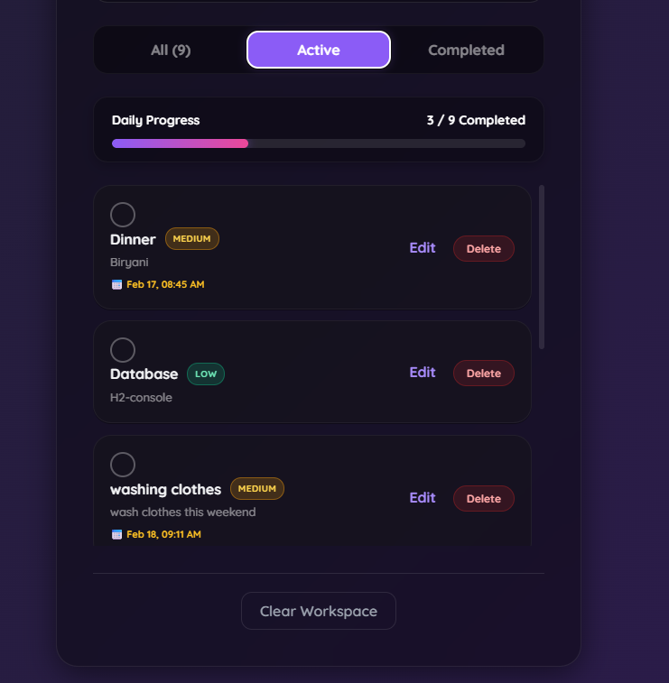

Priority & Progress bar
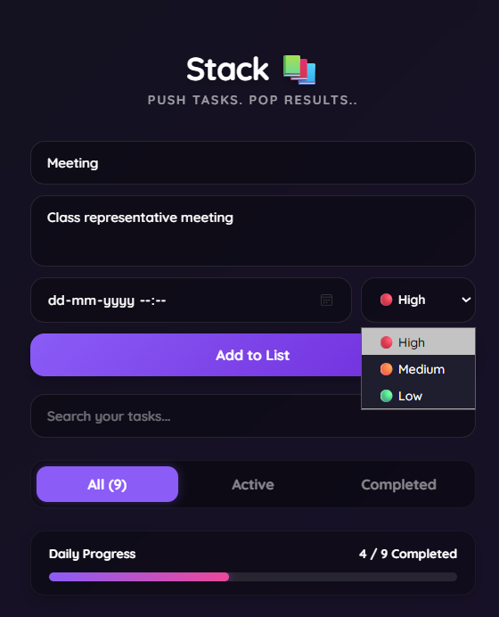

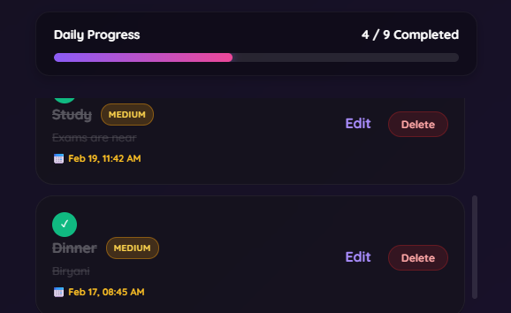

H2 Database Console
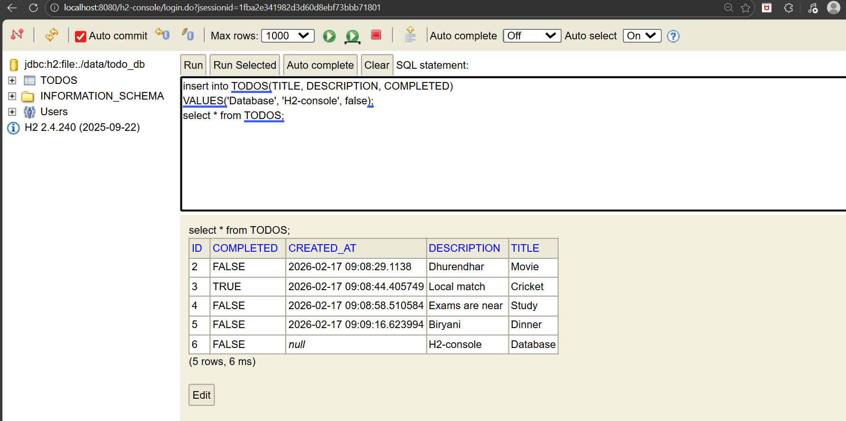

🤝 Contributing
- Fork the repository.
- Create your feature branch (git checkout -b feature/AmazingFeature).
- Commit your changes (git commit -m 'Add some AmazingFeature').
- Push to the branch (git push origin feature/AmazingFeature).
- Open a Pull Request.
📝 License
Distributed under the MIT License. See LICENSE for more information.

