EECS3421 Project 2

Kareem Mohamed Student#213948906

Contents

Source code.…………………………………….1
Recorded session of program execution………...2
Explanation of program mechanics……………..3

1 Source Code

public class App
{
public static void main(String[] args)
{
Controller c = new Controller();
View v = new View(c);
Model m = new Model();
c.setModel(m);
c.setView(v);
}
}

import java.awt.event.ActionEvent;
import java.awt.event.ActionListener;
import java.util.LinkedList;

import javax.swing.JTextField;

public class Controller implements ActionListener
{
private Model model;
private LinkedList<String> booksFounded = new LinkedList<String>();
private float currentMin;
private int year;
private View view;
private int customerID;
public void actionPerformed(ActionEvent event)
{
String action = event.getActionCommand();
Model model = this.getModel();
View view = this.getView();
if(action.equalsIgnoreCase("find customer"))
{
if(model != null)
{
boolean found = model.find_customer(view.getCid());
if(found)
{
customerID = view.getCid();
if(view.isNotFoundON())
{
view.custNotFoundOFF();
}
view.customerFound(model.getCustName(),model.getCustCity(),model.getCustID());
model.fetch_categories();
LinkedList<String> x = model.getCats();
String[] y = new String[x.size()];
for(int i=0;i<x.size();i++)
{
y[i] = x.get(i);
}
view.showCategories(y);
/*if(view.getChosenCat() != null)
{
view.bookTitleFieldON();
System.out.println(view.getBookText());
}*/
}
else
{
view.custNotFoundON();
}
}
}
else if(action.equalsIgnoreCase("ok"))
{
if(view.getBookSelected()!= null && view.getCatChosen() != null && view.getBookText() != null)
{

String copy = view.getBookSelected();
int year = Integer.parseInt(copy.replaceAll("\\D+","").substring(0, 4));
this.year = year;
float min = model.min_price(view.getBookText(), view.getCatChosen(), year);
currentMin = min;
view.bookSelected(min);
}
else if(view.getCatChosen()!= null && view.getBookText() != null && view.getBookSelected() == null)
{
view.promptOneOn();
booksFounded = model.find_book(view.getBookText(), view.getCatChosen());
view.findingBook(model.find_book(view.getBookText(), view.getCatChosen()));
}
}
else if(action.equalsIgnoreCase("proceed"))
{
if(view.getQ() == 0)
{
view.noQty();
}
else if(view.getQ() > 0)
{
view.lastPage(currentMin);
}
}
else if(action.equalsIgnoreCase("Buy"))
{
model.insert_purchase(customerID, model.getOfferedBy(), view.getBookText(), year, view.getQ());
view.exit();
}
else if(action.equalsIgnoreCase("back"))
{
if(view.getPhase() == 3)
{
view.back3to1();
currentMin = 0;
view.removeBooksFound(booksFounded);
}
else if(view.getPhase() == 2)
{
view.back2to1();
currentMin = 0;
view.removeBooksFound(booksFounded);
}
}
}
private Model getModel()
{
return this.model;
}

/**
* Returns the view.
*
* @return the view.
*/
private View getView()
{
return this.view;
}
public void setModel(Model model)
{
this.model = model;
}

/**
* Sets the view to the given view.
*
* @param view the view.
* @pre. view != null
*/
public void setView(View view)
{
this.view = view;
}

}

import java.util.*;
import java.net.*;
import java.text.*;
import java.lang.*;
import java.io.*;
import java.sql.*;

public class Model
{
private Connection conDB; // Connection to the database system.
private String url; // URL: Which database?
private LinkedList<String> cats = new LinkedList<String>(); // List of categories.
private Integer custID; // Customer ID.
private String custName; // Name of that customer.
private String custCity; // City of that customer.
private String offeredBy; // Club offering min price

public Model()
{
try {
// Register the driver with DriverManager.
Class.forName("COM.ibm.db2.jdbc.app.DB2Driver").newInstance();
} catch (ClassNotFoundException e) {
e.printStackTrace();
System.exit(0);
} catch (InstantiationException e) {
e.printStackTrace();
System.exit(0);
} catch (IllegalAccessException e) {
e.printStackTrace();
System.exit(0);
}

// URL: Which database?
url = "jdbc:db2:c3421m";

// Initialise the connection.
try {
// Connect with a fall-thru id & password
conDB = DriverManager.getConnection(url);
} catch(SQLException e) {
System.out.print("\nSQL: database connection error.\n");
System.out.println(e.toString());
System.exit(0);
}

// Let's have auto commit turned off. No particular reason here.
try {
conDB.setAutoCommit(false);
} catch(SQLException e) {
System.out.print("\nFailed trying to turn autocommit off.\n");
e.printStackTrace();
System.exit(0);
}
}
/**
* @return boolean if the customer was found or not.
*/
public boolean find_customer(int a)
{
custID = a;
String queryText = ""; // The SQL text.
PreparedStatement querySt = null; // The query handle.
ResultSet answers = null; // A cursor.

boolean inDB = false; // Return.

queryText =
"SELECT * "
+ "FROM yrb_customer "
+ "WHERE cid = " + getCustID();

// Prepare the query.
try {
querySt = conDB.prepareStatement(queryText);
} catch(SQLException e) {
System.out.println("SQL#1 failed in prepare");
System.out.println(e.toString());
System.exit(0);
}

// Execute the query.
try {
answers = querySt.executeQuery();
} catch(SQLException e) {
System.out.println("SQL#1 failed in execute");
System.out.println(e.toString());
System.exit(0);
}

// Any answer?
try {
if (answers.next()) {
inDB = true;
custName = answers.getString("name");
custCity = answers.getString("city");
} else {
inDB = false;
custName = null;
custCity = null;
}
} catch(SQLException e) {
System.out.println("SQL#1 failed in cursor.");
System.out.println(e.toString());
System.exit(0);
}

// Close the cursor.
try {
answers.close();
} catch(SQLException e) {
System.out.print("SQL#1 failed closing cursor.\n");
System.out.println(e.toString());
System.exit(0);
}

// We're done with the handle.
try {
querySt.close();
} catch(SQLException e) {
System.out.print("SQL#1 failed closing the handle.\n");
System.out.println(e.toString());
System.exit(0);
}

return inDB;
}
/**
* Fetches the categories and saves them in cats list
*/
public void fetch_categories()
{
String queryText = ""; // The SQL text.
PreparedStatement querySt = null; // The query handle.
ResultSet answers = null; // A cursor.
queryText =
"SELECT distinct cat "
+ "FROM yrb_category ";
// Prepare the query.
try {
querySt = conDB.prepareStatement(queryText);
} catch(SQLException e) {
System.out.println("SQL#2 failed in prepare");
System.out.println(e.toString());
System.exit(0);
}

// Execute the query.
try {
answers = querySt.executeQuery();
} catch(SQLException e) {
System.out.println("SQL#2 failed in execute");
System.out.println(e.toString());
System.exit(0);
}
// Any answer?
try
{
for(int i = 0;answers.next(); i++)
{
String x = answers.getString("cat");
cats.add(x);
}
} catch(SQLException e) {
System.out.println("SQL#2 failed in cursor.");
System.out.println(e.toString());
System.exit(0);
}
// Close the cursor.
try {
answers.close();
} catch(SQLException e) {
System.out.print("SQL#2 failed closing cursor.\n");
System.out.println(e.toString());
System.exit(0);
}

// We're done with the handle.
try {
querySt.close();
} catch(SQLException e) {
System.out.print("SQL#2 failed closing the handle.\n");
System.out.println(e.toString());
System.exit(0);
}
}
/**
*
* @param book
* @param catChosen
* @return a list of books with same name and category
*/
public LinkedList<String> find_book(String book, String catChosen)
{
LinkedList<String> out = new LinkedList<String>();
String queryText = ""; // The SQL text.
PreparedStatement querySt = null; // The query handle.
ResultSet answers = null; // A cursor.
queryText =
"SELECT title, year, language, weight "
+ "FROM yrb_book "
+ "WHERE title = '" + book + "' and cat = '"+ catChosen +"'";
// Prepare the query.
try {
querySt = conDB.prepareStatement(queryText);
} catch(SQLException e) {
System.out.println("SQL#3 failed in prepare");
System.out.println(e.toString());
System.exit(0);
}
// Execute the query.
try {
answers = querySt.executeQuery();
} catch(SQLException e) {
System.out.println("SQL#3 failed in execute");
System.out.println(e.toString());
System.exit(0);
}
// Any answer?
try {
for(;answers.next();)
{
out.add(answers.getString("title")
+" "+answers.getInt("year")
+" "+answers.getString("language")
+" "+answers.getInt("weight"));
}
} catch(SQLException e) {
System.out.println("SQL#3 failed in cursor.");
System.out.println(e.toString());
System.exit(0);
}
// Close the cursor.
try {
answers.close();
} catch(SQLException e) {
System.out.print("SQL#2 failed closing cursor.\n");
System.out.println(e.toString());
System.exit(0);
}

// We're done with the handle.
try {
querySt.close();
} catch(SQLException e) {
System.out.print("SQL#2 failed closing the handle.\n");
System.out.println(e.toString());
System.exit(0);
}
return out;
}
/**
* @param book
* @param catChosen
* @param yearChosen
* @return minimum price offered by the clubs this customer is a
* member of
*/
public float min_price(String book, String catChosen, int yearChosen)
{
float min = 0;
String queryText = ""; // The SQL text.
PreparedStatement querySt = null; // The query handle.
ResultSet answers = null; // A cursor.
queryText =
"SELECT club,price "
+ "FROM yrb_offer "
+ "WHERE title = '" + book + "'"
+ " and year = " + yearChosen + " and club IN(SELECT club"
+ " FROM yrb_member "
+ "WHERE cid = " + custID + ")";
// Prepare the query.
try {
querySt = conDB.prepareStatement(queryText);
} catch(SQLException e) {
System.out.println("SQL#4 failed in prepare");
System.out.println(e.toString());
System.exit(0);
}
// Execute the query.
try {
answers = querySt.executeQuery();
} catch(SQLException e) {
System.out.println("SQL#4 failed in execute");
System.out.println(e.toString());
System.exit(0);
}
// Any answer?
try {
if (answers.next())
{
min = answers.getFloat("price");
offeredBy = answers.getString("club");
for(;answers.next();)
{
float compare = answers.getFloat("price");
if( compare < min)
{
offeredBy = answers.getString("club");
min = compare;
}
}
}
} catch(SQLException e) {
System.out.println("SQL#4 failed in cursor.");
System.out.println(e.toString());
System.exit(0);
}
// Close the cursor.
try {
answers.close();
} catch(SQLException e) {
System.out.print("SQL#2 failed closing cursor.\n");
System.out.println(e.toString());
System.exit(0);
}

// We're done with the handle.
try {
querySt.close();
} catch(SQLException e) {
System.out.print("SQL#2 failed closing the handle.\n");
System.out.println(e.toString());
System.exit(0);
}
return min;
}
/**
* Inserts the chosen book in the yrb_purchases DB
* @param cid
* @param club
* @param title
* @param year
* @param qty
*/
public void insert_purchase(int cid, String club,String title, int year, int qty)
{

String queryText = ""; // The SQL text.
Statement querySt = null; // The query handle.
queryText =
"INSERT INTO yrb_purchase VALUES("
+ cid + ", '" + club + "'," + "'" + title + "',"
+ year + ", '" + new Timestamp(System.currentTimeMillis())+"',"
+ qty+")" ;

// Prepare the query.
try {
querySt = conDB.createStatement();
} catch(SQLException e) {
System.out.println("SQL#5 failed in prepare");
System.out.println(e.toString());
System.exit(0);
}
// Execute the query.
try {
querySt.executeUpdate(queryText);
conDB.commit();
System.out.println("ok");
} catch(SQLException e) {
System.out.println("SQL#5 failed in execute");
System.out.println(e.toString());
System.exit(0);
}
}

/**
* @return the custID
*/
public Integer getCustID() {
return custID;
}
/**
* @return the custName
*/
public String getCustName() {
return custName;
}
/**
* @return the custCity
*/
public String getCustCity() {
return custCity;
}

public LinkedList<String> getCats() {
return cats;
}

public String getOfferedBy()
{
return offeredBy;
}
}

import java.awt.BorderLayout;
import java.awt.Dimension;
import java.awt.GridLayout;
import java.awt.event.ActionEvent;
import java.awt.event.ActionListener;
import java.util.LinkedList;

import javax.swing.JButton;
import javax.swing.JComboBox;
import javax.swing.JFrame;
import javax.swing.JLabel;
import javax.swing.JPanel;
import javax.swing.JTextField;

public class View extends JFrame
{
private JPanel buttons = new JPanel();
private JFrame view = new JFrame("Application Program 3421");
private int qnty = 0;
private int booksFoundSize = 0;
String[] z = {""};
JLabel custDisplay = new JLabel("");
JLabel minPriceDisplay = new JLabel("");
JLabel qtyPrompt = new JLabel("");
JLabel NoqtyPrompt = new JLabel("");
JLabel askingPrice = new JLabel("");
JLabel exit = new JLabel("");
final JComboBox<String> cb = new JComboBox<String>(z);
JComboBox<String> booksFound = new JComboBox<String>(z);
private JTextField field = new JTextField(10);
private JTextField qty = new JTextField(10);
private JTextField bookTitle = new JTextField(10);
private int cid = 0;
private Object chosenCat = null;
private JButton x = new JButton("Find Customer");
private JButton buy = new JButton("Buy");
private JButton back = new JButton("Back");
private JButton ok = new JButton("Ok");
private JButton proceed = new JButton("Proceed");
private JButton findBook = new JButton("Find Book");
private JLabel custNotFound = new JLabel("Not found, Please try again");
private JLabel chooseAcat = new JLabel("Please choose a category");
JLabel prompt = new JLabel("Please choose a category and type book title then press ok");
JLabel prompt1 = new JLabel("Book not found please put in a new combination and hit ok");
JLabel prompt2 = new JLabel("Please choose a book from the list and enter quantity wanted");
JLabel lbl = new JLabel("Enter your ID");
private Object bookText = null;
private Object bookSelected = null;
private int phase = 1;
public View(Controller controller)
{
view.setDefaultCloseOperation(JFrame.EXIT_ON_CLOSE);
view.setSize(400, 400);
buttons.add(lbl,BorderLayout.NORTH);
buttons.add(field,BorderLayout.CENTER);
buttons.add(x, BorderLayout.SOUTH);
x.setActionCommand("Find Customer");
x.addActionListener(controller);
ok.setActionCommand("ok");
ok.addActionListener(controller);
buy.addActionListener(controller);
buy.setActionCommand("buy");
back.addActionListener(controller);
back.setActionCommand("back");
view.add(buttons);
cb.setVisible(true);
buttons.add(cb);
buttons.add(ok);
ok.setVisible(true);
buttons.add(bookTitle);
bookTitle.setVisible(false);
buttons.add(findBook);
findBook.setVisible(false);
buttons.add(booksFound);
booksFound.setVisible(false);
buttons.add(custNotFound);
buttons.add(chooseAcat);
proceed.setActionCommand("proceed");
proceed.addActionListener(controller);
chooseAcat.setVisible(false);
custNotFound.setVisible(false);
view.setVisible(true);
field.setActionCommand("field");
//buttons.add(back);
//buttons.add(buy);
buy.setVisible(false);
back.setVisible(false);
buttons.add(qty);
qty.setVisible(false);

/**
* @return the field
*/
qty.addActionListener(new ActionListener(){
public void actionPerformed(ActionEvent ae)
{
qnty = Integer.parseInt(qty.getText());
}
});
field.addActionListener(new ActionListener(){
public void actionPerformed(ActionEvent ae)
{
cid = Integer.parseInt(field.getText());
}
});

cb.addActionListener(new ActionListener()
{
public void actionPerformed(ActionEvent ae)
{
chosenCat = cb.getSelectedItem();
}
});

booksFound.addActionListener(new ActionListener()
{
public void actionPerformed(ActionEvent ae)
{
if(booksFound != null)
{
bookSelected = booksFound.getSelectedItem();
}
}
});

bookTitle.addActionListener(new ActionListener(){
public void actionPerformed(ActionEvent ae)
{
bookText = bookTitle.getText();
}
});

}
public int getQ()
{
return qnty;
}
public String getBookSelected()
{
if(bookSelected != null)
return bookSelected.toString();
else return null;
}
public String getCatChosen()
{
if(chosenCat != null)
return chosenCat.toString();
else return null;
}
public JTextField getField() {
return field;
}

public String getBookText()
{
if(bookText != null)
return bookText.toString();
else return null;
}
/**
* @param field the field to set
*/
public void setField(JTextField field) {
this.field = field;
}
public void showCategories(String[] x)
{

for(int i = 0; i < x.length;i++)
cb.addItem(x[i]);

}
public int getCid()
{
return cid;
}

public Object getChosenCat()
{
if(chosenCat != null)
{
return chosenCat.toString();
}
else
{
return null;
}
}
/*
* Removes the find customer button
*/
public void customerFound(String z, String y, int i)
{
x.setVisible(false);
custDisplay = new JLabel("Customer " + i
+" found \n Name: " + z
+" \n City: " + y);

buttons.add(custDisplay);
buttons.add(prompt);
custDisplay.setVisible(true);
prompt.setVisible(true);
field.setVisible(false);
lbl.setVisible(false);
bookTitle.setVisible(true);

}

public void custNotFoundON()
{
custNotFound.setVisible(true);
}

public void custNotFoundOFF()
{
custNotFound.setVisible(false);
}

public boolean isNotFoundON()
{
return custNotFound.isVisible();
}
public void findingBook(LinkedList<String> booksFound)
{
if(booksFound.size()<=0)
{
buttons.add(prompt1);

prompt1.setVisible(true);
prompt.setVisible(false);
}
else
{
cb.setVisible(false);
bookTitle.setVisible(false);
buttons.add(prompt2);
prompt2.setVisible(true);
prompt.setVisible(false);
setBooksFound(booksFound);
this.booksFound.setVisible(true);
}
}
public void promptOneOn()
{
if(prompt1.isVisible())
{
prompt1.setVisible(false);
}
}
public void bookSelected(float min)
{
booksFound.setVisible(false);
prompt1.setVisible(false);
prompt2.setVisible(false);
ok.setVisible(false);
qty.setVisible(true);
minPriceDisplay = new JLabel("The minimum price for this book is " + min);
qtyPrompt = new JLabel("Please enter the quantity");
buttons.add(minPriceDisplay);
buttons.add(qtyPrompt);
buttons.add(proceed);
buttons.add(buy);
buttons.add(back);
proceed.setVisible(true);
back.setVisible(true);
minPriceDisplay.setVisible(true);
qtyPrompt.setVisible(true);
//booksFound.removeAllItems();
phase = 2;
}

public void noQty()
{
qtyPrompt.setVisible(false);
NoqtyPrompt = new JLabel("No quantity entered please enter a quantity");
buttons.add(NoqtyPrompt);
NoqtyPrompt.setVisible(true);
}
public void lastPage(float min)
{
if(NoqtyPrompt.isVisible())
{
NoqtyPrompt.setVisible(false);
}
qtyPrompt.setVisible(false);
proceed.setVisible(false);
qty.setVisible(false);
minPriceDisplay.setVisible(false);
askingPrice = new JLabel("The asking price for " + qnty + " copies of "+bookText+" is " + (min * qnty));
buttons.add(askingPrice);

askingPrice.setVisible(true);
buy.setVisible(true);
phase = 3;
}
public void back2to1()
{
booksFound.setVisible(false);
proceed.setVisible(false);
back.setVisible(false);
minPriceDisplay.setVisible(false);
qtyPrompt.setVisible(false);
prompt1.setVisible(false);
prompt2.setVisible(false);
qty.setVisible(false);
qnty = 0;
cb.setVisible(true);
ok.setVisible(true);
bookTitle.setVisible(true);
prompt.setVisible(true);
bookSelected = null;
phase = 1;
}
public void back3to1()
{
bookText = null;
chosenCat = null;
buy.setVisible(false);
back.setVisible(false);
cb.setVisible(true);
ok.setVisible(true);
bookTitle.setVisible(true);
prompt.setVisible(true);
askingPrice.setVisible(false);
qnty = 0;
bookSelected = null;
phase = 1;
}
public void exit()
{
askingPrice.setVisible(false);
buy.setVisible(false);
back.setVisible(false);
exit = new JLabel("Thank you for your purchase the database has been updated");
buttons.add(exit);
exit.setVisible(true);
}
public int getPhase()
{
return phase;
}
public void bookTitleFieldON()
{
bookTitle.setVisible(true);
}

public void enterIDtextOff()
{
lbl.setVisible(false);
field.setVisible(false);
}

public void setBooksFound(LinkedList<String> z)
{
if(z != null)
{
for(int i=0;i<z.size();i++)
{
booksFound.addItem(z.get(i));
}
}
}

public void removeBooksFound(LinkedList<String> z)
{
if(z != null)
{
for(int i=0;i<z.size();i++)
{
booksFound.removeItem(z.get(i));
}
bookSelected = null;
}
else
{
System.out.println("NO");
}
}
}

2 Recorded session of program execution

This part contains screenshot of the program execution.

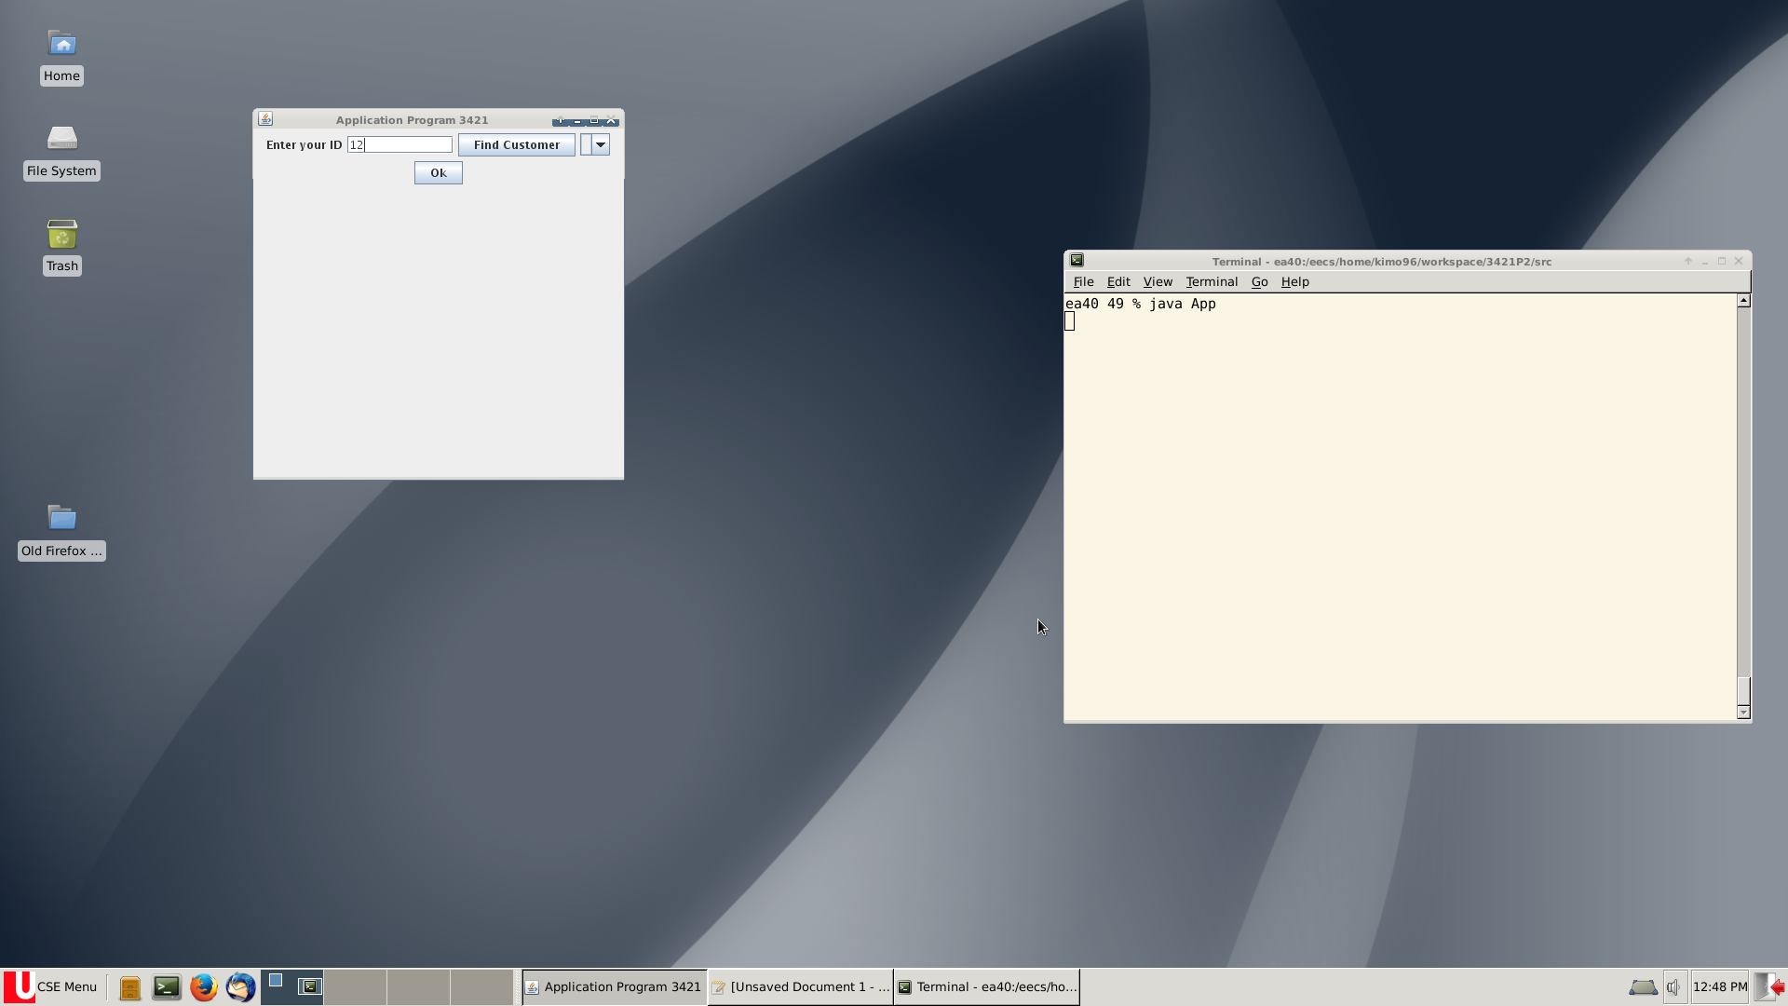
figure 1

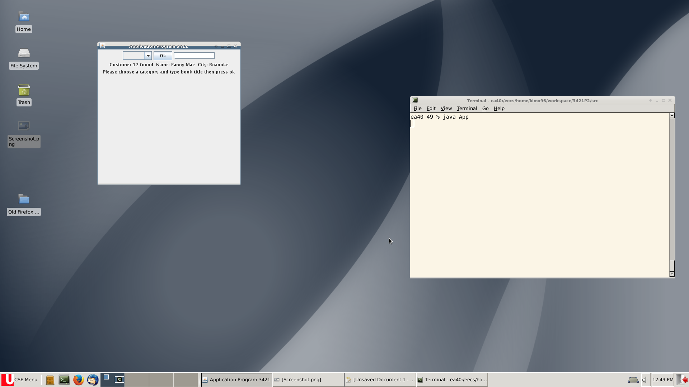
figure 2

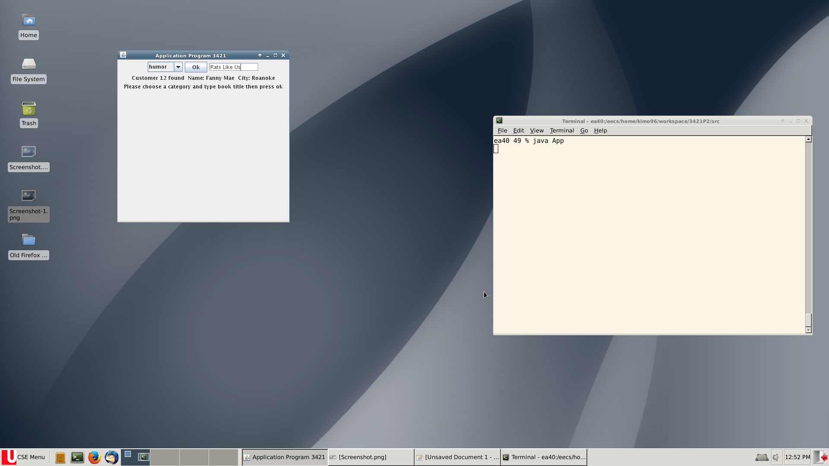
figure 3

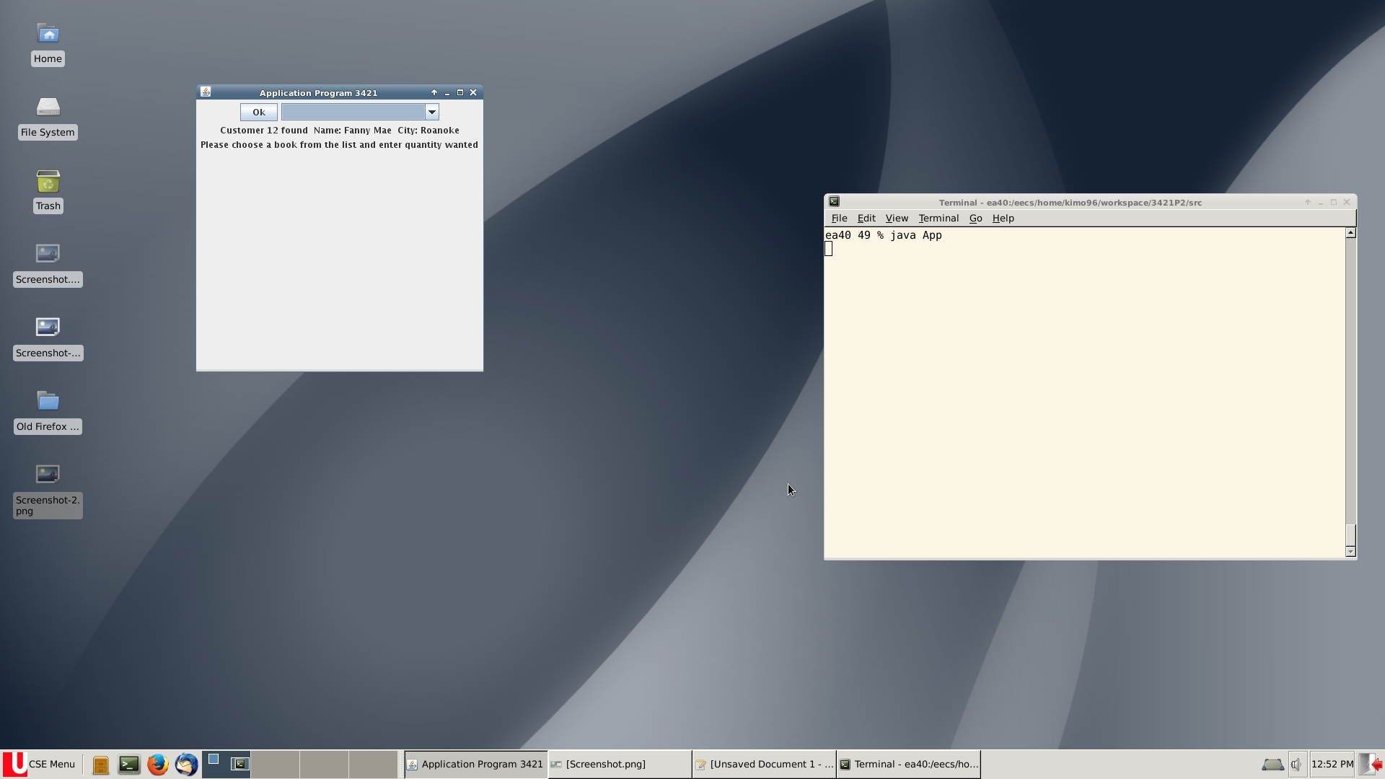
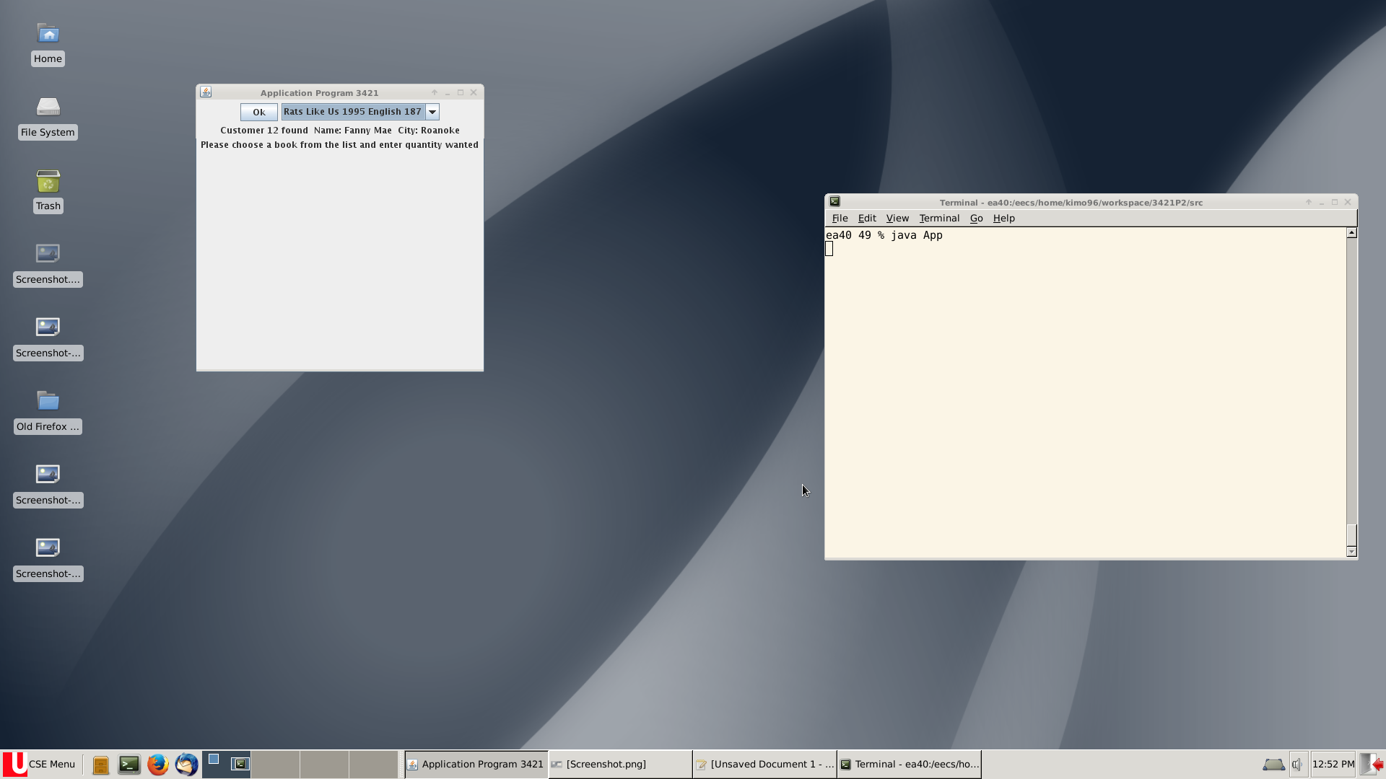
figure 4

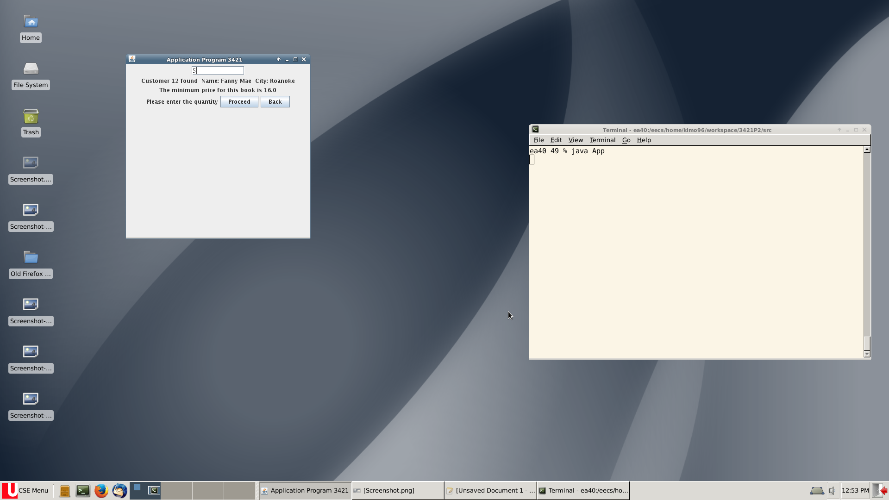
figure 5
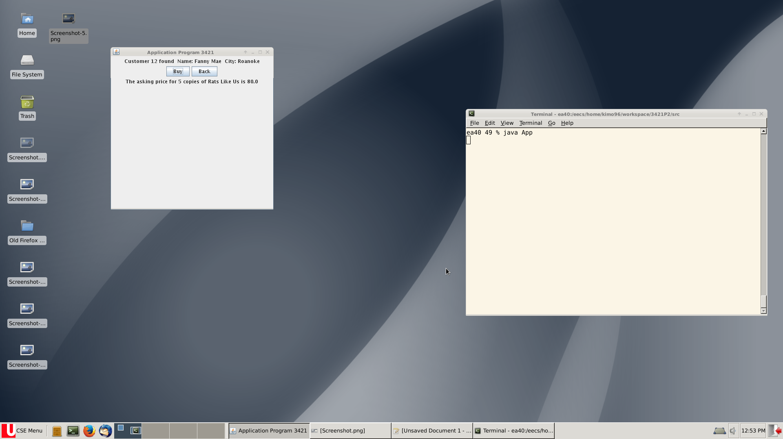
figure 6

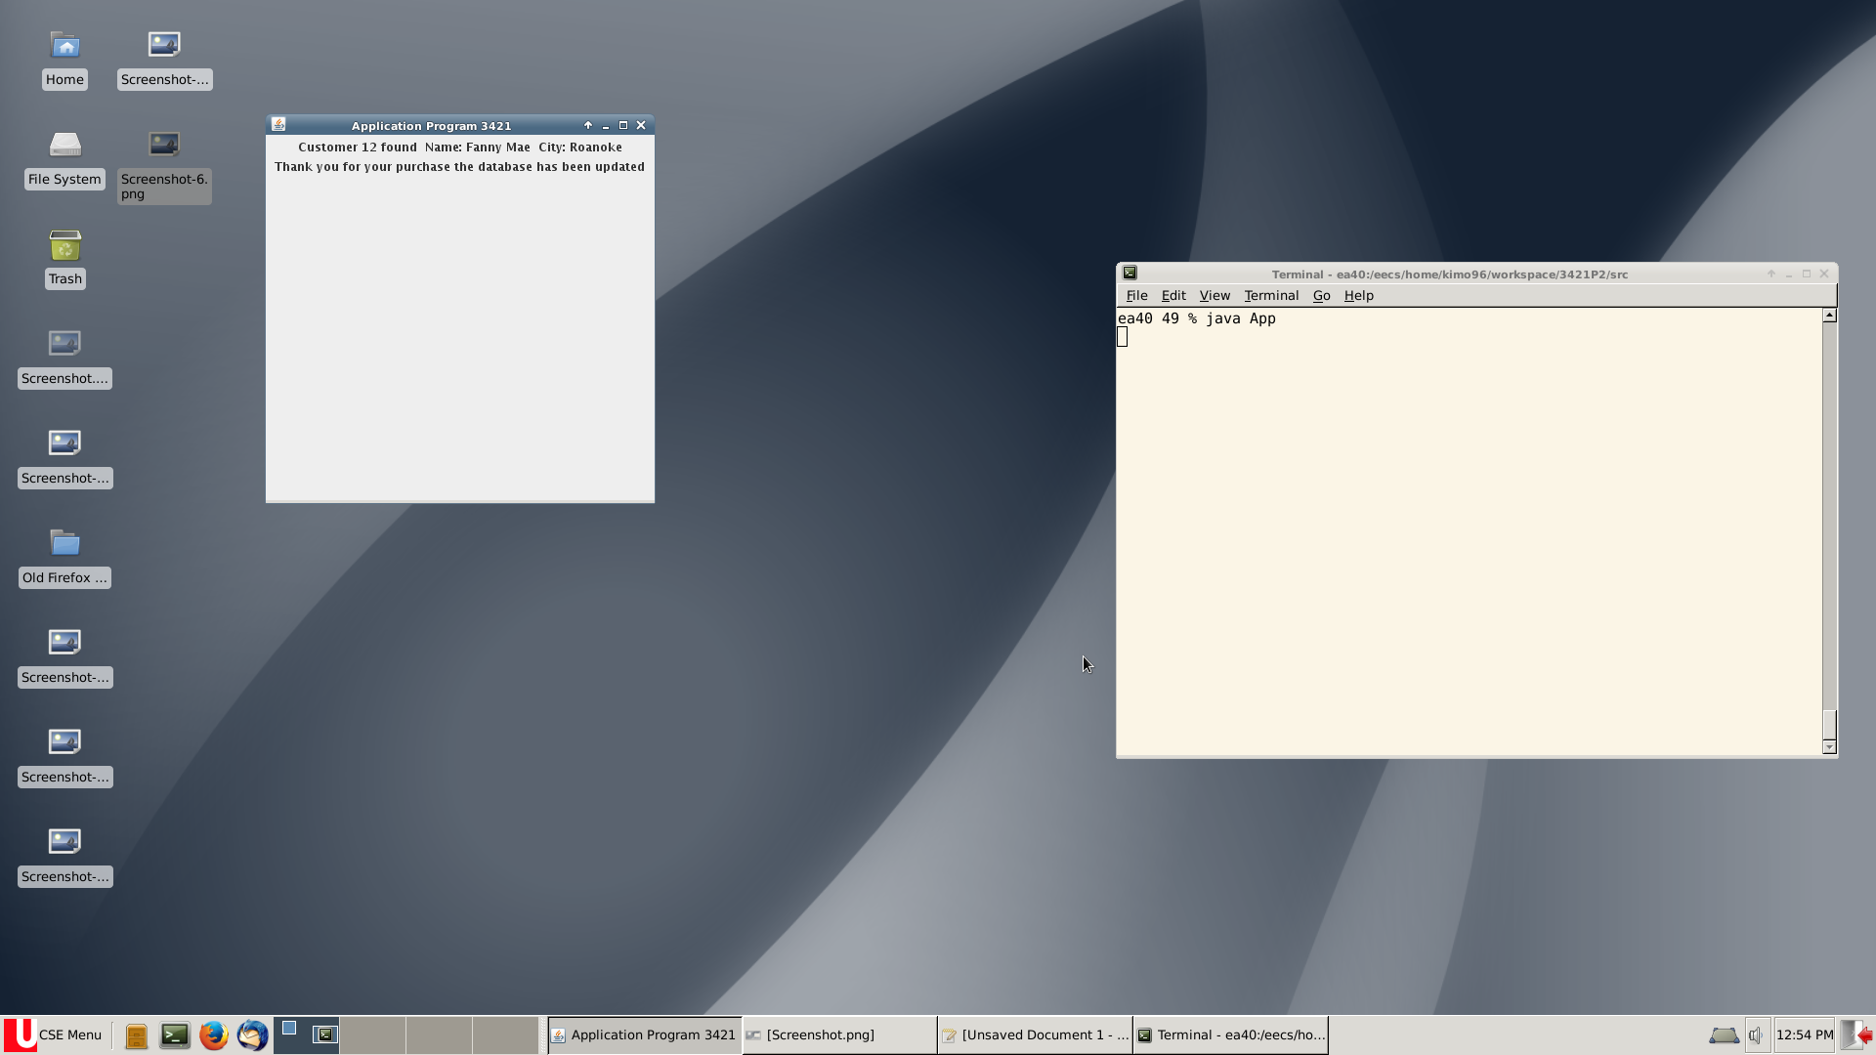
figure 7

3 Explanation of program mechanics

This part is a walk through the screenshots providing steps and explanation of the main parts of the program

in figure1: the client is supposed to enter the cid press enter then click the find customer button if found it will return the name and city of the customer
if not it will return a text saying not found

in figure2: this is phase 1 the client is asked to choose a category and enter the book title of the book the client wants to find then press ok to find the book if found program goes into phase otherwise it returns not found please try again

in figure4: client is supposed to choose a book from the list of found books then press ok if nothing is chosen nothing will happen on pressing ok

in figure5:phase 2 is started which asks the client to put in a quantity
it shows the minimum price offered by the clubs this customer is a member of and the client has 2 options proceeding to the buy phase (3)
or back. The back button takes the client back to phase 1 to find a new book

in figure6:phase 3 the program shows the client the asking price of the quantity entered and the client then has 2 options either buying by pressing buy or going back to phase 1 by pressing back2to1

in figure7: the program thanks the customer for the purchase

