

Help Desk Software
Kyle Kern
Revision History

Date | Revision | Author | Description | Document Tracking
01.11.15 | 1.0 | Kyle Kern | Genesis
0.1.17.15 | 1.1 | Kyle Kern | Added domain layer
01.25.15 | 1.2 | Kyle Kern | Added service layer structure

TABLE OF CONTENTS

- INTRODUCTION
- USE CASES BY PRIORITY
3. USE CASE DIAGRAM
4. UML DIAGRAM
5. FULLY DRESSED USE CASES

- INTRODUCTION

This app allows a business to easily implement a help desk ticketing system. The first implementation of this app will give the ticketing system its classic functionality, with future improvements to come in later iterations. The basic functionality will be account and ticket management.
Customers will be able to go to a companies website and ask a question of that companies support team. Before they are allowed to ask a question they must sign up for a help desk account. This account will allow them to create tickets, view past tickets and also sign up for account notifications via emails.
The agent of the help site signs up for an account the same as the customer however there account is given admin status. This means when they login they will see a different interface than the customer, mainly ticket queues that have the newly created tickets in it. Agents can also assign themselves to a customer’s ticket, and remove the ticket from the general ticket queue, which is visible to all. Once an agent responds to a ticket the customer can then log into their account and view the response.
Future implementations for the customer will include account alerts such as SMS or email. Admin accounts will also have the ability to customize their ticket queues and also sign up for account alerts based on ticket changes.

2. USE CASES BY PRIORITY

UC1: Create Help Desk Account – Required for other app functions
UC2: Log into existing account - Required for other app functions
UC3: Create new help ticket – Implemented in weeks 1-7
UC4: Create response to existing help ticket – Implemented in week 8
UC5: Update ticket status
UC6: Set up ticket notification settings
UC7: Create custom ticket queue

3. USE CASE DIAGRAM

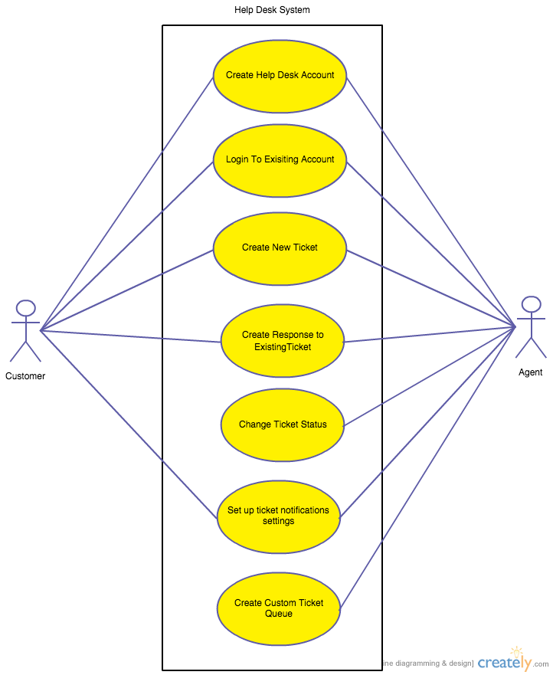
4. UML DIAGRAM
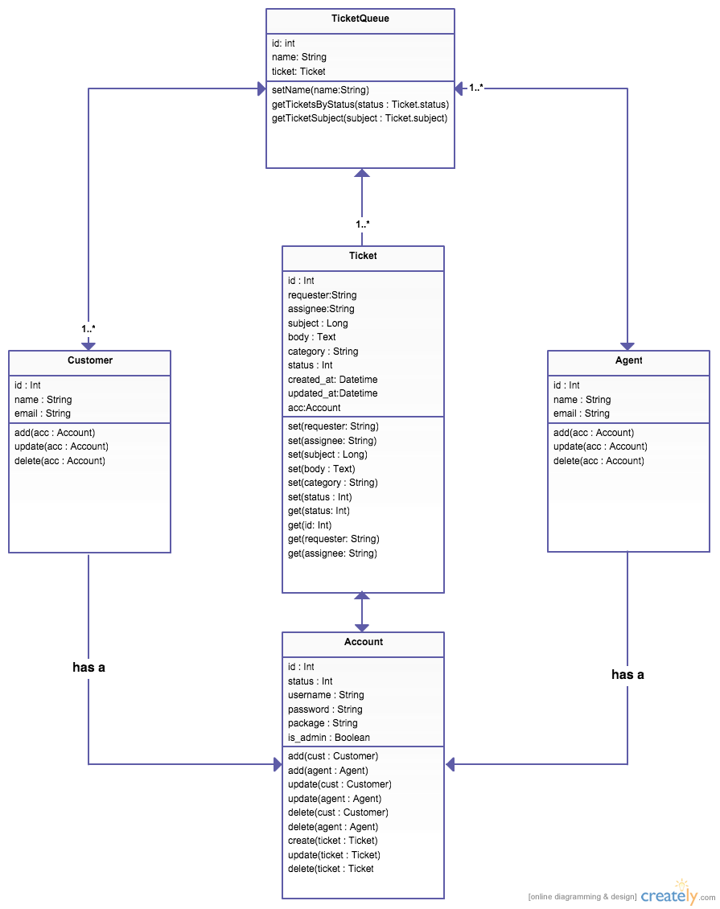

- FULLY DRESSED USE CASES

UC3: Create new help ticket
Primary Actor: Customer

Assumptions:
Customer has already created help desk account and has logged into account

Stakeholders:
Company implementing Help desk software wishes to give their customers access to a ticketing system where they can get their questions answered.

Pre-conditions:
The customer has a registered help desk account and has logged in successfully

Post-conditions (Success Guarantee):
Customer has successfully created and submitted a new help desk ticket and can view the ticket status in their help desk account.

Flow of Events:
- Customer is shown a UI that gives them the option to ‘Create a New Ticket

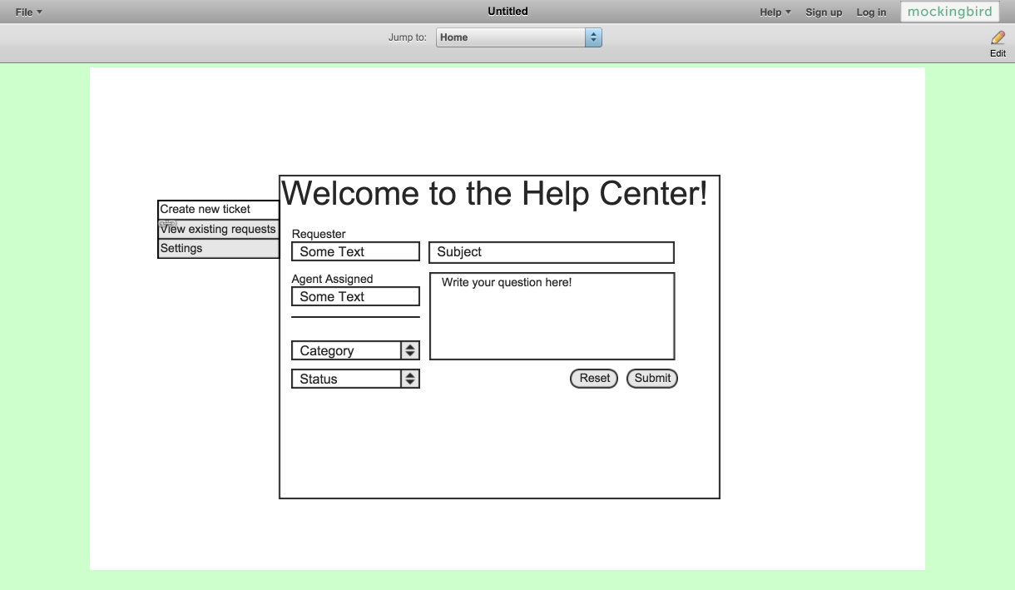
- Application checks all entered fields for format validity. (See requirements below.)
System/UI Requirements
  - ‘Requester’ Field must include a valid email address
  - Customer’s enter ‘Subject’ and ‘Body’ must include text
ALT FLOW 2.A1 Customer leaves a field blank
Will not submit until all field are filled.
Error window, tells customer that they must fill in all required fields

- Customer clicks the ‘Submit’ button
- Once Submitted the page will show a success page that includes the Ticket ID for reference.

Thanks for your request <username>, someone will get back to you shortly!
Ticket Reference ID: <ticketID>

UC4: Create response to existing help ticket
Primary Actor: Agent

Assumptions:
Agent has an admin account and is logged in

Stakeholders:
Company implementing Help desk software wishes to give their employees the ability to respond to a customer’s question via a ticket response

Pre-conditions:
The customer has created a ticket and the agent is logged into their admin account.

Post-conditions (Success Guarantee):
Agent is assigned to a customer created ticket and adds a response to the ticket which is visible to the customer

Flow of Events:
- Agent is shown a new ticket queue

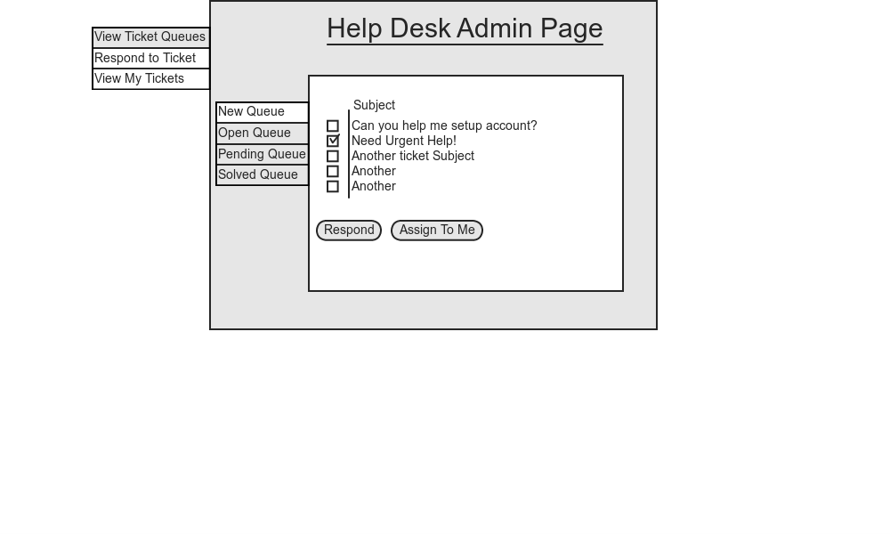
- Agent clicks on ticket
- Agent is shown customer created ticket with a text field to respond to customers request.
- Agents username is added to the tickets ‘Agent Assigned’ Field
- Application checks all entered fields for format validity. (See requirements below.)
System/UI Requirements
  - ‘Response’ text area must contain text
  - Customer’s enter ‘Subject’ and ‘Body’ cannot be edited
ALT FLOW 5.A1 Agent leaves a field blank
Will not submit until all field are filled.
Error window, tells agent that they must fill in all required fields

- Once Submitted the page will show a success page that includes the Ticket ID for reference.
Successfully updated: Ticket Reference Id is <ticketID>

