Week 5 Execution Doc – Kyle Kern
Week 5 HWExecution.doc – Kyle Kern

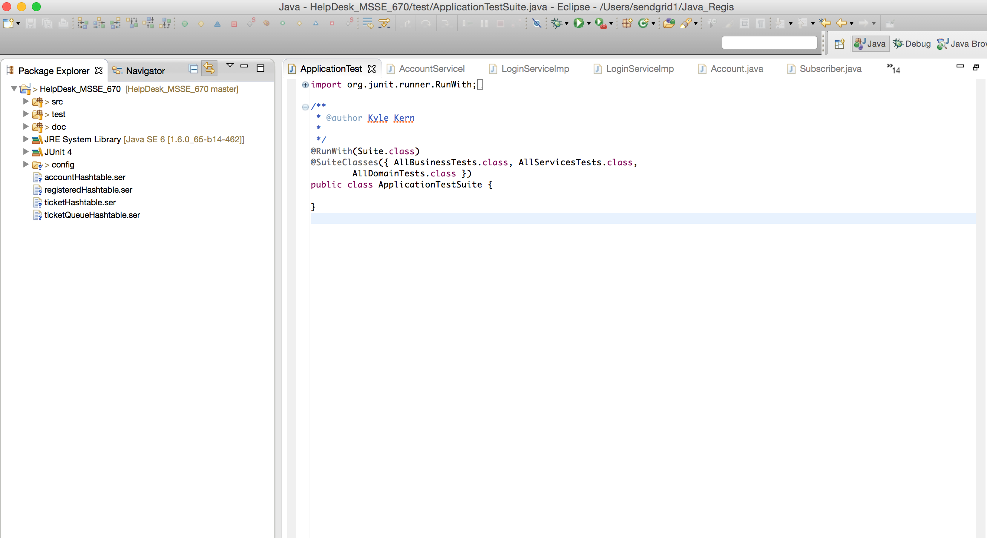

Week 2 HWExecution.doc – Kyle Kern

