Healthcare Worker Survey Analysis Report

Digital Transformation and Patient Records Assessment

Date: **17 Sep 2025**

# Table of Contents

1. Demographics and Professional Distribution

2. Tasks and Responsibilities

3. Work Environment Assessment

4. Digital Tools Usage

5. Patient Record System Evaluation

6. Digital Transformation Awareness and Impact

# 1. Demographics and Professional Distribution

This section presents the demographic characteristics and professional distribution of healthcare workers surveyed across various health facilities in Barbados.

## Distribution by Healthcare Facility

|  |  |  |
| --- | --- | --- |
| **Health Facility** | **n** | **Percentage (%)** |
| Queen Elizabeth Hospital | 27 | 32.9 |
| Winston Scott Polyclinic | 7 | 8.5 |
| Eunice Gibson Polyclinic | 6 | 7.3 |
| Branford Taitt Polyclinic | 5 | 6.1 |
| Randall Phillips Polyclinic | 5 | 6.1 |
| St. Jospeh Polyclinic | 5 | 6.1 |
| Maurice Byer Polyclinic | 5 | 6.1 |
| David Thompson Health and Social Services Complex | 5 | 6.1 |
| Six Roads Polyclinic | 5 | 6.1 |
| Edgar Cochrane Polyclinic | 4 | 4.9 |
| Frederick Miller Polyclinic | 1 | 1.2 |

## Gender and Age Distribution

Figure 1 shows the distribution of survey participants by gender and age groups.

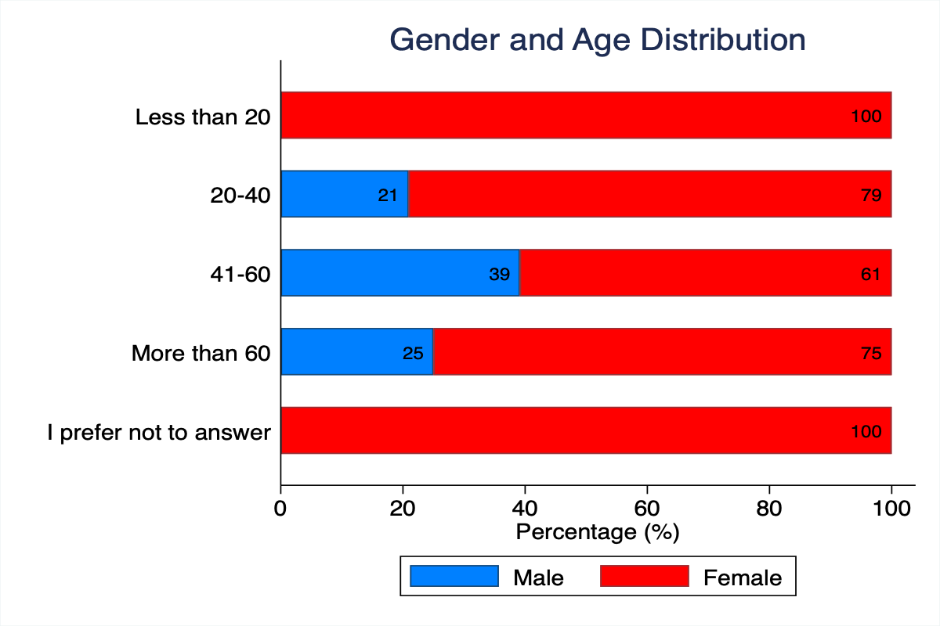

Figure 1: Gender and Age Distribution (Percentages)

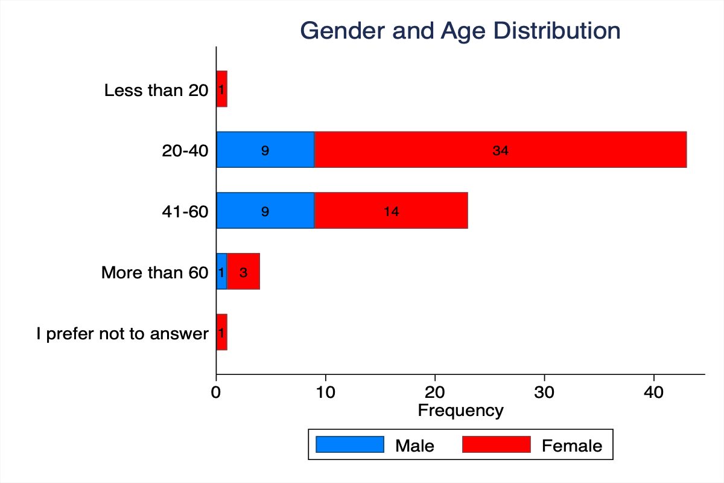

Figure 1b: Gender and Age Distribution (Frequency)

## Healthcare Professional Types

The survey included various types of healthcare professionals working across the facilities.

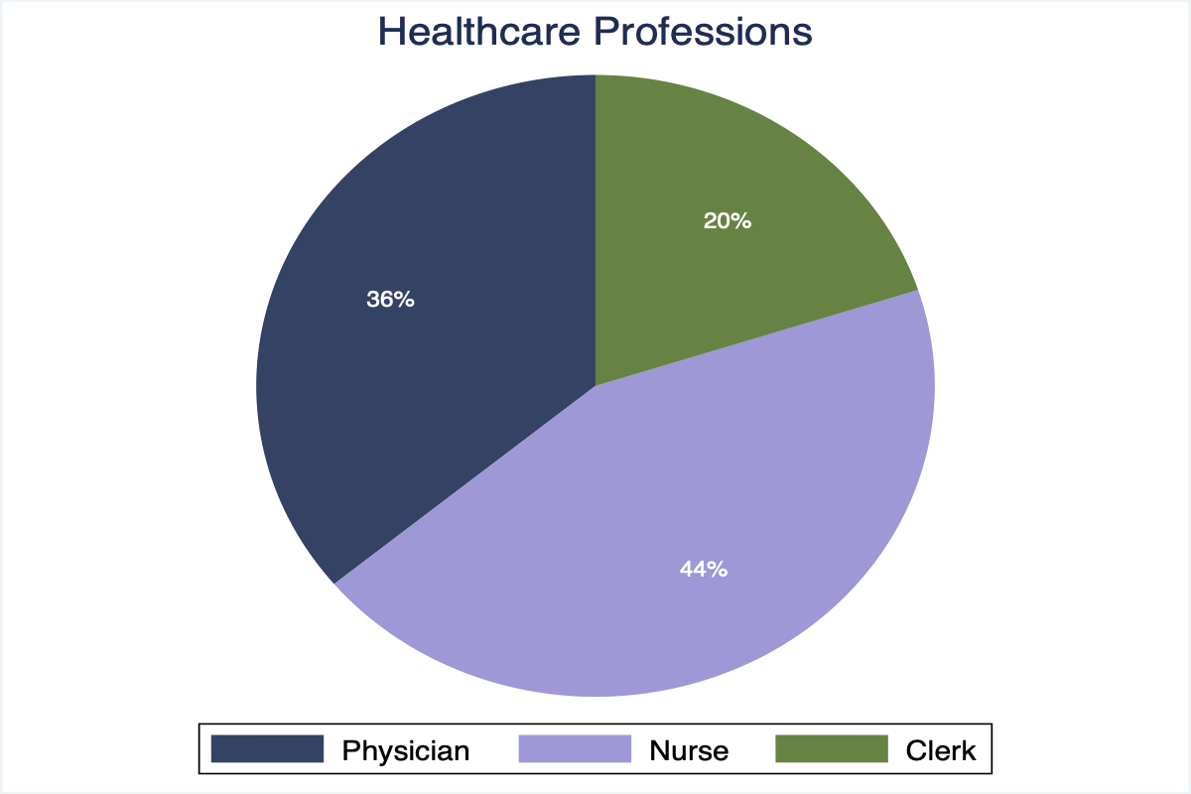

Figure 2: Distribution of Healthcare Professions

# 2. Tasks and Responsibilities

This section examines the various tasks and responsibilities undertaken by healthcare workers during their typical work week.

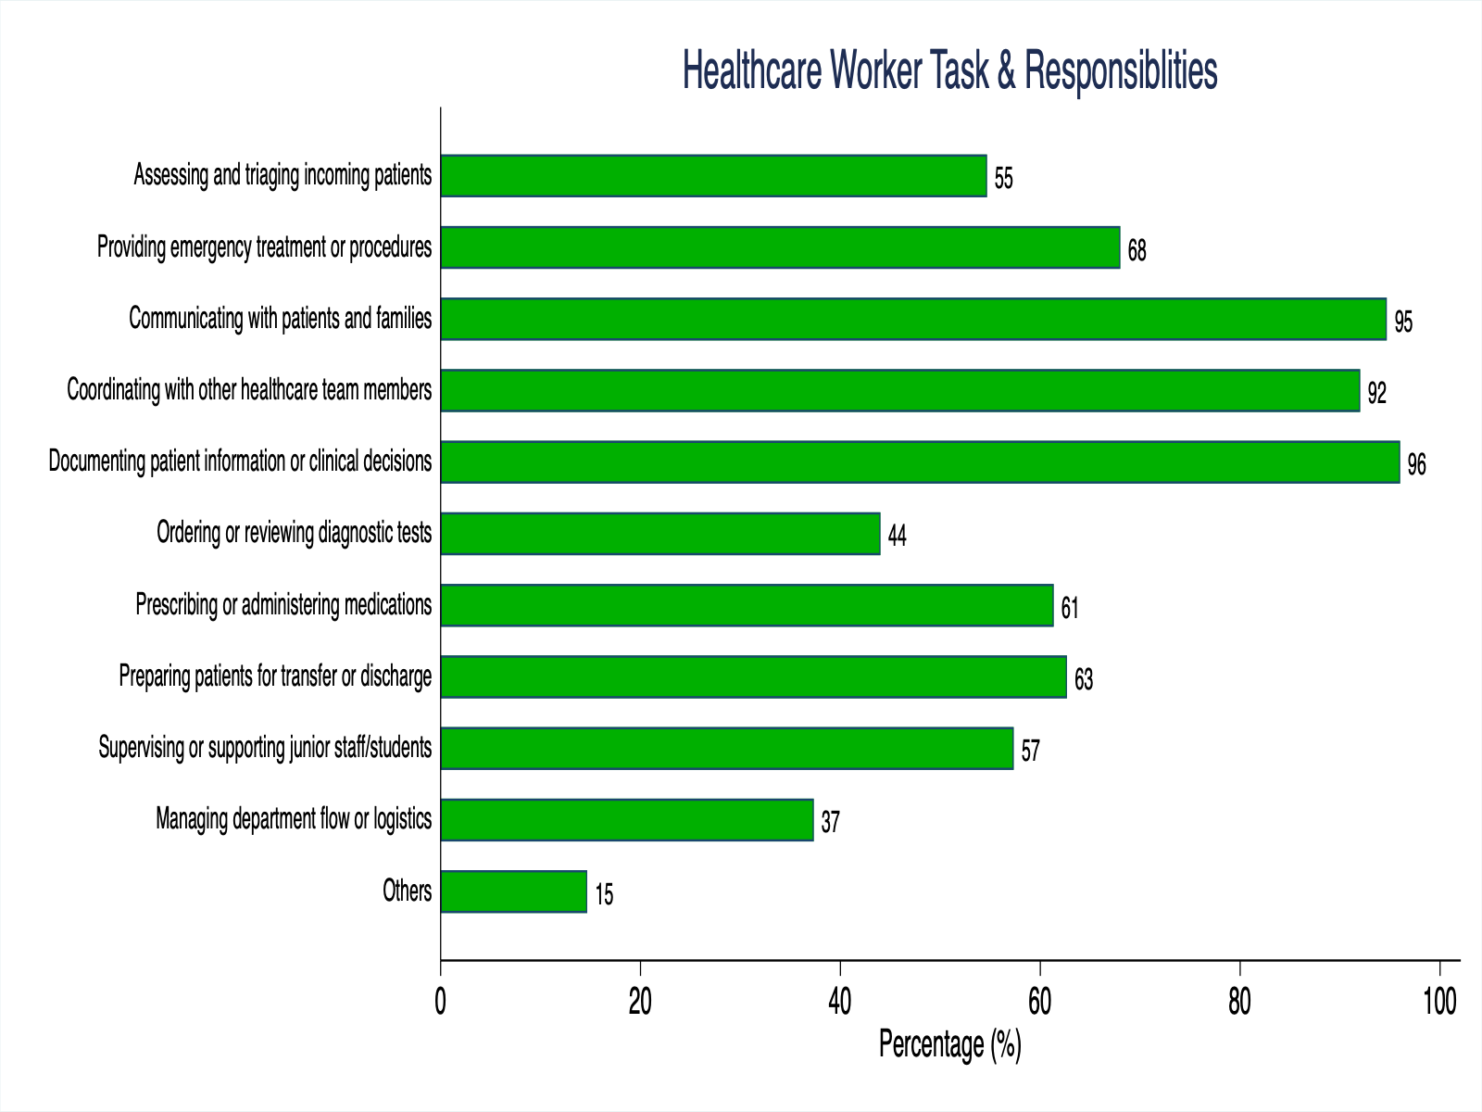

Figure 3: Healthcare Worker Tasks & Responsibilities

The chart above shows the percentage of healthcare workers engaged in different types of activities, highlighting the diverse nature of their roles and responsibilities.

# 3. Work Environment Assessment

## Typical Work Day Reflection

Healthcare workers were asked whether their surveyed shift reflected a typical day for them.

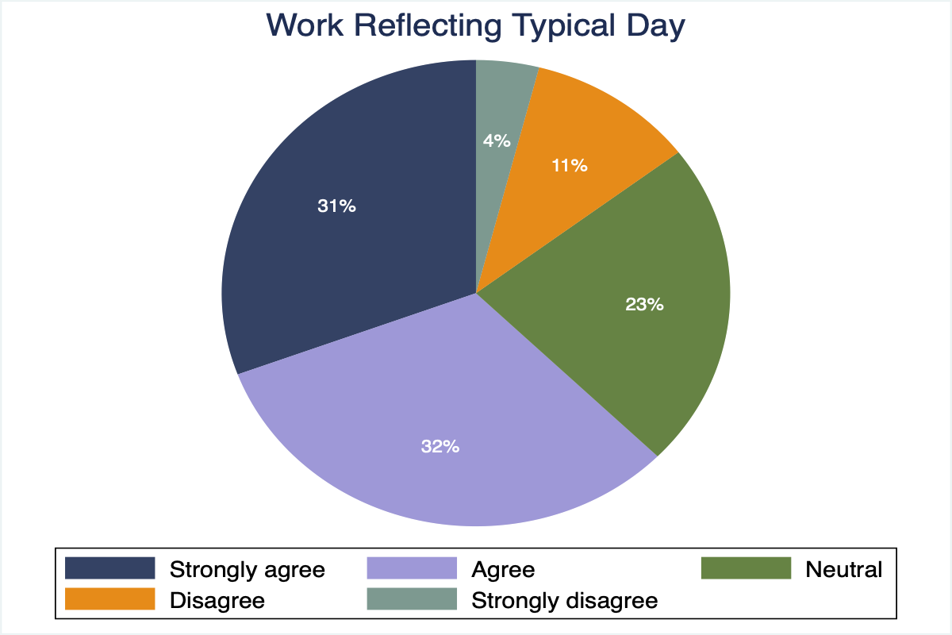

Figure 4: Work Reflecting Typical Day

# 4. Digital Tools Usage

## MedData Usage by Healthcare Professionals

The following chart shows how different types of healthcare professionals use MedData, the electronic medical records system.

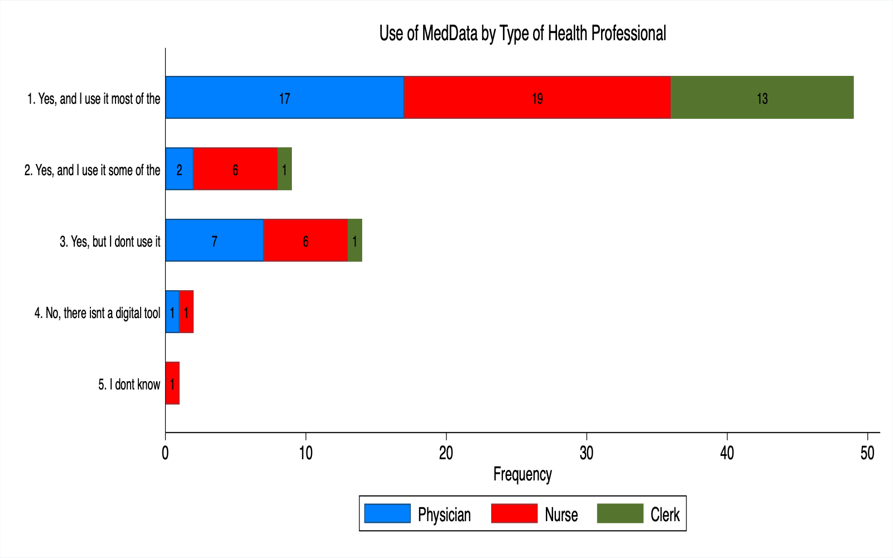

Figure 5: Use of MedData by Type of Health Professional

## Digital Tools and Systems Usage

Healthcare workers utilize various digital tools and systems in their daily workflow. The chart below shows the percentage of workers using different digital functionalities.

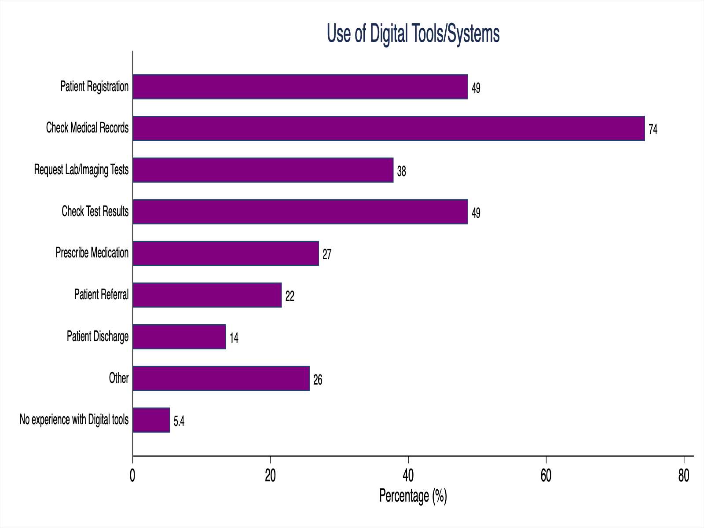

Figure 6: Use of Digital Tools/Systems

# 5. Patient Record System Evaluation

Healthcare workers provided detailed feedback on various aspects of the patient record system. The following analysis presents their perceptions across multiple dimensions of system usability and effectiveness.

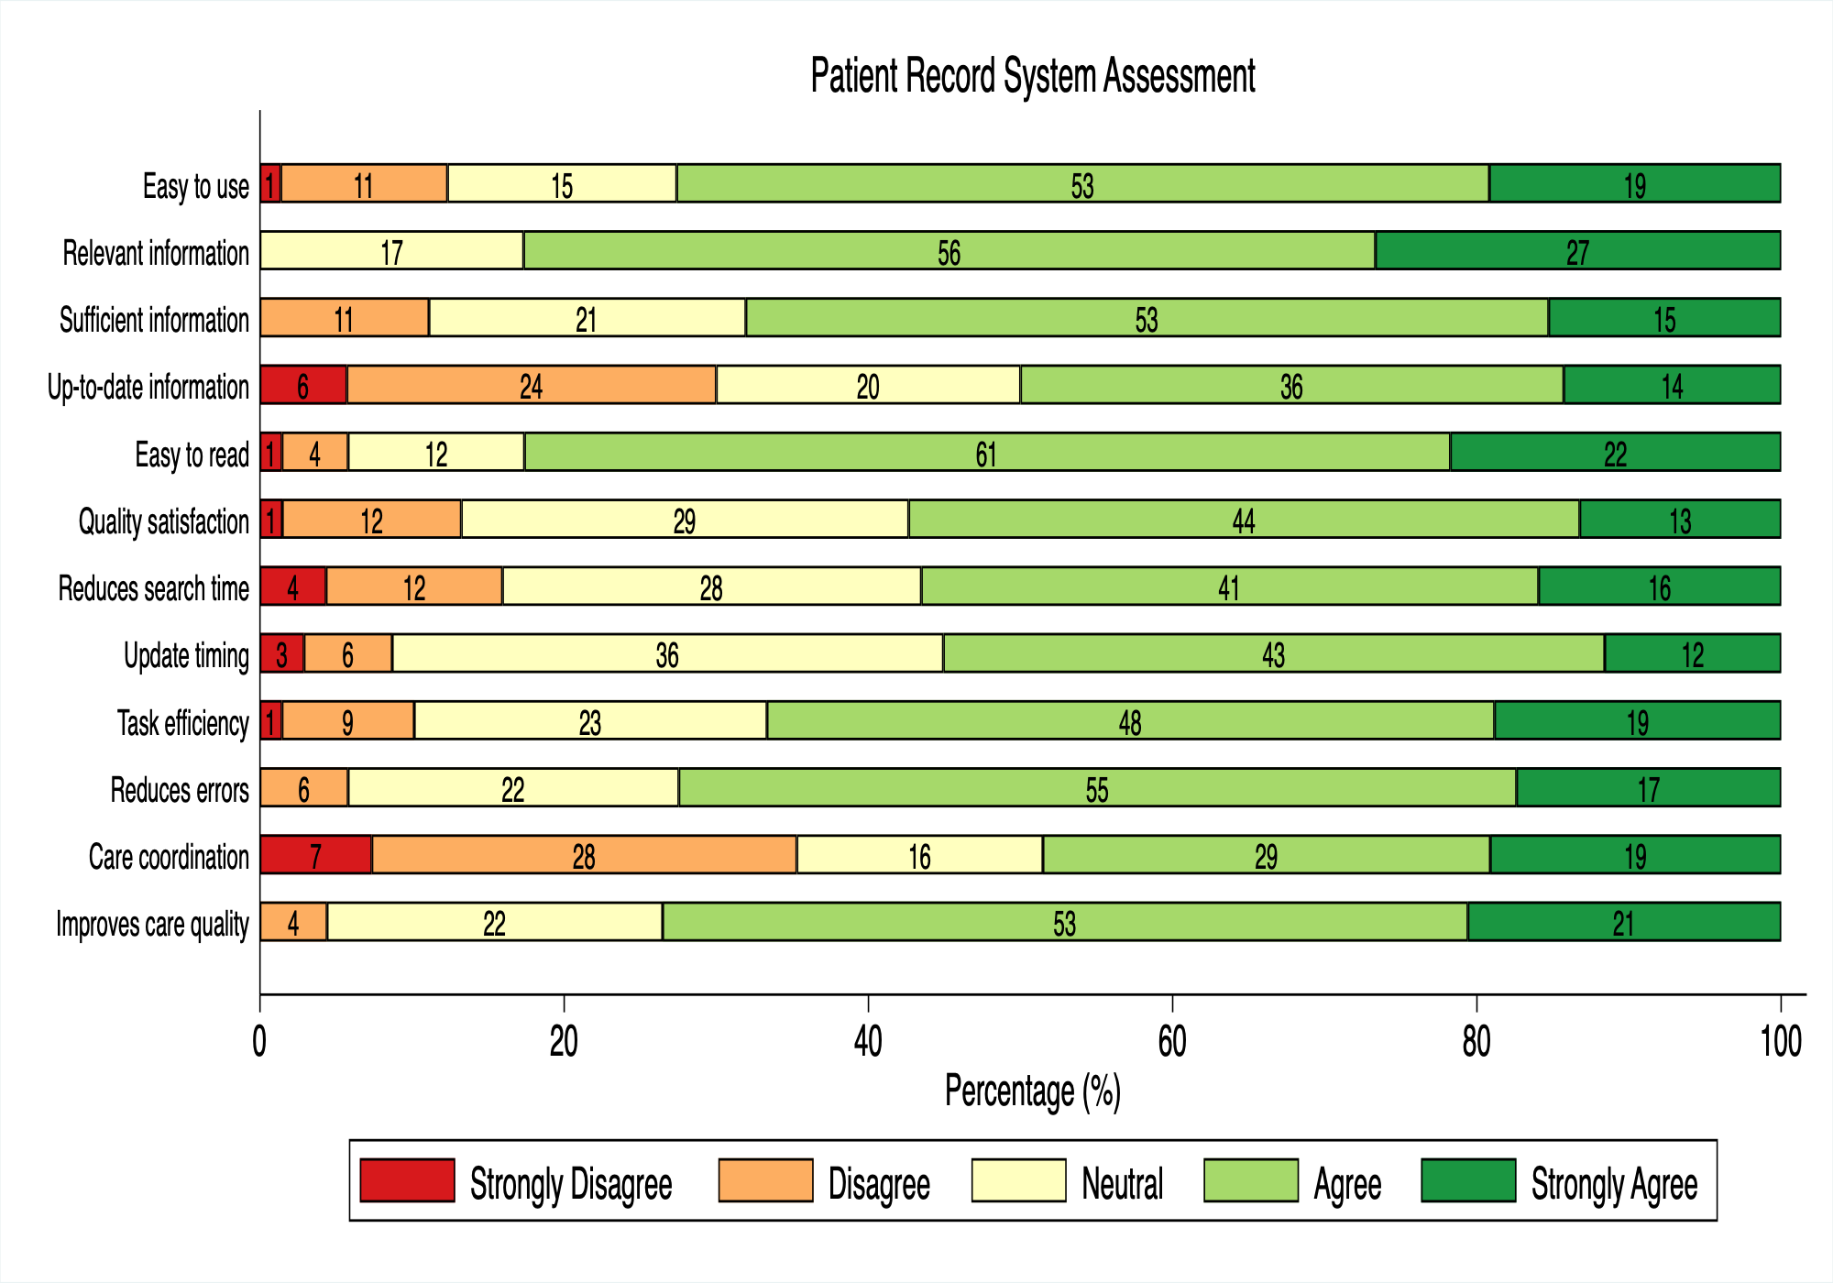

Figure 7: Patient Record System Assessment

The stacked bar chart above shows responses to twelve different statements about the patient record system, with responses ranging from 'Strongly Disagree' to 'Strongly Agree'. This provides insight into user satisfaction and areas for potential improvement.

# 6. Digital Transformation Awareness and Impact

## Awareness of Digital Transformation Project

Healthcare workers were surveyed about their awareness of the digital transformation project at Queen Elizabeth Hospital (QEH).

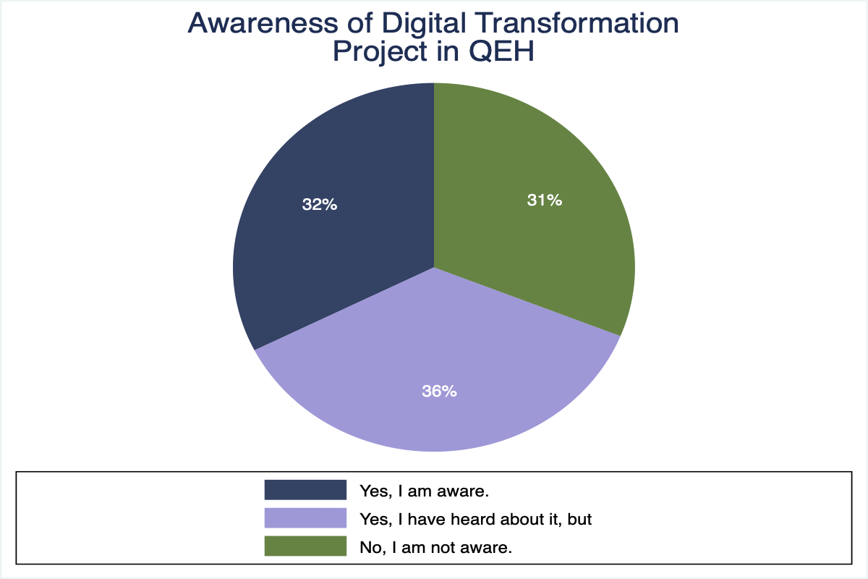

Figure 8: Awareness of Digital Transformation Project in QEH

## Perceived Impact of Digital Transformation

The following chart shows healthcare workers' perceptions of how digital transformation has impacted various aspects of their work and patient care.

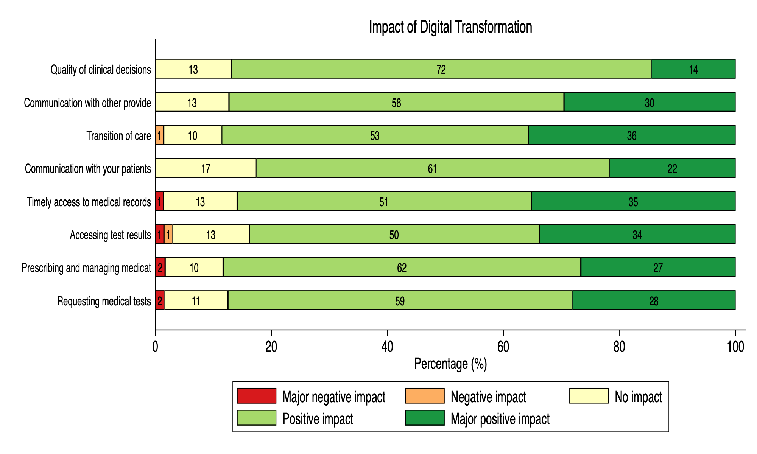

Figure 9: Impact of Digital Transformation

This comprehensive assessment reveals the multifaceted impact of digital transformation initiatives across different domains of healthcare delivery.

# Conclusions and Key Findings

## Key Findings:

• The survey captured responses from healthcare workers across multiple facilities

• Healthcare workers engage in diverse tasks and responsibilities

• Digital tools usage varies by profession and task type

• Patient record system shows mixed user satisfaction levels

• Awareness of digital transformation initiatives varies among staff

• Digital transformation impact is perceived differently across various work domains

## Recommendations:

• Enhance training programs for digital tool utilization

• Improve user experience design for patient record systems

• Increase communication about digital transformation initiatives

• Target interventions based on professional role and facility type