5G00GC09-3001/3002 Datapipelines [sic]
Data Pipeline Project
Phase 0: Planning and Preparation

This pipeline-construction assignment is an individual work. It has been split into phases to be completed in order. The phases require their corresponding Moodle submissions and have their own deadlines. These instructions are for the initial Phase 0, and the instructions for the following phases are going to be published at a later time.
Deadline for Phase 0: March 31, 2025, 23:59 EEST
During Phase 0, you are to make an overall plan about a pipeline, select technologies, and get ready to acquire the needed data. Report your work by filling this document and submitting it in Moodle before the deadline.

Planning the Pipeline: the Overall Idea
The data pipeline to be implemented must satisfy these requirements:
- The pipeline must somehow make your life (personally) easier. (I.e., the pipeline must be actually useful for you.) The pipeline can be related to, for example, school, hobbies/interests, economy, planning/scheduling, decision-making, or something else.
- The pipeline must gather data from several (more than one) sources and combine them in a sensible manner.
- The pipeline must include several distinct steps of moving/processing data. The split into these steps (tasks) must be logical, and each of them must have a well-defined purpose. Ideally, the tasks and executing them can be distributed across multiple computers (not strictly required, though).
- The pipeline must be robust and work reliably. Even if you know that the data sources generally produce high-quality data, the pipeline must validate the data and be prepared for unexpected situations. Erroneour data should be corrected, if possible. Some kind of a retry functionality should be included.
- The pipeline must clearly transform the data. Some new data must be produced by the process.
- Data must be loaded into a database at some point during the process. (E.g., a simple local SQLite database will do.)

Plan the pipeline you are going to implement and fill the table.
Question | Answer
What does the pipeline do? | The pipeline takes the data of collectible cards from the game Bang Dream (aka Bandori) via API, the user can pick the cards that they have collected and see the optimal combination of cards for different kinds of events.
What kind of a pipeline is it: a batch-processing pipeline, a stream-based one, or what? Is the pipeline run manually, is it triggered by some event, or is it, perhaps, run periodically by some timer or scheduling mechanism? Is parallel execution applied? | As the data is not very fluid (it is updated in small batches +- once in 10 days), it is a batch-processing pipeline. User builds the database of their own cards by themselves, so it is run manually. Parallel execution is implemented, when the same data is being demonstrated on the HTML page, and at the same time it is being transformed by another function.
What is the actual purpose/goal? (Why is the pipeline useful for you? What problem does the pipeline solve?) | Basic idea of the game: it is a rhythm game, where you play songs and get some score. To play it, you need to form a group of 5 characters. Each character has many cards, which may differ by rarity, power, skills, and attributes. There is always an event in the game, during which some cards give the player bonus score, and you get better awards in the end of the event.  The pipeline helps the user form these bands, so their bonus score is at maximum.
How are the outputs of the pipeline used? (Perhaps visualized by some dashboard view? Written into reports – to be used how? Emailed? Posted somewhere? ...) | The user will see 3 pages: all cards in the game, all cards that they own, and the formed groups, which is the final product of this project.
What input data are used by the pipeline and from which sources? Can you acquire them legally? (If not, you should, naturally, modify/change your pipeline idea...) | The input data will be taken from Bandori Party API, which can be used freely. The file with user’s cards is created manually.
Tell about your expectations regarding the input data. Consider, e.g., the quality and availability of them. What kinds of data-related problems may occur? | The data from the API can be easily checked in-game. There shouldn’t be any problems with acquiring the data, however, this API is missing some important attributes belonging to the data, such as in which servers the card is available. This should not affect the pipelines anyhow, but it lowers the reliability of the data.  User’s data can contain, for example, invalid IDs of the cards, so it should be double checked for quality.
How are the data transformed when processed by the pipeline? | The data is sorted and then combined into different groups.
What kind of a database(s) is going to be used and how? | - The whole list of cards from Bandori Party API, in json format. Will be visualised on the main page and from it will be formed user’s own database.  - User’s cards. A csv file with IDs of cards, that the user owns.  - The formed groups, the resulting database, in json format.
/0.5 XP
Add here a figure/diagram illustrating different tasks/phases of the pipeline and how the data flows between them. Use, for example, boxes or circles for the tasks and arrows to indicate the data flows. Also, add text to clarify the situation – at least names for the tasks and some explanations/descriptions about the nature of the data flowing between them should be present.
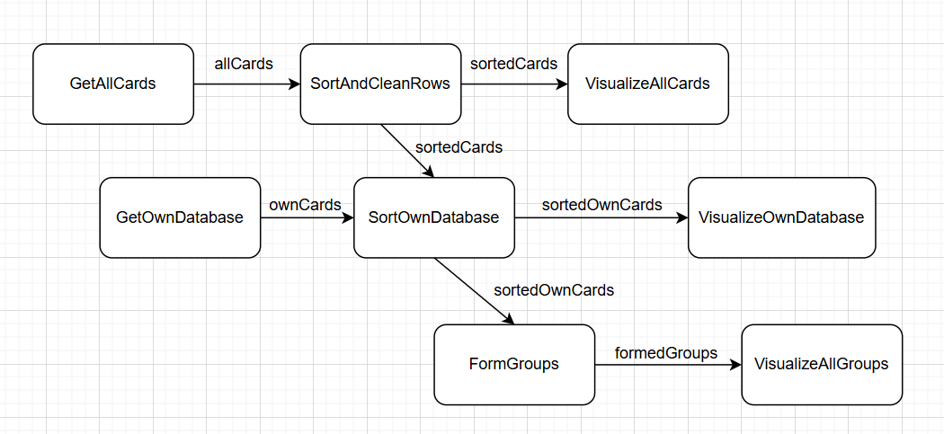/0.5 XP
For each individual task (or such) depicted in the figure you added, fill a table row. (Add rows as necessary.)
Name of the task | Input data for this task and its origin(s) (e.g., another task) | Output data and its destination(s) (e.g., receiving task(s)) | The purpose/function of the task explained briefly | List errors/problems that may occur when running this task. How is data quality guaranteed and how are errors handled?
GetAllCards | Bandori Party API | Json file allCards with all cards, SortAndCleanRows | We get the whole database of cards | The data maybe unavailable for some reason; if the response has an errorous code, the user will see it on the page.
SortAndCleanRows | allCards, GetAllCards | sortedCards,  VisualizeAllCards, | The page allows the user to sort the whole list by character or attribute; the task will sort it according to chosen filters | If user chooses filters, for which no card fits, they will see a message. If some rows lack some data (e. g., pictures), they will be removed.
VisualizeAllCards | sortedCards,  SortAndCleanRows |  | The user sees the sorted list of cards. Sorting and visualizing can be repeated many times.
GetOwnDatabase | User’s csv file | List of ID’s cards ownCards, SortOwnDatabase | We get the database of user’s cards | If the file does not exist, the user will be informed.
SortOwnDatabase | allCards,  ownCards, GetOwnDatabase | sortedOwnCards, FormGroups | The cards from ownCards are retrieved. | If some ID’s in ownCards are invalid, they will be skipped.
VisualizeOwnDatabase | sortedOwnCards,  SortOwnDatabase |  | Own cards are show on the page.
FormGroups | sortedOwnCards, SortOwnDatabase | formedGroups, VisualizeAllGroups | The groups are formed from own cards. | If the ownCards database has less than 5 entities, no group can be formed. The user will be informed. |  |  | The user sees the sorted list of cards. Sorting and visualizing can be repeated many times.
VisualizeAllGroups | formedGroups, FormGroups |  | The user sees tables with all groups formed. |  |  | ownCards, FormGroups | The user sees the sorted cards and can add them to the database. | If the user tries to add a card, which is already in the database, the user will be informed about it.
/0.5 XP

Technologies
Consider technologies (programs/platforms/frameworks/libraries/languages/...) that might be used to implement your pipeline. You should consider several options and try to find a good one for the task at hand. Fill the table.
Question | Answer
What technologies do you intend to use? (Consider all the parts of the pipeline.) | I intend to use Prefect pipelines for the pipelines. Also I’m going to use requests, json, and os to work with the databases. For the page I’m going to use React.
Why? What are their benefits regarding your intents, goals, and problem setting? | Prefect seems like an easy-to-use tool, which appears to have much more materials about.
What alternatives were considered, and why were they dismissed? | I also considered Luigi, but it seemed more suitable for big data, which is not handled in this project.
Based on the technological choices made, is it possible to distribute the execution of the tasks of the pipeline across multiple computers? Regarding which tasks and how? | I think it is not possible.
Are there any special constraints, limitations, or needs (e.g., regarding hardware requirements, software licences, or the ways of implementing the data-processing logic) or other matters you have to take into account in your implementation because of the technological choices? | —
/0.5 XP
totally: /2 XP

