

Faculty of Engineering

Cairo University

Computer Engineering Department

**Advanced Programming Techniques**

Extra Features Phase One

SEM Team 10

Submitted to**:**

Dr. Mayada Hadhoud

Submitted by:

Kerollos Eshak Takla

Mostafa Yasser Darwish

Omar Hashim

Ehsan Sayed

We will make like google accounts, each user will have his own account with specific email and password.

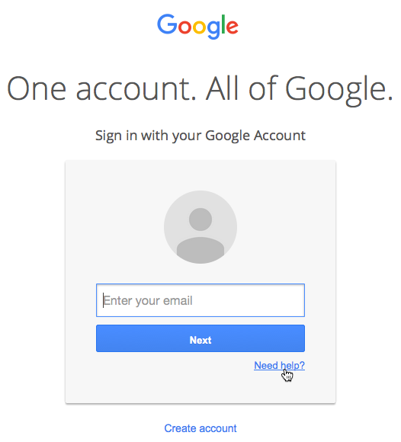

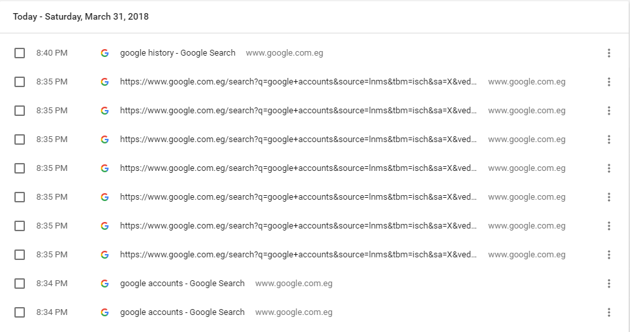Also, we will store searching queries for each user show them in the history.