
Higher Technological Institute
10th Of Ramadan City
Computer Science Department

BridgeX
Social E-Learning Platform with AI-Powered Learning Communities

Abdullah Osama Salem Abaza 42021382
Abd El-Rahman Ayman Ahmed Fahmy 42021381
Kerolos Ayman William 42021148
Mostafa Mohammed Mostafa 42021383
Omar Mohammed Tawfik El-Tabakh 42021308

Supervised by: Dr. Eman Nassar

Acknowledgment

Abstract

Table of Contents
1 Chapter 1 Backend 7
1.1 What is the backend? 7
1.2 System Architecture 8
1.2.1 Architecture Patterns 8
1.2.2 Component diagram 11
1.2.3 High Level System Architecture 12
1.2.4 Technologies Used 12
1.2.5 Database Overview 13
1.3 Database design 14

Table of Figures
Figure ‎1.1 Why LLMs Hallucinate 5

List of Tables
Table ‎1-1Table 1 5

Abbreviations

Abbreviation | Full Form

Chapter 1 Backend

What is the backend?
Backend development refers to the server-side part of any application development. It focuses on how a website or application works behind the scenes, including everything from data modeling, storage, security concerns, the logic, databases, servers, and APIs that process user requests and send appropriate data to the front end (what users see and interact with).
Backend is the most important part in any system cause it deals with the user data directly and nothing is more important than the data.
Key Elements of Backend Development:
- Server: A machine or program that handles requests from clients (like browsers) and sends back responses.
- Database: Stores and manages data (e.g., user profiles, posts, products). Common databases include MySQL, PostgreSQL, and MongoDB.
- Backend Languages: Used to write the logic of the application. Common ones are:
  - JavaScript (Node.js)
  - Python (Django, Flask)
  - Java (Spring Boot)
  - PHP (Laravel)
  - Ruby (Rails)
- APIs: Interfaces that allow the frontend and backend (or other services) to communicate.
- Authentication & Security: Managing user login, authorization, and protection of data.
- Frameworks: Provide tools and structure to speed up backend development (e.g., Express.js, Django, Spring, Nest.js).

System Architecture

Architecture Patterns
Architecture Patterns are a means of representing, sharing and reusing knowledge.
An architectural pattern is a stylized description of good design practice, which has been tried and tested in different environments.
We used in the Bridgex system a combination of Modular architecture with 3-tier and repositories architecture to get the best of each architecture and dodge the disadvantage of them.
We will discuss each architecture we used with project structure and component diagram.

Repository architecture:
Sub-systems must exchange data. This may be done in two ways:
- Shared data is held in a central database or repository and may be accessed by all sub-systems.
- Each sub-system maintains its own database and passes data explicitly to other sub-systems. ″When large amounts of data are to be shared, the repository model of sharing is most used, and this is an efficient data sharing mechanism.
Advantages:
- Components can be independent, they do not need to know of the existence of other components.
- Changes made by one component can be propagated to all components. All data can be managed consistently.
Disadvantages:
- The repository is a single point of failure so problems in the repository affect the whole system.
- May be inefficiencies in organizing all communication through the repository.
- Hard to maintain the same logic across all same repository instances.
- Distributing the repository across several computers may be difficult and hard to scale in the long run.

3-Tier architecture:
It is a type of layered architecture that separates the structure into 3 layers. Supports the incremental development of sub-systems in different layers. When a layer interface changes, only the adjacent layer is affected.
- Data Layer: Manages data storage, access.
- Business Logic: Processes command, makes decisions, performs calculations, etc.
- Presentation Layes: Interface between user and application.
Advantages:
- Allows replacement of entire layers so long as the interface is maintained.
- Redundant facilities can be provided in each layer to increase the dependability of the system.
Disadvantages:
- Providing a clean separation between layers is often difficult and a high-level layer may have to interact directly with lower-level layers rather than through the layer immediately below it.
- Performance can be a problem because of multiple levels of interpretation of a service request as it is processed at each layer.
- It can be difficult to maintain when the application is very big due to each layer can contain a lot of services

Modular Architecture:
Modular architecture is a software design technique that emphasizes separating a system into independent, interchangeable modules that encapsulate specific functionality. Each module communicates through well-defined interfaces.
- Each module has a single responsibility.
- Modules can be developed, tested, deployed, and maintained independently.
- Modules interact via interfaces or APIs, not direct dependencies.
Advantages:
- Scalability: Easy to scale individual modules based on demand.
- Maintainability: Bugs are easier to isolate and fix.
- Reusability: Modules can be reused in other systems.
- Team Productivity: Teams can work on different modules simultaneously.
- Flexibility: Easier to upgrade or replace a module without affecting the whole system.
- Testing: Modules can be tested independently, simplifying unit testing.
Disadvantages:
- Complex Integration: Coordinating modules and managing inter-module communication can be challenging.
- Performance Overhead: Using APIs or messaging adds latency.
- Increased Initial Design Effort: Requires careful planning to define module boundaries and interfaces.
- Dependency Management: Requires discipline to avoid tight coupling.
So to get the best of all we used each architecture carefully to each vital and important component after carefully drawing his boundary will be a module each module contains 3-tier architecture one layer for business service and its interface, second layer is for database entities and last layer is for the API (Presentation layer), om the business services we used the repository patter to achieve its best across the module.
We don’t forget about the common module with contain common logic to not repeat any code across modules

Project Structure:
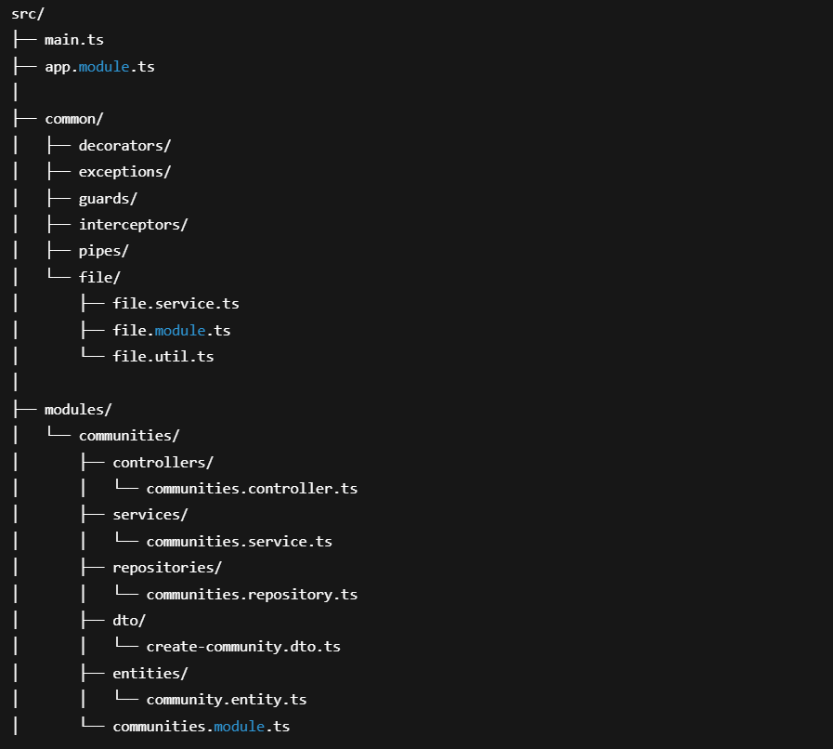
Figure ‎1.1 Project structure

Component diagram
Component diagram depicts how components are wired together to form larger components or software systems. They are used to illustrate the structure of arbitrarily complex systems.
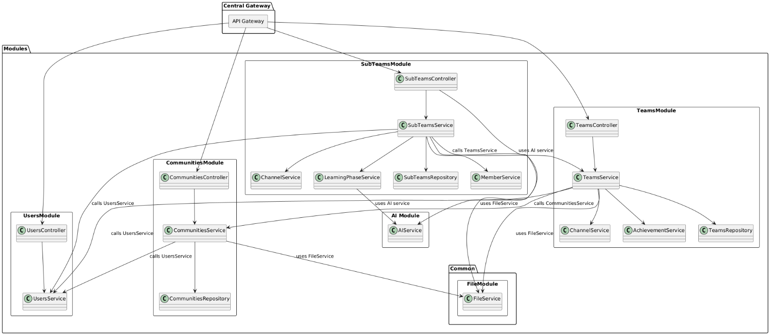
Figure ‎1.2 component diagram

High Level System Architecture

High-Level Architecture refers to a broad overview of a system's structure without diving into too much detail. It’s used to communicate the core components and how they interact, typically aimed at non-technical stakeholders or during the early stages of design.
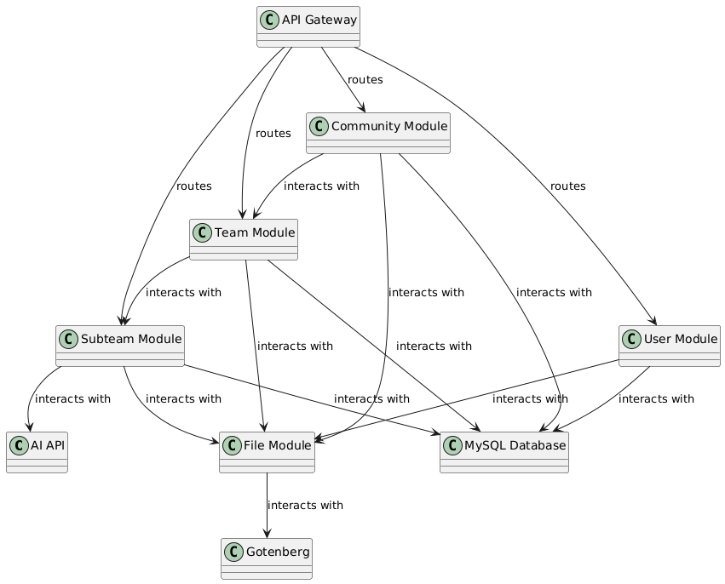
Figure ‎1.3 High-Level Architecture Diagram

Technologies Used
We used technologies and tools to facilitate the development of the app.
Our decision was based on:
- Focusing on the business itself rather than the technology
- Developer’s familiarity with the tools
- Testability
- Maintainability

Technology
- TypeScript: Instead of JavaScript we used TS to use strict types for easy and accurate development
- Nest.js: Framework for easily backend development to focus on the business logic.
- Multer (library): To save files to the hard disk.
- Passport.js (library): For authentication and authorization.
- Node Mailer (library): To send email to the users
- MySQL: as data storage
- Redis: Cache and for pub sub messages

Tools
- Git: Used Git as source control for the code.
- GitHub: To save the code on the cloud.
- Caddy: As web server to serve https
- Docker: To easily facilitate code deployment

Database Overview

Database type:
MySQL is a relational database management system (RDBMS). It uses structured query language (SQL) for defining and manipulating data and is known for its reliability, speed, and ease of use. It is an open-source solution supported by Oracle, and it’s widely used across industries for structured data storage.

Why This Database Was Chosen
MySQL was chosen for its maturity, performance, and strong support for ACID-compliant transactions. It integrates well, and it supports a broad ecosystem of tools. For applications needing strong relational integrity and structured data models, MySQL is a natural choice.

General Role in the Backend
In this project, MySQL serves as the primary data store for structured and relational data. It is responsible for storing:
    - User Data
    - Application data (Community, teams and sub teams).

Database design

ER Diagram / Schema Diagram
Entity Relationship diagram is very important, it helps us to visualize the starting point of the database, the actual and crucial system objects, helping us gather more system and technical information.
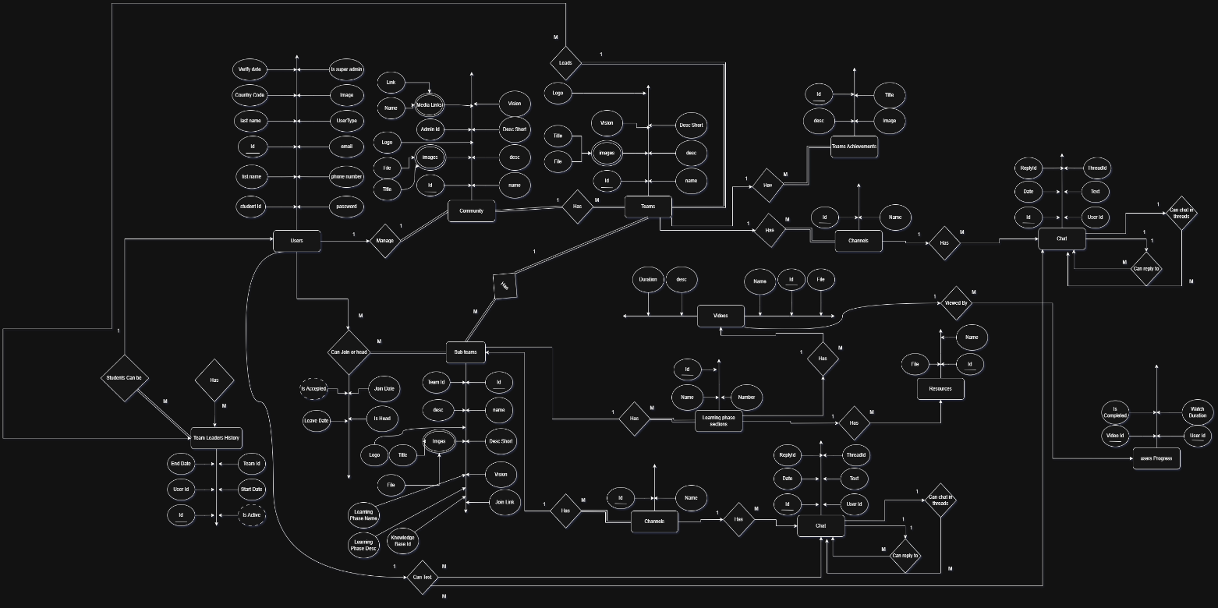
Figure ‎1.4 ERD

Tables and Their Descriptions

Table: communities
Column | Type | Null | Default
Name | varchar(15) | NO
Desc | varchar(325) | YES
DescShort | varchar(80) | YES
Logo | varchar(255) | YES
Vision | varchar(325) | YES
LeaderId | varchar(32) | NO
Id | varchar(32) | NO
CreatedAt | datetime(6) | NO | CURRENT_TIMESTAMP(6)
UpdatedAt | datetime(6) | NO | CURRENT_TIMESTAMP(6)

Table: communities_images
Column | Type | Null | Default
Name | varchar(50) | YES
File | varchar(255) | NO
CommunityId | varchar(32) | NO
Id | varchar(32) | NO
CreatedAt | datetime(6) | NO | CURRENT_TIMESTAMP(6)
UpdatedAt | datetime(6) | NO | CURRENT_TIMESTAMP(6)

Table: communities_media
Column | Type | Null | Default
Name | varchar(50) | YES
Link | varchar(255) | NO
CommunityId | varchar(32) | NO
Id | varchar(32) | NO
CreatedAt | datetime(6) | NO | CURRENT_TIMESTAMP(6)
UpdatedAt | datetime(6) | NO | CURRENT_TIMESTAMP(6)

Table: learning_phase_chat
Column | Type | Null | Default
message | varchar(2000) | NO
SubTeamId | varchar(32) | NO
response | json | NO
UserId | varchar(32) | NO
Id | varchar(32) | NO
CreatedAt | datetime(6) | NO | CURRENT_TIMESTAMP(6)
UpdatedAt | datetime(6) | NO | CURRENT_TIMESTAMP(6)

Table: learning_phase_resources
Column | Type | Null | Default
Name | varchar(50) | NO
SectionId | varchar(32) | NO
File | varchar(500) | NO
AIAssetId | varchar(24) | YES
Id | varchar(32) | NO
CreatedAt | datetime(6) | NO | CURRENT_TIMESTAMP(6)
UpdatedAt | datetime(6) | NO | CURRENT_TIMESTAMP(6)

Table: learning_phase_sections
Column | Type | Null | Default
Name | varchar(50) | NO
SubTeamId | varchar(32) | NO
Number | int | NO | 0
Id | varchar(32) | NO
CreatedAt | datetime(6) | NO | CURRENT_TIMESTAMP(6)
UpdatedAt | datetime(6) | NO | CURRENT_TIMESTAMP(6)

Table: learning_phase_videos
Column | Type | Null | Default
Name | varchar(50) | NO
SectionId | varchar(32) | NO
File | varchar(500) | NO
Desc | varchar(325) | YES
Duration | decimal(12,2) | YES
Id | varchar(32) | NO
CreatedAt | datetime(6) | NO | CURRENT_TIMESTAMP(6)
UpdatedAt | datetime(6) | NO | CURRENT_TIMESTAMP(6)

Table: migration
Column | Type | Null | Default
id | int | NO
timestamp | bigint | NO
name | varchar(255) | NO

Table: sub_team_channel_chats
Column | Type | Null | Default
Text | text | NO
ChannelId | varchar(32) | NO
UserId | varchar(32) | NO
Id | varchar(32) | NO
CreatedAt | datetime(6) | NO | CURRENT_TIMESTAMP(6)
UpdatedAt | datetime(6) | NO | CURRENT_TIMESTAMP(6)
Deleted | tinyint | NO | 0
ThreadId | varchar(32) | YES
ThreadStart | tinyint | NO | 0
ReplyToId | varchar(32) | YES

Table: sub_team_channels
Column | Type | Null | Default
Name | varchar(50) | NO
SubTeamId | varchar(32) | NO
Id | varchar(32) | NO
CreatedAt | datetime(6) | NO | CURRENT_TIMESTAMP(6)
UpdatedAt | datetime(6) | NO | CURRENT_TIMESTAMP(6)

Relationships & Constraints

Relationships

communities
- One-to-Many
  - communities_images (via CommunityId)
  - communities_media (via CommunityId)
  - sub_teams (via CommunityId)
  - teams (via CommunityId)
- Many-to-One
  - users (via LeaderId)

communities_images
- Many-to-One
  - communities (via CommunityId)

communities_media
- Many-to-One
  - communities (via CommunityId)

learning_phase_chat
- Many-to-One
  - sub_teams (via SubTeamId)
  - users (via UserId)

learning_phase_resources
- Many-to-One
  - learning_phase_sections (via SectionId)

learning_phase_sections
- Many-to-One
  - sub_teams (via SubTeamId)
- One-to-Many
  - learning_phase_videos (via SectionId)

learning_phase_videos
- Many-to-One
  - learning_phase_sections (via SectionId)
- One-to-Many
  - user_progress (via VideoId)

sub_team_channel_chats
- Self-Referential Many-to-One
  - sub_team_channel_chats (via ReplyToId)
- Many-to-One
  - sub_team_channels (via ChannelId)
  - users (via UserId)

sub_team_channels
- Many-to-One
  - sub_teams (via SubTeamId)
- One-to-Many
  - sub_team_channel_chats (via ChannelId)

sub_team_members
- Many-to-One
  - users (via UserId)
  - communities (via CommunityId)
  - sub_teams (via SubTeamId)
  - teams (via TeamId)

sub_teams
- Many-to-One
  - communities (via CommunityId)
  - teams (via TeamId)
- One-to-Many
  - learning_phase_chat
  - learning_phase_sections
  - sub_team_channels
  - sub_team_images
  - sub_teams_media
- Many-to-Many
  - users (via sub_team_members)
  - teams (via sub_team_members)

team_achievements
- Many-to-One
  - teams (via TeamId)

team_leaders
- Many-to-One
  - users (via LeaderId)
  - teams (via TeamId)

teams
- Many-to-One
  - communities (via CommunityId)
  - users (via LeaderId)
- One-to-Many
  - sub_teams
  - team_achievements
  - team_channels
  - team_images
  - team_leaders
  - teams_media
- Many-to-Many
  - users (via team_leaders, sub_team_members)

user_progress
- Many-to-One
  - learning_phase_videos (via VideoId)
  - users (via UserId)

users
- Referenced By
  - communities, learning_phase_chat, sub_team_channel_chats, sub_team_members, team_channel_chats, team_leaders, teams, user_progress

Constraints

Primary Keys
Every entity in the system inherits from an object called Base Entity which by default gives an Id where this is the Primary key

Unique Constraints
- communities.IDX_05e286a425e01f024d6a3c0a23 (on LeaderId)
- communities.IDX_7354ce1ecdeb35407ec62855fe (on Name)
- sub_team_members.IDX_4e73b4710cca697cb8bd779947 (on SubTeamId, UserId)
- teams.IDX_276c49f9292c3ea1e108854284 (on CommunityId, Name)
- teams.IDX_415301d191ba6d526554c7ce9f (on CommunityId, LeaderId)
- users.IDX_97672ac88f789774dd47f7c8be (on email)
- users.IDX_ecd08249a32b08dabf8242623d (on studentid)

Security
Authentication is the process of verifying who a user is (e.g., login with username and password).
Security involves protecting this process and the data from threats like impersonation, token theft, or session hijacking.
Key elements of securiyt:
- Password hashing (e.g., bcrypt)
- Multi-factor authentication (MFA)
- Session management
- Transport security (e.g., HTTPS)
- Data validation
- Error handling
- Rate Limiting

Authentication

Authentication Methods
- Password-Based Authentication
- How it works: Users log in using a username/email and password.
- Pros: Simple and widely used.
- Cons: Vulnerable to brute-force, leaks, and reuse attacks if not properly secured (e.g., no hashing or MFA).
- Multi-Factor Authentication (MFA)
- How it works: Combines two or more factors:
  - Something you know (password)
  - Something you have (phone, token)
  - Something you are (biometrics)
- Pros: Stronger security.
- Cons: Adds user friction and implementation complexity.

- Token-Based Authentication (e.g., JWT)
- How it works: After login, a server generates a token that the client stores (usually in localStorage or memory) and sends with each request.
- Pros: Stateless, scalable, works well in APIs.
- Cons: Tokens can be stolen if not secured; need strategies like expiration and refresh tokens.
- Biometric Authentication
- How it works: Uses fingerprints, facial recognition, or retina scans.
- Pros: Convenient and hard to replicate.
- Cons: Requires hardware support; privacy concerns.
- Certificate-Based Authentication
- How it works: Clients present a digital certificate to verify identity.
- Pros: Strong cryptographic identity validation.
- Cons: Complex management of certificates; mostly used in enterprise or secure APIs.
- Magic Link / One-Time Password (OTP)
- How it works: User gets a one-time login link or code (via email or SMS).
- Pros: Passwordless; easier for users.
- Cons: Depends on email/SMS security and delivery reliability.

Why JWT (JSON Web Token) for Authentication?
- Stateless: No need to store sessions on the server. The token contains user info and is self-contained.
- Compact: It’s lightweight and works well over HTTP headers.
- Scalable: Ideal for microservices or distributed systems where session storage is impractical.
- Signed: Ensures the token’s integrity and authenticity. Only the server can verify or generate valid tokens.
- Flexible: Can be used for both access tokens and ID tokens in APIs and OAuth flows.

Why OTP for verify code?
- One-Time Use = High Security
- OTPs are valid for only one session or action, reducing the risk if intercepted.
- They often expire quickly (e.g., 5–10 minutes), limiting the attack window.
- No Need to Remember
- Users don’t have to create or remember a password—making the process more user-friendly.
- Simple to Implement
- Easy to generate, send, and verify.
- Works well with SMS, email, or authenticator apps.
- Widely Understood
- Most users are familiar with the concept (e.g., from banking or 2FA), so it's low-friction in terms of user experience.

Data Validation
Data validation is the process of ensuring that input data is correct, clean, and useful before it is processed or stored.
It protects applications from:
- Invalid or malformed input
- Security vulnerabilities like injection attacks
- Logic errors caused by unexpected data types or values
It is very important because:
- Data Integrity: Ensures stored data is consistent and predictable.
- Application Stability: Prevents crashes and bugs from unexpected input.
- User Experience: Helps provide clear error messages and feedback
The Business logic takes its data from the Controller’s DTOs (Data Transfer object)
Data Transfer Object: is an object that is used to encapsulate data and send it from one subsystem of an application to another ensuring to not expose sensitive information and the data is clear and safe.
We Used a package called Class validator to validate each property input the user entered
here is the most important functions we used to validate:
- @IsEmail(): Checks if the email is valid or not.
- @IsNotEmpty(): Ensures the provided data is not empty.
- @MaxLength(Number): Check the data length that is not more than the specified number.
- @IsNumber(): Check if the provided data is number or not.
- @IsIs([]): Check the provided data is in the array or not.
- @IsURL(): Check if the string is valid URL or not.
- @IsBollean(): Check if data is true or false.

Error Handling & Sanitization
Error handling and data sanitization are two foundational practices in development that ensure reliability, security, and smooth user experience to not compromise any user or any data in the system and not by accident slip any sensitive information to user.

Error Handling
Purpose: Prevent application crashes and provide meaningful responses when something goes wrong.
- Types of Errors:
  - Synchronous Errors (e.g., divide by zero, file not found).
  - Asynchronous Errors (e.g., network failures, timeouts).
  - Expected Errors (e.g., user input validation failures).
  - Unexpected Errors (e.g., null pointer exceptions, database crashes).
- Error Classification:
  - 4xx Client Errors: User’s fault (e.g., 400 Bad Request, 401 Unauthorized, 404 Not Found).
  - 5xx Server Errors: Server-side issue (e.g., 500 Internal Server Error).
- Best Practices:
  - Use try/catch blocks to gracefully handle exceptions.
  - Centralize error handling via middleware (e.g., in Express.js).
  - Log errors with enough detail for debugging.
  - Don’t expose stack traces or sensitive info to users in production.

Sanitization
Purpose: Protect your backend from malicious input like SQL injection, XSS, and command injection.
Input Validation vs. Sanitization:
- Validation: Check if input meets criteria (e.g., email format, required fields).
- Sanitization: Clean or neutralize potentially dangerous content (e.g., escaping HTML).

Rate Limiting
Rate limiting is a way of controlling how often someone can make requests to a server within a certain amount of time. It’s like putting a speed limit on a road to prevent traffic accidents—except here, it’s to protect your backend systems.
- Prevents abuse (like bots or spammers).
- Protects against DDoS attacks (too many requests at once).
- Improve performance by reducing overload.
- Ensures fairness so one user doesn’t hog all the resources
We use global rate limiting within the web server we use this ensure we don’t forget any endpoint rate limiting and ensure it will work correctly without any errors and without putting too much load on the backend.

Data and System Flow
Data flow refers to the movement of data within a system or process, showing how input data is transformed into output. It typically involves sources, processes, data stores, and destinations. Data flow diagrams (DFDs) are often used to visualize this movement, helping identify how data is processed and where inefficiencies or errors might occur.

Class Diagram
A class diagram visually models the static structure of a system by illustrating its classes, attributes, methods, and the relationships between them.
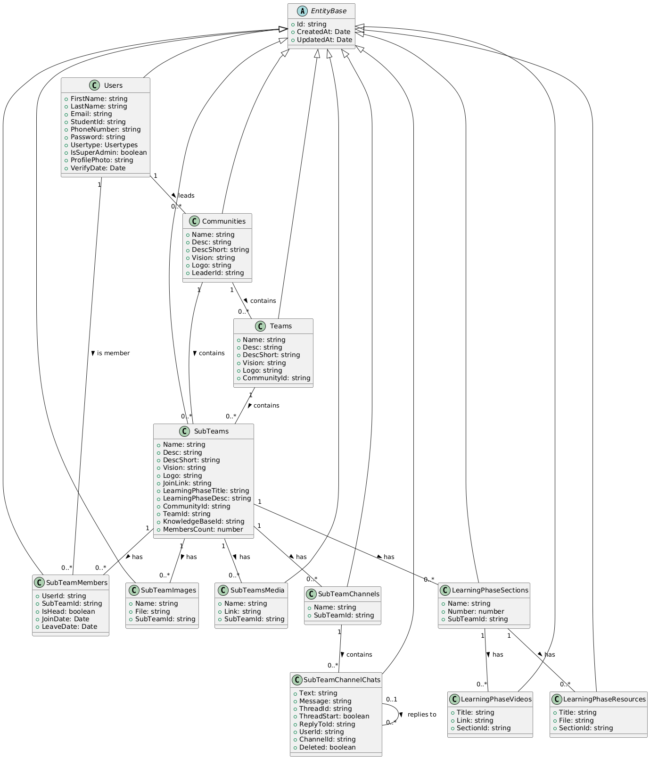
- Doman Models
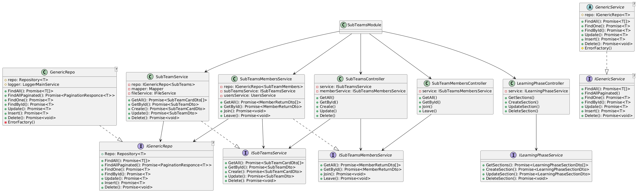
- Design Patterns (Sub team example)

Create Community
Not all users can create community only users with super admin rule can create community also community name and the admin of the community must both be unique and the admin can’t be member, also after the community leader has been admin he must be notified.
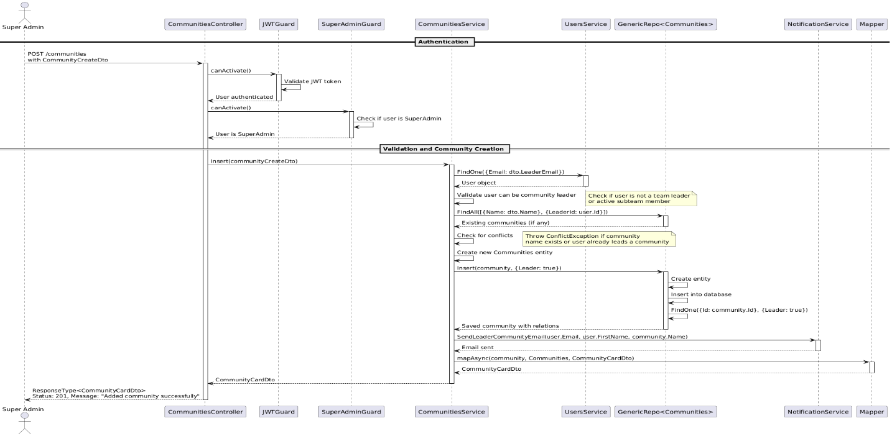
Figure ‎1.5 Create Community Sequence Diagram
Activity Diagram:
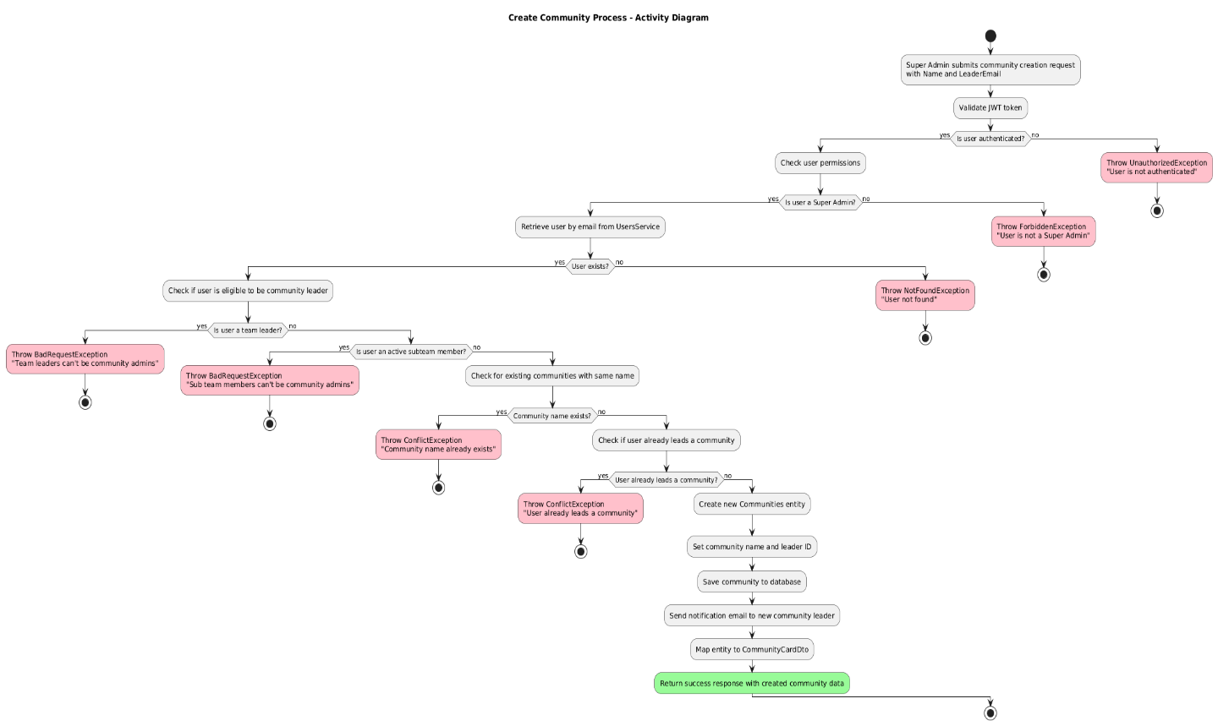
Figure ‎1.6 Create Community Activity Diagram

Team Leader History
team leader history management process, covering three key workflows: initial team creation, team leader updates, and viewing leader history. During team creation and updates, the system maintains historical records by creating TeamLeaders entries with StartDate and EndDate fields, ensuring leadership transitions are properly documented. When viewing team details, the system retrieves the complete leadership history, allowing users to see all past and current team leaders with their respective tenure periods.
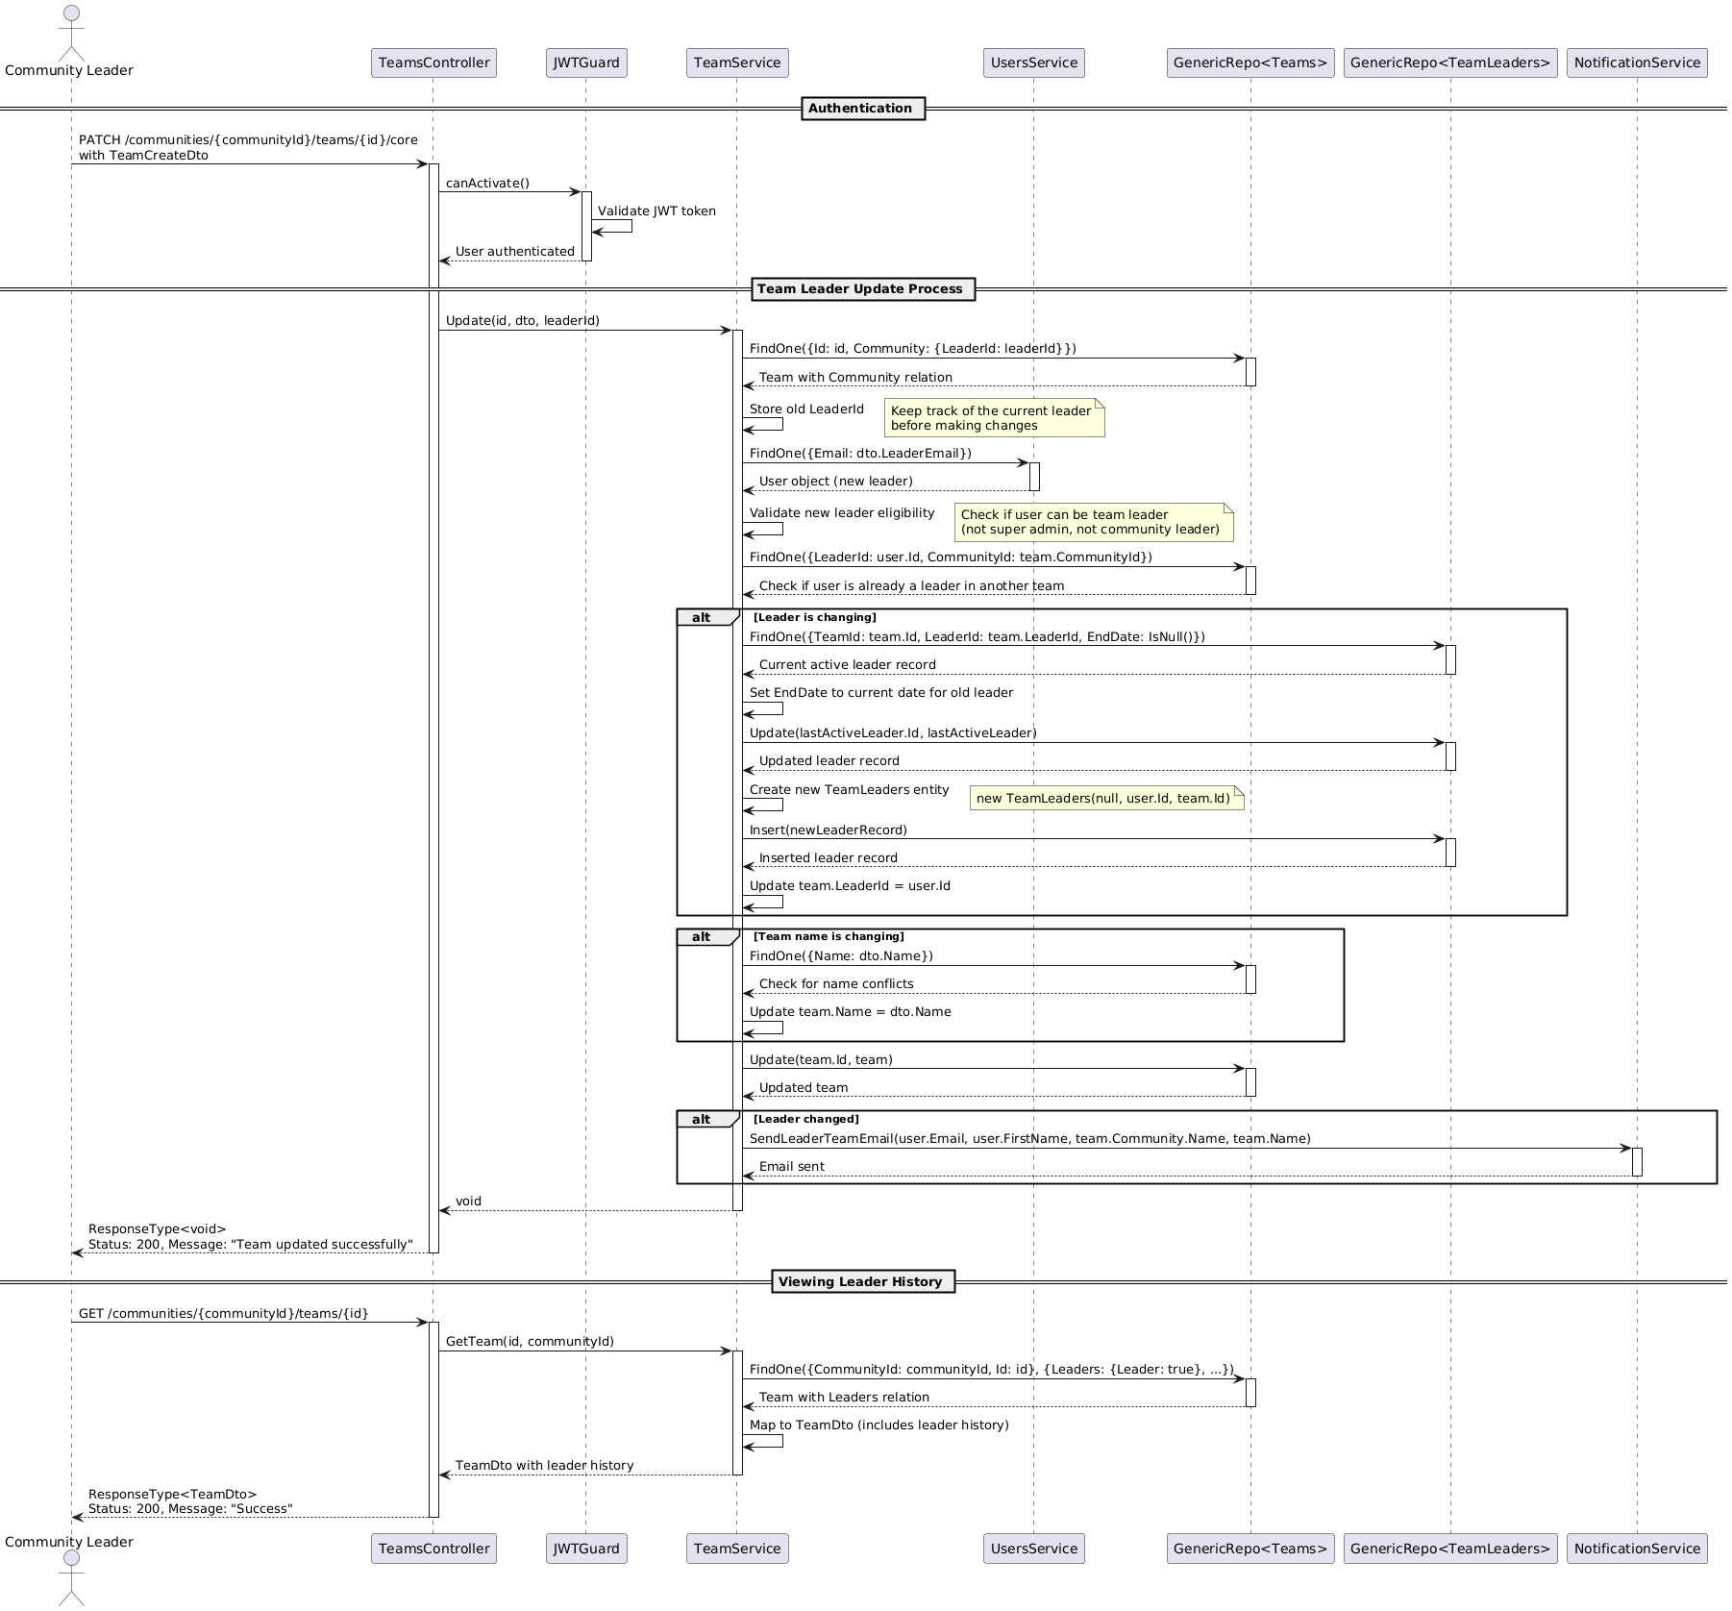
- Sequence Diagram

Figure ‎1.7 Team leader’s history sequence diagram

Sub team Members Join
The user joins flow checks if the user is a super admin, community leader, or team leader (all prohibited), verifies they aren't in another subteam, and handles cases where they've previously left or already joined. The leader-initiated member addition includes similar validation plus checks for head position conflicts. The acceptance flow verifies leader permissions and ensures the member exists and hasn't already been accepted before updating their status.
- User cannot be a super admin
- User cannot be a community leader
- User cannot be a team leader in this community
- User cannot already be in another subteam
- If user is already in this subteam:
  - If user previously left, their record is updated (LeaveDate reset)
  - If user is already accepted, request is rejected
  - If user is not yet accepted, join link is returned
- For head position (leader adding flow):
  - Subteam cannot already have a head
Accept Member Conditions:
- Leader must have proper permissions
- Member must exist in the system
- Member must not already be accepted

- Activity Diagram
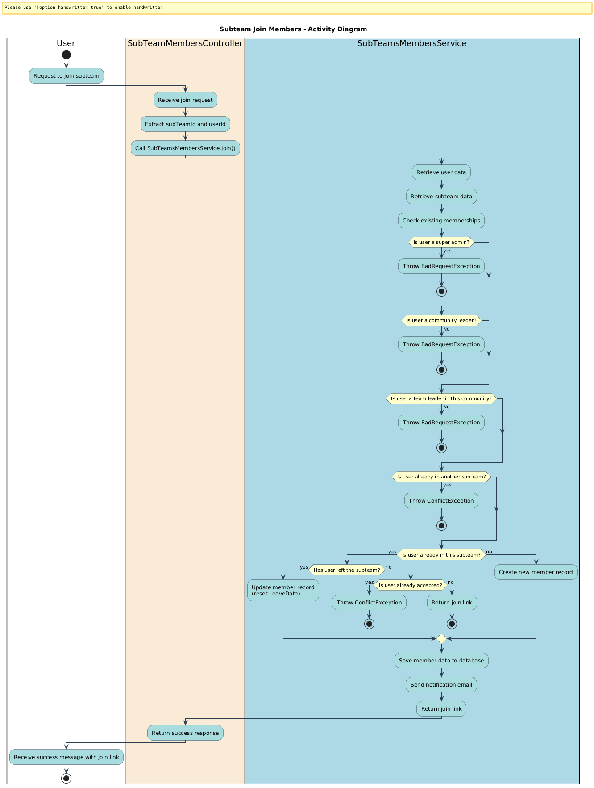
Figure ‎1.8 Member join activity diagram

Learning Phase resources
The process of uploading learning resources to a section, with AI integration for document processing, first user with appropriate permission creating section in the learning phase each section contains some resources those resources feed the AI so it can provide useful answers in the chat.
- Conditions
- Users must have leader permission to upload resources
- Supported file types include PDF, DOC, DOCX, and TXT for AI processing
- Each resource is associated with a specific learning phase section
- User Interactions
- User submits a resource file with metadata via POST request
- User receives confirmation with resource details upon successful upload
- Backend Interactions with AI
- Backend converts DOC/DOCX files to PDF before AI processing
- Backend uploads PDF/TXT files directly to AI knowledge base
- AI service processes document and returns asset IDs for future reference
- Backend stores AI asset IDs with resource records for later retrieval

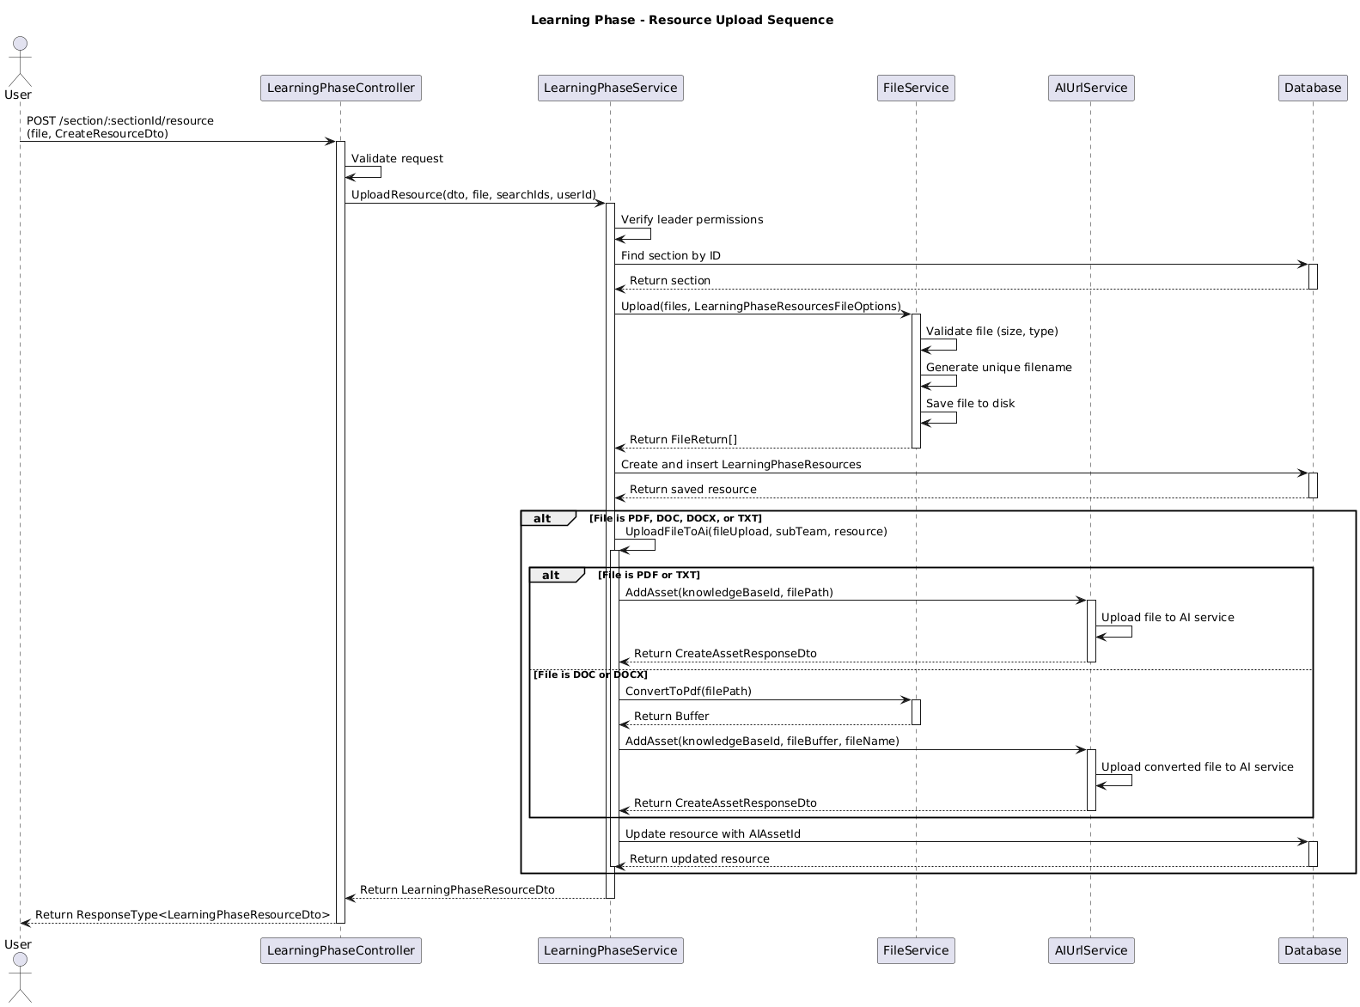
Figure ‎1.9 Learning phase upload recourses sequence diagram

Channels and chats

Create Channel
Channel creation allows team/sub team leaders to add new communication channels. The process validates user permissions, checks for duplicate channel names, and creates a new channel in the database. The API returns a 201 Created response with the channel details when successful.
The method in the creation of channel in team and sub team are the same with the difference of the permission, Sub team head can add sub team channels but cannot add team channels but team leader can add both.
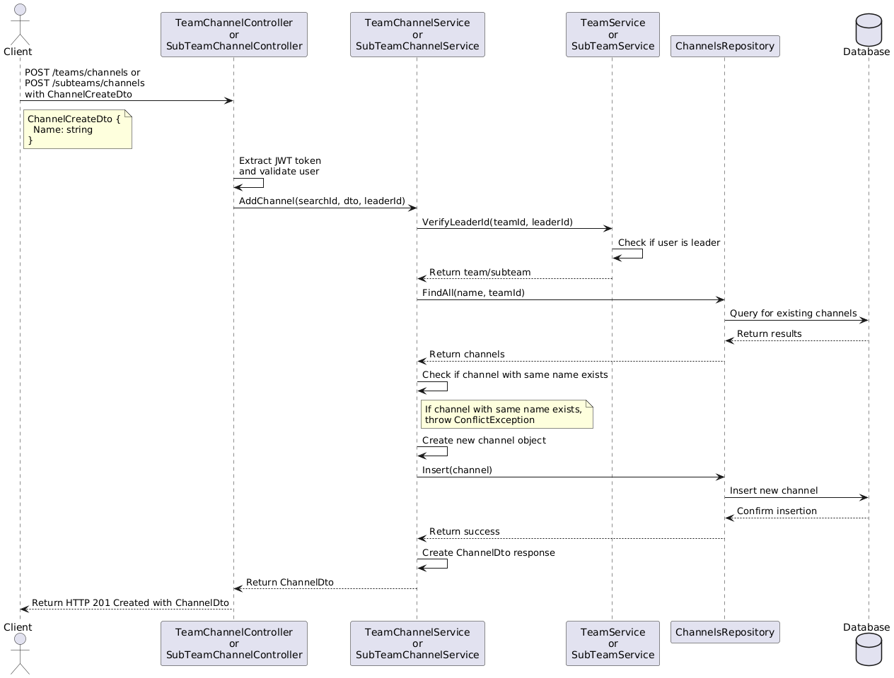
Figure ‎1.10 Channel creation sequence diagram

Sending Message
Channel message sending enables users to post messages to team/subteam channels. The process validates user authentication, verifies channel membership, creates a message object (with optional thread/reply functionality), and publishes the message via Redis for real-time delivery.
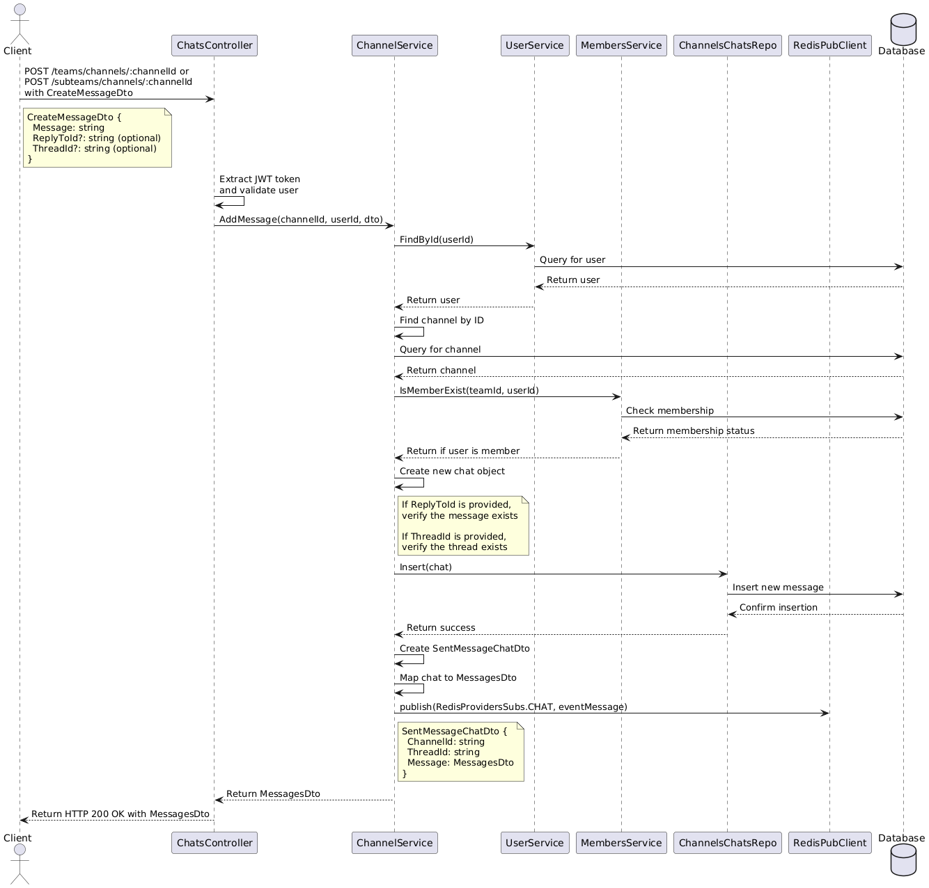
Redis is used as a pub/sub messaging system to enable real-time communication. When a message is sent, the service publishes it to a Redis channel (using publish(RedisProvidersSubs.CHAT, eventMessage)), and subscribers (connected clients) receive it instantly. This pattern decouples the message sender from receivers, allowing for scalable, event-driven architecture where multiple clients can receive messages without direct connections to each other. Redis pub/sub is particularly efficient for broadcasting messages to many clients simultaneously with minimal latency.
Figure ‎1.11 Send message sequence diagram
Redis with WebSockets creates a powerful real-time communication system in this application. The RedisIoAdapter integrates Socket.IO with Redis using the @socket.io/redis-adapter, enabling horizontal scaling across multiple server instances.
When clients connect via WebSockets through the ChatGateway, they join specific rooms based on channel and thread IDs (${channelId}_${threadId}). Messages published to Redis channels are received by the redisSubClient in the gateway, which then broadcasts them to all clients in the appropriate room using server.to(roomId).emit().
This architecture solves several challenges: it maintains WebSocket connections across server restarts, enables load balancing across multiple server instances, and ensures all connected clients receive messages regardless of which server they're connected to. The Redis pub/sub mechanism acts as a central message broker, while WebSockets provide the persistent, low-latency connection to clients.
The roomId Consists of two parts Channel Id and Thread Id to maintain clean chat, avoid messages overlap between main thread (Id NULL) and other user’s threads and nice user experince with consideration of performance.
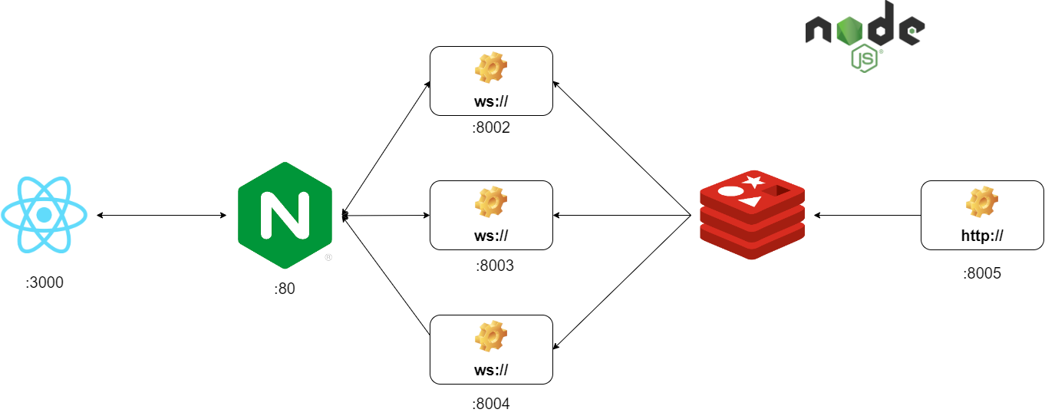
Figure ‎1.12 Horizontal web socket server

Receiving Messages
- Message Reception and Processing
- Redis Subscription: The ChatGateway has already subscribed to the Redis "chat" channel during initialization.
- Message Reception: When a message is published, the redisSubClient receives it via the Redis subscription.
- Event Handling: The afterInit method in ChatGateway has set up an event listener for "message" events from Redis.
- Message Parsing: The gateway parses the JSON string back into a SentMessageChatDto.
- Room Targeting: The gateway determines the target room using the format ${data.ChannelId}_${data.ThreadId}.
- Socket.IO Emission: The gateway uses Socket.IO's room feature to emit the message only to clients in the specific room: this.server.to(roomId).emit(RedisProvidersSubs.CHAT, data.Message).
- Client Connection and Room Joining
- WebSocket Connection: The receiving client connects to the WebSocket server via Socket.IO.
- Connection Handling: ChatGateway.handleConnection() validates the client's JWT token from the connection query parameters.
- Room Joining: The client emits a 'JoinChannel' event with ChannelId and optional ThreadId
- Room Management: ChatGateway.handleJoinRoom() processes this request and adds the client to the appropriate Socket.IO room using client.join(${channelId}_${threadId}).
- User Counting: The gateway counts users in the room and emits a 'totalUsers' event to all clients in the room.
- Message Delivery to Client
- Room-Based Delivery: When a message is published to Redis and processed by the gateway, it's emitted only to clients who have joined the specific room.
- Client Reception: The client's Socket.IO connection receives the 'chat' event with the message data.
- UI Update: The client-side application processes the received message and updates the UI accordingly.

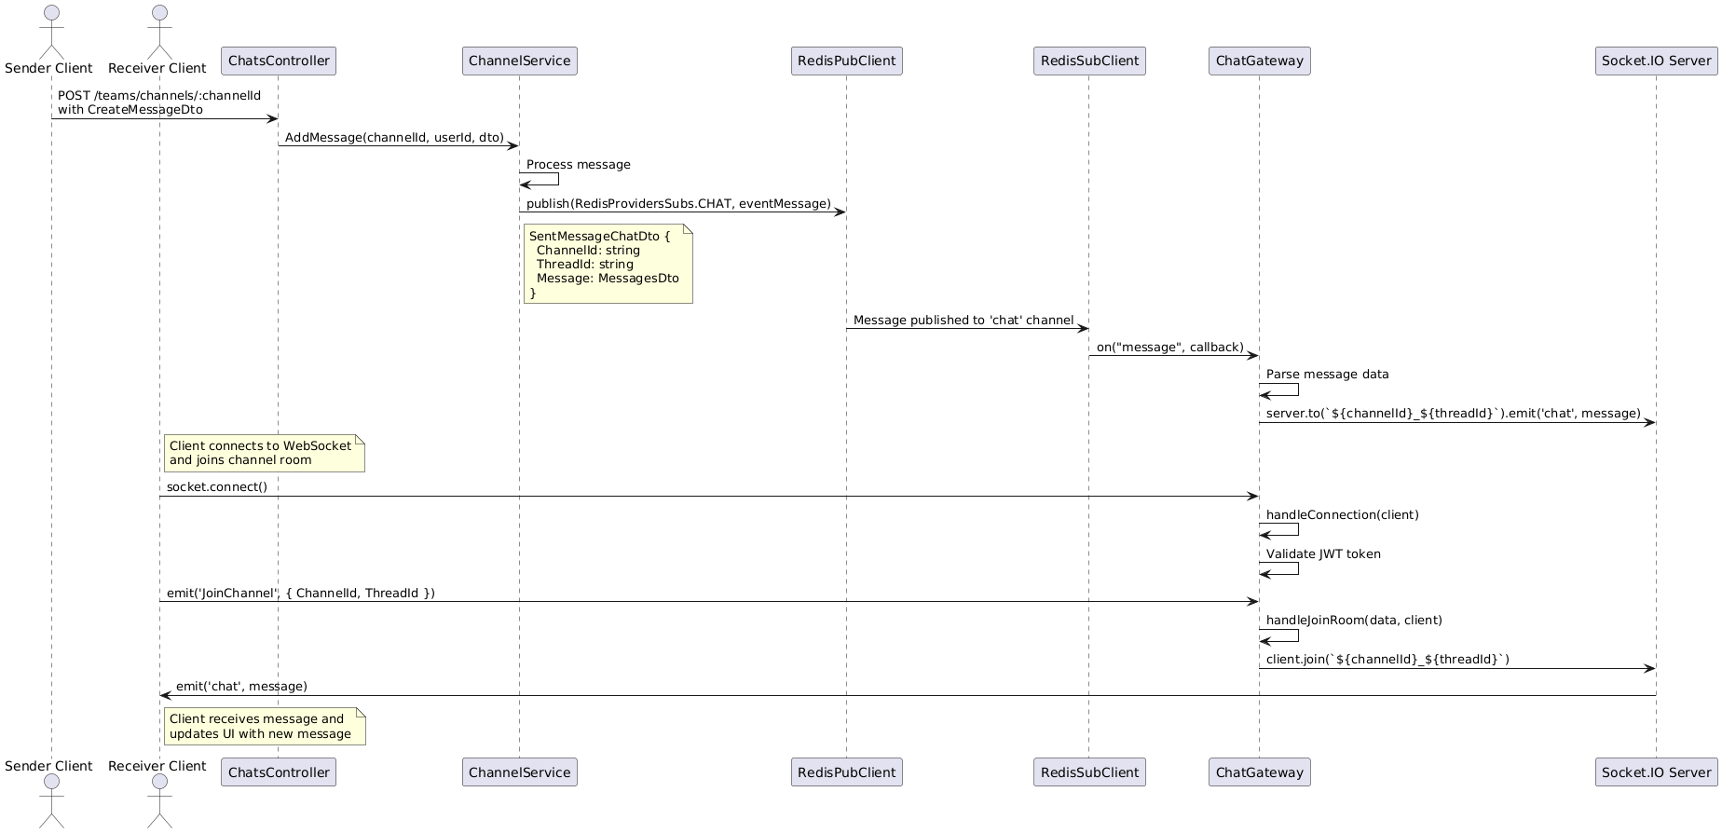
Figure ‎1.12 Receive message sequence diagram

Setup & Deployment

Requirements
- Node.js ≥ 14.x (Node 22.8.0 recommended as per Dockerfile)
- npm ≥ 6.x
- Nest CLI ≥ 8.x
- OpenSSL (for RSA key generation)
- MySQL/MariaDB (for database)
- Redis (for caching and WebSocket)
- Gotenberg (for convert word to pdf)

Run Guide
- Pull the app docker image from bridgex backend repository with the latest tag
``` docker pull bridgex/backend:latest ```
- Either run sperate instances of each of Redis, MySQL, Gotenberg or in one step pull the docker-compose.yml file and run it with:
docker compose up -d
- Set up environment variables for the backend

Environment variables
PORT= This is the port that app will run on recommended to be 8000 changes it requires changes at the docker compose

Database configs
DBCONNECTIONSTRING= The Database must be mariadb/mysql connection string
REDISURL= The Redis connection string

JWT configs
JWTEXPIREDURATION= JWT expiration duration as number determined hours or second by the JWTEXPIREDURATIONTYPE env
JWTEXPIREDURATIONTYPE= h for Hours, s for seconds
ALGORITHM=aes-256-cbc
ENCRYPT_SECRET_KEY=SECRETKEY
ENCRYPT_IV=IV

Email config
EMAILHOST= The email host name
EMAILPORT= Email host port
EMAILUSER= Email user itself that will send the email
EMAILPASS= Email user password

Verify and reset pass configs config
CODETTLINMINUTES= Code Time to live on redis
NEXTTRYINSECONDS= Nex retry in seconds

External Urls
FRONTEND_DOMAIN= Frontend domain name
FRONTEND_PORT= Frontend Port (so if it runs on whatever it will work)
FRONTEND_PROTOCOL= Frontend Protocol (so if it runs on dev environment or no ssl it will work)
FRONTEND_VERIFY_RELATIVE_URL=signUp/verifyEmail # DON'T change
AIBASEURL=The AI URL
GotenbergUrl= The Gotenberg server that will change word docs to pdf so the AI can use it

Testing and documentation

Testing Strategy
We used E2E testing (end to end) where we test each end point how it interact with the system as whole observing any logical or run time error and fix it.

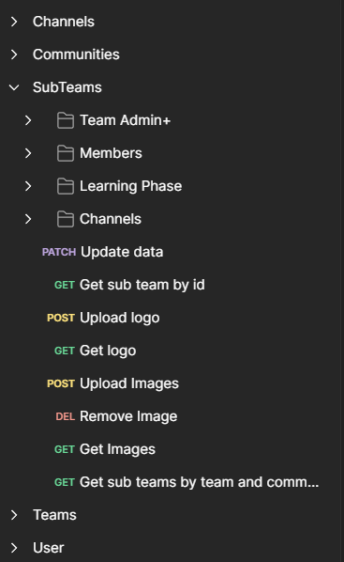
We user POSTMAN to facilitate the testing phase each end point is tested carefully with multiple test cases to cover any unexpected logic.
For each module we have created a separate collection to maintain clarity and handle the high end-point numbers in the long run.

Each collection has its own environment variables to make it easy while testing while keeping the sensitive information safe and to facilitate testing on different stages like development, testing and staging phase.

Figure ‎1.13 Postman collections

Post man examples:
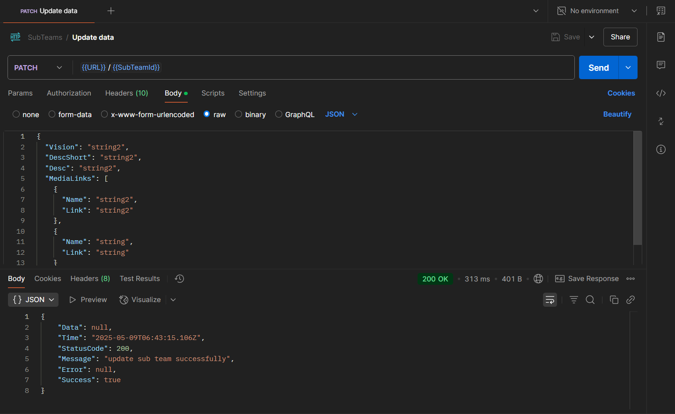
Figure ‎1.14 Postman Update Sub team data by Id

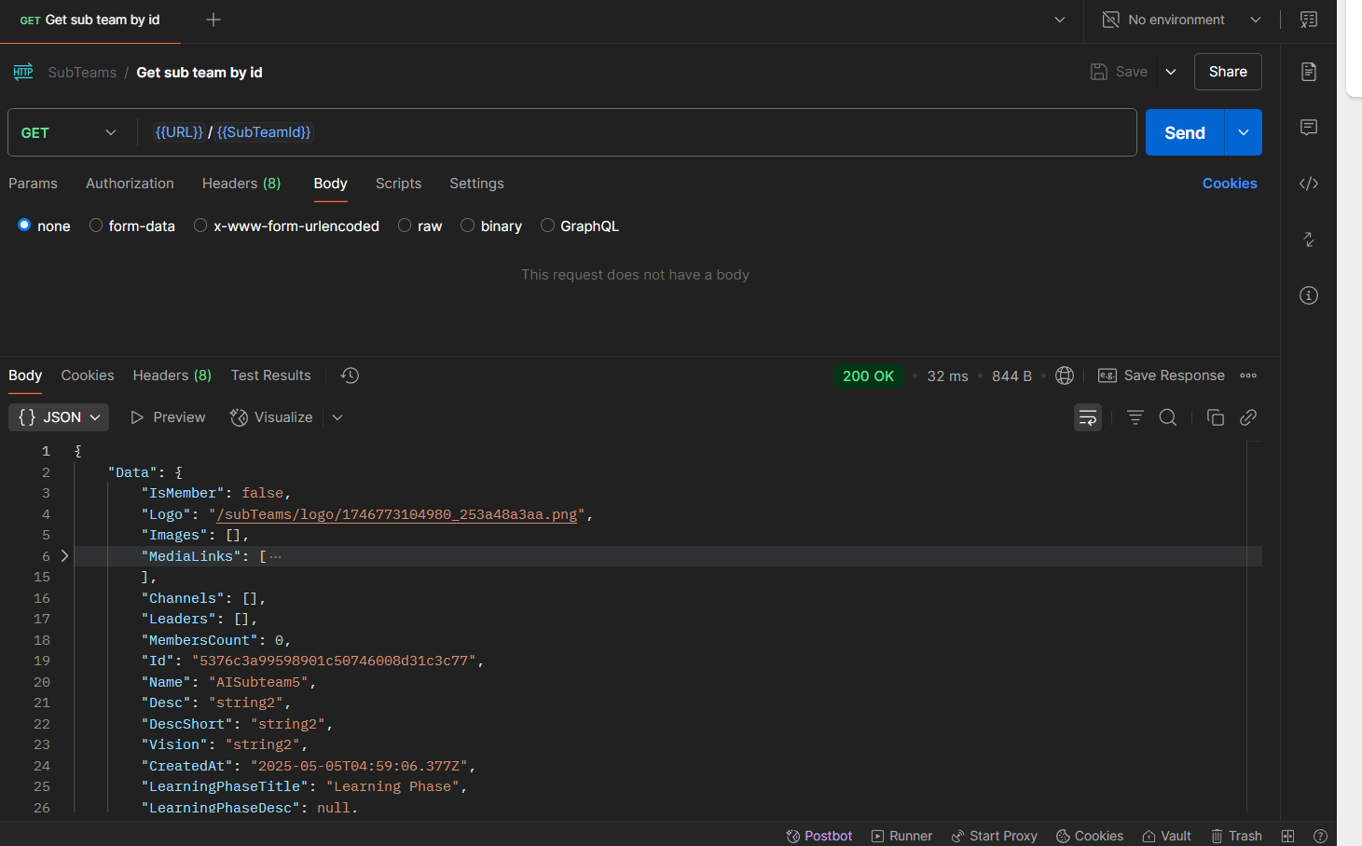
Figure ‎1.15 Postman Get Sub team data by Id

Documentation

Why is Documentation So Important?
- Well-maintained documentation allows teams to quickly understand the codebase, its architecture, and how different components work together. This significantly reduces the learning curve and accelerates their integration into the team.
- Facilitating Collaboration: Documentation acts as a single source of truth, ensuring that all team members have a shared understanding of the project. This minimizes misunderstandings, reduces redundant work, and fosters more effective collaboration.
- Improving Maintainability: Years down the line, when you or someone else needs to update or debug the software, clear documentation becomes invaluable. It provides context, explains design decisions, and makes it easier to identify and fix issues.
- Enhancing Usability: For libraries, APIs, and end-user applications, documentation guides users on how to effectively utilize the software's features. Clear instructions, examples, and explanations lead to a better user experience and increased adoption.
- Reducing Support Costs: By providing comprehensive information upfront, good documentation can significantly reduce the number of support requests. Users can often find answers to their questions independently, freeing up support teams to focus on more complex issues.
- Knowledge Preservation: Team members come and go. Documentation ensures that critical knowledge about the project isn't lost when someone leaves. It acts as a persistent record of the development process and the software's inner workings.

Documentation Using Swagger
Swagger, now known as the OpenAPI Specification, is a powerful and widely adopted framework for describing and documenting RESTful APIs. It provides a standardized, language-agnostic way to represent your API's structure, making it both human-readable and machine-readable.

Key Benefits of Using Swagger:

- Standardized Format: The OpenAPI Specification provides a common language for describing APIs, making it easier for different tools and teams to understand and interact with them.
- Interactive Documentation: Swagger UI is a popular tool that automatically generates interactive API documentation from your OpenAPI specification. This allows developers to explore your API endpoints, send requests, and view responses directly in their browser.
- Client SDK Generation: Tools like Swagger Codegen can automatically generate client libraries (SDKs) in various programming languages based on your OpenAPI specification. This significantly simplifies the process of integrating with your API.
- Server Stub Generation: Similarly, Swagger Codegen can generate server stubs, providing a starting point for implementing your API in different frameworks.
- API Design First: Swagger encourages an "API design first" approach. By defining your API specification before writing code, you can ensure a well-structured and consistent API.
- Improved Collaboration: A clear and well-defined OpenAPI specification facilitates better communication and collaboration between frontend, backend, and third-party developers.
- Automated Testing: The OpenAPI specification can be used to generate automated tests, ensuring that your API behaves as expected.

Populare Decoration in the code
To use swagger with Nest.hs we use decorators
- @ApiTags(): Group related API endpoints under a specific tag
- @ApiOperation() : Provide a concise summary and a more detailed description of the API operation
``` @ApiOperation({ summary: 'Get All communitites', description: Get all communities paginated with take and page and searchable by name' }) ```
- @ ApiResponse(): Define the possible responses for an API operation, including the HTTP status code, a description of the response, and the expected data type (often a DTO). You can specify multiple @ApiResponse decorators for different status codes (e.g., 400 for bad request, 404 for not found).
``` @ApiResponse({ status: 200, description: 'Success response', type: [TeamDto] }) ```
- @ApiBody(): Used for POST, PUT, and PATCH requests to define the expected structure and schema of the request body. You typically specify a DTO class as the type.
``` @ApiBody({ type: CreateCommunityDto, description: 'Request body for creating a community }) ```
- @ApiParam(): Used to document path parameters in your API endpoints.
``` @ApiParam({ name: 'id', type: string, description: “ID of the Community” }) ```
- @ApiQuery(): Used to document query parameters in your API endpoints
- @ApiProperty(): Automatically generate schema definitions for your request and response bodies.

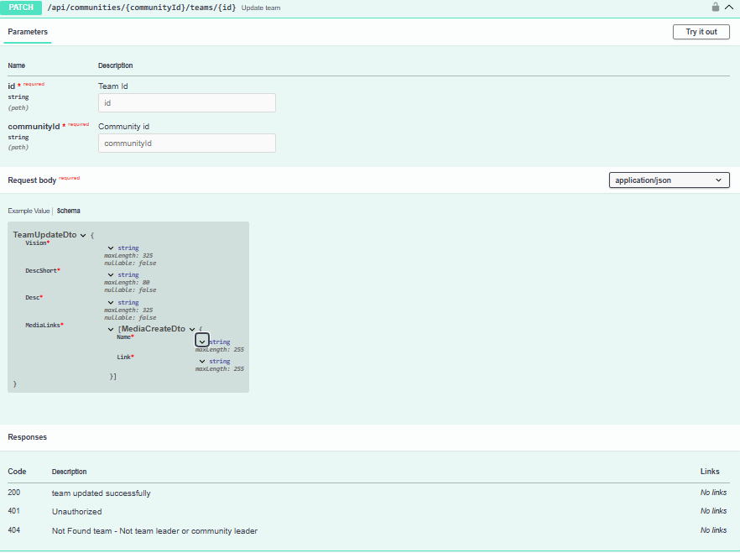
Swagger Examples:
Figure ‎1.15 Postman Get Sub team data by Id
Figure ‎1.16 Swagger update team data by Id
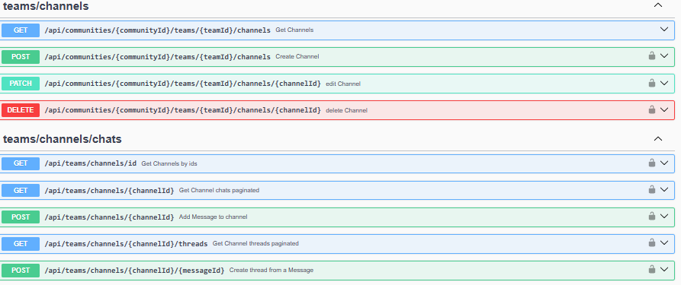
Figure ‎1.17 Team channel and chats Swagger groups end points

