**HTML Interview Questions:**

**\* What’s HTML?**

Hype text markup language use to creating and displaying pages on the internet.

**\* What’s HTML Tag?**

HTML Tag use to placing the element in proper and appropriate format and need not closed tag always.(img / input)

**1-What’s the difference between span and div?**

**Span** element is an inline container used to mark up a part of a text, without implying (الإشارة إلى) any structural meaning.

**div** element is a block-level container used to group content together.

**2-What’s the difference between section and div?**

Div is a generic container element that does not carry any semantic meaning (معنى دلالي). It is mostly used for grouping related elements together and applying styling to them via CSS.

Section is a semantic element that represents a specific section of a web page with a distinct topic or purpose.

مثال للفرق بيهم : زى مثلا div عبارة عن box فية h3 ,image , pدول عناصر عايز احطهم فى container علشان اديهم بعض الخصائص فى css على عكس لما استخدم section علشان اعمل about section فى الصفحة ويكون ليها titleوباقى العناصر بتاعتها وكدة انا عرفت اللى هيجى بعدى ان section كبير خاص about .

**3-What’s web sockets?**  
web Sockets is a communication protocol that provides full-duplex communication channels over a single TCP connection. It allows bi-directional communication between a client (such as a web browser) and a server, enabling real-time data transfer. Unlike traditional HTTP connections, which are typically request-response-based and stateless, Web Sockets allow continuous communication, which is particularly useful for applications that require real-time updates, such as chat applications, online gaming, collaborative editing tools, and financial trading platforms.

whenever we initiate the connection between client and server, the client-server made the handshaking and decide to create a new connection and this connection will keep alive until terminated by any of them.

**4-What’s web service?**

A web service is a software system designed to support interoperable machine-to-machine interaction over a network.

**Interoperability**: Web services use standard protocols such as HTTP, XML, and JSON to ensure that different systems can communicate with each other.

**Types of web services include:**

**SOAP and REST : send request and processing by the receiver.**

SOAP (Simple Object Access Protocol): SOAP is a protocol for exchanging structured information in web services. It uses XML for message formatting and can be used over a variety of transport protocols, including HTTP, SMTP, and more.

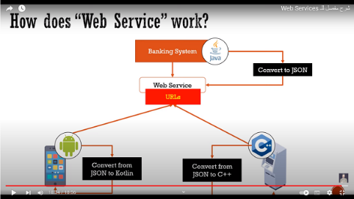REST (Representational State Transfer): REST is an architectural style for designing networked applications. RESTful web services use standard HTTP methods (such as GET, POST, PUT, DELETE) to perform CRUD (Create, Read, Update, Delete) operations on resources.

Traditional way : send request and processing on server side.

**5-What’s the difference between local storage , session storage and cookies?**

local storage , session storage and cookies are three different ways to store data in a user's browser.

Storage mechanisms on the client side. This means the clients can read and modify the values.

Key-value based storage.

They are only able to store values as strings. Objects will have to be serialized into a string (JSON.stringify()) in order to be stored., but they have some key differences:

|  |  |  |  |
| --- | --- | --- | --- |
| **Property** | **Local Storage** | **Session Storage** | **Cookies** |
| **definition** | Is useful for storing data that the user will need to access later, such as offline data, because it stores the data in the browser and the system.(5MB) | is a great way to improve the performance of your web applications .(5MB) | are a good choice for storing data that should not be persisted for a long time.(4KB) |
| **Scope** | Has no expiration time and persists even after the browser is closed. It is scoped to the domain. | is only available for the duration of the page session. It is not persistent and is lost when the browser tab is closed. | Cookies can have an expiration time and can persist across browser sessions |
| **Usage** | Useful for storing data that should persist across browser sessions, such as user preferences. | Useful for storing temporary(مؤقت) data that should be cleared when the session ends, such as form data | Useful for storing data that needs to be sent to the server with each request, such as authentication tokens. |
| **Send to server with http request** | Cookies are automatically being send via cookie header | No | No |

**6-** **What’s the difference between window ,document and screen?**

**The browser window is the rectangular area on your screen where web pages are displayed. It contains various elements such as the address bar, navigation buttons.**

1. **Window :**

* object represents the browser window that contains the document.
* it is the global object in client-side JavaScript and provides access to various properties and methods related to the browser window, such as window.innerWidth , window.location ,etc.

1. **document:**
   * Object represents the web page loaded in the browser window.
   * It is a property of the window object (window.document) and provides access to the content of the document, such as its structure (DOM), elements, and styles.
   * It allows you to manipulate the content of the web page dynamically using JavaScript, for example, by adding or removing elements, changing styles, or handling events.
2. **Screen:**

* object represents the user's screen or monitor.
* It provides information about the user's screen, such as its width (screen.width), height (screen.height)

**7- What does Doctype mean ?**

All HTML documents must start with a <!DOCTYPE> declaration.

The declaration is not an HTML tag. It is an "information" to the browser about what document type to expect.

It helps the browser to render the page correctly by ensuring that it knows which version of HTML is being used and how to interpret the rest of the document (تفسير باقية المستند).

**8-** **What's semantic HTML and why we should use it?**

Semantic HTML that refers to the use of HTML tags that convey(يوصل) the meaning. It's about using HTML elements to define the structure of the content, rather than just using elements for their default styling. Semantic HTML helps improve the accessibility(امكانية الوصول), search engine optimization(تحسين) (SEO), and maintainability of web pages.

**Accessiblity:** Semantic HTML helps screen readers and other assistive technologies understand the structure and meaning of the content.

**SEO**: Search engines use the structure of the HTML document to understand the content and context of the page. Using semantic elements can improve the search engine ranking (تصنيف)of your pages.

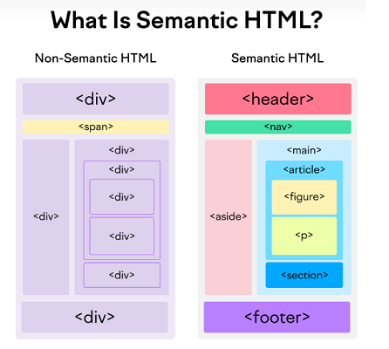**Readability and Maintainability**: Semantic HTML makes the code more readable and easier to maintain for other developers.

**9- What’s the difference between attribute and property?**

Attrubute: are part of HTML elements and provide additional information about the element.

Properties: are part of the DOM (Document Object Model) representation of an HTML element and are accessed and manipulated using JavaScript

1. <img id=”myImage” scr=”image.jpg”>
2. Document.getElementById(“myImage”)

In summary, attributes are part of the HTML markup(1) and are used to initialize properties of DOM elements(2), while properties are part of the DOM representation of elements and represent the current state of those elements.

**10-What’s heading elements?**

Heading elements in HTML are used to define the headings or titles of sections on a webpage.

They are represented by the <h1> to <h6> tags where <h1> is the highest level heading, and <h6> is the lowest level.

The main purpose of heading elements is to provide structure and hierarchy to a webpage's content.

**11- What are the HTML Lists?**

1. **Ordered List(<ol> tag):** Used to create a list of items in a specific order. Each item in the list is preceded by a number or another kind of marker.
2. **Unordered List(<ul> tag):** Used to create a list of items without any specific order. Each item in the list is preceded by a bullet point
3. **Description or Definition List(<dl>,<dt>,<dd> tag):**Used to create a list of terms(مصطلحات) and their descriptions.

**12- What’s Legend tag ?**

The <legend> tag in HTML is used in the <fieldset> element to provide a caption or title for the content within the <fieldset>.

This helps to organize and label the form fields, making it easier for users to understand the purpose of each group of fields.

   <form action="">

        <fieldset>

            <legend>fsdfdf</legend>

            <input type="text">

            <input type="text">

            <input type="text">

        </fieldset>

    </form>

**13- Why do you use viewport ?**

The viewport meta tag in HTML is used to control the layout of a webpage on mobile browsers. It allows web developers to set the initial scale, width, and other properties of the viewport, which can help ensure that the webpage is displayed correctly and is responsive on mobile devices.

**14- What’s Image maps?**

An image map in HTML is an image that has been divided into clickable areas.

Shape :rect , circle, poly(شكل عشوائى)

بستخدم موقع اسمه image map generate بستخدمه علشان احدد احداثيات الصورة .

<img src="example.jpg" usemap="#map1" alt="Example">

<map name="map1">

  <area shape="rect" coords="0,0,50,50" href="page1.html" alt="Page 1">

  <area shape="rect" coords="50,50,100,100" href="page2.html" alt="Page 2">

</map>

**15- What can we do to increase the rank of our website from HTML?**

1. **Use Semantic HTML**
2. **Optimize Meta Tags:** Use relevant and descriptive meta tags, including the <title>, <meta description>, and <meta keywords> tags.
3. **Stay up to date(ابق على اطلاع ) with the latest SEO techniques**.

**16- How to create custom HTML attribute?**

To create a custom HTML attribute, you can prefix the attribute name with data-customattribute

<div data-customattribute="value">Custom Attribute Example</div> <!-- in HTML -->

ele.target.dataset.color or   ele.target.dataset.color/* in JS */

**17- What’s the difference between readonly and disabled attribute in input form?**

Readonly :can not update the value but sent to back

Disabled: cannot update the value and not sent to back.

**18-how to create nested web pages in html ?**

Can make nest webpage using iframe.