1. **What is JavaScript? What is the role of JavaScript engine?**

JavaScript is a programming language that is used for converting static web pages to interactive and dynamic web pages.

now the question is we receive only the JavaScript code from the server but how is the browser understanding that code and executing it that is because every browser has a JavaScript engine inside

it example:

[V8 (chrome) , spider Monkey (firefox) , Javascript-Core (Safari) , Chakra (Edge , internet exploere)]

**A JavaScript engine** : is a program present(موجود) in web browsers that executes JavaScript code.

1. 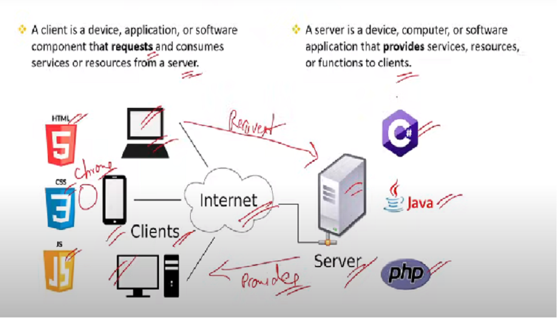**what are Client side and Server side?**
2. **What is Scope in JavaScript?**

Scope determines where variables are defined and where they can be accessed.

There are three types of Scopes:

1. **global scope:** where we Define the variable at top of the program like:

let globalVariab1e =" global " ; // global -accessible anywhere

tom();

1. **function Scopes** : variables are defined inside the function

 function test(params) {

  var functionvariable="function " // Function - accessbile inside function only

 }

1. **local or block Scope**: where the variable is defined inside an if block or elseblock or any other block

 function test(params) {

  var functionvariable="function " // Function - accessbile inside function only

  if (true) {

    let localvariable="local or block" //Block- accessbile inside block only

  }

 }

1. **what is JSON?**

JSON (JavaScript Object Notation) is a lightweight data interchange format.

1. **What is Hoisting in JavaScript?**

**Hoisting is a JavaScript behavior where functions and variable declarations are moved to the top of their respective scopes during the compilation phase.**

// Function hoisting

myFunction();

function myFunction() {

console. log( "Hello ! ")

}

// Output: Hello

The code here function is called first and then we are declaring and defining. Now the question is how is it even possible to call the function first even before declaring and defining it. This is possible because JavaScript code will be executed in top down approach then this should give an error exactly but this is possible because of Hosting. When you run this code the JavaScript engine will automatically move the method declaration to the top of the scope.

1. **What is different between var , let ,const ?**

|  |  |  |  |
| --- | --- | --- | --- |
| **item** | **var** | **let** | **const** |
| **Scope** | function | block | block |

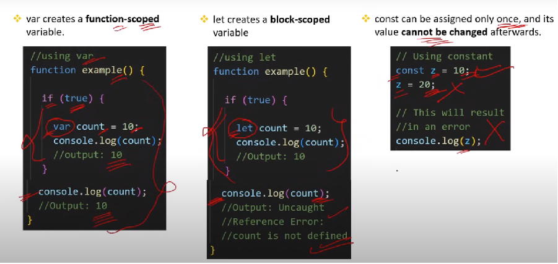

1. **What are datatypes in JS?**

A data type determines the type of variable. And type of datatypes:

|  |  |
| --- | --- |
| **primitive** | **Non-primitive** |
| Number - String – Undefined – Null-Boolean | Object – Array – RegExp – Function – Date |
| Primitive data types can hold only single value. | Non-primitive data types can hold multiple values and methods. |
| Primitive data types are immutable (ثابت) and their values cannot be changed. | Non-primitive data types are mutable and their values can be changed. |
| Primitive data types are simple data types. | Non-primitive data types are complex data types. |

1. **What is the difference between null and undefined in JS?**

|  |  |
| --- | --- |
| **Null** | **Undefined** |
| null variables are intentionally(عمدا) assigned the null value (absence of data). | When a variable is declared but has not been assigned a value, it is automatically initialized with undefined. |
| Null can be used, when you are sure yo do not have any value for the particular variable. | Used when you don't have the value right now, but you will get it after some logic or operation. |

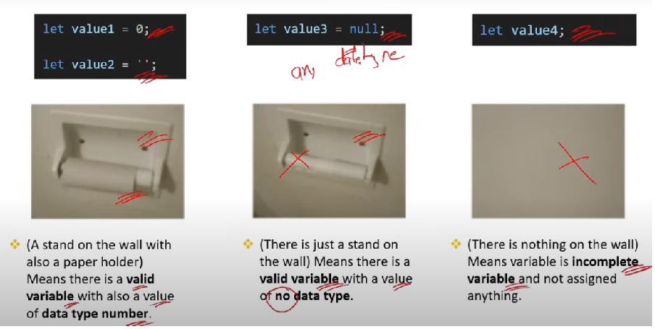s

1. **What is type coercion (type casting) in JS?**

var numVar=10

    var strVar="10"

    var boolVar=true

    var nullVar=null

    console.log(numVar + strVar) // string concatenate number convert to string 1010

    console.log(numVar - strVar) // 0

    console.log(numVar == strVar) // true

    console.log(numVar + boolVar) // 11

    console.log(nullVar + boolVar) // 1

**Type coercion** is the automatic conversion of values from one data type to another during certain operations or comparisons and can be use in:

1. Can be used during String and Number concatenation.
2. Can be used while using comparison operators .
3. **What is operator precedence (الأولوية)?**

As per operator precedence, operators with higher precedence are evaluated first.

let a=6

    let b=3

    let c=2

    /* bracketOf - Division - Multipliction - add - sub */

    let result=a+b*c+(a-b) //6+3*2+(3)=15

    console.log(result)

1. **What is the difference between unary, binary and Ternary Operator?**

* **(+) unary plus** 🡺return number if its not number
* 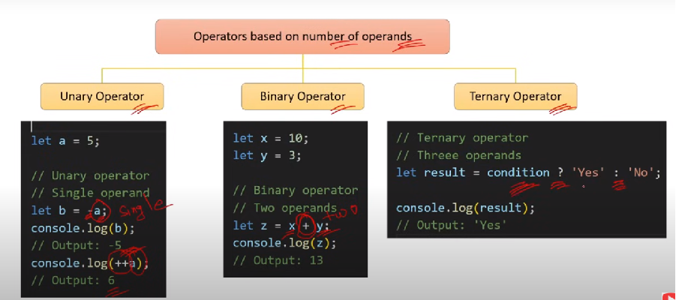**(-) unary Negative 🡺**retrun number if its not number + negative it

1. **What is the difference between double equal to and triple equal (== and ===)?**

 // Loose Equality

console. log(1== "1")

console. log(true == "1")

console. log(true == 1)

// Output: true

1. **Loose Equality (==)** compares two values for equality after performing type coercion

  // strict Equality

console. log(1=== "1")

console. log(true === "1")

console. log(true === 1)

// Output: false

1. **Strict Equality (===)** operator compares two values for equality without performing type coercion.
2. **What is the difference between Spread (نشر) and Rest operator in JS?**

 //spread operator

  let arr=[1,2,3]

  console.log(arr)  //[1,2,3]

  console.log(...arr)  // 1 2 3

**The spread operator(...)** is used to expand(توسيع) or spread elements from an iterable (such as an array, string, or object) into individual elements.

**The spread operator used in:**

1. Coping an Array:

//coping an Array

  let arr=[1,2,3]

  let copingarr=[...arr]

  console.log(copingarr)  //[1,2,3]

1. Merging Arrays:

//merging Arrays

  let arr1=[1,2,3]

  let arr2=[4,5]

  let margeArr=[...arr1,...arr2]

  console.log(margeArr)  //[1,2,3,4,5]

1. Passing multiple arguments to a function:

  //3.  Passing multiple arguments to a function

  let arr1=[1,2,3,4,5,15]

  sum(...arr1)

  function sum(...params) {

    let result=0

    params.forEach((i)=>{

         result=result + i

    })

    console.log(result)

  }

**The rest operator** is used in function parameters to collect all remaining arguments into an array.

 sum(1,2,3,4,5)

  function sum(one,two,...params) {

    console.log(one)  //1

    console.log(two) //2

    console.log(params) //[3,4,5]

  }

1. **what are the types of conditions statements in JS?**

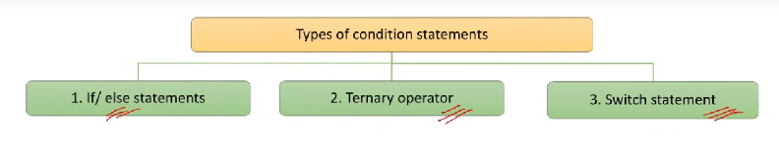

1. **What are Arrays in JS? How to get, add & remove elements from arrays?**

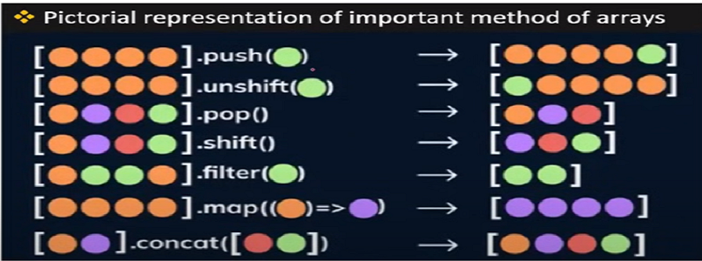**An array** is a data type that allows you to store multiple values in a single variable**.**

1. **What is the indexOf() method of an Array?**

IndexOf () method gets the index of a specified element in the array.

1. **What is the difference between slice () find () and filter () methods of an Array?**
2. **Find ():** method get the first element that satisfies a condition,return undefined if not found any ele.
3. **Filter ():** method get an array of elements that satisfies a condition and if the one element satisfies the condition will return array of one element , return undefined if not found any ele..
4. **Slice ():** method get a subset from start index to end index (end not included).

const numbers = [5, 12, 8, 130, 44];

// find method()

const firstEven = numbers.find(number => number % 2 === 0);

console.log(firstEven); // Output: 12

// filter method

const allEven = numbers.filter(number => number % 2 == 0);

console.log(allEven); // Output: [12, 8, 130, 44]

//---------------------------------------------

const allEven2= numbers.filter(number => number % 2 !== 0);

console.log(allEven2); // Output: [5]

// slice method

const silceEven=numbers.slice(1,4)

console.log(silceEven); // Output: [12, 8, 130]

1. **What is the splice () method of an Array?**

The splice () method is used to add, remove, or replace elements in an array.

 // array. splice(startlndex, deleteCount, ...itemsToAdd);

    /* let test = ["a" ,"b" , "c"] */

    // add x and y to array

    test.splice(1,0,"x","y")

    console.log(test)  // ["a" ,"x","y","b" , "c"]

    // remove b from array

    let test = ["a" ,"b" , "c"]

    test.splice(1,1)

    console.log(test) //["a" , "c"]

    // replace b by kero in array

    let test = ["a" ,"b" , "c"]

    test.splice(1,1,"kero")

    console.log(test)  //["a" ,"kero", "c"]

1. **What is the difference between the map() and forEach () methods of an Array?**
2. **Map ():** method is used when you want to modify each element of an array and create a new array with the modified values.
3. **forEach()**: method is used when you want to perform some operation on each element of an array without creating a new array.

//    Using Map

let maparr=[1,2,3]

   let newArr=maparr.map((m)=>m * 2)

   console.log(newArr) //[2,4,6] return new array

 console.log(maparr) //[1,2,3] return origin array

   //using forEach

   let forarr=[1,2,3]

   forarr.forEach((e)=>{ //does not return anything

    console.log(e * 2)}) //2 4 6

    console.log(forarr) // [1,2,3]

1. **what is Array Destructuring in JS?**

array destructuring allows you to extract elements from an array and assign them to individual variables in a single statement.

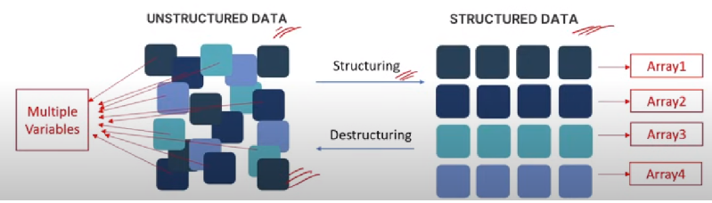

let fruits=["banana" , "apple" ,"orange"]

  //array destructuring

  let [a,b,c]=fruits

  console.log(a) //"banana"

  console.log(b)  //"apple"

  console.log(c)  //"orange"

1. **What is a loop? What are the types of loops in JS?**

A loop is a programming way to run a piece of code repeatedly until a certain condition is met.

1. **What is the difference between break and continue statement?**
2. **Break:** **The "break" statement is used to terminate (إنهاء) the loop.**

  for (let index = 1; index <=5; index++) {

     if(index === 3) {

        break;

     }

     console.log(index) //  1 2

1. **Continue:** **The "continue" statement is used to skip the current iteration of the loop and move on to the next iteration.**

for (let index = 1; index <=5; index++) {

     if(index === 3) {

        continue;

     }

     console.log(index) //  1 2 4 5

1. **When to use for..of loop and when to use forEach method in applications?**

let arr=[1,2,3]

for (const iterator of arr) {

console.log(iterator)

if (iterator == 2) {

break; // 1 2 } }

arr.forEach((item)=>{

console.log(item)

if (item == 2) {

break; //Illegal break statement

}})

* **for...of loop is** suitable when you need more control over the loop, such as using break statement or continue statement inside.
* **forEach** method iterate (يدور / يكرر) over each element of the array and perform some action on each element.

1. **What is function in js ? what are types of function?**

A function is a reusable block of code that performs a specific task**.**

(Named, Anonymous, Function Expression, Arrow, IIFE , Callback, higher-Order)

1. **What is the difference between named and anonymous? When to use in applications?**

Named functions have a name identifier

function sum(a, b){

    return a + b;

}

console.log(sum(2,3))// Output: 5

* Use named functions for big and complex logics.
* Use when you want to reuse one function at multiple places.

Anonymous functions do not have a name identifier and cannot be referenced or called directly by name.

mybtn.addEventListener("click",function () {

        console.log("click")

        })

* Use anonymous functions for small logics.
* Use when want to use a function in a single place.

1. **What is Function Expression?**

A function expression is a way to define a function by assigning it to a variable.

   let test=function sum(a,b){

    return a+b

}

console.log(test(1,2)) // 3

console.log(sum(1,2))  //error sum is not function

1. **What is arrow function?**

Arrow functions, also known as fat arrow functions, is a simpler and shorter way for defining function in JS.

    let add =(x,y)=>{return  x+y}  or  let add =(x,y)=> x+y

     console.log(add(3,12))

1. **What is callback function?**

A callback function is a function that is passed as an argument to another function.

  function add(x,y) {return x + y}

     function subtract(x,y) {return x - y}

     function multply(x,y) {return x * y}

     function display(x , y, opertion) {

         let result=opertion(x,y)

         console.log(result)}

     display(10,5,add) //15

     display(10,5,subtract) //5

     display(10,5,multply)  //50

     setTimeout(() => {

        console.log("i am callback")

      }, 1000);

1. **What is Higher-order function In JS?**

Take one or more functions as arguments (callback function) OR return a function as a result.

1. **What is the difference between arguments and parameters?**

**Parameters** are the placeholders (العناصر النائبة) defined in the function declaration.

**Arguments** are the actual values passed to a function when it is invoked or called.

 // a and b are parameters

      function add(a ,b) {

        console.log(a+b)

      }

      // 3 and 4 are arguments

      add(3,4)

1. **What is default parameters in functions?**

In JavaScript, default parameters allow you to specify default values for function parameters.

 function test(name="kerolos") {

        console.log("hello " + name)

      }

      test()  //hello kerolos

      test("ahmed")  //hello ahmed

1. **What are Pure(نقية) and Impure functions in JS?**

* **A pure function** is a function that always produces the same output for the same input.
* **Pure functions** cannot modify the state.

     // pure function

      function add(x ,y ) {return x + y}

      console.log(add(2,3))  //5

      console.log(add(2,3))  //5

* **An impure function**, can produce different outputs for the same input.
* **An impure functions** can modify the state (change the value of total in next example).

   let total=0

      function addToTotal(value) {

        total+=value

  return total}

      console.log(addToTotal(5))  //5

console.log(addToTotal(5))  //10

1. **What is Function Currying in JS?**

Currying in JavaScript transforms a function with multiple arguments into a nested series of functions, each taking a single argument.

//  normal function

    function add(a, b, c) {

        return a + b + c;

    }

    console.log(add(1,2,3)); // Output: 6

    // curring function

function curriedAdd(a) {

  return function(b) {

    return function(c) {

      return a + b + c;

    };

  };

}

// Using the curried function

console.log(curriedAdd(1)(2)(3)); // Output: 6

1. **What are call, apply and bind methods in JS?**
2. **The call method** invokes a function with a specified this (object context) value and arguments provided individually**.**

function greet(greeting, punctuation) {

  console.log(greeting + ', ' + this.name + punctuation);

}

const person = { name: 'Alice' };

greet.call(person, 'Hello', '!'); // Output: Hello, Alice!

1. **The apply method** is similar to call, but it takes the arguments as an array.

function greet(greeting, punctuation) {

  console.log(greeting + ', ' + this.name + punctuation);

}

const person = { name: 'Alice' };greet.apply(person, ['Hello', '!']); // Output: Hello,Alice!

1. **The bind method** creates a new function that, when called, has its this value set to the provided value, with a given sequence of arguments preceding any provided when the new function is called.

function greet(greeting, punctuation) {

  console.log(greeting + ', ' + this.name + punctuation);

}

const person = { name: 'Alice' };

const kero =greet.bind(person)

kero("hello" ,"!") // Output: hello, Alice! */

* call and apply invoke the function immediately.
* bind returns a new function that can be invoked later.

1. **What are template literals and string interpolation in strings?**

A template literal, also known as a template string, is a feature introduced in ECMAScript 2015 (ES6) for string interpolation and multiline strings in JavaScript.

  // templete literal with interpolation (backtick)

    let name ='kerolos'

    console.log(`hello ${name}`)  //hello kerolos

    // --------------------------------------------------

    // templete literal with multiline string (backtick)

    let multi=`

    hello sir

    my name is kerolos

    `

1. **How many ways you can concatenate strings?**

let s1="hello" ; let s2="kerolos"

     // + operator

     console.log(s1 + s2)  //hello kerolos

    //  concat method

    console.log(s1.concat(s2))  //hello kerolos

    //templete literal

    console.log(`${s1} ${s2}`)  //hello kerolos

    //join

    let s3=[s1,s2]

    console.log(s3.join(" ")) //hello kerolos

1. **What is DOM? What is the difference between HTML and the DOM?**

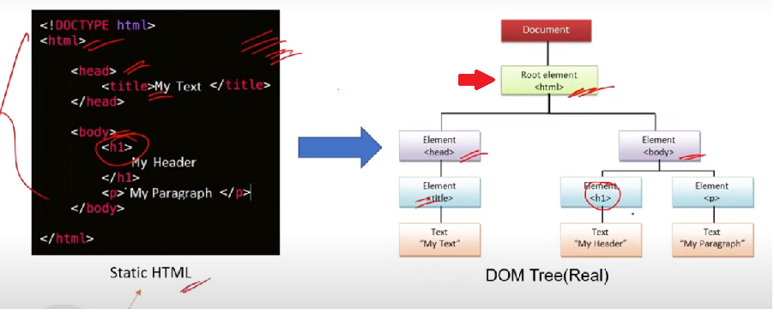

**The DOM**(Document Object Model) represents the webpage as a tree-like structure that allows JavaScript to dynamically access and manipulate the content and structure of web page.

**in short HTML** is just a markup language for reading and writing purposes for developers and users in reality memory plays with Dom.

1. **What is selector in JS?**

Selectors in JS help to get specific elements from DOM based on IDs, class names, tag names.

(getElementByld() - getElementsByClassName() - getElementsByTagName()-querySelector() –querySelectorAll())

1. **What are the methods to modify elements properties and attributes?**

(textContent – innerHTML -setAttribute()-removeAttribute() - style.setProperty-classList.add())

1. **What is different between textContent and innerHTML?**

let element = document.getElementById("example");

element.innerHTML="Hello <strong>kerolos</strong>" //in browser Hello kerolos

element.textContent="Hello<strong>kerolos</strong>"//in browser Hello<strong>kerolos</strong>

element.textContent="Hello<strong>kerolos</strong>"//in browser Hello<strong>kerolos</strong>

1. **How to add or remove properties of HTML elements in the DOM ?**

We can add or remove properties using setAttribute or removeAttribute method.

   let element = document.getElementById("example");

   element.setAttribute("data-info","new value")

   element.removeAttribute("data-info")

1. **How to add or remove style of HTML elements in the DOM ?**

We can add or remove style using setProperty or classList method.

 let element = document.getElementById("example");

   element.style.setProperty("background-color" , "red")

   element.classList.add("active")

  element.classList.remove("active")

1. **What is cloneNode() method?**

<div id="parent">

        <h1>child</h1>

    </div>

   <script>

   let element = document.getElementById("parent");

   let cloneEle=element.cloneNode(true)

   cloneEle.textContent='i am clone '

   document.body.append(cloneEle)

   //the output in DOM is <div id="parent"> i am clone   </div>

1. **What is Error handling in JS?** Errorhandling is the process of managing errors.

   try {

let result=somevarible + 10

console.log(result)

} catch (error) {

console.log("error in code is "+error.message) //error in code is somevarible is not defined}

1. **What is the role of finally block in JS?**

Finally, block is used to execute some code irrespective (بغض النظر) of error.

1. **What is the purpose of the throw statement in JS?**

The throw statement stops the execution of the current function and passes the error to the catch block of calling function.

function userData() {

    try {

        validateAge(10)

        validateAge("10")

        validateAge(25)

    } catch (error) {

        console.log(error.message)

    }

}

function validateAge(age) {

    if (typeof age !== "number") {

        throw new Error("this age not valid")

    }

    console.log("this age valid "+ age)

}

userData()

//output

// this age valid 10

//  this age not valid

1. **what are the different types of errors In JS?**

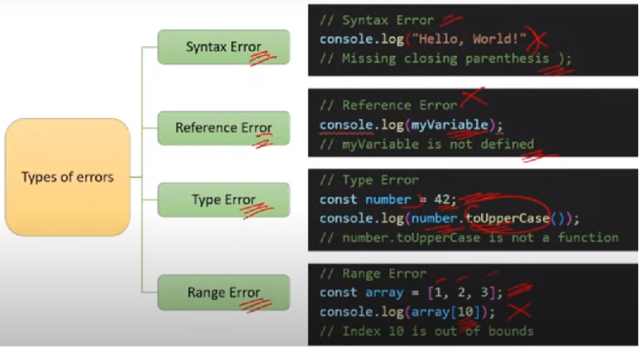

1. **what is object in JS?**

An Object is a data type that allows you to store key-value pairs.

1. **What is the difference between an array and an object?**

|  |  |
| --- | --- |
| **Array** | **Object** |
| Arrays are collection of value | Objects are collections of key-value pairs. |
| Arrays are denoted by square brackets () | Objects are denoted by curly braces {}. |
| Elements in array are ordered (zero index). | Properties in objects are unordered. |

1. **how do you add or modify or delete properties of an object**

let myobj={}

    //add properties

    myobj.name="kerolos"

    //modify properties

    myobj.name="amr"

    //delete properties

    delete myobj.name

1. **Explain the difference between dot notation and bracket notation?**

* Both dot notation and bracket notation are used to access properties or methods of an object.
* Dot notation is more popular and used due to its simplicity.

  let myobj={

        name:"kerolos",

        age:30}

        console.log(myobj.name) // dot notation kerolos

        console.log(myobj["name"]) //bracket notation kerolos

**Limitation of dot notation - In some scenarios bracket notation is the only option, such as when accessing properties when the name is stored in a variable.**

let myobj={

        name:"kerolos",

        age:30}

        let myvarible="age"

        console.log(myobj.myvarible) // dot notation undefined

        console.log(myobj[myvarible]) //bracket notation 30

1. **What are some common methods to iterate over properties in Object?**

   let myobj={

        name:"kerolos",

        age:30}

       //   using for... in loop

       for (const key in myobj) {

          console.log(key + " "+ myobj[key]) //name kerolos age 30

       }

      // using keys() method

      Object.keys(myobj).forEach((param)=>{

        console.log(param + " "+ myobj[param]) //name kerolos age 30

      })

      // using values() method

      Object.values(myobj).forEach((values)=>{

        console.log(values) // kerolos 30

      })

1. **How do you check if a property exists in an object?**

  let myobj={

        name:"kerolos",

        age:30}

       //   using the in Operator

       console.log("name" in myobj) // true

       console.log("city" in myobj) //false

       //   using hasOwnProperty method

       console.log(myobj.hasOwnProperty("name")) // true

       console.log(myobj.hasOwnProperty("city")) // false

1. **how do you clone or copy an object?**

  let myobj={

        name:"kerolos",

        age:30}

       //   using spread syntax (shallow copy نسخه سطحية)

       const copyObject={...myobj}

      console.log(copyObject)

      //    using assign method() (shallow copy)

      const copyObject2=Object.assign({},myobj)

      console.log(copyObject2)

      // using JSON.parse() and JSON.stringify() (deep copy)

      const copyObject3=JSON.parse(JSON.stringify(myobj))

      console.log(copyObject)

1. **What is the difference between deep copy and shallow copy?**

  let myobj={

        name:"kerolos",

        address:{

            city:'assuit',

            street:"3"

        }}

   const shalloecopy=Object.assign({},myobj)

    shalloecopy.address.city="cairo"

    console.log(shalloecopy.address.city) //cairo

    console.log(myobj.address.city)  //cairo

   //=============================

   const deepcopy=JSON.parse(JSON.stringify(myobj))

    deepcopy.address.city="Alex"

    console.log(deepcopy.address.city) //Alex

    console.log(myobj.address.city) //assuit

Shallow copy in **nested objects** case will **modify** the parent object property value, if cloned object property value is changed. But deep copy will not modify the parent object property value.

1. **What is Set Object in JS?**

The Set object is a collection of **unique** values meaning that duplicate values are not allowed.

const uniqueVal=new Set()

uniqueVal.add(5)

uniqueVal.add(10)

uniqueVal.add(5) // ignore duplicate values

console.log(uniqueVal.size) // 2 (10 , 5)

console.log(uniqueVal.has(10)) //true

uniqueVal.delete(10)

console.log(uniqueVal.size) // 1 (5)

//remove duplicate value in array

let arr=[1,4,2,4]

const myobj=new Set(arr)

let newarr=[...myobj]

console.log(newarr) // [1,4,2]

1. **What are Events ?**

Events are actions that happen in the browser, such as a button click, mouse movement, or keyboard input.

1. **What are Event Object in JS ?**

Whenever any event is triggered, the browser automatically creates an event object and passes it as an argument to the event handler function.

The event object contains various properties and metheds that provide information about the event, such as the type of event , the element that triggered the event etc.

let mybtn=document.getElementById("mybtn")

mybtn.addEventListener("click" , handleEvent)

function handleEvent(event) {

    console.log(event.target) // <button id="mybtn">click</button>

    console.log(event.type)  //click

}

1. **what is Event Delegation in JS?**

Event delegation in JavaScript is a technique where you attach a single event handler to a parent element to handle events on its child elements.

 <ul id="mylist">

        <li>item1</li>

        <li>item2</li>

        <li>item3</li>

    </ul>

<script>

let mybtn=document.getElementById("mylist")

mybtn.addEventListener("click" , handleEvent)

function handleEvent(event) {

    console.log(event.target.textContent)

}

When click in item1 …item1 will appearance in console and When click in item2 …item2 will appearance in console ……

1. **What is Event Bubbling In JS?**

Event bubbling is the process in JavaScript where an event triggered on a child element propagates up the DOM tree, triggering event handlers on its parent elements.

    <div id="outer">

        <div id="inner">

            <button id="mybtn">dasd</button>

        </div>

    </div>

<script>

let mybtn=document.getElementById("mybtn")

let outer=document.getElementById("outer")

let inner=document.getElementById("inner")

outer.addEventListener("click" , handleEvent)

inner.addEventListener("click" , handleEvent)

mybtn.addEventListener("click" , handleEvent)

function handleEvent(event) {

    console.log(this.id) // mybtn inner outer

}

1. **How can you stop event propagation (إنتشار) or event Bubbling in js?**

function handleEvent(event) {

    console.log(this.id)

    event.stopPropagation() //mybtn

}

1. **What is Event capturing In JS?**

Event capturing is the process in JavaScript where an event is handled starting from the highest-level ancestor (the root of the DOM tree)and moving down to the target element (opposite of event bubbing).

    <div id="outer">

        <div id="inner">

            <button id="mybtn">dasd</button>

        </div>

    </div>

<script>

let outer=document.querySelector("#outer")

let inner=document.querySelector("#inner")

let mybtn=document.querySelector("#mybtn")

outer.addEventListener("click",kkk,true)

inner.addEventListener("click",kkk,true)

mybtn.addEventListener("click",kkk,true)

function kkk(event) {

    console.log(this.id) //outer inner mybtn

}

