

Practices for Secure Software Report

Table of Contents
Document Revision History 3
Client 3
Instructions 3
Developer 4
1. Algorithm Cipher 4
2. Certificate Generation 4
3. Deploy Cipher 4
4. Secure Communications 4
5. Secondary Testing 4
6. Functional Testing 4
7. Summary 4
8. Industry Standard Best Practices 4

Document Revision History

Version | Date | Author | Comments
1.0 | 10/15/2026 | Kerolos Ramsis

Client



Instructions

Submit this completed practices for secure software report. Replace the bracketed text with the relevant information. You must document your process for writing secure communications and refactoring code that complies with software security testing protocols.

- Respond to the steps outlined below and include your findings.
- Respond using your own words. You may also choose to include images or supporting materials. If you include them, make certain to insert them in all the relevant locations in the document.
- Refer to the Project Two Guidelines and Rubric for more detailed instructions about each section of the template.

Developer
Kerolos Ramsis

Algorithm Cipher

For Artemis Financial, I recommend using AES-256-GCM as the primary encryption cipher. AES stands for Advanced Encryption Standard, and it is a symmetric encryption algorithm, which means the same secret key is used to encrypt and decrypt the data. AES-256 uses a 256-bit key, which provides a strong level of protection for sensitive financial and customer information. GCM, or Galois/Counter Mode, also provides authentication, which helps verify that the encrypted data has not been changed during transmission.
In addition to encryption, SHA-256 can be used for hashing and checksum verification. SHA-256 creates a 256-bit hash value from the input data. A hash is different from encryption because it is designed to be one-way and is not decrypted back into the original data. In this project, SHA-256 can be used to verify data integrity by comparing checksum values before and after data is processed or transmitted.
Secure encryption also depends on the proper use of random values. AES-GCM uses a unique initialization vector, or IV, for each encryption operation. The IV should be generated using a cryptographically secure random number generator and should not be reused with the same key. AES is a symmetric algorithm, while algorithms such as RSA are asymmetric and use a public key and a private key. Asymmetric encryption is often used for certificates and secure key exchange, while symmetric encryption is generally faster and is better suited for protecting larger amounts of application data.
Encryption methods have changed over time as older algorithms became less secure. Algorithms such as DES and 3DES are now considered outdated because of their smaller key sizes and known weaknesses. AES became the modern standard for symmetric encryption and is widely used because of its strong security and performance. Current secure applications also use modern hashing algorithms such as SHA-256 instead of older functions such as MD5 or SHA-1, which are no longer considered secure for many security purposes.

Certificate Generation
Insert a screenshot below of the CER file.

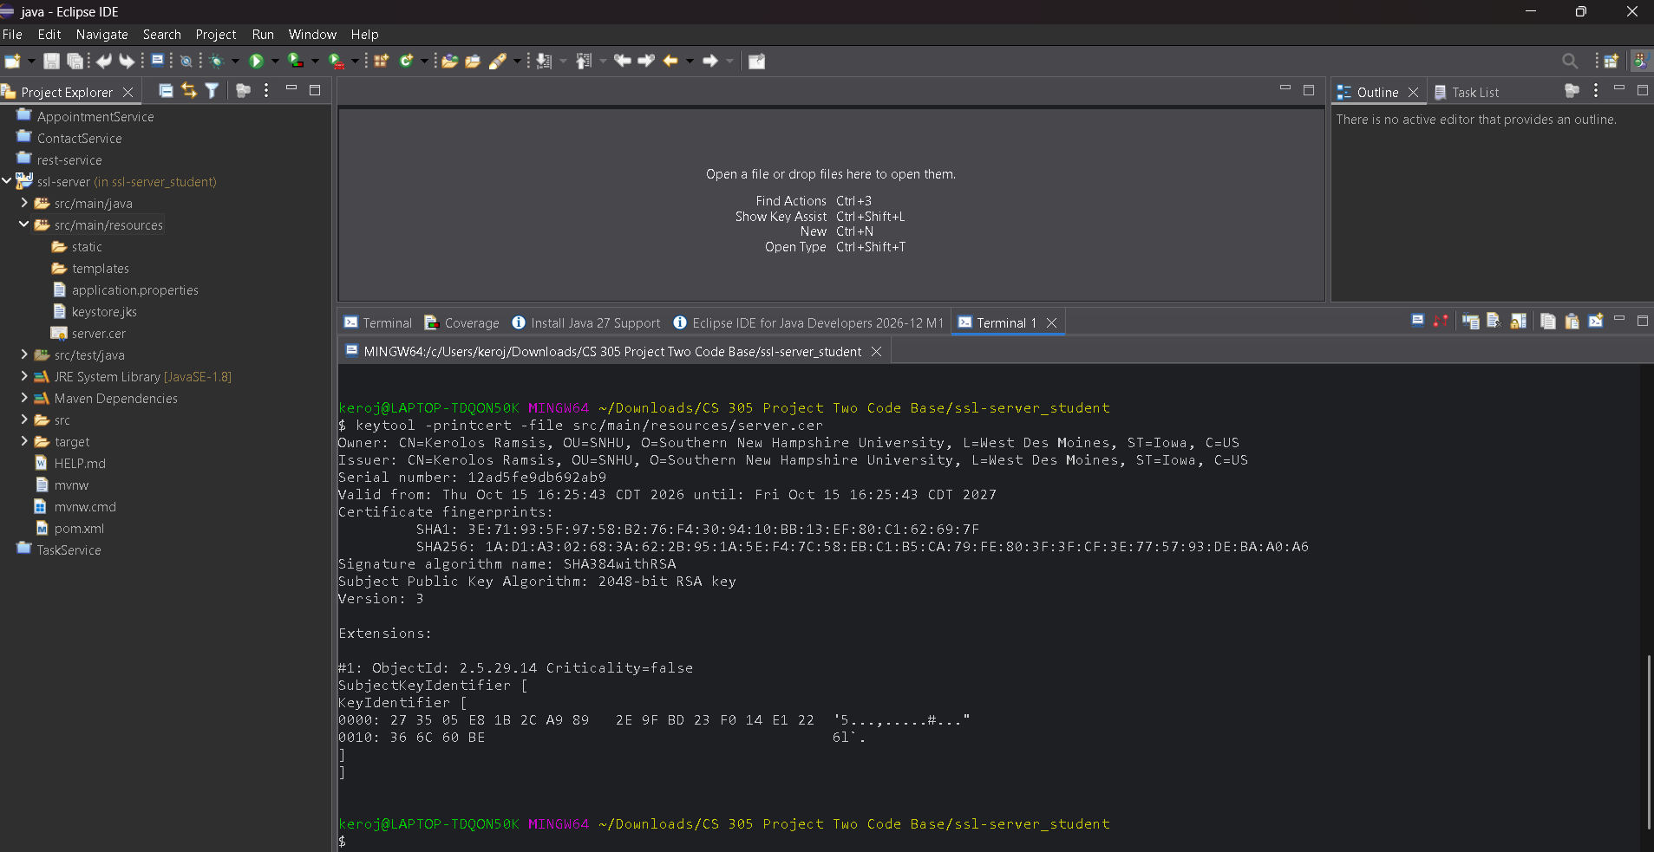

Deploy Cipher
Insert a screenshot below of the checksum verification.



Secure Communications
Insert a screenshot below of the web browser that shows a secure webpage.

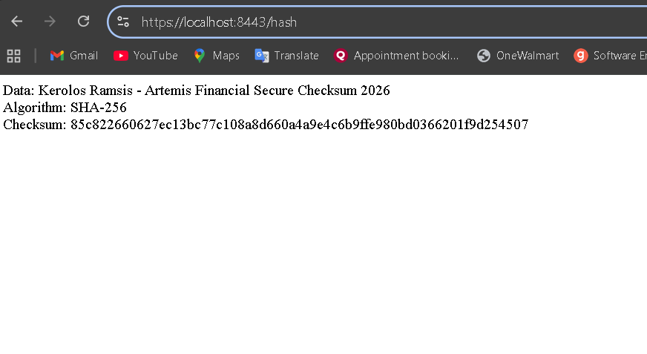

Secondary Testing
Insert screenshots below of the refactored code executed without errors and the dependency-check report.

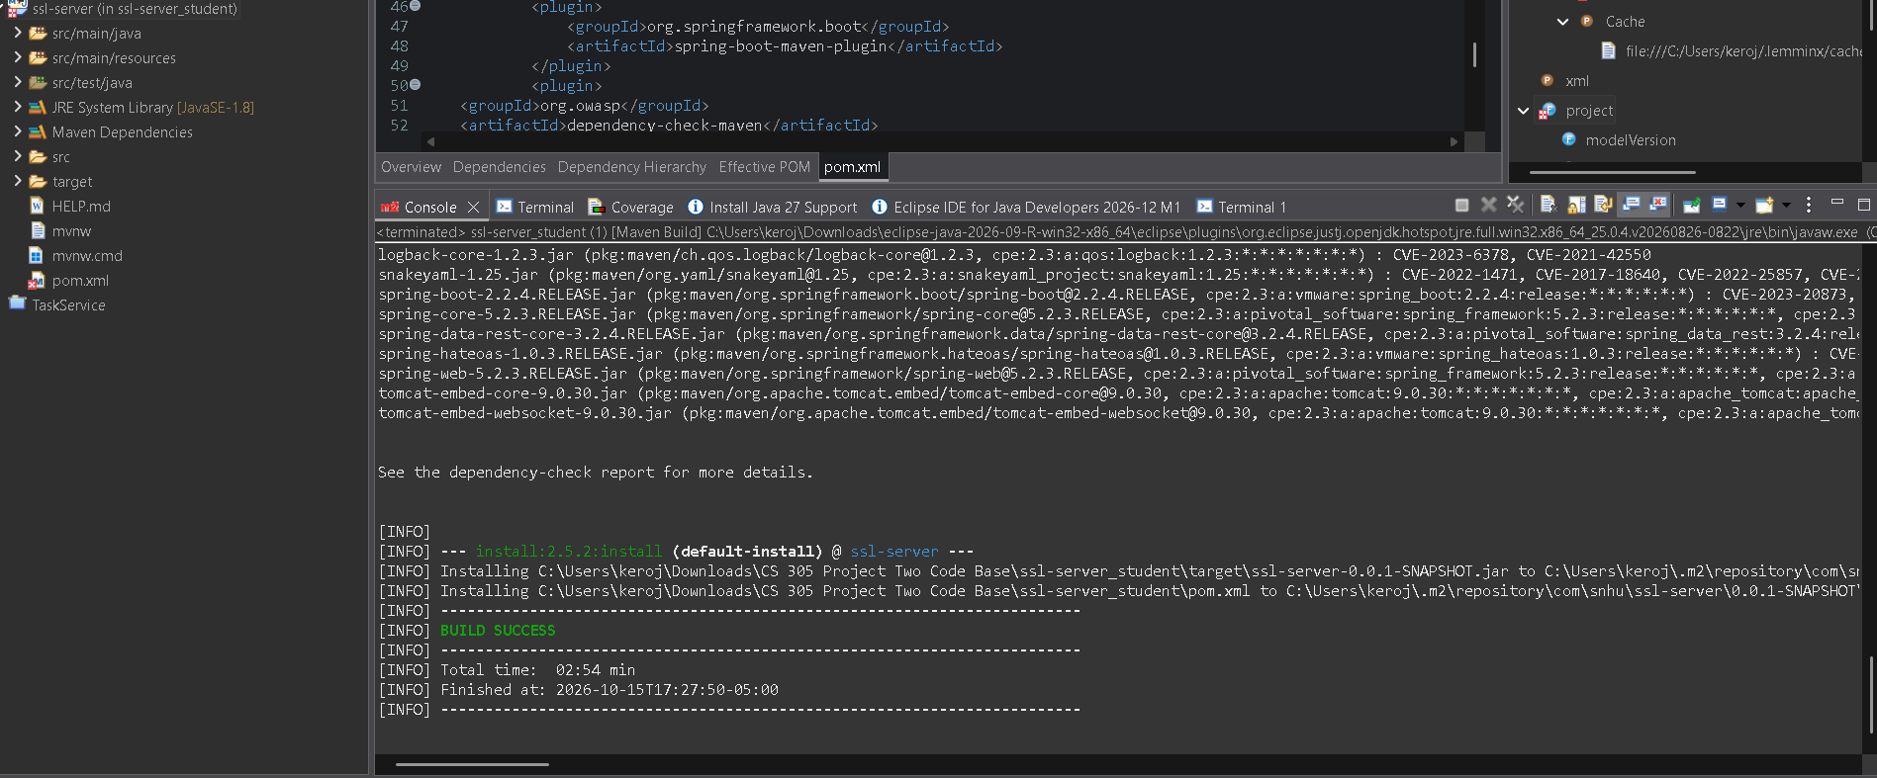
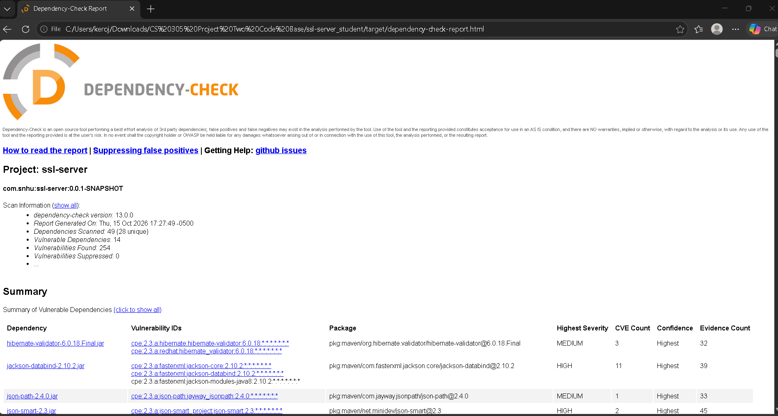

Functional Testing
Insert a screenshot below of the refactored code executed without errors.

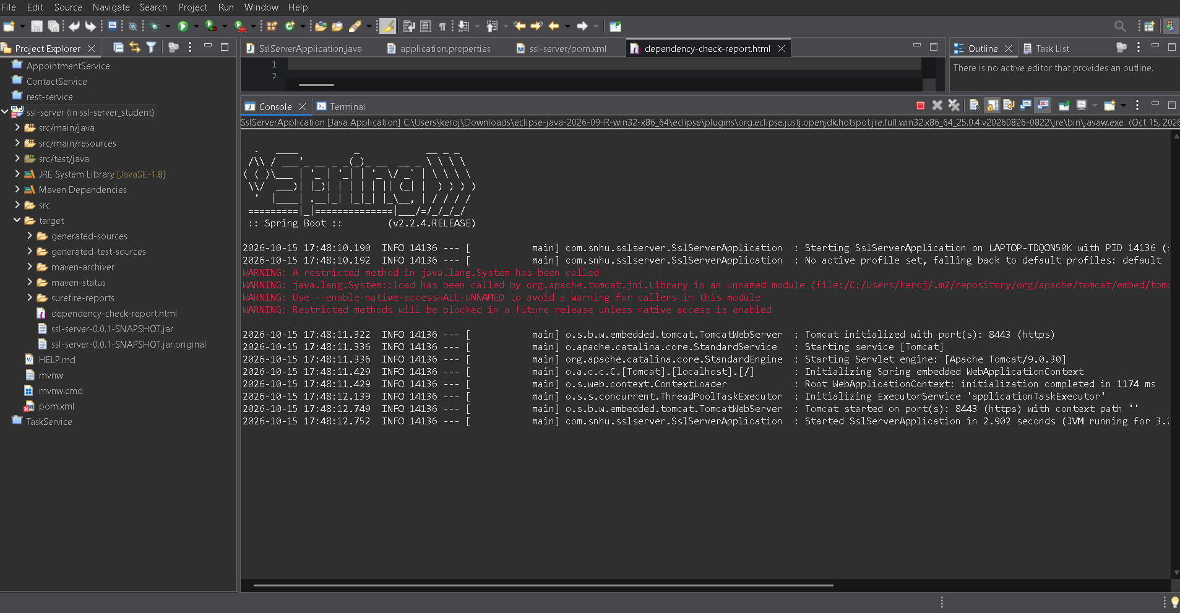

Summary

For this project, I refactored the Artemis Financial application to add multiple layers of security. I added a SHA-256 checksum to verify data integrity, generated and used a self-signed certificate, and configured the application to use HTTPS on port 8443. I also updated the Maven Dependency-Check plug-in and ran a secondary static test to review the project for known vulnerabilities.
The vulnerability assessment process helped guide the security changes I made. I addressed cryptography by using SHA-256 for checksum verification, and I addressed client/server security by changing the application from HTTP to HTTPS. I also reviewed the code for syntax, logic, and security issues to support code quality and secure error handling. The final testing showed that the application could run successfully over HTTPS and that the checksum feature worked as expected.
I added security in layers instead of relying on only one protection method. The certificate and HTTPS configuration protect data while it is being transmitted, while the checksum helps verify that the data has not been changed. The dependency check and manual code review provided additional testing to identify security issues. Using multiple layers of security helps make the application more secure and reduces the chance that one weakness could compromise the entire system.

Industry Standard Best Practices

I used several industry standard best practices while refactoring the Artemis Financial application. I used SHA-256 for checksum verification instead of an outdated hashing method, configured HTTPS to protect data in transit, and used a certificate and keystore to support secure communication. I also used Maven Dependency-Check to scan the project for known vulnerabilities and manually reviewed the code for syntax, logic, and security issues. These practices helped maintain the application’s existing security while adding new protections.
Following secure coding best practices is important because it reduces the chance of introducing weaknesses into the application. It also helps protect customer information, supports reliable software, and makes security testing easier to repeat in the future. For Artemis Financial, these practices are especially valuable because the application handles sensitive financial information. Using secure standards can help reduce security risks, protect customer trust, and support the company’s overall reliability and reputation.

