QuestradeReconcile Python Script

QuestradeReconcile © 2019 kerouac01850

Table of Contents
QuestradeReconcile © 2019 kerouac01850 1
1 Introduction 2
1.1 Reconcile a Spreadsheet with Questrade 4
1.2 Spreadsheet Fields and Formatting 5
1.2.1 Accounts Sheet 6
1.2.2 Balances Sheet 8
1.2.3 Positions Sheet 9
1.2.4 Equities Sheet 10
1.2.5 Activities Sheet 12
1.2.6 Dividends Sheet 13
2 Installation and Configuration 14
2.1 LibreOffice Installation 16
2.2 LibreOffice Macro Security Configuration 17
2.3 Questrade API Activation 20
2.3.1 Create Questrade Token 20
2.5 Python Questrade Macro Installation 23

1 Introduction
The QuestradeReconcile macro is python code that uses the Questrade application programming interface (API) to fetch account, position, balance, equity, 30 day activity, and dividend data into a LibreOffice spreadsheet file. This script is meant to be run infrequently to help provide a dashboard view when, for example, re-balancing a portfolio. It is not meant to track real time market conditions and will raise an error when invoked too frequently.
The Questrade platform requires that client applications like the QuestradeReconcile script help protect the integrity of the service from abuse. The service provides a clear expectation of the level of service that the API commits to fulfill. See details here: https://www.questrade.com/api/documentation/rate-limiting.

Index of Tables
Table 1: Spreadsheet Formatting Codes 5
Table 2: Accounts Sheet Column Definitions 6
Table 3: Account Type Column Values 6
Table 4: Client Account Type Column Values 7
Table 5: Account Status Column Values 7
Table 6: Balances Sheet Column Definitions 8
Table 7: Positions Sheet Column Definitions 9
Table 8: Equities Sheet Column Definitions 10
Table 9: Listing Exchange Column Values 11
Table 10: Security Type Column Values 11
Table 11: Activities Sheet Column Definitions 12
Table 12: Dividends Sheet Column Definitions 13
Table of Figures
Figure 1: Run the QuestradeReconcile Python Macro 4
Figure 2: QuestradeReconcile Configuration Properties 15
Figure 3: LibreOffice Download at www.libreoffice.org 16
Figure 4: LibreOffice Tools Options 17
Figure 5: LibreOffice Macro Security 18
Figure 6: LibreOffice Medium Security Level 18
Figure 7: LibreOffice Run HelloWorldPython 19
Figure 8: LibreOffice HelloWorld (in Python) 19
Figure 9: Questrade Launch Settings Menu 20
Figure 10: Questrade Settings Dialog 20
Figure 11: QuestradeReconcile Security Dialog 21
Figure 12: Questrade Security Token Dialog 21
Figure 13: LibreOffice QuestradeReconcile Security Token Configuration 22
Figure 14: questrade-reconcile-master Download Zip 23
Figure 15: Downloads and Extracted questrade-reconcile.master Folder 24
Figure 16: Contents of Extracted questrade-reconcile-master Folder 24
Figure 17: Administrator Window INSTALL.BAT 25

1.1 Reconcile a Spreadsheet with Questrade
Open the Sample spreadsheet and press the [Reconcile] button. Inspect the newly updated values in the Accounts, Balances, Positions, Equities, Activities, and Dividends sheets.
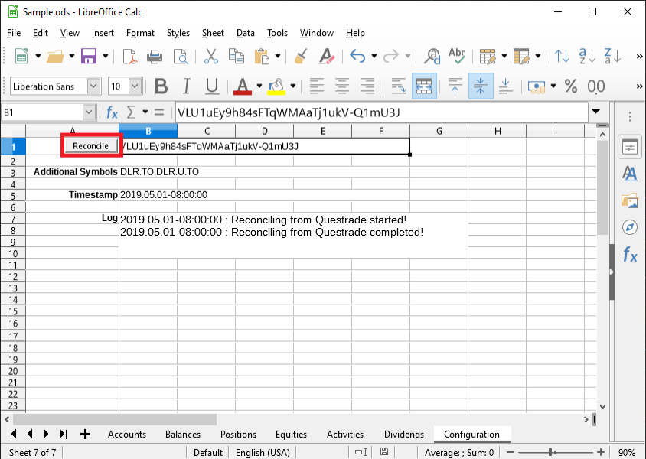Figure 1: Run the QuestradeReconcile Python Macro
Subsequent sections describe the column definitions.

1.2 Spreadsheet Fields and Formatting
This legend lists the field type, ‘s’ for example for strings, and the corresponding spreadsheet formatting applied to that type of value. These field types are used internally by the python script and are only included here to help document the corresponding columns.

Table 1: Spreadsheet Formatting Codes
Description | Field Type | Calc Format
String | s | @
Date | d | MMM D, YYYY
Boolean | b | BOOLEAN
General | n | General
Number with 1 Decimal Place | n0 | #,##0;[RED]-#,##0
Number with 2 Decimal Places | n1 | #,##0.0;[RED]-#,##0.0
Number with 3 Decimal Places | n2 | #,##0.00;[RED]-#,##0.00
Number with 4 Decimal Places | n3 | #,##0.000;[RED]-#,##0.000
Number with 5 Decimal Places | n4 | #,##0.0000;[RED]-#,##0.0000
Number with 6 Decimal Places | n5 | #,##0.00000;[RED]-#,##0.00000

The following sections list the supported data fields and their formatting for each sheet.

1.2.1 Accounts Sheet
https://www.questrade.com/api/documentation/rest-operations/account-calls/accounts

Table 2: Accounts Sheet Column Definitions
Column Name | Field Type | Description
number | n | Eight-digit account number (e.g., "26598145").
type | s | Type of the account (e.g., "Cash", "Margin"). See Account Type section for all allowed values.
clientAccountType | s | Type of client holding the account (e.g., "Individual"). See Client Account Type for full list of values.
status | s | Status of the account (e.g., Active). See Account Status for full list of values.
isPrimary | b | Whether this is a primary account for the holder.
isBilling | b | Whether this account is one that gets billed for various expenses such as inactivity fees, market data, etc.
1.2.1.1 Account Type
Table 3: Account Type Column Values
type | Description
Cash | Cash account.
Margin | Margin account.
TFSA | Tax Free Savings Account.
RRSP | Registered Retirement Savings Plan.
SRRSP | Spousal RRSP.
LRRSP | Locked-In RRSP.
LIRA | Locked-In Retirement Account.
LIF | Life Income Fund.
RIF | Retirement Income Fund.
SRIF | Spousal RIF.
LRIF | Locked-In RIF.
RRIF | Registered RIF.
PRIF | Prescribed RIF.
RESP | Individual Registered Education Savings Plan.
FRESP | Family RESP.
1.2.1.2 Client Account Type
The following table specifies all supported account client types.
Table 4: Client Account Type Column Values
clientAccountType | Description
Individual | Account held by an individual.
Joint | Account held jointly by several individuals (e.g., spouses).
Informal Trust | Non-individual account held by an informal trust.
Corporation | Non-individual account held by a corporation.
Investment Club | Non-individual account held by an investment club.
Formal Trust | Non-individual account held by a formal trust.
Partnership | Non-individual account held by a partnership.
Sole Proprietorship | Non-individual account held by a sole proprietorship.
Family | Account held by a family.
Joint and Informal Trust | Non-individual account held by a joint and informal trust.
Institution | Non-individual account held by an institution.
1.2.1.3 Account Status
The following table specifies all supported account status values.
Table 5: Account Status Column Values
status
Active
Suspended (Closed)
Suspended (View Only)
Liquidate Only
Closed

1.2.2 Balances Sheet
https://www.questrade.com/api/documentation/rest-operations/account-calls/accounts-id-balances

Table 6: Balances Sheet Column Definitions
Column Name | Field Type | Description
balanceType | s | The type of balance is one of perCurrencyBalances, or combinedBalances.
account | n | Eight-digit account number (e.g., "26598145").
accountType | s | Type of the account (e.g., "Cash", "Margin"). See Client Account Type section for all values.
currency | s | Currency of the balance figure (e.g., "USD" or "CAD").
cash | n2 | Balance amount.
marketValue | n2 | Market value of all securities in the account in a given currency.
totalEquity | n2 | Equity as a difference between cash and marketValue properties.
buyingPower | n2 | Buying power for that particular currency side of the account.
maintenanceExcess | n2 | Maintenance excess for that particular side of the account.
isRealTime | b | Whether real-time data was used to calculate the above values.

1.2.3 Positions Sheet
https://www.questrade.com/api/documentation/rest-operations/account-calls/accounts-id-positions

Table 7: Positions Sheet Column Definitions
Column Name | Field Type | Description
account | n | Eight-digit account number (e.g., "26598145").
accountType | s | Type of the account (e.g., "Cash", "Margin"). See User Account Type section for all allowed values.
currency | s | Currency of the equity (e.g., "USD" or "CAD").
symbol | s | Equity symbol.
symbolId | n | Internal symbol identifier.
openQuantity | n3 | Position quantity remaining open.
currentPrice | n2 | Current price of the position symbol.
currentMarketValue | n2 | Market value of the position (quantity x price).
averageEntryPrice | n3 | Average price paid for all executions constituting the position.
totalCost | n2 | Total cost of the position.
openPnl | n2 | Unrealized profit/loss on this position.
dayPnl | n2 | Unrealized profit/loss on this position based on open current prices.
closedQuantity | n3 | Portion of the position that was closed today.
closedPnl | n2 | Realized profit/loss on this position.
isUnderReorg | b | Designates whether a symbol is currently undergoing a reorg.
isRealTime | b | Designates whether real-time quote was used to compute PnL.

1.2.4 Equities Sheet
https://www.questrade.com/api/documentation/rest-operations/market-calls/symbols-id

Table 8: Equities Sheet Column Definitions
Column Name | Field Type | Description
account | n | Eight-digit account number (e.g., "26598145").
accountType | s | Type of the account (e.g., "Cash", "Margin"). See User Account Type section for all allowed values.
currency | s | Currency of the equity (e.g., "USD" or "CAD").
symbol | s | Equity symbol namer.
symbolId | n | Internal symbol identifier.
description | s | Symbol description (e.g., "Microsoft Corp.").
listingExchange | s | Primary listing exchange. See Listing Exchange section for the list of all listing exchanges.
securityType | s | Security type (e.g., "Stock"). See Security Type section for all allowed values.
prevDayClosePrice | n2 | Closing trade price from the previous trading day.
yield | n4 | Dividend yield (dividend / prevDayClosePrice).
pe | n4 | Trailing 12-month price to earnings ratio.
eps | n4 | Trailing 12-month earnings per share.
outstandingShares | n0 | Total number of shares outstanding.
marketCap | n0 | Market capitalization (outstandingShares * prevDayClosePrice).
averageVol20Days | n0 | Average trading volume over trailing 20 days.
averageVol3Months | n0 | Average trading volume over trailing 3 months.
dividend | n4 | Dividend amount per share.
dividendDate | d | Dividend declaration date.
exDate | d | Dividend ex-date.
lowPrice52 | n2 | 52-week high price.
highPrice52 | n2 | 52-week high price.
tradeUnit | b | Smallest number of units that can be traded.

1.2.4.1 Listing Exchange
The following table specifies all supported listing exchanges.
Table 9: Listing Exchange Column Values
listingExchange | Description
TSX | Toronto Stock Exchange.
TSXV | Toronto Venture Exchange.
CNSX | Canadian National Stock Exchange.
MX | Montreal Exchange.
NASDAQ | NASDAQ.
NYSE | New York Stock Exchange.
NYSEAM | NYSE AMERICAN
ARCA | NYSE ARCA.
OPRA | Option Reporting Authority.
PinkSheets | Pink Sheets.
OTCBB | OTC Bulletin Board.
1.2.4.2 Security Type
The following table specifies all supported security types.
Table 10: Security Type Column Values
securityType | Description
Stock | Common and preferred equities, ETFs, ETNs, units, ADRs, etc.
Option | Equity and index options.
Bond | Debentures, notes, bonds, both corporate and government.
Right | Equity or bond rights and warrants.
Gold | Physical gold (coins, wafers, bars).
MutualFund | Canadian or US mutual funds.
Index | Stock indices (e.g., Dow Jones).

1.2.5 Activities Sheet
Account activities, including cash transactions, dividends, trades, etc.
https://www.questrade.com/api/documentation/rest-operations/account-calls/accounts-id-activities

Table 11: Activities Sheet Column Definitions
Column Name | Field Type | Description
account | n | Eight-digit account number (e.g., "26598145").
accountType | s | Type of the account (e.g., "Cash", "Margin"). See User Account Type section for all allowed values.
currency | s | Currency of the equity (e.g., "USD" or "CAD").
transactionDate | d | Transaction date.
symbol | s | Equity symbol name.
symbolId | n | Internal symbol identifier.
type | s | Activity Type
action | s | No documentation from Questrade.
quantity | n3 | The quantity
price | n4 | The price
grossAmount | n2 | Gross amount
commission | n2 | The commission
netAmount | n2 | Net Amount
tradeDate | d | Trade date
settlementDate | d | Settlement date
description | s | No documentation from Questrade.

1.2.6 Dividends Sheet
Here you'll find dividend information and dividend paying stocks with complete payout histories, increase announcements, growth, yield and much more.

Source TSX: https://dividendhistory.org/
Source NASDAQ, BATS, ARCA: https://www.nasdaq.com

Table 12: Dividends Sheet Column Definitions
Column Name | Field Type | Description
account | n | Eight-digit account number (e.g., "26598145").
accountType | s | Type of the account (e.g., "Cash", "Margin"). See User Account Type section for all allowed values.
symbol | s | Equity symbol name.
symbolId | n | Internal symbol identifier.
currency | s | Currency of the equity (e.g., "USD" or "CAD").
dividend | d | Dividend declaration date.
payout | d | Dividend ex date.
amount | n6 | Dividend amount per share.
note | s | TSX: ** indicates unconfirmed/estimated  NASDAQ, BATS, ARCA: Type of dividend (i.e., Cash)
quantity | n3 | Beginning of current month plus two months ahead this column is assigned from positions openQuantity. Other rows are left empty.
income | n2 | Beginning of current month plus two months ahead this column multiplies quantity by dividend amount. Other rows are left empty.

2 Installation and Configuration
The spreadsheet file must have seven sheets with the following names: Accounts, Positions, Balances, Equities, Activity, Dividends and Configuration. Except for the Configuration sheet any existing data on these sheets will be cleared when the QuestradeReconcile python macro is run. Data from the Questrade on-line platform will be used to update these sheets. The sheets can be moved within the file: sheet order does not affect anything. Any other sheets in the file are ignored.
The Configuration sheet must have the following cells defined for the QuestradeReconcile macro to function correctly. In the Sample spreadsheet file the adjacent cells to the left are used as labels. The labels are not required by the macro. Add these cells to your custom spreadsheet.
- $Configuration.B1: Questrade authentication token_value text string. See 2.3 Questrade API Activation for more details.
- $Configuration.B3: A text cell with a comma separated list of equity symbols. The equities on the positions sheet is sourced directly from the Questrade API. Equity values for these symbols are appended to the Equities sheet in addition to those already referenced by the Positions sheet.
- $Configuration.B5: A date cell indicating the last time the macro was run. It is updated automatically by the QuestradeReconcile script.
- $Configuration.B7: A text cell for logging macro status. Usually helps to merge surrounding cells to form a text block using B7 as the root cell. This cell is overwritten with each invocation of the macro and records any errors encountered when running the script.
- $Configuration.B9: A text cell used by the Questrade API wrapper to store OAuth tokens.
- $Configuration.B11: Number of requests allowed against the current limit.
- $Configuration.B13: Time when the current limit will expire (Unix timestamp).
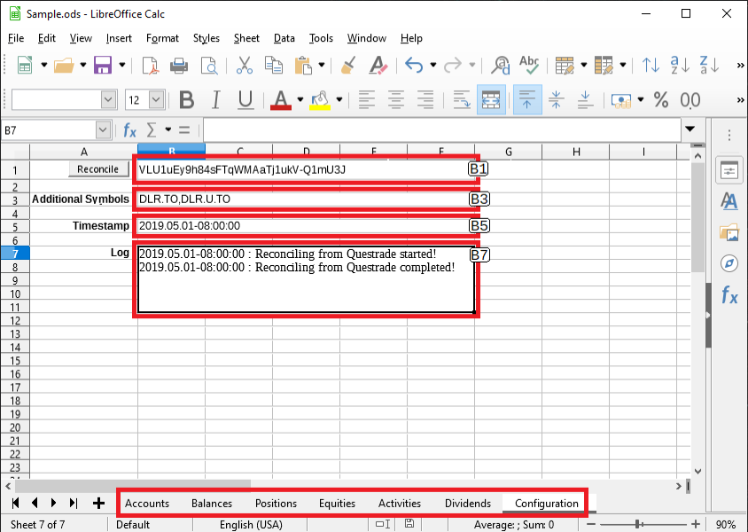Figure 2: QuestradeReconcile Configuration Properties
The configuration items can be changed to different pages or cell locations by modifying the python code. See config values at the top of the QuestradeReconcile.py macro file. The file can be modified by using a Windows text editor such as Notepad or Write.
config_token = '$Configuration.B1'
config_equities = '$Configuration.B3'
config_timestamp = '$Configuration.B5'
config_log = '$Configuration.B7'
config_apicache = '$Configuration.B9'
config_remaining = '$Configuration.B11'
config_reset = '$Configuration.B13'
The following sections describe the installation steps necessary to run the QuestradeReconcile python macro from within the Sample or any other LibreOffice Calc spreadsheet.

2.1 LibreOffice Installation
Go to https://www.libreoffice.org/download/download/ to download and find installation instructions for the LibreOffice suite.
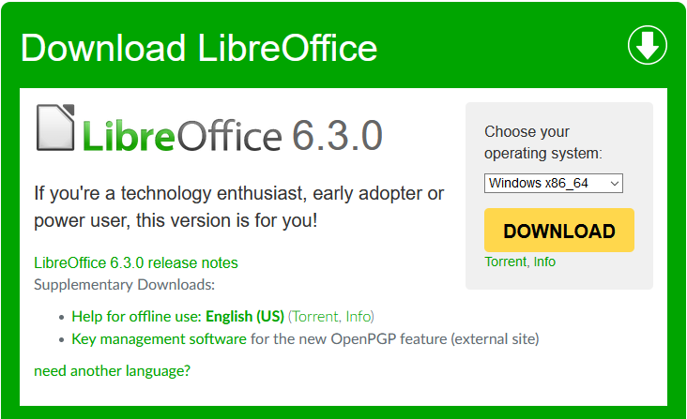Figure 3: LibreOffice Download at www.libreoffice.org
When LibreOffice installation is complete verify:
- Directory C:\Program\Files\LibreOffice\program exists and the python.exe file can be found there.
- Launch LibreOffice Calc using whatever method you like.

2.2 LibreOffice Macro Security Configuration
LibreOffice macros must be enabled to run the QuestradeReconcile python script. Open the Calc Sample spreadsheet and navigate to the [Tools → Options] dialog or press [Alt+F12].
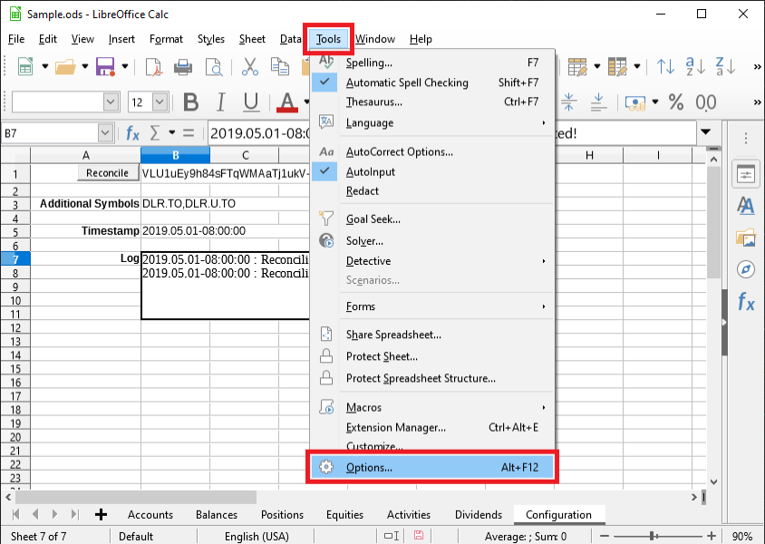Figure 4: LibreOffice Tools Options
Set security to Medium to require confirmation before the QuestradeReconcile python macro will run.
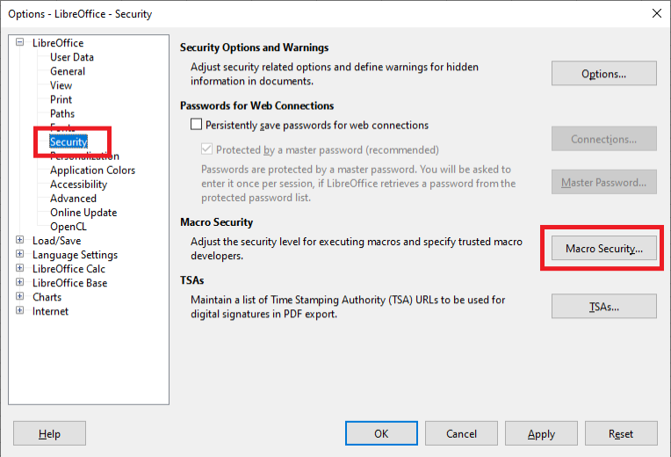Figure 5: LibreOffice Macro Security

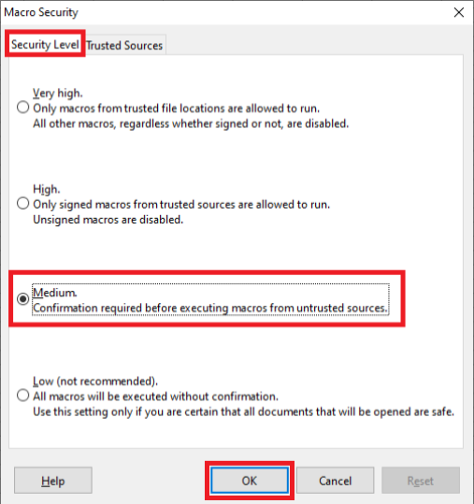Figure 6: LibreOffice Medium Security Level
When security settings have been updated then proceed to verify that python macros are enabled by choosing the [Tools → Macros → Run Macro] menu option from within LibreOffice Calc, then run HelloWorldPython from the HelloWorld Library.

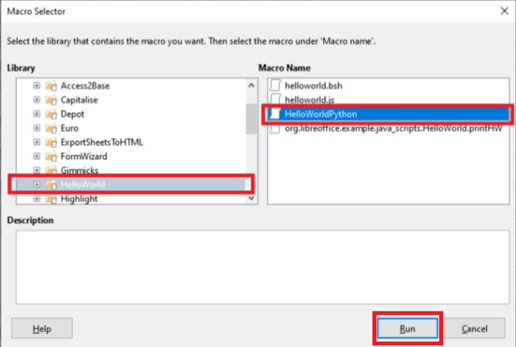Figure 7: LibreOffice Run HelloWorldPython

The HelloWorldPython macro will open a LibreOffice Writer document showing “Hello World (in Python)” when successful.

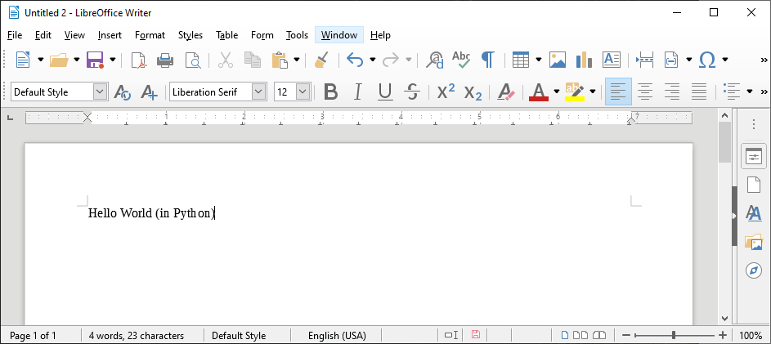Figure 8: LibreOffice HelloWorld (in Python)

2.3 Questrade API Activation
The Questrade platform implements security measures as defined by the OAuth 2.0 protocol. To allow QuestradeReconcile to be authorized by the Questrade platform a refresh token is needed. This token is obtained by registering the QuestradeReconcile application and then by generating a time limited authorization token within the Questrade web portal.

2.3.1 Create Questrade Token
First, log into Questrade web portal and navigate to settings from the [Client Name] pull-down menu.
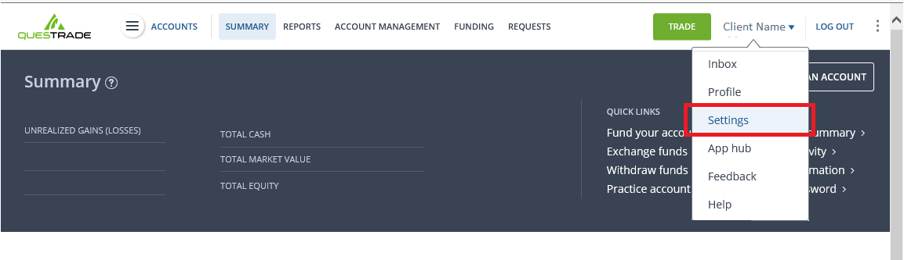Figure 9: Questrade Launch Settings Menu
Read the Questrade API terms and conditions and agree that you wish to enable authenticated connections from QuestradeReconcile. Rejecting the terms and conditions means the macro will not be permitted to access the Questrade API and the QuestradeReconcile macro will fail.
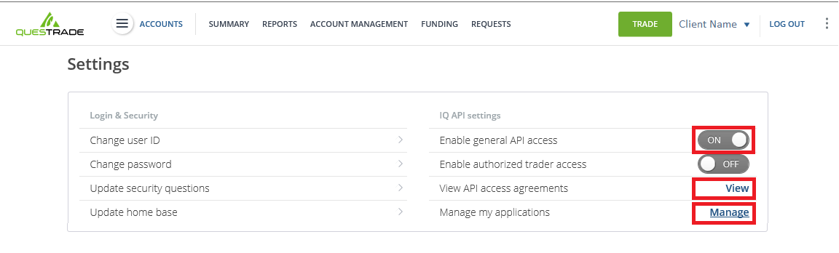Figure 10: Questrade Settings Dialog
Register QuestradeReconcile as a personal application.
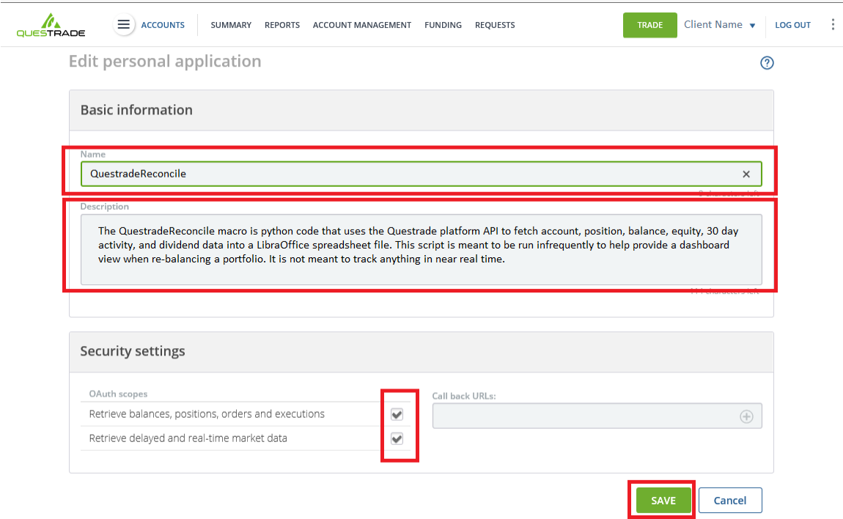Figure 11: QuestradeReconcile Security Dialog
Generate a refresh token. DON’T CLOSE THE POP-UP WINDOW. Read the next step before proceeding.
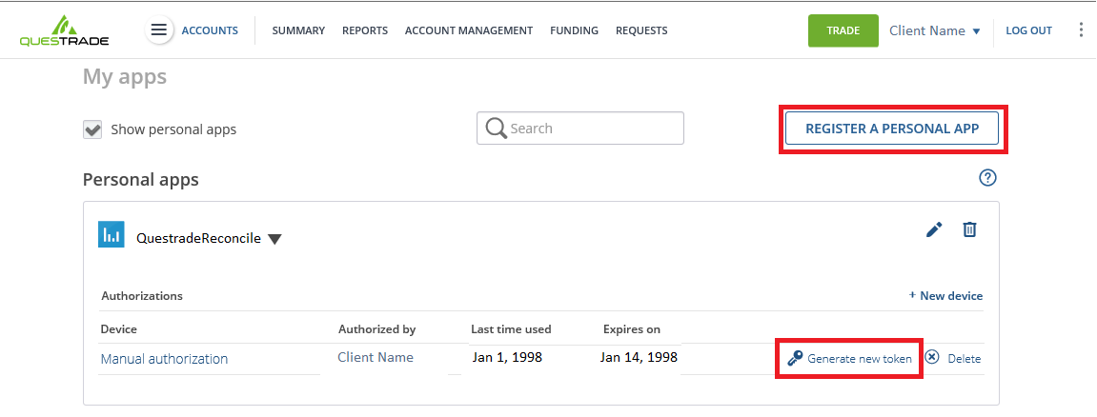Figure 12: Questrade Security Token Dialog
Copy the token from the Questrade pop-up window into the Sample spreadsheet or within your own customized spreadsheet then close the Questrade pop-up window.
The only guaranteed method of copying the token is to select it as a text block in the browser, then copy using the right-click context menu, then paste into the spreadsheet cell. Don’t close the pop-up window until you’ve verified the copied text is identical.
The pop-up window is the only permanent record of the token so closing the window without first copying means the token is lost forever and a new one must be generated.
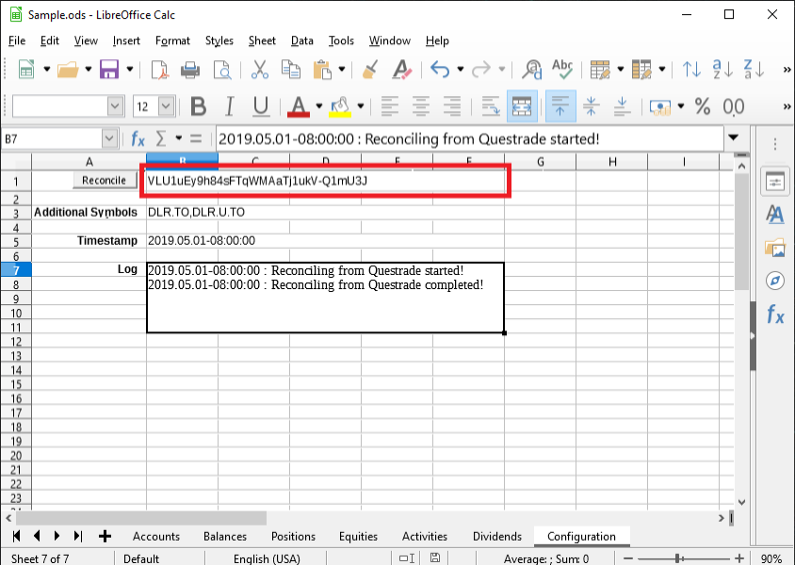Figure 13: LibreOffice QuestradeReconcile Security Token Configuration
To revoke authorization at any time click Delete within the Questrade Personal apps menu shown above.

2.5 Python Questrade Macro Installation
The QuestradeReconcile macro must be installed into the LibreOffice python Scripts directory and the Questrade API wrapper goes into the LibreOffice python site-packages directory.
First download the ZIP file from https://github.com/kerouac01850/questrade-reconcile.
Click on [Clone or Download] button then select [Download ZIP] to download questrade-reconcile-master.zip into your download directory.
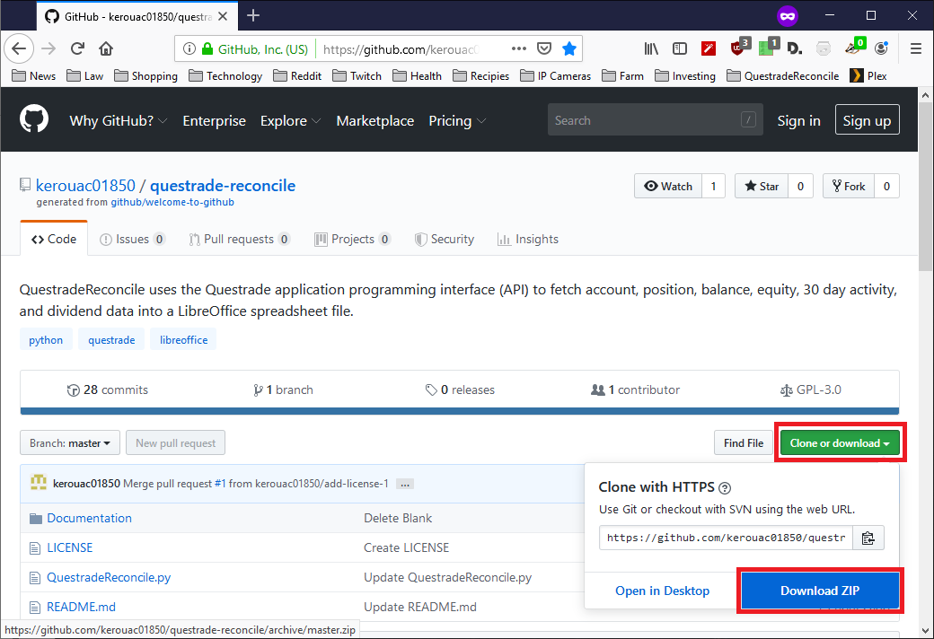Figure 14: questrade-reconcile-master Download Zip
Next, download the questrade-api-master.zip ZIP file from https://github.com/kerouac01850/questrade-api.
Click on [Clone or Download] button then select [Download ZIP] to download questrade-api-master.zip into your download directory.
From the download directory select the questrade-reconcile-master.zip file and then use the right-click Windows context menu to extract all files from the ZIP archive into the download directory.
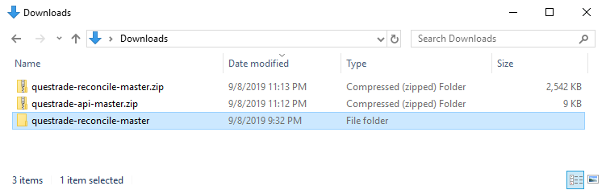
Figure 15: Downloads and Extracted questrade-reconcile.master Folder
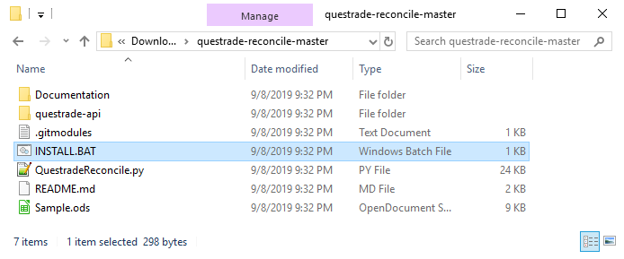
Figure 16: Contents of Extracted questrade-reconcile-master Folder

Open a command prompt window as Administrator and navigate to the Downloads directory and run INSTALL.BAT.
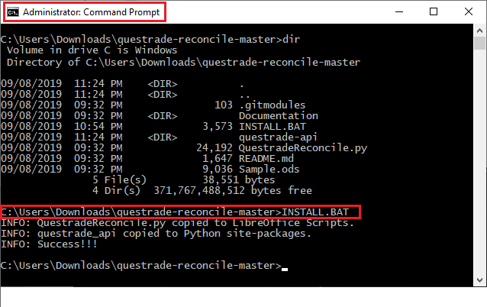Figure 17: Administrator Window INSTALL.BAT
Installation Done. Proceed to 1.1 Reconcile a Spreadsheet with Questrade.

