Activity 5.1: Supervised Learning using Decision Tree & Random Forest (Playing Golf Dataset)

Name:_______________ Date:________________
Section:______________ Score:_______________

- Objectives

Students should be able to:
- Understand Supervised Learning (Classification)
- Apply Decision Tree (J48) and Random Forest in WEKA
- Evaluate model performance using metrics

- Learning Outcomes (Skills/Competencies)

Students will be able to:
- Build classification models in WEKA
- Interpret decision trees and ensemble models
- Explain evaluation metrics conceptually

- Exercises (Laboratory Activity)

PART 1: Data Loading and Inspection

Instructions:
- Open WEKA Explorer
- Click Preprocess tab
- Click Open file
- Load: weather.nominal.arff

Questions
Q1. How many instances are in the dataset?
Answer: The dataset has 14 instances.
Answer: The dataset has 14 instances.
Q2. What is the class attribute?
Answer: The class attribute is play.
Answer: The class attribute is play.
Q3. What type of problem is this? (Classification or Clustering problem)
Answer: This is a classification problem because the goal is to predict whether the value of play is yes or no.

PART 2: Decision Tree (J48) – Training Set

Instructions:
- Go to Classify tab. Choose → trees → J48
- Under Test Options → select:
✔ Use training set (The training set is the collection of examples (rows in your dataset) used to fit the model.)
- Click Start

Questions
Q4. What is the accuracy using the training set?
Answer: The accuracy using the training set is 100% or 14 out of 14 correctly classified instances.
Q5. Why is the accuracy very high?
Answer: The accuracy is very high because the model was tested on the same data it used for training. Since the dataset is small, the model was able to fit the patterns very closely.

PART 3: Decision Tree (J48) – Cross Validation

Instructions:
- Keep J48 selected
- Change Test Options →
✔ 10-fold cross-validation
- Click Start

Questions
Q6. What is the accuracy using cross-validation?
Answer: The cross-validation accuracy is 64.29% or 9 out of 14 correctly classified instances.
Q7. Why did the accuracy decrease?
Answer: The accuracy decreased because cross-validation checks the model on unseen data instead of the exact data used during training. It gives a more realistic view of how the model performs.

PART 4: Decision Tree Visualization and Structure

Instructions:
- In the result list, right-click J48 result
- Click Visualize tree

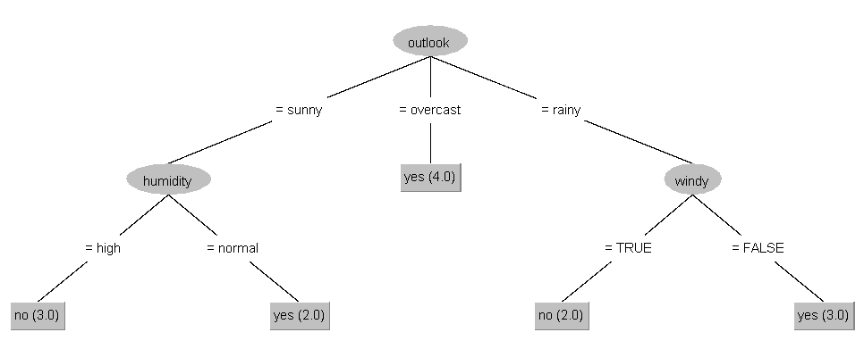
Identify the Parts of the Tree:
Q8. What is the root node?
Answer: The root node is outlook.
Q9. What are the internal nodes?
Answer: The internal nodes are humidity and windy.
Q10. What are the leaf nodes?
Answer: The leaf nodes are play = yes and play = no.

Understanding the Tree
Q11. Write one IF-THEN rule from the tree:
Example answer: IF outlook = overcast → play = yes
Answer: One valid rule is: IF outlook = sunny AND humidity = high, THEN play = no.
Q12. How does the tree make decisions? Answer: The tree makes decisions by checking one attribute at a time from the root to a leaf node. Once it reaches a leaf, that class becomes the prediction.

PART 5: Random Forest (Comparison: Training Set vs Cross-Validation)

A. Random Forest – Training Set

Instructions:
  - Click Choose → trees → RandomForest
  - Under Test Options, select:
  - Use training set
  - Keep default settings
  - Click Start

Guide Questions

Q13. What is the accuracy using the training set? Answer: The Random Forest accuracy using the training set is 100% or 14 out of 14 correctly classified instances.

Q14. Why is the accuracy high? Answer: The accuracy is high because the model is being evaluated on the same data it learned from, and the dataset is small enough for the forest to fit the patterns very well.

B. Random Forest – Cross-Validation

Instructions:
- Keep RandomForest selected
- Change Test Options →
- ✔ 10-fold cross-validation
- Click Start

Guide Questions

Q15. What is the accuracy using cross-validation? Answer: The Random Forest cross-validation accuracy is 50% or 7 out of 14 correctly classified instances.

Q16. Compare Random Forest results in terms of accuracy (Training vs Cross-Validation).
Answer: Training set -> 100%. Cross-validation -> 50%. This shows that the model performs perfectly on the training data, but its performance drops when tested on unseen folds.
Training set →
Cross-validation →

C. Conceptual Understanding

Q17. Can you visualize the Random Forest? Answer: Not as clearly as J48. Random Forest contains many decision trees, so it is harder to present as one simple and easy-to-read structure.

Q18. How is Random Forest different from J48?
Answer: J48 builds one decision tree, so it is easier to interpret. Random Forest combines many trees, so it is usually more stable but less easy to explain visually.

J48 →
Random Forest →

Q19. Why is Random Forest more robust than J48? Answer: Random Forest is more robust because it combines predictions from many trees built from random samples and random features. This helps reduce overfitting and makes the model less sensitive to noise.

Q20. Based on cross-validation, which model is more reliable? Answer: Based on the cross-validation results in this activity, J48 is more reliable because it performed better than Random Forest on unseen data.

PART 6: Evaluation Metrics
Instructions:
Look at WEKA output and identify metrics.

Guide Questions
Q10. What is Accuracy? Answer: Accuracy is the percentage of predictions that the model got correct.

Q11. What is RMSE (Root Mean Squared Error)? Answer: RMSE measures the average size of the prediction errors, and larger errors affect it more because the errors are squared first.

Q12. What is MAE (Mean Absolute Error)? Answer: MAE is the average absolute difference between the predicted values and the actual values.

Q13. What is R² (Coefficient of Determination)? Answer: R2 shows how much of the variation in the target is explained by the model. A value closer to 1 usually means a better fit.

Q14. Which metrics are more relevant for this dataset? Answer: For this dataset, accuracy, confusion matrix, precision, and recall are more relevant because the task is classification. RMSE and MAE can still be reported, but they are more commonly emphasized in regression problems.

- Glossary
- Supervised Learning – Uses labeled data
- Decision Tree – Rule-based classification model
- Random Forest – Ensemble of decision trees
- Accuracy – Correct predictions percentage
- Training set – The data used to teach the model. Example: practice questions before an exam.
- Model – The learned structure or rules created from the training set. Example: the decision tree built by J48.
- Unseen data – Data not used in training, reserved for testing. Example: the actual exam questions.
- Cross‑validation – A method of testing generalization by rotating which data is unseen. Example: rotating practice questions among students so each faces new ones.
- Overfitting – When a model memorizes the training set instead of learning general patterns. Example: a student memorizing answers word‑for‑word but failing on new questions.
- Generalization – The ability of a model to apply what it learned to new, unseen data. Example: understanding concepts so you can answer different exam questions.
- J48 – WEKA’s implementation of the C4.5 decision tree algorithm. Builds a single tree that is easy to interpret but prone to overfitting.

RUBRIC FOR DATA MINING LAB ACTIVITIES

Criteria | 4 – Excellent | 3 – Very Good | 2 – Satisfactory | 1 – Needs Improvement | Score
Technical Skills | Performs all required tasks correctly and independently | Performs tasks with minor oversight | Performs tasks with some guidance | Has difficulty performing tasks
Understanding of Concepts | Demonstrates clear and deep understanding of concepts | Shows good understanding of concepts | Shows basic understanding | Shows limited understanding
Creativity and Originality | Shows original thinking, unique ideas, and personal insight | Shows some creativity and personal input | Shows minimal creativity | Very little originality
Application of Concepts | Applies concepts effectively to practical situations | Applies concepts with minor confusion | Makes simple applications | Weak or incorrect application
Organization and Presentation | Work is neat, well-organized, and easy to follow | Mostly organized with minor issues | Adequately organized | Poorly organized
TOTAL

