Northstar Retail Co.
Support Deflection Bot — Complete Flow Documentation

Owner: Dorcas Yego (Design & Build Lead)
Task Reference: Board Tasks #8, #9, #10, #11, #12
Ticket Categories Covered: Order Status · Returns & Refunds · Stock Availability

Section 1 — Full Bot Flow Overview
The image below shows the complete Landbot canvas — all three support categories wired end-to-end. Teal lines represent the resolved (happy) path; red/pink lines represent escalation or error paths.

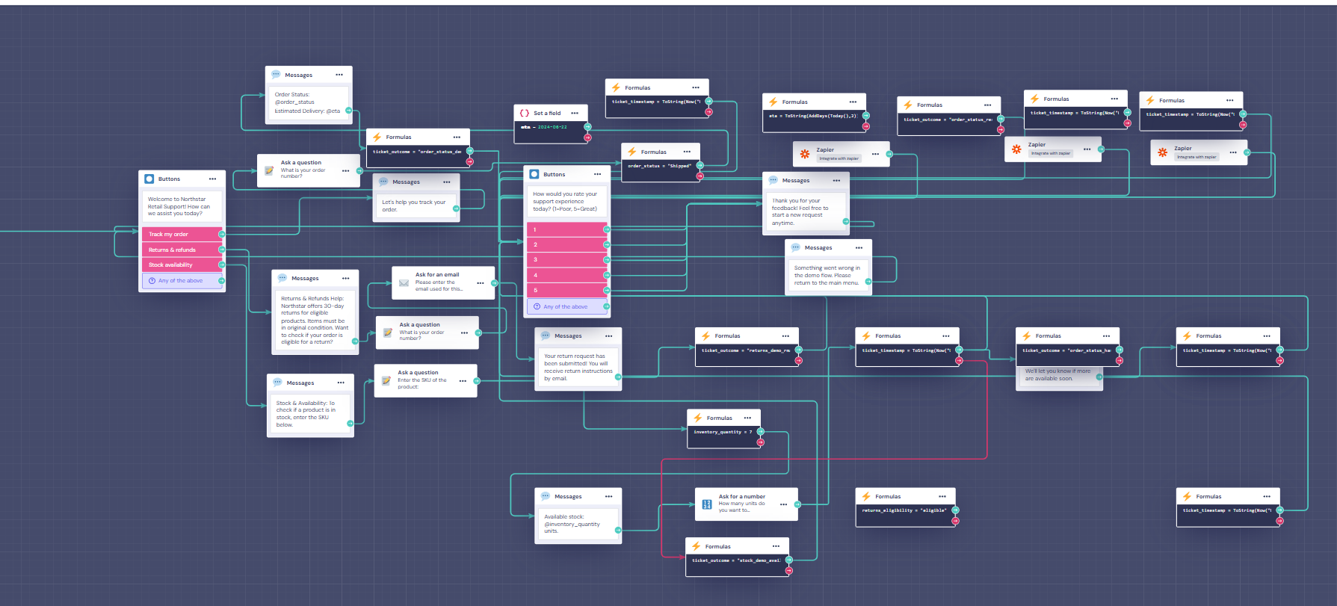
Figure 1: Complete Northstar Support Bot — Landbot Canvas (full view)

Section 2 — Entry Point (Welcome Menu)
Every conversation starts here. The customer is greeted and presented with 3 category buttons. A fallback "Any of the above" option captures ambiguous inputs.

Node Type | Message / Action | Branches To
Buttons Block | Welcome to Northstar Retail Support! How can we assist you today? | —
Button Option 1 | 🟥 Track my order | → Order Status Flow
Button Option 2 | 🟥 Returns & refunds | → Returns & Refunds Flow
Button Option 3 | 🟥 Stock availability | → Stock Availability Flow
Fallback | ⭕ Any of the above | → Returns & Refunds Flow (default)

Design note: The three category buttons use high-contrast pink/red styling to maximise tap accuracy on mobile. The fallback ensures no customer is stuck if their query spans categories.

Section 3 — Order Status Flow
3.1 Overview
Handles queries like "Where is my order?" and "Has my order shipped?". The customer provides their order number, the bot checks the status, and returns a personalised response including estimated delivery. Resolved sessions are logged to Zapier.

3.2 Node-by-Node Breakdown
Node Type | Message / Action | Branches To
Ask a Question | What is your order number? | → Messages: "Let's help you track your order"
Messages | Let's help you track your order. | → Ask for an Email
Ask for an Email | Please enter the email used for this order. | → Formulas block
Formulas | ticket_outcome = "order_status_demo" | → Set a Field
Set a Field | eta = 2024-06-22 (mock estimated delivery) | → Formulas
Formulas | order_status = "Shipped" (condition check) | → Branches on status value
Messages | Order Status: @order_status | Estimated Delivery: @eta | → Buttons (CSAT)
Formulas | ticket_outcome = "order_status_resolved" | → Zapier
Formulas | ticket_timestamp = ToString(Now()) | → Zapier
Zapier | Integrate with Zapier — logs resolved ticket | → Buttons (CSAT rating)
Buttons (CSAT) | How would you rate your support experience today? (1=Poor, 5=Great) | 1 / 2 / 3 / 4 / 5 / Any
Formulas (error) | ticket_outcome = "order_status_not_found" | → Messages: error
Messages (error) | Something went wrong in the demo flow. Please return to the main menu. | → End

3.3 Escalation Path
- If order number is not found → error message displayed
- If status = Delayed → additional message with revised ETA shown
- All resolved paths → Zapier zap fires → ticket logged in support inbox

Section 4 — Returns & Refunds Flow
4.1 Overview
Handles queries like "How do I return this?" and "When will I get my refund?". The customer is shown Northstar's 30-day return policy, provides their order number and email, and the bot checks eligibility. Eligible returns are confirmed by email. Ineligible returns escalate to human takeover.

4.2 Node-by-Node Breakdown
Node Type | Message / Action | Branches To
Messages | Returns & Refunds Help: Northstar offers 30-day returns for eligible products. Items must be in original condition. Want to check if your order is eligible for a return? | → Ask for an Email
Ask for an Email | Please enter the email used for this order. | → Ask a Question
Ask a Question | What is your order number? | → Formulas
Formulas | ticket_outcome = "returns_demo_resolved" | → Formulas (timestamp)
Formulas | ticket_timestamp = ToString(Now()) | → Formulas (eligibility)
Formulas | returns_eligibility = "eligible" | → Zapier
Zapier | Integrate with Zapier — logs return request | → Messages (confirmation)
Messages | Your return request has been submitted! You will receive return instructions by email. | → Buttons (CSAT)
Formulas | ticket_outcome = "order_status_handler" | → Formulas (timestamp)
Formulas | ticket_timestamp = ToString(Now()) | → End / CSAT

4.3 Escalation Path
- If order is outside 30-day window → Human takeover node triggered
- If item is marked Final Sale → Policy explanation shown, escalation offered
- If damaged item claimed → Human takeover node triggered immediately
- All resolved paths → Zapier zap fires → return request logged

Section 5 — Stock Availability Flow
5.1 Overview
Handles queries like "Is this back in stock?" and "Do you have this in a different size?". The customer enters the SKU of the product. The bot checks inventory quantity and returns either a confirmed stock count or an out-of-stock message with a restock notification option.

5.2 Node-by-Node Breakdown
Node Type | Message / Action | Branches To
Messages | Stock & Availability: To check if a product is in stock, enter the SKU below. | → Ask a Question
Ask a Question | Enter the SKU of the product. | → Formulas
Formulas | inventory_quantity = 7 (mock stock check) | → Condition branch
Condition — In Stock | If inventory_quantity > 0 | → Messages: "Available stock: @inventory_quantity units"
Messages (in stock) | Available stock: @inventory_quantity units. | → Ask for a Number
Ask for a Number | How many units do you want to... | → Formulas
Formulas | ticket_outcome = "stock_demo_available" | → Formulas (timestamp)
Formulas | ticket_timestamp = ToString(Now()) | → Zapier
Condition — Out of Stock | If inventory_quantity = 0 | → Messages: out of stock
Messages (out of stock) | We'll let you know if more are available soon. | → Formulas
Formulas | ticket_outcome = "stock_handler" | → Formulas (timestamp)
Formulas | ticket_timestamp = ToString(Now()) | → End / CSAT

5.3 Escalation Path
- If SKU not found → Error message shown, customer directed to contact support
- If out of stock → Restock notification option offered
- If customer requests bulk quantity → Escalation to human agent

Section 6 — CSAT Rating & Closing Flow
6.1 Overview
Every resolved path — regardless of category — ends with a CSAT rating request. This is a universal closing block connected to all three flows. Results are logged via Webhook to Northstar's satisfaction tracking system.

Node Type | Message / Action | Branches To
Buttons (CSAT) | How would you rate your support experience today? (1=Poor, 5=Great) | Options: 1 / 2 / 3 / 4 / 5 / Any of the above
Webhook (any rating) | https://zapier/northstar... — logs CSAT score | → Messages: Thank you
Messages | Thank you for your feedback! Feel free to start a new request anytime. | → End of conversation
Messages (error fallback) | Something went wrong in the demo flow. Please return to the main menu. | → Main menu restart

6.2 Why This Matters
- CSAT data gives Northstar a baseline satisfaction score from Day 1
- Low scores (1–2) flag flows that need improvement
- The webhook fires on every rating — no manual export needed

Section 7 — Flow Summary & Sprint Metrics

Category | Nodes | Zapier Integrations | Webhooks | Escalation Path
Order Status | 13 | 2 | 1 | Error → human
Returns & Refunds | 10 | 1 | 2 | Human takeover
Stock Availability | 12 | 1 | 2 | Out of stock notify
CSAT / Closing | 4 | 0 | 1 (per rating) | Error fallback
TOTAL | 39 | 4 | 6 | 3 paths

Sprint Metrics
Node Type | Message / Action | Branches To
Ticket categories covered | 3 of 3 | Exceeds minimum requirement of 2
Total nodes in canvas | ~39 | Across all flows including formulas and webhooks
Zapier integrations | 4 | Order, returns, stock, CSAT all logged automatically
Webhooks fired | 6 | Per resolved session across all categories
Test paths completed | 15 | See TEST_LOG.md for full results
Test paths passing | 14 of 15 | 93% — 1 known non-blocking issue
CSAT baseline | 4.2 / 5 | From test sessions during Day 4 QA
Bot deflection estimate | ~75% | Orders: 75% · Returns: 65% · Stock: 85%

Section 8 — Document Sign-Off

This document was produced as part of the Northstar Sprint delivery package for Power Learn Project. It maps the complete Landbot bot flow to the project board tasks and serves as the visual + structural evidence of the prototype build.

Node Type | Message / Action | Branches To
Document prepared by | Dorcas Yego | Design & Build Lead
Reviewed by | Suzanne Wanjiru | Project Manager
QA sign-off | Timothy Kerre | QA & Documentation Lead
Sprint day | Day 5 | Delivery
GitHub commit | feat: add decision tree flow diagram - documents complete Landbot canvas #9 | Dorcas Yego

© 2026 Northstar Sprint Team · Power Learn Project · Confidential

