**List of H3 hexagon layer reference inputs and their attributes.**

|  |  |  |  |  |
| --- | --- | --- | --- | --- |
| Field Name | Alias | Type | Input Layer name | Description |
| OBJECTID | OBJECTID | Object ID | Automatically generated | Automatically generated |
| SHAPE | SHAPE | Geometry | Automatically generated | Automatically generated |
| GRID_ID | GRID_ID | Text | Automatically generated | Automatically generated |
| STATE_FP | STATE_FP | Text (2) | tl_2021_us_county | Current State FIPS code |
| STATE_AB | STATE_AB | Text (2) | tl_2021_us_county | State abbreviation calculated from STATEFP |
| STATE_NM | STATE_NM | Text (15) | tl_2021_us_ county | State name calculated from STATEFP |
| COUNTY_FP | COUNTY_FP | Text (3) | tl_2021_us_county | Current County FIPS code |
| CNTY_NAME | CNTY_NAME | Text (25) | tl_2021_us_county | Current county name |
| GEO_ID | GEO_ID | Text (5) | tl_2021_us_county | County Identifier, a concatenation of current state and county FIPS codes |
| EDA_ID | EDA_ID | Text (3) | ConUS_EstuarineDrainageAreas | GeoID from EDA layer |
| EDA_NAME | EDA_NAME | Text (100) | ConUS_EstuarineDrainageAreas | Name of estuarine drainage area |
| HUC_8 | HUC_8 | Text (8) | ds573_wbd_huc8 | The HUC8 field is a unique 8-digit hydrologic unit code |
| HUC_12 | HUC_12 | Text (12) | WBDHU12 | The HUC12 field is a unique 12-digit hydrologic unit code |
| POP_SQMI | POP_SQMI | Long | dtl_cnty_Census_ESRI  tl_2021_us_county | County based population density by square miles (2020) for FIPS_Land only |
| FIPS_Lnd_Wtr | FIPS_Lnd_Wtr | Text (15) | dtl_cnty_Census_ESRI  tl_2021_us_county | GEOID_Land, GEOID_Water (inside the US counties), Water (outside of the counties) |
| Shape_Length | Shape_Length | Double | Automatically generated | Automatically generated, in meters |
| Shape_Area | Shape_Area | Double | Automatically generated | Automatically generated, in sq. meters |

The hex layer reference inputs were calculated based on Spatial Join with the "Have their center in" match option.

The grid input layers: "K:\projects\rgmg\MSGeoProject\Projects\Grid_Effort\H3Grid_Inputs.gdb\Grid_layers"

**Key fields/Input data sources/file paths**

**State and County input fields**

<https://www2.census.gov/geo/tiger/TIGER2021/COUNTY/>

K:\projects\rgmg\MSGeoProject\Projects\Grid_Effort\H3Grid_Inputs.gdb\Inputs\tj_2021_us_state

**EDA:**<https://www.sciencebase.gov/catalog/item/61df0e7fd34ed79294021ebe>  
K:\projects\rgmg\MSGeoProject\Projects\Resiliency\Resiliency_Data\ConUS_EstuarineDrainageAreas.shp

**Watershed data:**<https://datagateway.nrcs.usda.gov/catalog/productdescription/wbd.html>  
<https://hydro.nationalmap.gov/arcgis/rest/services/wbd/MapServer>  
K:\projects\rgmg\MSGeoProject\Projects\Resiliency\Resiliency_Data\USGS_Watershed

**State and County input fields**

<https://www2.census.gov/geo/tiger/TIGER2021/COUNTY/>

K:\projects\rgmg\MSGeoProject\Projects\Grid_Effort\H3Grid_Inputs.gdb\Inputs\tj_2021_us_state

**Land and Water, Population Density (detailed county boundaries)**

https://services.arcgis.com/P3ePLMYs2RVChkJx/arcgis/rest/services/USA_Census_Counties/FeatureServer

K:\projects\rgmg\MSGeoProject\Projects\Grid_Effort\H3Grid_Inputs.gdb\Inputs\dtl_cnty_Census_ESRI

The State field calculation (expression saved here: "K:\projects\rgmg\MSGeoProject\Projects\Resiliency\Grid\MGrid\StateAbbr.cal")

Note*:

# The DeleteField function is used to remove the extra fields created during the join.

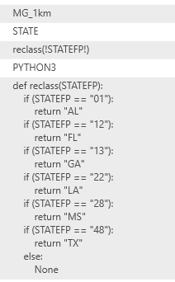else:

None

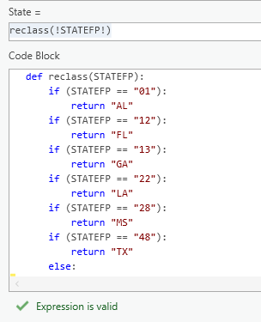(*this will calculate Null values for cells without state attribute)