Correlation Analysis of Apple and Microsoft Monthly Stock Returns (2000-Present)

Analysis Report  
**March 31, 2025**

# Table of Contents

1. Executive Summary

2. Introduction

3. Data and Methodology

4. Monthly Returns Analysis

5. Correlation Analysis

6. Annual Performance Comparison

7. Rolling Correlation Analysis

8. Distribution of Returns

9. Conclusion

10. References

# 1. Executive Summary

This report presents a comprehensive correlation analysis of monthly stock returns for Apple Inc. (AAPL) and Microsoft Corporation (MSFT) from January 2000 to the present. The analysis reveals a moderate positive correlation of **0.4723** between the monthly returns of these two technology giants, with a statistically significant p-value of **0.0000000000**. Over the analyzed period, Apple stock demonstrated a higher average monthly return of **2.52%** compared to Microsoft's **1.15%**. However, Apple's returns also exhibited greater volatility with a standard deviation of **11.00%** versus Microsoft's **7.97%**. The rolling correlation analysis indicates that the relationship between these stocks has varied considerably over time, with periods of both strong positive correlation and near-zero correlation. This report provides detailed visualizations and analysis of these findings, offering insights into the dynamic relationship between two of the world's most valuable technology companies.

# 2. Introduction

Apple Inc. and Microsoft Corporation represent two of the most influential and valuable technology companies in the world. Both companies have been at the forefront of technological innovation for decades, though with different business models and product focuses. Apple has primarily focused on consumer hardware products like the iPhone, iPad, and Mac computers, along with related services, while Microsoft has traditionally concentrated on software, cloud services, and enterprise solutions.

Understanding the correlation between the stock returns of these two technology giants provides valuable insights for investors, portfolio managers, and financial analysts. Correlation analysis helps in assessing diversification benefits, portfolio risk management, and understanding how these major technology stocks move in relation to each other during different market conditions and economic cycles.

This report examines the monthly stock returns of Apple and Microsoft from January 2000 to the present, covering more than two decades of data. This period encompasses several significant events including the dot-com bubble burst, the 2008 financial crisis, the subsequent bull market, the COVID-19 pandemic, and recent market volatility. By analyzing the correlation between these two stocks over this extended timeframe, we can identify patterns, trends, and changes in their relationship.

The analysis includes an examination of monthly returns, correlation coefficients, rolling correlations, annual performance comparisons, and return distributions. Through comprehensive statistical analysis and visual representations, this report aims to provide a thorough understanding of how these two major technology stocks have moved in relation to each other over the past two decades.

# 3. Data and Methodology

**Data Source:** The analysis utilizes monthly closing price data for Apple Inc. (AAPL) and Microsoft Corporation (MSFT) obtained from Yahoo Finance. The dataset spans from January 2000 to March 2025, providing approximately 25 years of monthly observations. Adjusted closing prices were used to account for corporate actions such as stock splits and dividend distributions.

**Return Calculation:** Monthly returns were calculated as percentage changes in the adjusted closing prices using the formula:  
Monthly Return (%) = ((Price_current - Price_previous) / Price_previous) × 100

**Correlation Analysis:** The Pearson correlation coefficient was used to measure the linear relationship between the monthly returns of Apple and Microsoft stocks. This coefficient ranges from -1 to +1, where:  
• +1 indicates a perfect positive correlation  
• 0 indicates no correlation  
• -1 indicates a perfect negative correlation

**Rolling Correlation:** A 12-month rolling correlation was calculated to observe how the relationship between the two stocks has evolved over time. This approach uses a moving window of 12 months to compute the correlation coefficient at each point in time.

**Annual Analysis:** Annual returns were calculated by compounding the monthly returns within each calendar year. Annual correlations were computed by calculating the correlation coefficient of monthly returns within each calendar year.

**Statistical Significance:** The p-value associated with the correlation coefficient was calculated to assess the statistical significance of the observed correlation. A p-value less than 0.05 is generally considered statistically significant, indicating that the observed correlation is unlikely to have occurred by chance.

# 4. Monthly Returns Analysis

The analysis of monthly returns for Apple and Microsoft reveals interesting patterns in their performance over the past two decades. Figure 1 illustrates the monthly percentage returns for both companies from 2000 to the present.

Figure 1: Monthly Returns Comparison (2000-Present)

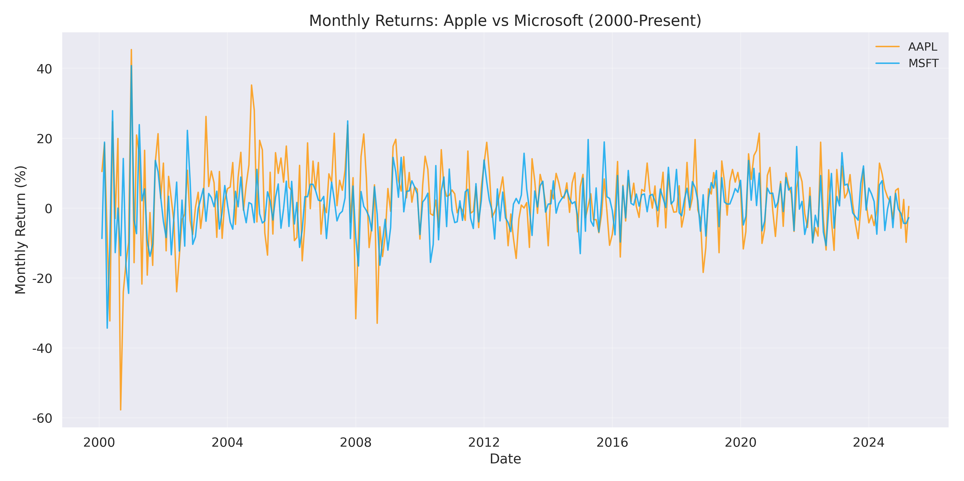

As shown in Figure 1, both stocks have experienced significant volatility in their monthly returns over the analyzed period. Several key observations can be made:

First, both stocks show similar patterns of volatility clustering, with periods of high volatility often coinciding with major market events. Notable periods of high volatility include the dot-com bubble burst (2000-2002), the global financial crisis (2008-2009), and the COVID-19 pandemic (2020). During these periods, both stocks experienced larger than average fluctuations in their monthly returns.

Second, Apple's monthly returns demonstrate greater amplitude in both positive and negative directions compared to Microsoft. This is reflected in Apple's higher standard deviation of **11.00%** versus Microsoft's **7.97%**. This difference in volatility can be attributed to Apple's business model, which has historically been more dependent on product cycles and consumer sentiment, particularly following the introduction of the iPhone in 2007.

Third, over the entire period, Apple achieved a higher average monthly return of **2.52%** compared to Microsoft's **1.15%**. This difference in average returns reflects Apple's remarkable growth story, particularly during the 2010s when the company solidified its position in the smartphone market and expanded its ecosystem of products and services.

The distribution of monthly returns, as shown in Figure 6, further illustrates the differences in return patterns between the two companies.

# 5. Correlation Analysis

The correlation analysis between Apple and Microsoft monthly returns reveals a moderate positive correlation of **0.4723** with a p-value of **0.0000000000**. This statistically significant positive correlation indicates that the monthly returns of these two technology giants tend to move in the same direction, though not perfectly in tandem.

Figure 2: Correlation Scatter Plot with Regression Line

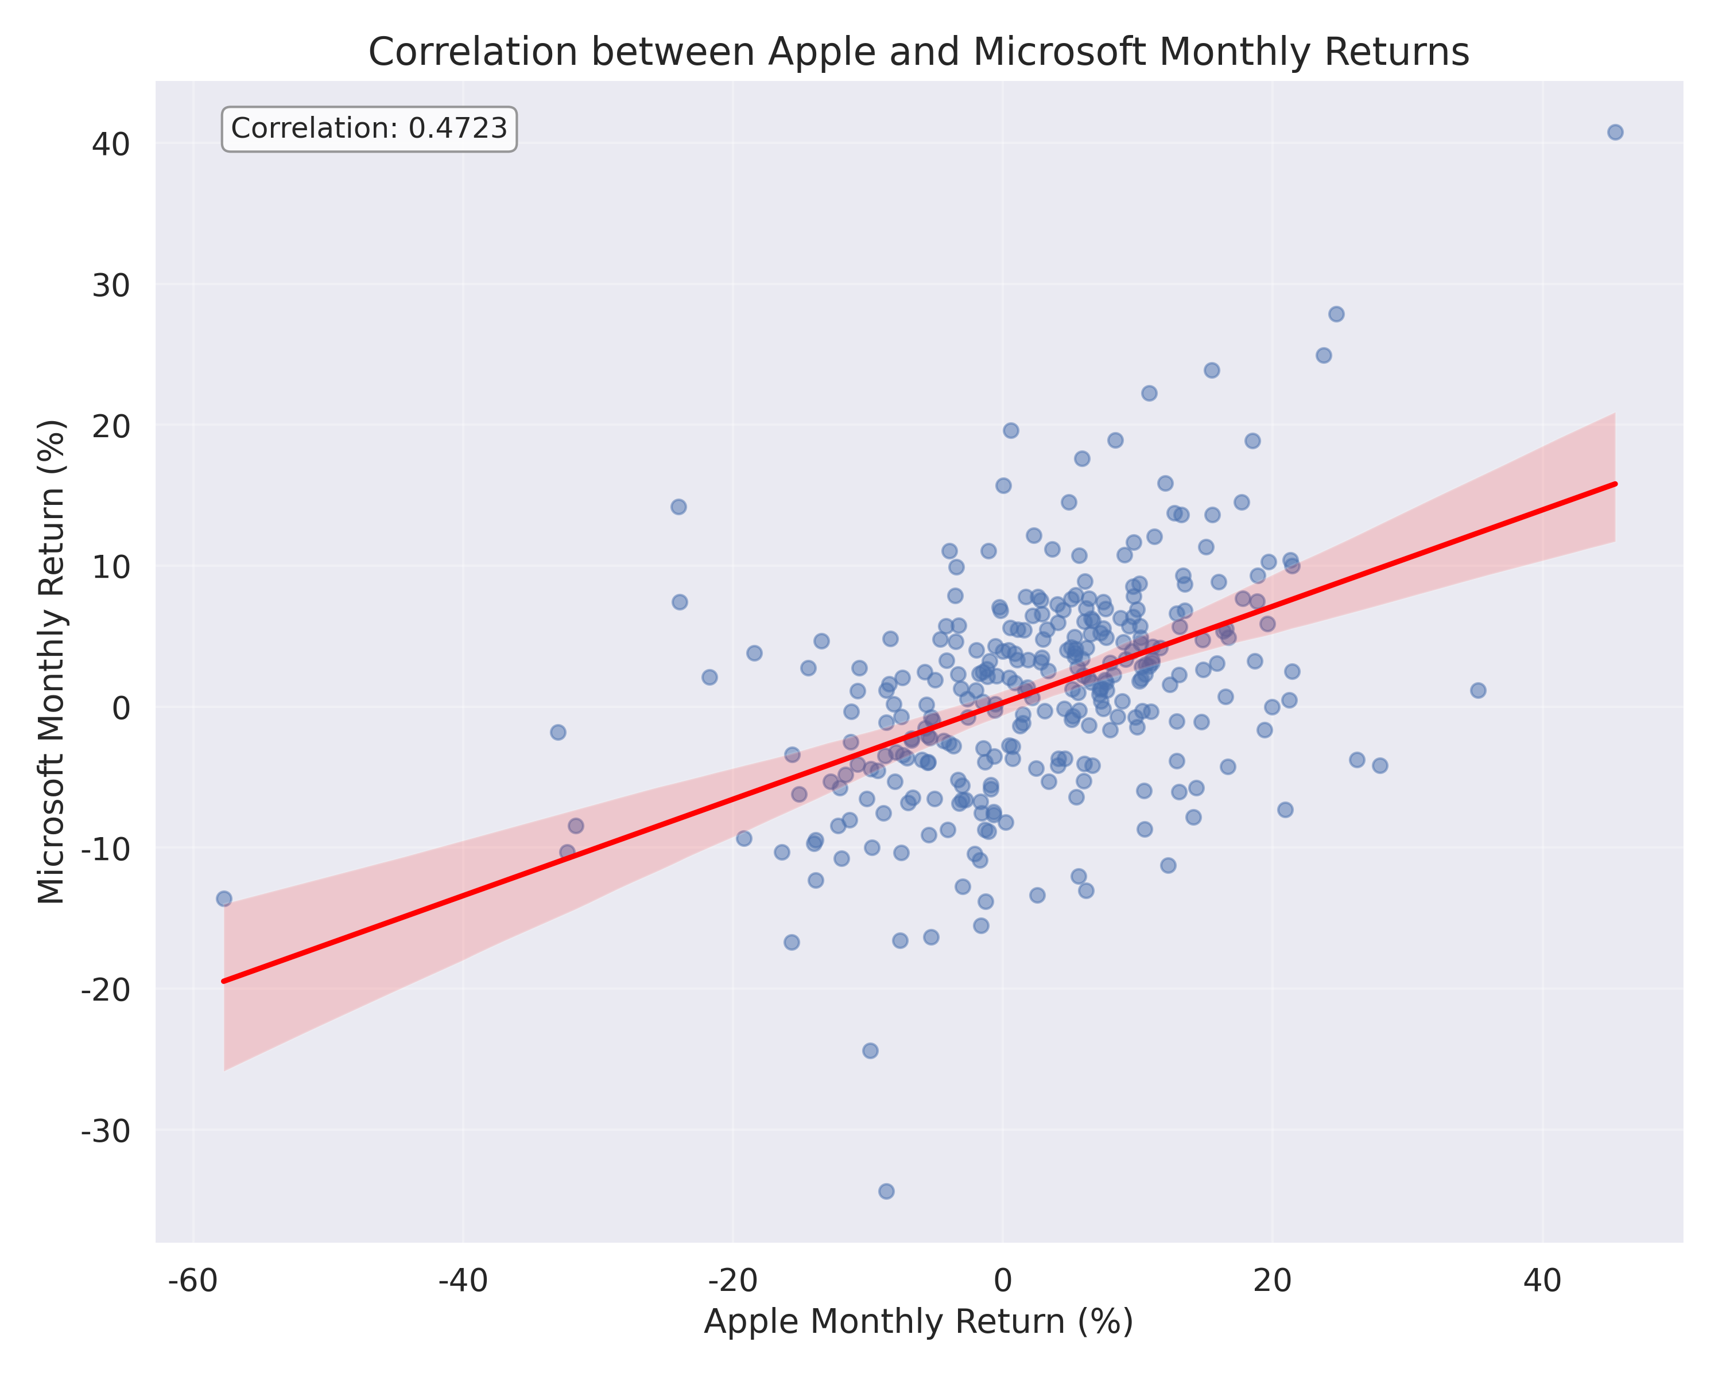

Figure 2 presents a scatter plot of Apple's monthly returns against Microsoft's monthly returns, with a regression line illustrating their relationship. The positive slope of the regression line visually confirms the positive correlation between the two stocks. However, the considerable dispersion of points around the regression line indicates that while there is a relationship, it is not extremely strong.

This moderate correlation suggests that while both companies operate in the technology sector and are influenced by similar macroeconomic factors, they also have distinct business models and revenue streams that cause their stock returns to diverge significantly at times. Apple's business has been increasingly driven by consumer hardware products and related services, while Microsoft has focused more on enterprise software, cloud services, and business solutions.

The correlation coefficient of **0.4723** has important implications for portfolio diversification. While investing in both stocks does not provide complete diversification (which would require a correlation closer to zero or negative), the moderate correlation suggests that holding both stocks in a portfolio would still offer some diversification benefits compared to holding just one of them.

The extremely low p-value (**0.0000000000**) indicates that the observed correlation is highly statistically significant and very unlikely to have occurred by chance. This confirms that there is a genuine relationship between the monthly returns of Apple and Microsoft stocks.

# 6. Annual Performance Comparison

Examining the annual returns provides a broader perspective on the performance of Apple and Microsoft stocks over the years. Figure 4 presents a comparison of annual returns for both companies from 2000 to the present.

Figure 3: Annual Returns Comparison (2000-Present)

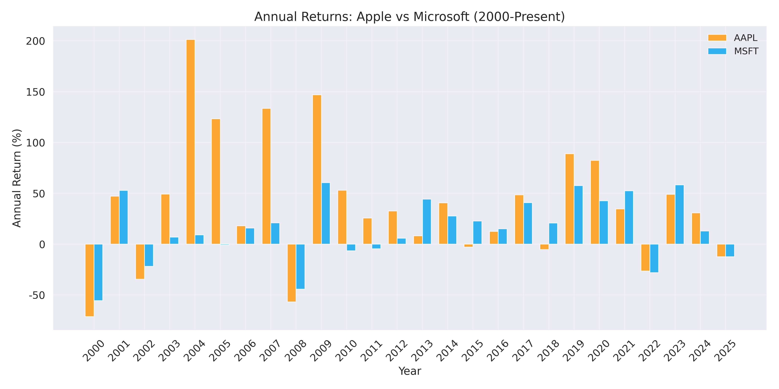

The annual returns comparison reveals several interesting patterns and periods of divergence between the two stocks:

During the early 2000s, following the dot-com bubble burst, both companies experienced negative returns, though Microsoft generally fared better than Apple during this challenging period. The mid-2000s saw Apple begin its remarkable ascent, particularly following the introduction of the iPhone in 2007, which transformed the company's business model and growth trajectory.

The global financial crisis of 2008-2009 negatively impacted both companies, but Apple recovered more quickly and delivered exceptional returns in the subsequent years as the smartphone market expanded rapidly. The 2010s generally saw strong performance from both companies, though with notable year-to-year variations in their relative performance.

More recently, both companies have benefited from the technology sector's strong performance, though with different drivers: Apple's growth has been fueled by its expanding ecosystem of products and services, while Microsoft has thrived due to its successful pivot to cloud computing and subscription-based services.

The annual correlation between Apple and Microsoft returns has also varied considerably over time, as shown in Figure 7.

Figure 4: Annual Correlation Trend

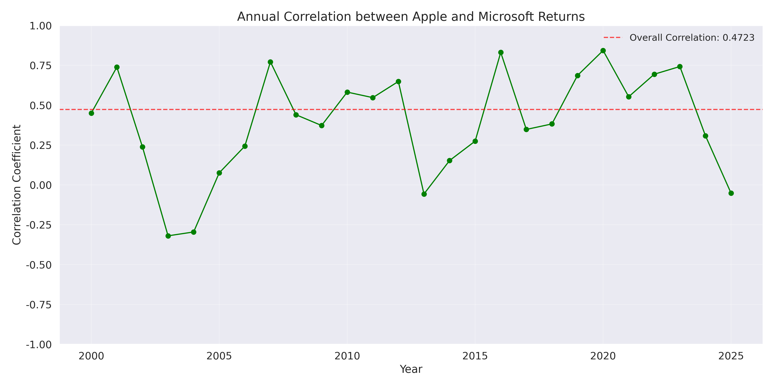

This chart illustrates how the correlation between Apple and Microsoft returns has fluctuated on an annual basis. Some years show strong positive correlation, while others show weak or even negative correlation. This variation highlights how the relationship between these two stocks is not static but evolves based on company-specific factors, industry trends, and broader market conditions.

# 7. Rolling Correlation Analysis

To better understand how the relationship between Apple and Microsoft returns has evolved over time, a 12-month rolling correlation analysis was performed. Figure 3 presents the results of this analysis.

Figure 5: Rolling 12-Month Correlation

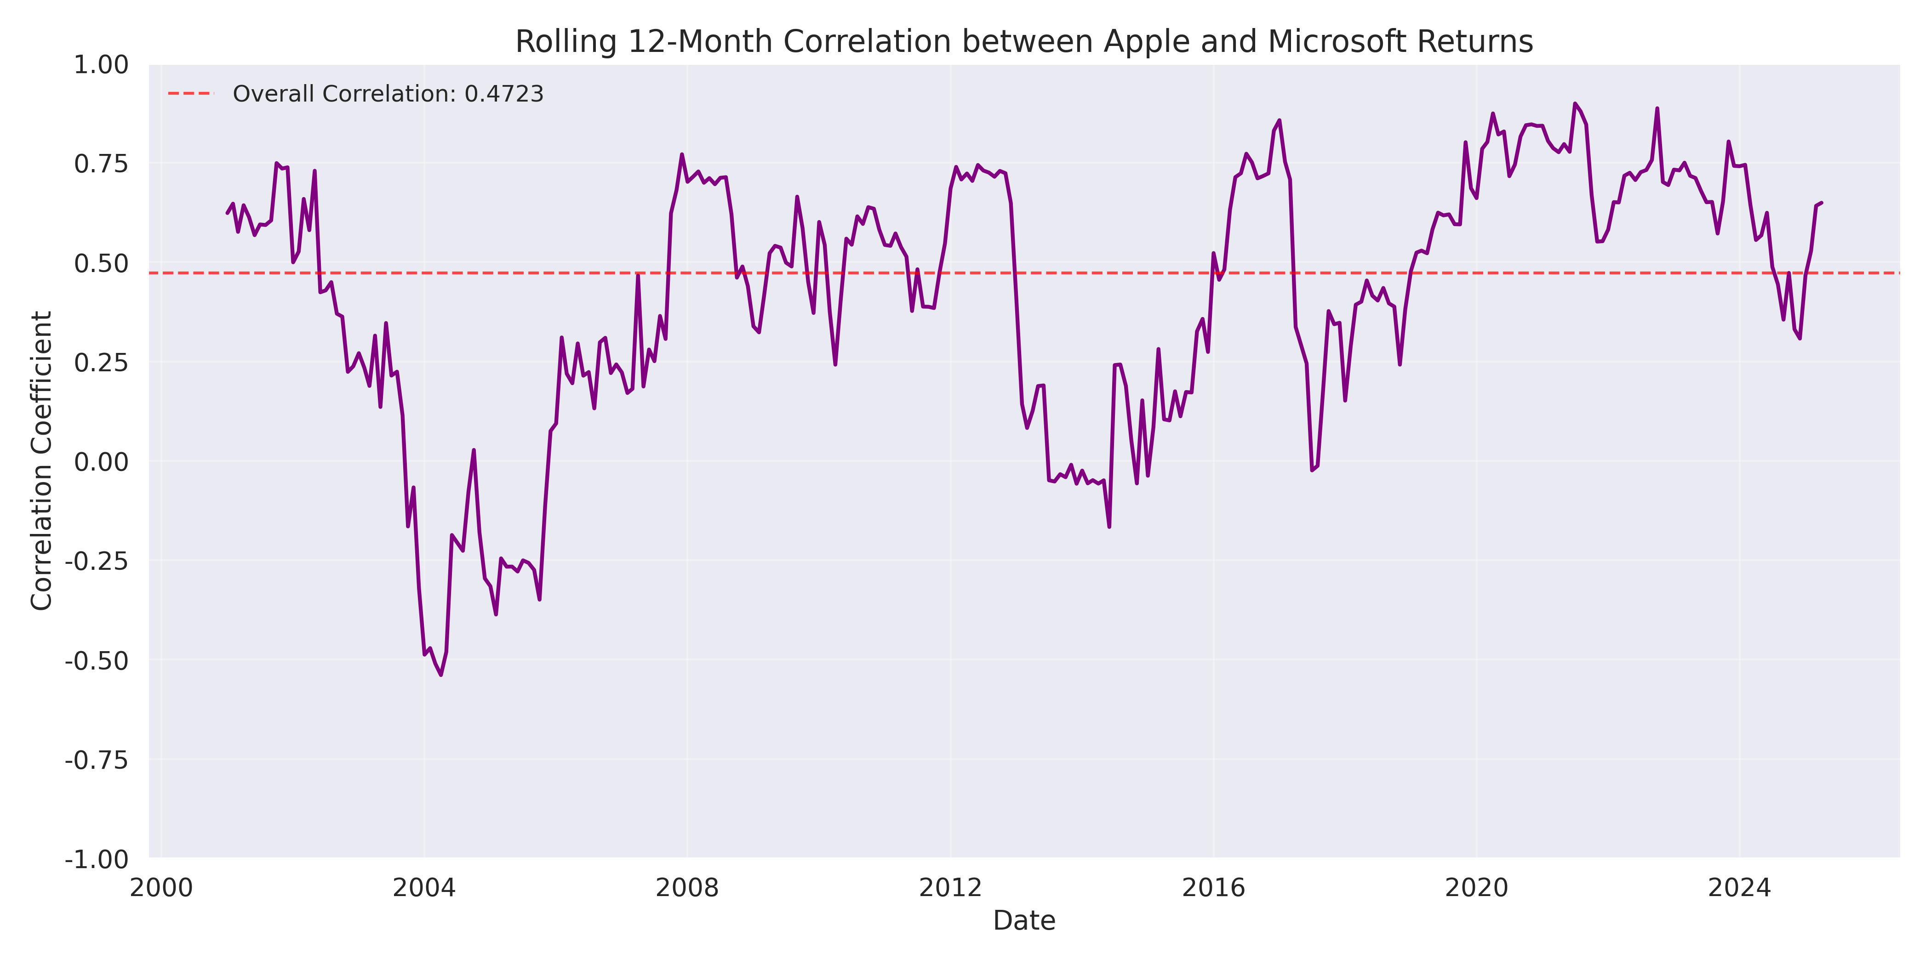

The rolling correlation analysis reveals significant variations in the relationship between Apple and Microsoft returns over the analyzed period. The correlation has ranged from strongly positive (approaching +0.8) to near-zero or even slightly negative at times. This variation indicates that the relationship between these two stocks is dynamic and influenced by changing market conditions, company-specific developments, and shifts in their respective business models.

Several patterns are evident in the rolling correlation:

During periods of market stress, such as the 2008 financial crisis and the 2020 COVID-19 market crash, the correlation between Apple and Microsoft tends to strengthen. This is consistent with the well-documented phenomenon that correlations between stocks often increase during market downturns as systematic risk factors dominate over company-specific factors.

Conversely, during periods of relative market stability, the correlation between the two stocks often decreases, reflecting the greater influence of company-specific factors on their respective returns. This pattern suggests that the diversification benefits of holding both stocks may be reduced precisely when diversification is most needed—during market crises.

The heatmap in Figure 5 provides another perspective on how the correlation has varied over time, showing patterns by year and month.

Figure 6: Monthly Correlation Heatmap by Year



The heatmap visualization reveals interesting temporal patterns in the correlation between Apple and Microsoft returns. Certain years show consistently high correlation across most months, while others display more variable patterns. This visualization helps identify specific time periods when the relationship between the two stocks was particularly strong or weak.

# 8. Distribution of Returns

Analyzing the distribution of monthly returns provides insights into the risk and return characteristics of Apple and Microsoft stocks. Figure 6 presents the distribution of monthly returns for both companies.

Figure 7: Distribution of Monthly Returns

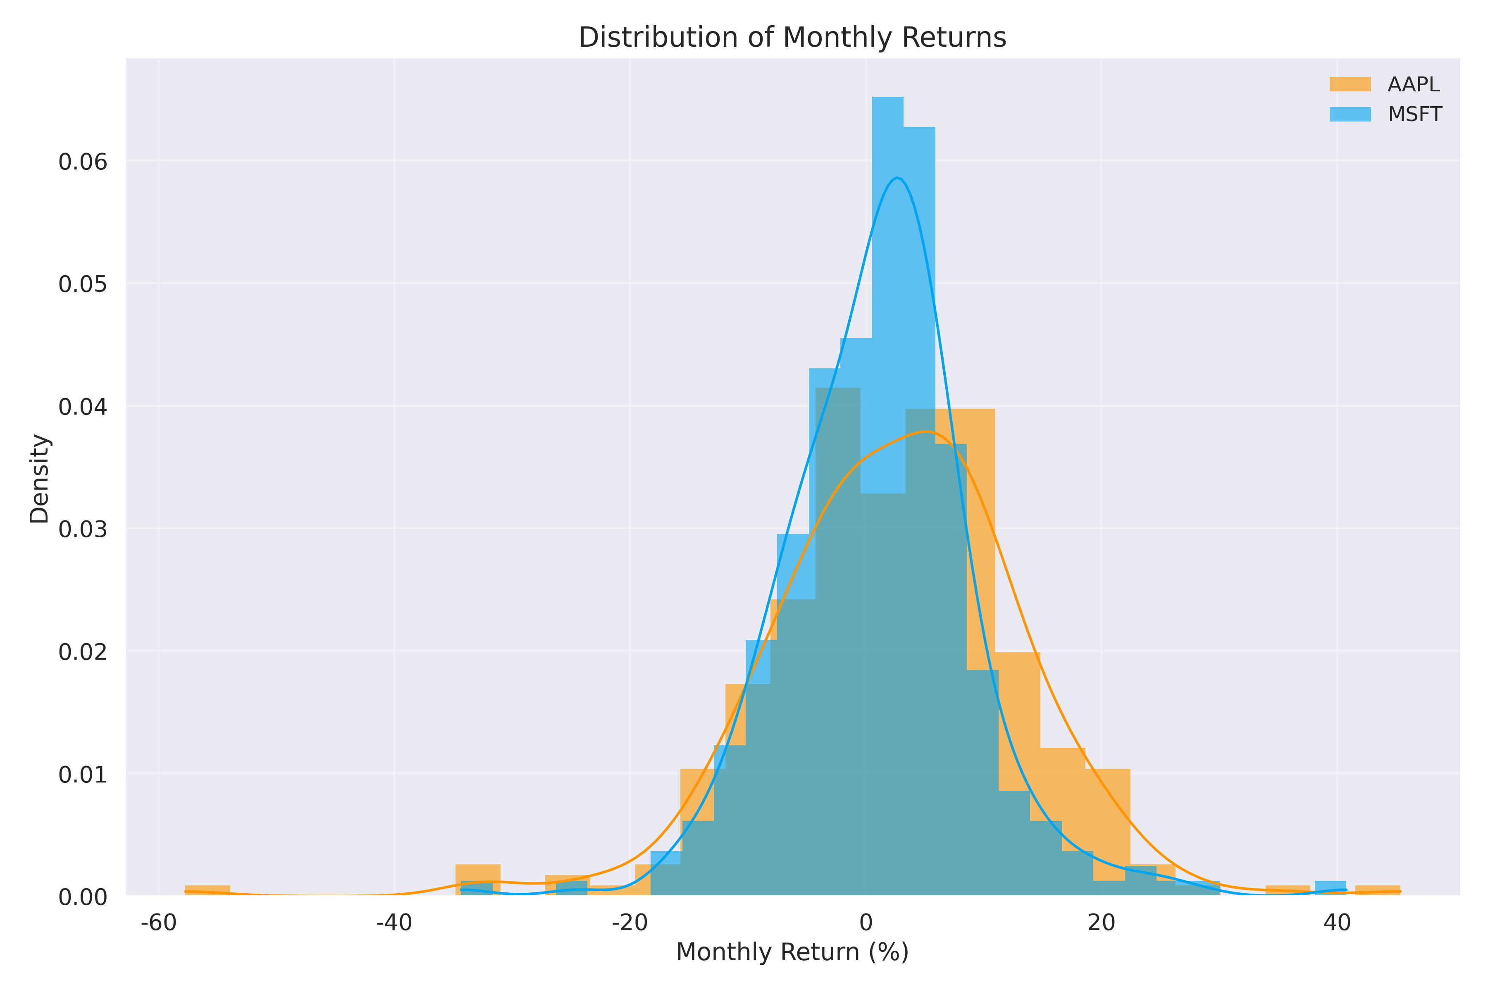

The distribution chart reveals several key differences between Apple and Microsoft returns:

Apple's return distribution is wider, reflecting its higher volatility (standard deviation of **11.00%**). This wider distribution indicates that Apple stock has experienced more extreme monthly returns, both positive and negative, compared to Microsoft. This higher volatility is consistent with Apple's business model, which has historically been more dependent on product cycles and consumer sentiment.

Microsoft's return distribution is more concentrated around its mean, with a standard deviation of **7.97%**. This narrower distribution suggests that Microsoft has generally experienced less extreme monthly returns, reflecting its more diversified business model and revenue streams that have historically been less cyclical than Apple's.

Both distributions show slight positive skewness, indicating that both stocks have experienced more extreme positive returns than negative returns. This positive skewness is a favorable characteristic for investors, as it suggests that the stocks have had more upside potential than downside risk over the analyzed period.

The difference in return distributions between Apple and Microsoft reflects their distinct business models, growth trajectories, and risk profiles. Apple's higher average return (**2.52%** vs. Microsoft's **1.15%**) has come with higher volatility, illustrating the fundamental risk-return tradeoff in investing.

# 9. Conclusion

This comprehensive analysis of Apple and Microsoft monthly stock returns from 2000 to the present has revealed several important findings:

The overall correlation coefficient of **0.4723** indicates a moderate positive relationship between the monthly returns of these two technology giants. This statistically significant correlation suggests that while both stocks are influenced by similar factors, they also have distinct drivers that cause their returns to diverge significantly at times.

Apple has demonstrated higher average monthly returns (**2.52%** vs. Microsoft's **1.15%**) but with greater volatility (standard deviation of **11.00%** vs. Microsoft's **7.97%**). This risk-return profile reflects Apple's remarkable growth story, particularly following the introduction of the iPhone, but also the greater uncertainty associated with its business model.

The rolling correlation analysis revealed significant variations in the relationship between Apple and Microsoft returns over time, with correlation coefficients ranging from strongly positive to near-zero. This dynamic relationship highlights how company-specific factors, industry trends, and broader market conditions influence the correlation between these stocks.

The correlation tends to strengthen during periods of market stress, such as the 2008 financial crisis and the 2020 COVID-19 market crash, potentially reducing diversification benefits precisely when they are most needed. This pattern is consistent with the well-documented phenomenon that correlations between stocks often increase during market downturns.

For investors and portfolio managers, these findings have several implications:

Including both Apple and Microsoft in a portfolio provides some diversification benefits, though these benefits may be reduced during market crises. The moderate positive correlation suggests that while both stocks will often move in the same direction, the magnitude of their movements can differ significantly, offering partial diversification.

The different risk-return profiles of Apple and Microsoft allow investors to adjust their exposure based on their risk tolerance and return objectives. Apple's higher returns and higher volatility may be more suitable for investors with higher risk tolerance, while Microsoft's more moderate returns and lower volatility may appeal to more conservative investors.

The varying correlation over time suggests that the optimal allocation between these stocks may change based on market conditions and the specific business trajectories of the companies. Regular rebalancing and monitoring of the relationship between these stocks may be beneficial for portfolio management.

In conclusion, while Apple and Microsoft are both leading technology companies, they offer distinct investment characteristics and their relationship has evolved significantly over the past two decades. Understanding this dynamic relationship is valuable for investors seeking to optimize their technology sector exposure and overall portfolio construction.

# 10. References

1. Yahoo Finance. (2025). Apple Inc. (AAPL) Historical Data. Retrieved from https://finance.yahoo.com/quote/AAPL/history/  
2. Yahoo Finance. (2025). Microsoft Corporation (MSFT) Historical Data. Retrieved from https://finance.yahoo.com/quote/MSFT/history/  
3. Markowitz, H. (1952). Portfolio Selection. The Journal of Finance, 7(1), 77-91.  
4. Campbell, J. Y., Lettau, M., Malkiel, B. G., & Xu, Y. (2001). Have Individual Stocks Become More Volatile? An Empirical Exploration of Idiosyncratic Risk. The Journal of Finance, 56(1), 1-43.  
5. Longin, F., & Solnik, B. (2001). Extreme Correlation of International Equity Markets. The Journal of Finance, 56(2), 649-676.