**Getting setup with LoopFlopy for Seamless Geo-Structural Modelling!**

**1. Install Anaconda (Conda)**

Conda is anOpen-source package and environment management system that runs on Windows, macOS, and Linux. Install, run, and update packages and their dependencies.

[Download Anaconda Distribution | Anaconda](https://www.anaconda.com/download)

**2. Install VS Code**

Visual Studio Code (VS Code) is a **free, cross-platform code editor** developed by Microsoft. It is designed to provide a streamlined and efficient coding experience for developers working on various platforms, including Windows, macOS, and Linux.

[Download Visual Studio Code - Mac, Linux, Windows](https://code.visualstudio.com/Download)

Open Extensions icon on the left , and install the **Python** extension.

**3. Install Git**

**Git**is a **distributed version control system** designed to track changes in source code during software development. It allows multiple developers to work on a project simultaneously without interfering with each other's work.

[Download Git Software](https://git-scm.com/downloads)

If you have a Mac, look in Appendix A for instructions!

**4. Create a GitHub Account**

[GitHub](https://github.com/)

**5. Create a Projects folder on your hard drive**

Running script from a cloud location can get messy. Create a “Projects” folder somewhere on your hard drive where you can save your GitHub repositories. Don’t worry - these scripts will get backed up when you use Git! That’s what it is for!

**6. Install loopflopy package from source**

In VSCode, open a new terminal and navigate to your Projects directory.

*Hints:*

|  |  |
| --- | --- |
| *dir (ls* for Mac) | lists your directory |
| cd *foldername* | To navigate into that folder |
| *cd..* | To go back up a level |
|  |  |

When in Projects, type:

*git clone*[*https://github.com/kerrybardot/loopflopy.git*](https://github.com/kerrybardot/loopflopy.git) which downloads the loopflopy package

**7. Create a new Python virtual environment**

A virtual environment in Python is a self-contained directory that includes a specific Python version and additional packages. It helps isolate dependencies required by different projects, ensuring that each project has its own set of packages without interfering with the global Python installation.

**From scratch:**

In the Anaconda Prompt (windows app) or terminal (mac):

Create a new environment by:

*conda env list* lists your available environments

*conda create --name ENVNAME python=3.12* creates a new environment (replace ENVNAME with something meaningful)

*conda env list* lists your available environments again

*conda activate ENVNAME* activates our new environment

*conda list* lists all the packages in an environment

Install necessary python packages (example for loopflopy environment):

*conda install -c conda-forge geopandas rasterio rasterstats*

*conda install -c conda-forge -c loop3d loopstructural loopstructuralvisualisation pyvista trame trame-vtk trame-vuetify*

*conda install -c conda-forge flopy pyshp fiona xlrd openpyxl seaborn folium ipython ipykernel*

**From an existing YAML (here is an example for loopflopy):**

In the Anaconda Prompt (windows app) or terminal (mac), navigate to Projects> loopflopy:

*conda env create –file environment.yml*

**8. Install loopflopy from source (because it’s currently under development!)**

In the Anaconda Prompt (windows app) or terminal (mac), navigate to Projects> loopflopy:

*pip install .* which installs the loopflopy package which you can then use in your new project using “import loopflopy”

**Create your first loopflopy project**

Now you are all set up and ready to start using loopflopy! We won’t need Anaconda now. We’ll be doing everything in Visual Studio Code. Let’s get your first project going.

**1. Create GitHub Repository**

* **Log In**: Go to [GitHub](https://github.com/) and log in to your account.
* **Create a New Repository**
* **Fill in Repository Details**
* **Initialize the Repository** (don’t include any files – we’ll do that in a minute)
* If you’re starting from scratch, check **Add a README file** (optional but recommended).
* Add a .gitignore and we will talk about that later.
* **Click "Create Repository"**:
* Your repository is now ready!

**2. Link your Project Folder to Git Repository**

1. **Set Up Git**: If not already, make sure Git is installed on your computer. If not, install it from [git-scm.com](https://git-scm.com/).
2. **Initialize Your Project**: Open a terminal in VS Code and navigate to the Project directory. Type *git init*
3. **Add a Remote Repository**: Open your repository on GitHub and copy the Copy the repository URL. Type:

*git remote add origin* [*https://github.com/your-username/repository-name.git*](https://github.com/your-username/repository-name.git)

1. **Setup subfolders and add project work**: You should now see a folder of your Repo appeared in your Projects directory. Now is the time to set up subfolders and add anything in there you’ve already been working on. For consistency, its recommended to set up folders that look something like this:

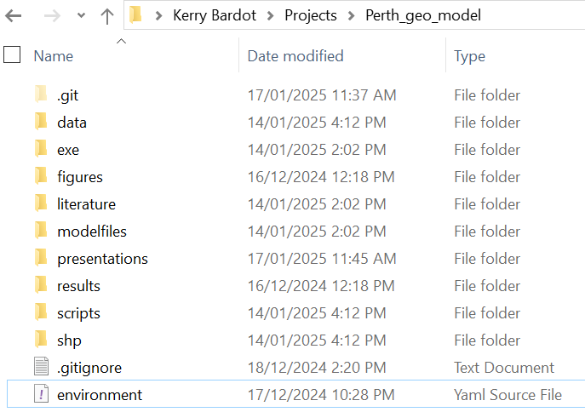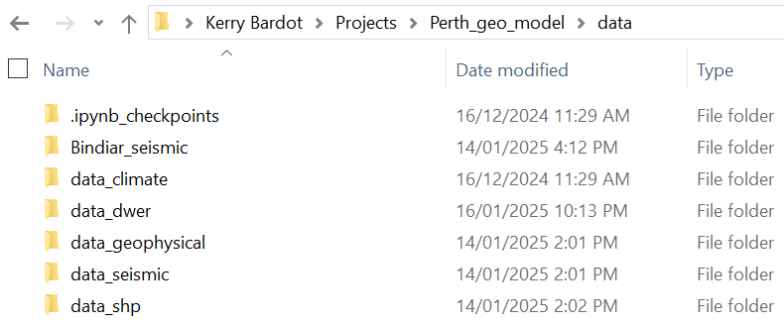

1. **Add, Commit and Push to GitHub**:

Now you are ready to get this work pushed into your remote GitHub repository so that it is shareable and also backed up! There are three steps to do this: ADD, COMMIT, PUSH. Adding (or “staging”) a file or folder means that you are tagging it as having been changed and you will be shortly declaring (“committing”) that change to Git. At any time, all files in your repo are either 1) staged, 2) modified/deleted, 3) untracked or 3) ignored. You might

In a new terminal in

git add -A

git commit -m "Initial commit"

git push

**To Use LoopFlopy**

1. Using Anaconda, navigate to where you want to save the LoopFlopy repository.
2. Type: “git clone <https://github.com/kerrybardot/loopflopy.git>”
3. Using Visual Studio Code, navigate to LoopFlopy folder and “pip install .”
4. Then you should be able to run scripts using “import loopflopy”

**Appendix A – Installing Git Software for Mac**

