**Getting setup with LoopFlopy for Seamless Geo-Structural Modelling!**

**1. Install Anaconda (Conda)**

Conda is anOpen-source package and environment management system that runs on Windows, macOS, and Linux. Install, run, and update packages and their dependencies.

[Download Anaconda Distribution | Anaconda](https://www.anaconda.com/download)

**2. Install VS Code**

Visual Studio Code (VS Code) is a **free, cross-platform code editor** developed by Microsoft. It is designed to provide a streamlined and efficient coding experience for developers working on various platforms, including Windows, macOS, and Linux.

[Download Visual Studio Code - Mac, Linux, Windows](https://code.visualstudio.com/Download)

**3. Install Git**

**Git**is a **distributed version control system** designed to track changes in source code during software development. It allows multiple developers to work on a project simultaneously without interfering with each other's work.

[Download Git Software](https://git-scm.com/downloads)

If you have a Mac, look in Appendix A for instructions!

**4. Create a GitHub Account**

[GitHub](https://github.com/)

**5. Create a Projects folder on your hard drive**

Running script from a cloud location can get messy. Create a “Projects” folder somewhere on your hard drive where you can save your GitHub repositories. Don’t worry - these scripts will get backed up when you use Git! That’s what it is for!

**6. Install loopflopy package from source**

Open the Anaconda Prompt App and navigate to your Projects directory.

*Hints:*

*dir* lists your directory

*cd starttypingfoldername…* and tab to select folder

*cd..* to go up a level

When in Projects, type:

*git clone*[*https://github.com/kerrybardot/loopflopy.git*](https://github.com/kerrybardot/loopflopy.git) which downloads the loopflopy package

**7. Create a new Python virtual environment**

A virtual environment in Python is a self-contained directory that includes a specific Python version and additional packages. It helps isolate dependencies required by different projects, ensuring that each project has its own set of packages without interfering with the global Python installation.

We will create a loopflopy environment so it contains all the bits and pieces (dependencies) you need to run loopflopy.

**WINDOWS**

Open the Anaconda Prompt and navigate to Projects> loopflopy

Create a new environment based on the requirements listed in the YAML file. This will we create a new environment called “loopflopy”

*conda env create --name loopflopy --file environment.yml*

*conda env list* lists your available environments

*conda activate loopflopy* activates our new environment

*conda list* lists all the packages in an environment

**MAC**

Open the terminal.

1. Create a new environment: *conda create –name loopflopy*
2. Activate the environment: *conda activate loopflopy*
3. Install packages:

**Geopandas**

conda install python=3 geopandas

**LoopStructural**

(this is all in one line)

conda install -c loop3d -c conda-forge loopstructural pyvista trame trame-vuetify trame-vtk loopstructuralvisualisation jupyter

**Flopy**

conda install conda-forge::flopy

**Others**

conda install anaconda::pyshp

conda install conda-forge::fionay

conda install conda-forge::xlrd

conda install conda-forge::spyder

conda install anaconda::openpyxl

conda install seaborn -c conda-forge

conda install conda-forge::rasterio

conda install conda-forge::rasterstats

conda install -c conda-forge pyemu

conda install conda-forge::folium

**8. Install loopflopy from source (because it’s currently under development!)**

LET’S DO THIS TOGETHER!

Navigate to the loopflopy main directory and then install:

*pip install .* which installs the loopflopy package which you can then use in your new project using “import loopflopy”

**Nina – stop here!! Just have a poke around the example folder to see how the script works!!**

**Create your first loopflopy project**

Now you are all set up and ready to start using loopflopy! We won’t need Anaconda now. We’ll be doing everything in Visual Studio Code. Let’s get your first project going.

**1. Create GitHub Repository**

* **Log In**: Go to [GitHub](https://github.com/) and log in to your account.
* **Create a New Repository**
* **Fill in Repository Details**
* **Initialize the Repository** (don’t include any files – we’ll do that in a minute)
* If you’re starting from scratch, check **Add a README file** (optional but recommended).
* Add a .gitignore and we will talk about that later.
* **Click "Create Repository"**:
* Your repository is now ready!

**2. Link your Project Folder to Git Repository**

1. **Set Up Git**: If not already, make sure Git is installed on your computer. If not, install it from [git-scm.com](https://git-scm.com/).
2. **Initialize Your Project**: Open a terminal in VS Code and navigate to the Project directory. Type *git init*
3. **Add a Remote Repository**: Open your repository on GitHub and copy the Copy the repository URL. Type:

*git remote add origin* [*https://github.com/your-username/repository-name.git*](https://github.com/your-username/repository-name.git)

1. **Setup subfolders and add project work**: You should now see a folder of your Repo appeared in your Projects directory. Now is the time to set up subfolders and add anything in there you’ve already been working on. For consistency, its recommended to set up folders that look something like this:

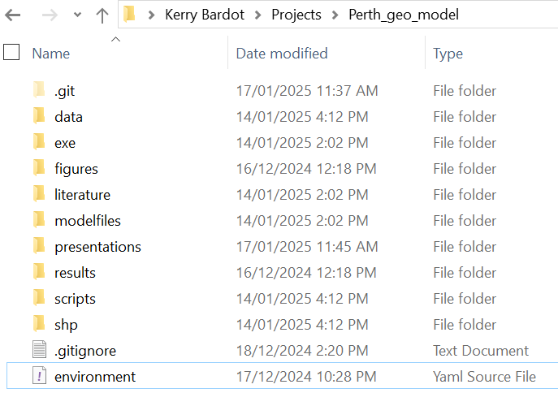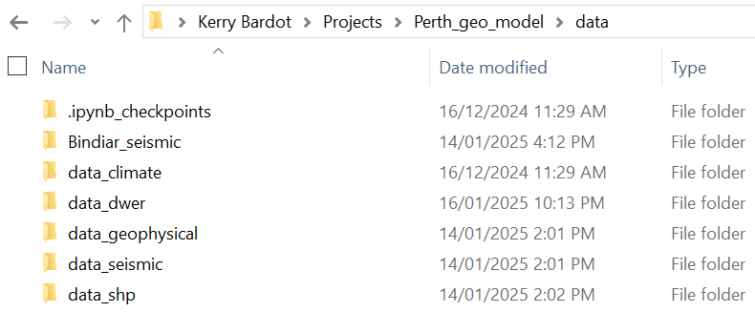

1. **Add, Commit and Push to GitHub**:

Now you are ready to get this work pushed into your remote GitHub repository so that it is shareable and also backed up! There are three steps to do this: ADD, COMMIT, PUSH. Adding (or “staging”) a file or folder means that you are tagging it as having been changed and you will be shortly declaring (“committing”) that change to Git. At any time, all files in your repo are either 1) staged, 2) modified/deleted, 3) untracked or 3) ignored. You might

In a new terminal in

git add -A

git commit -m "Initial commit"

git push

**To Use LoopFlopy**

1. Using Anaconda, navigate to where you want to save the LoopFlopy repository.
2. Type: “git clone <https://github.com/kerrybardot/loopflopy.git>”
3. Using Visual Studio Code, navigate to LoopFlopy folder and “pip install .”
4. Then you should be able to run scripts using “import loopflopy”

**Appendix A – Installing Git Software for Mac**

